TECHNOLOGY ACQUISITION PROCESS

Presented by:
Deborah Ludford
Cambridge West Partnership, LLC

Table of Contents

Purpose of the Document 3
District Environment 3
Mission, Vision, Value and Goals 3
Current Technology Environment 5
Current Technology Acquisition Approval Process 5
District-wide Technology Organization 6
District Information Systems 6
Campus Information Technology Departments 7
Summary of Student, Staff and Administration Perspectives regarding Technology 7
Correlation Between District and Campus Goals 9
Proposed Technology Acquisition Approval Process 10
Proposed Acquisition Process Flow 11
Proposed Acquisition Process Documents 12
Program/Administrative Reviews 12
Project Proposal/Total Cost of Ownership 12
Prioritization Rubric 12
Appendix A – Example Project Request Form & TCO Analysis 13
Appendix B – Project Prioritization Matrix 16

Purpose of the Document
The purpose of the Technology Acquisition Process is to clearly document for all constituents the process for technology acquisition, approval, prioritization and implementation at State Center Community College District. In addition, this document recommends changes for improvement in the process that will streamline the approval process, identify the total cost of ownership including one-time and ongoing costs, improve communications and provide consistent information for prioritization of projects.

During the process of developing the District-wide Technology Plan 2019-2022, constituents across the District overwhelming agreed that a clear and well-documented process for the acquisition of technology would be very beneficial. As a result, the following initiative was proposed:

9.a.2 Review, optimize, document and widely distribute the process for technology (hardware and software) acquisition including involvement of appropriate IT and purchasing department resources (III.C.2)

This document is designed to address this initiative.

District Environment

Mission, Vision, Value and Goals

The SCCCD District Strategic Plan 2017-2020 identified the Mission, Vision, Core Values and Goals. The Mission, Vision, Core Values and Goals also provide the focus for this analysis and the resulting recommendations. Highlighted are those items that indicate a well-documented technology acquisition process is needed:

Mission Statement
State Center Community College District (SCCCD) is committed to empowering our colleges in their efforts to promote exemplary educational opportunities and to provide safe, inclusive, and supportive learning environments leading to student success and global competitiveness which will transform our region.
Vision Statement
Empowering through Educational Excellence
Core Values
STEWARDSHIP
We are committed to the enhancement, preservation, conservation, and effective utilization of our resources.
COLLABORATION
We are committed to fostering a spirit of teamwork internally with our students, faculty, classified professionals and administrators while expanding our external partnerships with education, industry, and our community.
INTEGRITY
We are accountable, transparent and adhere to the highest professional standards.
INNOVATION
We are committed to an educational environment promoting actions and processes that create new methods, ideas, or products.
INCLUSIVITY
We are committed to and intentional in creating an environment that cultivates, embraces, and celebrates diversity.
Goals
EXCELLENCE IN EDUCATION
SCCCD is committed to empowering our colleges to cultivate excellence in educational programs and student support services.
INSTITUTIONAL EFFECTIVENESS
SCCCD is committed to data-informed but people-driven continuous quality improvement of processes and resources.
LEADER IN HIGHER EDUCATION AND COMMUNITY COLLABORATION
SCCCD is committed to being a force for positive change by expanding partnerships in education and workforce development.

Most significant to consider in the Technology Acquisition Process is the goal of Institutional Effectiveness and the values of stewardship, collaboration and innovation.

Current Technology Environment

Current Technology Acquisition Approval Process
The current District-wide IT Governance structure used in decision making is depicted below:

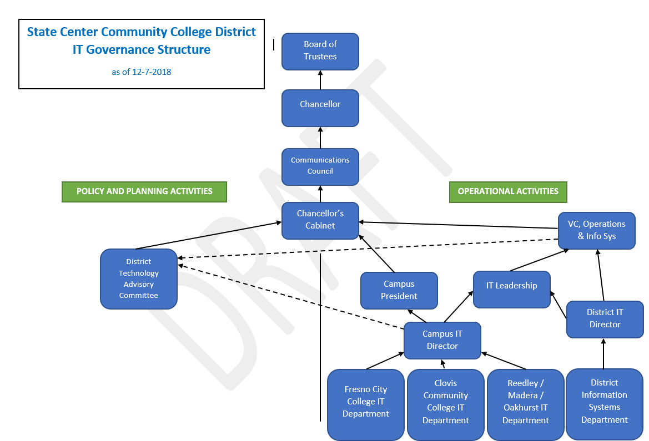

This IT Governance Structure describes the decision-making environment under which the staff currently operates. Approvals of projects and setting of priorities are determined through this decision-making process. The current decision-making process is not well defined and not clearly understood by constituents in the District. This is evidenced by the large number of pathways used to move information through the process. This causes confusion and frustration for many in the District.

District-wide Technology Organization

District Information Systems
The District Information Systems Department (IS) works very closely with the Campus IT Departments to support the full range of IT-related capabilities in the District. The IS Department provides the following services for the entire District:
- Enterprise Resource Planning System (Colleague) and related systems
- Telephony
- Internet Services
- Wide-Area Network
- Teleconferencing
- Helpdesk
The diagram below depicts the systems supported:
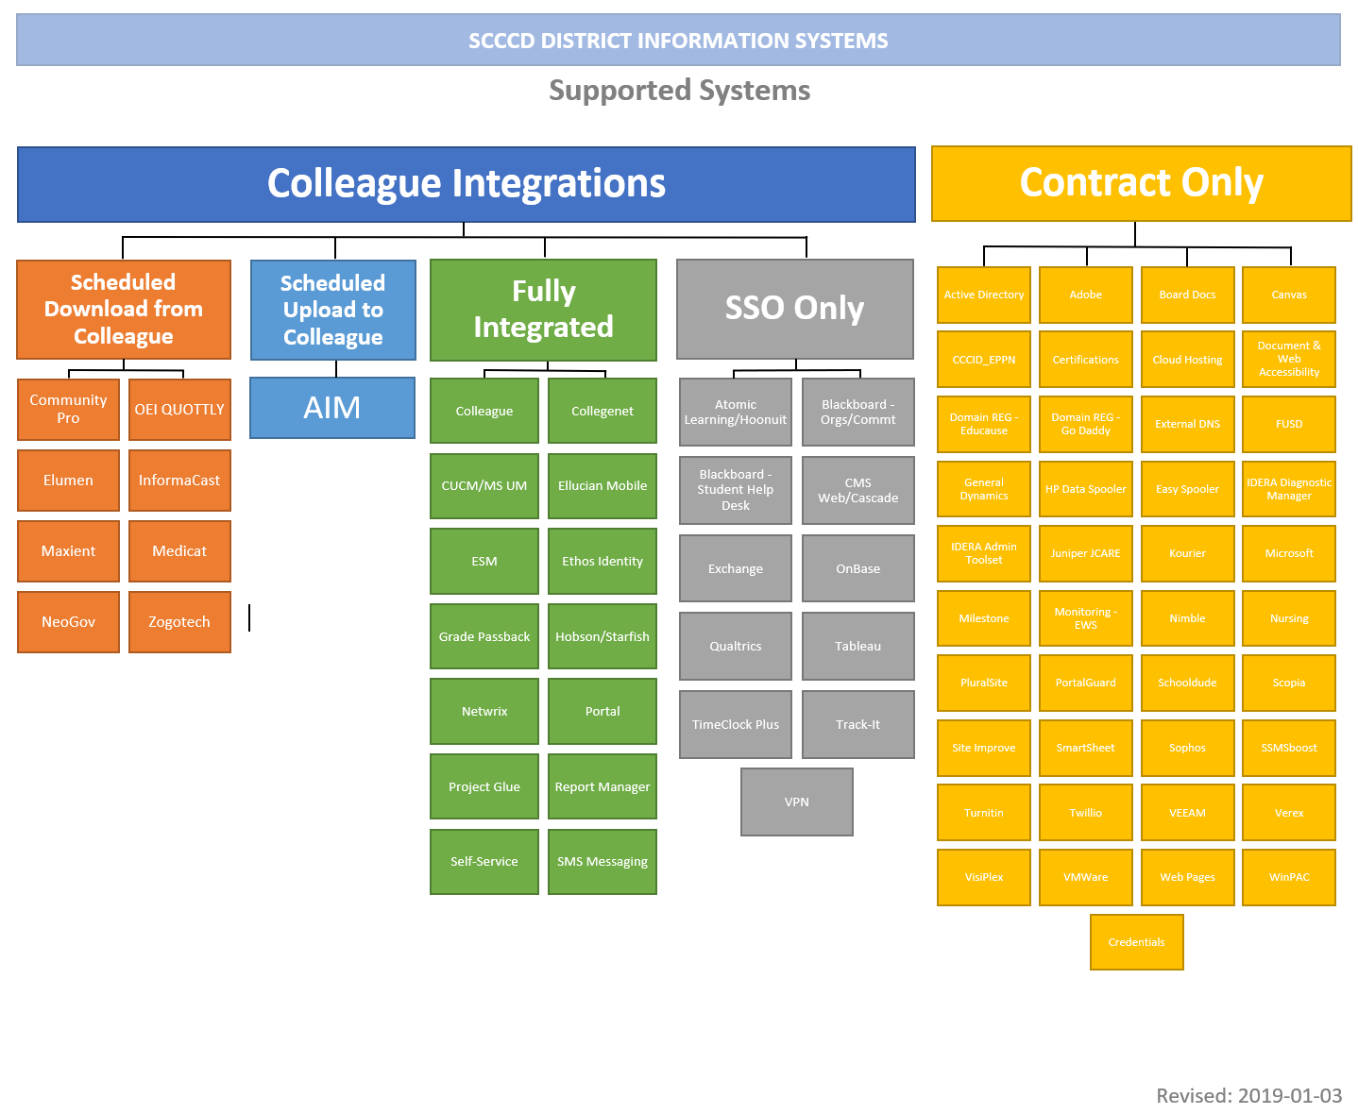

Campus Information Technology Departments
The Campus IT Departments are responsible for PC support, classroom IT support, help desk support, and campus resources such as shared folders. Each campus has its own decision-making processes for technology acquisition that are completed before requests are forwarded for discussion and funding at the District level.

Summary of Student, Staff and Administration Perspectives regarding Technology
During the development of the SCCCD District-wide Technology Plan 2019-2022 interviews and surveys resulted in thirty-six (36) key items to be included in the plan numbered below in priority order. These items were grouped into ten (10) strategic themes. Below are the results of the consolidation. Highlighted are those key items that should also be considered when determining the technology acquisition process:
State Center Community College District
Technology Plan Summit
Strategic Themes
Strategic Theme | Key Items
Effective Planning | 1. IT Project List assessed, prioritized, managed and communicated; software evaluation process documented; clear goals; who screams the loudest gets projects done; IT says “Yes” to everything
 | 13. Assess equipment (network, servers, storage, A/V etc.); replacement planning; performance improvement; Wi-Fi is not working well in all locations; equipment disposal
 | 15. Plan for support of mission critical applications; administrative reviews; IT departments in reactive mode; focus on the agreed upon system
 | 16. Leadership and vision for meeting technology demands; Strategic Planning on an ongoing basis
 | 24. Align with District/campus plans; i.e. Facilities Master Plan, Distance Education, Technology Plan, etc.
 | 25. Link plan to student success initiatives like Guided Pathways etc. which are clearly defined and used for prioritization; define how technology can help us meet the goals in these areas
 | 27. Identify new systems that make the institution better; i.e. staff more effective and efficient
 | 29. Leverage Statewide projects
 | 32. Annual Review of the plan is part of the plan
Adequate Staff and Resources | 2. Organizational review and staffing analysis; roles and responsibilities between campus and district defined; review of job descriptions and required skills; why not centralized management; need at CIO; succession planning
 | 8. IT departments unable to meet demand; result in end arounds or duplicate systems; IT departments not working together; no incentive to coordinate; IT (campus and District) not involved from beginning
 | 17. Help for end users-staff and students; shared help desk; after hours support plan; self-help services i.e. question answering
 | 33. District as a support organization to campuses
 | 36. Inadequate work space for technical staff
Effective Policies/Procedures/ Standards/Guidelines | 3. Policies/procedures/guidelines/standards need to be reviewed, documented, standardized across District, agreed too and followed; currently based on personal integrity; construction standards; drone policy
 | 9. Data Governance; too many people have too much access; shadow systems; some need more access to do their jobs
 | 21. Interface to outside systems; integration of systems
 | 28. Accessibility standard
Secure Data and Systems | 4. Security planning and assessment, standards and proper staffing; mitigate risks i.e. Active Directory; consider a Security Officer
Effective Governance and Decision Making | 5. IT Governance needs to be reviewed, strengthened, clarified, documented; constituents not getting information about issues and decisions; clarify role of DTAC; each campus does their own thing; need a CTO to represent the department
 | 6. Review, clarify, document and enhance technology decision-making process
Effective Communications/Training | 10. Training on systems and security for users; technical staff in need of more training; cross training of technical staff; training for new employees
 | 11. Better communications across the District; improved emergency communications; outage notifications
 | 17. Help for end users-staff and students; shared help desk; after hours support plan; self-help services i.e. question answering
 | 28. Accessibility support
Optimization of Technology | 12. Systems portfolio analysis; how will we sustain all systems; eliminate duplication; ensure continued operation; licensing needs reviewed; minimize customizations
 | 14. Standardization of systems and equipment across the District for effectiveness and efficiency; i.e. Help Desk, Network, etc.
 | 20. Evaluate ERP (Colleague); assess effectiveness and use; leverage capabilities
 | 22. Email is limiting ability to do work; postmaster accounts not used properly
 | 23. Use economies of scale when acquiring and/or managing technology across the District; inefficiencies
 | 29. Leverage Statewide projects
 | 30. Cloud evaluation for systems
Process Improvement | 18. Review technology acquisition processes; document and communicate
 | 19. Business process analysis and alignment with systems; streamline processes
Emergency Preparedness | 7. Disaster recovery/business continuity planning; safety of data centers; fire suppression
Support Instruction | 26. Support for instruction and curriculum development including LMS; Canvas support from one campus; pedagogy to drive technology

Correlation Between District and Campus Goals
Technology goals across the District also correlate with the District Strategic Goals and District Strategic Themes. The chart below shows the correlation and the highlighted areas also indicate the need for streamlined effective processes in technology acquisition:

District Strategic Goal | District Strategic Themes | Fresno City College Goals | Reedley College Goals | Clovis Community College Goals
Excellence in Education | Support Instruction | 1,4,5 | 1,2,4 | 2,3,4
Institutional Effectiveness | Effective Planning | 3 | 1,5 | 2,4
Institutional Effectiveness | Adequate Staff and Resources | 1,2,3,4,5 | 1,2 | 1,2
Institutional Effectiveness | Effective Policies / Procedures / Standards / Guidelines |  | 4 | 3,4
Institutional Effectiveness | Secure Data and Systems
Institutional Effectiveness | Effective Governance and Decision-making | 3,6
Institutional Effectiveness | Effective Communications and Training | 5 | 3
Institutional Effectiveness | Optimization of Technology | 1,2 | 1,2,4 | 1,2,4
Institutional Effectiveness | Process Improvement | 4
Community Collaboration | Emergency Preparedness

Proposed Technology Acquisition Approval Process
The first step in a more effective process is an improvement to the decision-making structure under which SCCCD operates. Below is a suggested revision to the structure to streamline the decision-making process as it relates to technology:
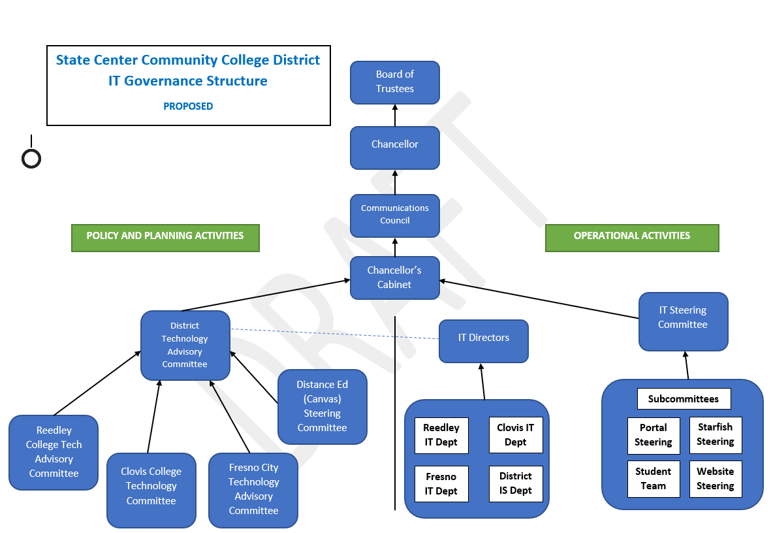
The most notable change is the formation of an operational decision-making committee composed of practitioners and first level managers from all aspects of the District including Student Services, Instruction, IT (campus and District), Finance, Facilities, Human Resources, Research and Educational Services. This group will review all acquisition requests for District-wide projects or projects referred to them by Chancellor’s Cabinet and recommend to the District Technology Advisory Committee the prioritization of these projects. These campus and District staff are best suited to understand the needs of students and staff because they work with the systems each day and know the pain points. The District Technology Advisory Committee will review and approve of the priorities and move the results forward to the Chancellor’s Cabinet and Chancellor for approval. This proposed change would provide for separation of operational decisions and policy/planning decisions. This also makes the workload more manageable for all committees and staff involved in the process. There is simply too much to be done for one committee to make operational, policy and planning decisions.

Proposed Acquisition Process Flow
Given this new decision-making structure, the following process for acquisition of technology resources would provide for campus autonomy in local projects while establishing coordination for technology acquisitions that could be shared or could benefit all campuses and the District. The new proposed process is depicted below:
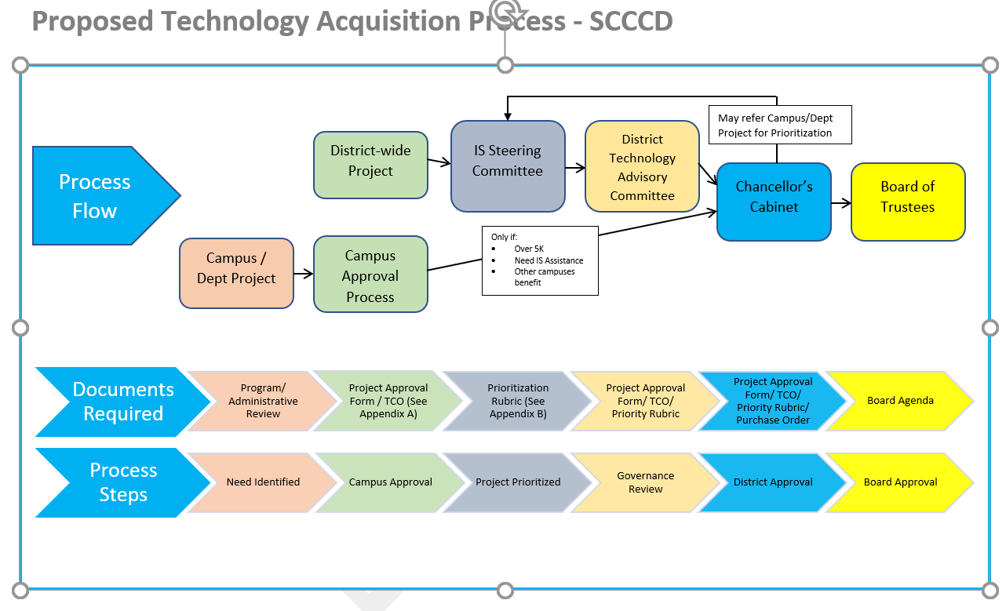

Projects/systems could be proposed from either the campus or at the District level. If a project originates at the campus and is under $5K, requires IS resources to complete or could be beneficial to other campuses or the District the proposal is sent to Chancellor’s Cabinet. Chancellor’s Cabinet could approve or refer the project to the IS Steering Committee for prioritization prior to approval.

If the Project is District-wide the proposal proceeds directly to IS Steering. Appendix A contains a recommended Project Request Form for the project proposal as well as an analysis of the Total Cost of Ownership (TCO). TCO analysis is beneficial to understand the on-going as well as one-time costs associated with technology acquisition and is identified in Accreditation standards.

The IS Steering Committee makes a recommendation on the prioritization of all projects. Hardware only A recommended rubric for prioritization is contained in Appendix B. Quarterly or as projects are identified the prioritization is reviewed and approved at the District Technology Advisory Committee (DTAC) to ensure input from all constituent groups. The DTAC forwards their recommendation of project priority to Chancellor’s Cabinet for approval.

Items which meet specific criteria based on District guidelines are presented to the Board.

Proposed Acquisition Process Documents

Program/Administrative Reviews
Each campus and the District have various processes for their respective reviews, but these reviews should drive the requests for technology acquisition through the campus and District planning process.

Project Proposal/Total Cost of Ownership
Appendix A contains an example form that can be used to request a project. It can be used for both campus and District projects. It captures key information such as general project information and description, objectives, level of effort, impact to the institution and costs over 5 years. Proposers identify appropriate District and Campus goals met by the project.

Prioritization Rubric
Appendix B contains an example form that can be used by DTAC to evaluate the priority of projects along with the Project Proposal/Total Cost of Ownership. This can be done collectively by DTAC or individually and then DTAC reviews the results and prioritizes.

Appendix A – Example Project Request Form & TCO Analysis
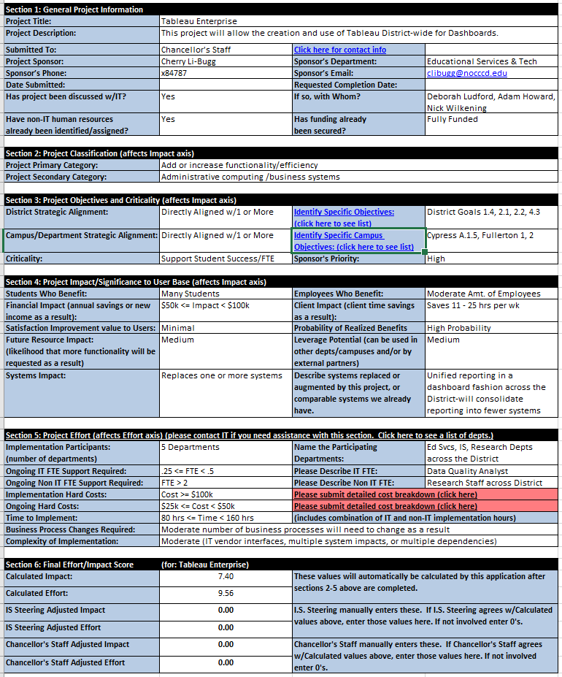

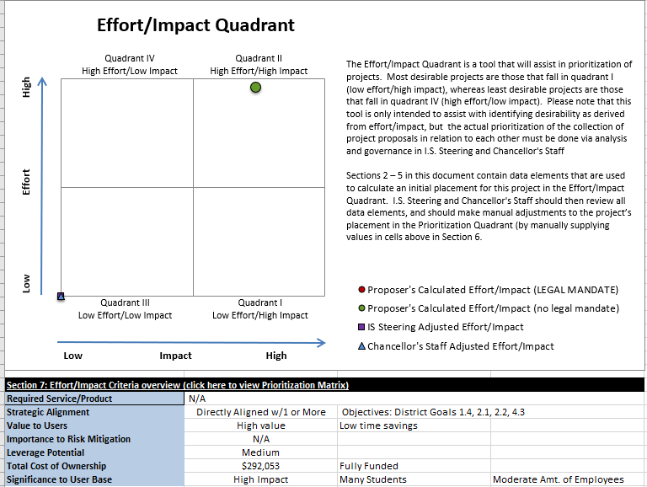

Total Cost of Ownership (TCO)
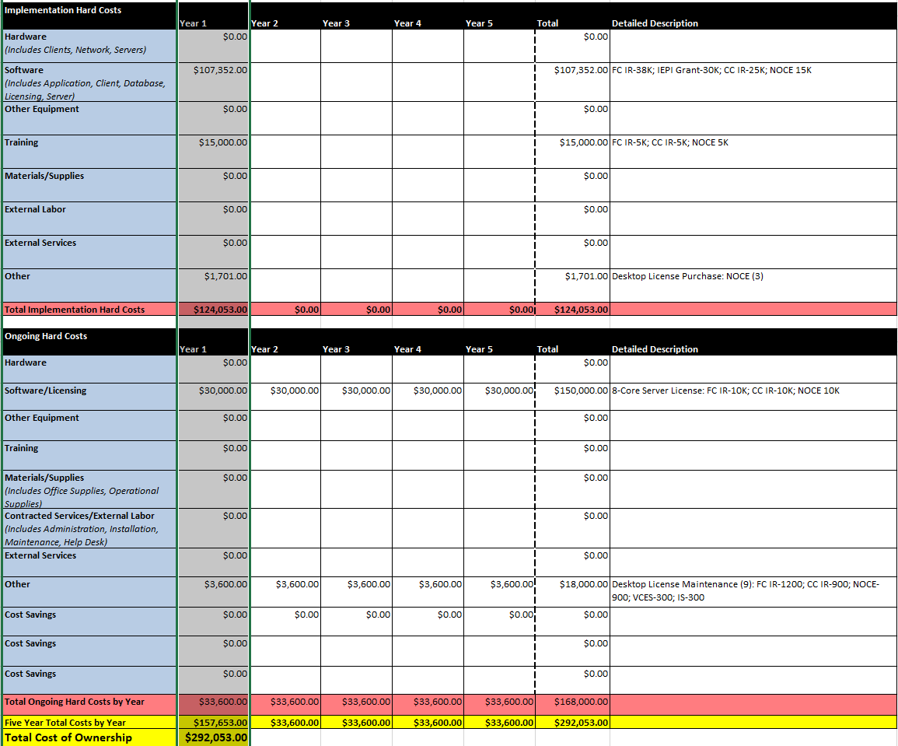

Appendix B – Project Prioritization Matrix

