2010 - 2012 Integrated Planning at Reedley College
Integrated planning “is an interactive process in which an institution, through its governance processes, thoughtfully uses its values and vision to set priorities and deploy its resources and energies to achieve institutional changes and improvements at various levels of the organization in response to current or anticipated conditions.” (ACCJC News Fall 2009)

The Reedley College integrated planning model consists of three key components that are intertwined with an evaluation process. The three key components are: the administrative structure, the faculty, staff and students (which comprise the participatory governance structure), and the various documents and plans that encompass Reedley College. The administrative structure and the participatory governance structure are described elsewhere in this handbook.In addition, the integrated planning model describes the evaluation process and the roles that the people involved play, distinguishing the work we do designing, implementing and revising plans. Further, it discusses the processes of assessing these plans, determining revisions (outputs) and introducing these revisions as inputs to create an evaluation cycle.
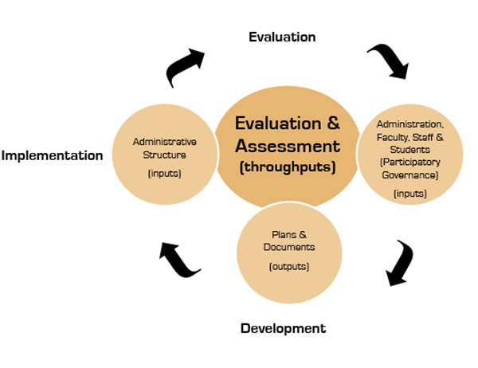
Figure 1

Long Term (Strategic) and Short Term (Annual) Planning

All planning activities are cyclical, some have a relatively short term annual cycle, and some that are strategic in nature have a longer cycle of five to twenty years. Short-term planning includes:
- annual reports such as the ARCC report, staffing reports and grant reports
- unit planning such as that required to develop program review annual updates,
Note: Unit planning refers to the plans of each area of the college; a unit may be an instructional department, a student service program or an administrative office.
- annual budget development and approval
- annual resource allocation for ongoing programmatic needs and one-time projects
- other annual planning activities.
Long-term strategic planning includes:
- long -term plans such as the strategic plan, educational master plan and facilities master plan
- unit planning that is long-term in nature but also feeds into the annual planningcycle
- an analysis of success in addressing goals such as the strategic plan goals
- an assessment of success in attaining goals in the long-term planning documents
- an evaluation of existing programs such as required for the comprehensive program review
- an overall evaluation of college planning such as an evaluation of each of the long-term plans and the planning process itself

The long and short term planning cycles are shown graphically in Figure 2.

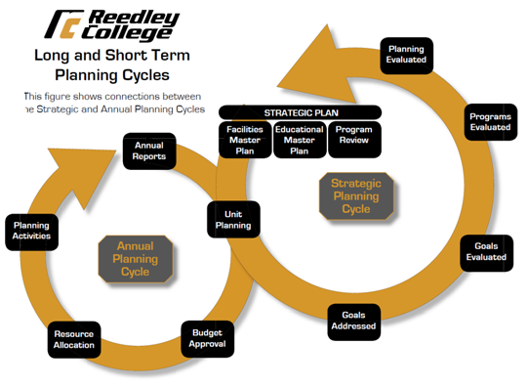
Figure 2

The following example illustrates how one item might move through the cycles shown in Figure 2. An example of how the Integrated Planning process is implemented is found in the new Reedley College Entrepreneurship Center (E-Center.) Business faculty members first envisioned and described a new Reedley College E-Center (unit planning). Recognizing a need of program students and community members, the faculty requested funding to establish an E-Center as part of the comprehensive fall 2011 program review. The Program Review Committee endorsed this discipline goal. A request was sent by the faculty to the Strategic Planning Committee which found that the request was substantiated (tied to Strategic Plan.) College Council discussed, endorsed the project and recommended the project's completion to the president. The proposal was then forwarded to the Facilities Committee and the Budget Committee to both identify a location (tied to Facilities Master Plan) and secure funding to create the E-Center (Funds found within approved budget.) A room with easy accessibility for the community and metered parking in a near-by parking lot was identified that could be rededicated as an E-Center. Faculty in the Communication Department agreed to relocate their classes. Two Business instructors and one Economics instructor agreed to relocate their offices to the E-Center and provide staffing (planning activities.) A small amount of college funds was used for touch-up painting (resource allocation.) A $35,000 grant from the Coleman Foundation which was received as part of a joint project with the Lyles Center at CSU Fresno was used to purchase furniture and computers for the new center. The Reedley College E-Center opened in fall 2012. The E-Centerwill be assessed on a regular basis as part of the department annual program review and unit planning. The E-Center outcomes will be assessed as any other program, through annual program review and scheduled program evaluation. At each of these assessment points, the E-Center outcomes will be substantiated with the college Goals, Strategic Plan, and Facilities Master Plan.

Important Documents at Reedley College
A discussion of the various plans, reports and documents and the manner that they connect to one another is a crucial component of the Integrated Planning Model. These documents are createdand evaluated by the constituent groups through the participatory governance model. Occasionally, some plans are so large in scope and/or so specific in their requirements that outside vendors are contracted to work with the college. Even in such cases, drafts are submitted for input during development and are reviewed by the constituency groups through the participatory governance model, and the graphic shown in Figure 1 is still followed. Plans developed and/or reviewed by participatory governance committees (which have constituency group representation) are recommended to the College Council. Representatives to the College Council are then tasked to take the proposal back to their respective organizations for review and comment. This feedback is reported at the next College Council meeting. If the body agrees to all of the proposed changes/comments, the revised document is then returned to the committee of origin with a period of time to review the proposed revisions. If the changes are substantive, a constituent representative organization may request an extended period of review. If the committee of origin objects to the revision, it may address its concerns to the College Council for further consideration before a recommendation is made to the College President. If not, the recommendation is forwarded to the College President for final approval.
These documents become the foundation for decision making and resource allocation at Reedley College. Most large financial proposals require substantiation in the form of adherence to and support of Strategic Objectives (from both the District and the College Strategic Plans), Program Review recommendations (from comprehensive or annual Program Review reports), or other forms of institutional data. This focuses the actions of the college toward a defined institutional direction that has been developed in broad consultation with all college constituency groups. It also reaffirms the process of developing such plans and legitimizes the work these committees do so that they clearly see their role in decision-making.
Although the college has many important documents, the core documents are the Mission Statement, Educational Master Plan, the Strategic Plan and the Program Review Reports.
Many of the core documents have relatively long-term objectives and life spans and help guide the planning of short-term documents as shown in the Long-term (right) circle of Figure 2.
Describing the relationship of these plans to one another is an important task of this document. Understanding and carrying out the objectives identified in the various plans is central to collaborative, data-based decision making on Reedley College’s campus.

Figure 3
As shown in Figure 3, at the very top of this hierarchy are the mission and core values of the college. Reedley College ensures that all plans are consistent with the college mission statement.Integrated planning begins with the consideration of the college mission and core values, which collectively inform and guide all planning. Below the Mission Statement are the two essential types of Reedley College documents. Each of these documents is required for awell-integrated planning process. The first is a comprehensive Educational Master Plan. This long-term (12-15 year) plan is designed to provide the direction for the college and its programs. The Educational Master Plan is the driving force behind the Facilities Plan and the Technology Plan, and provides information relative to upgrade and update priorities to the District and the State of California. The Technology Plan details the timeline for replacement of major technology on campus and the upgrade of existing technological infrastructure. The Facilities Master Plan outlines structural changes to existing facilities and future facilities needed for the college based upon projected future growth.The Strategic Plan outlines our strategy for addressing themission, the Educational Master Plan, the college goals and the goals of the various Program Review Reports.
Each year the college community must establish a priority of goals. Through collegial consultation members of all constituency groups help to determine the annual college goals. The Reedley College Strategic Plan aligns with and expands upon the State Center Community College District Strategic Plan. The Program Review Reports are a perfect example of the integration of planning, implementation, assessment and improvement.
The resource allocation process is an important part of annual planning. The resource allocation process:
- ensures that resource allocations are made in alignment with the College mission and goals;
- provides a method whereby allocations are linked to strategic planning and program review;
- clearly ties allocations to the analysis of quantitative and qualitative data; and finally,
- guarantees the role of participatory governance practices in allocationrecommendations.

In addition, the Budget Committee also gathers priority rankings of the various Resource Action Plan Proposals (RAPPs) from the Strategic Planning Committee prior to making their own ranking. Both rankings are submitted to College Council in order to make a priority list of projects to be recommended to the College President for funding. The process is designed to take into account the mission, goals and vision from the above documents in conjunction with the pragmatic needs of the plans listed below.

The final “level” of plans in Figure 3 is a level that governs the actions of the college most closely. These are primarily short-term plans (the left circle of figure 2)This level includes College Committee Plans (such as the Student Success Committee’s plans), various Grant-defined Plans, a Staffing Plan, and a Budget Plan. Generally, these are developed each year and must refer to the Strategic Plan, college goals and mission for their support.

Mission Statement and Core Values
The Reedley College mission states:
Reedley College provides an accessible, student-centered educational environment featuring high-quality learning opportunities. We offer basic skills enhancement, associate degree programs, career technical education, and transfer-level courses as an integral component for life-long learning within a diverse local and global community.

Reedley College is dedicated the following core values:

- An atmosphere of intellectual curiosity
- Personal integrity, accountability and individual accomplishment
- Experiences designed to promote critical thinking
- Cultural literacy
- A highly qualified staff of educators and support personnel who reflect the diversity of our unique community
- A flexible attitude towards change and encourage innovation
- To develop each student’s full potential
- Respect for self and others
- Comprehensive curriculum offerings and lifelong learning opportunities
- Quality services for students to support and enhance their success

Educational Master Plan
The Reedley College Educational Master Plan is a comprehensive plan for the Collegethatprovides specific direction and parameters for the implementation of programs and activities relating to the educational and support service programs of the College.
The Educational Master Plan includes an analysis of internal and external data that results in recommendations that provide a basis for dialogue about the college’s effectiveness in fulfilling its mission. The Educational Master Plan is revised based upon the objectives of the Strategic Plan and the Program Review documents thus creating an interdependent continuous improvement cycle.

Program Review
Every organizational unit of the college completes a comprehensive Program Review every five years and an annual report on progress/modifications.

The purposes of program review are to:

- Systematically assess instructional programs, student support services and administrative services using quantitative, qualitative, and student learning data for the purpose of:
    - demonstrating, improving and communicating program effectiveness
    - identifying program strengths and emerging trends
    - facilitating improvements through substantiated goals
- Assess the degree to which programs and services effectively support the:
  - Mission (Statement, Core Values and Vision)
  - Strategic Plan
- Influence curriculum, college planning, decision-making, and resource allocation
- Promote collaboration and dialogue across campuses and disciplines.
Program Review is part assessment, part evaluation and part recommendation, Program Review describes a process by which academic programs, student service programs, and administrative units assess effectivenessof their programs and services, and use this analysis to recommend changes to improve their effectiveness. In many ways the Program Review process is the ideal model for the term “integrated planning.” The Educational Master Plan, for example, includes program descriptions derived from the various program review documents. Long-term unit plans should inform planning documents like the Educational Master Plan. For short-termgoals, faculty and staff in program areas are expected to completeResource Action Plan Proposals (part of the budget planning process) in order to meet their most pressing needs that are identified in annual program review updates and annual SLO reports.This process exemplifies how the Educational Master Plan, the Strategic Plan and the Program Review Reports support each other.
Faculty and staff will have more experience working with Program Review than with any other plan or evaluation/assessment process, as this is most closely related to the work they do every day. The Program Review Committee reviews each report, listens to oral presentations, and sets goals. Program faculty/staff respond to these goals as a part of their annual program review update.

Strategic Plan
The Strategic Plan promotes continuous improvement by explicitly stating strategic goals and objectives for the college to address. The goals of the 2008 - 2012 Reedley College Strategic Plan are:
- Reedley College will strengthen the community through building partnerships.
- Reedley College will seek to improve collegiality, diversity, personal development, open access and campus safety.
- Reedley College will provide innovative learning opportunities to improve student success and completion.
- Reedley College will support students’ educational development and personal growth.
- Reedley College will systematically collect and analyze data for the purpose of improving institutional effectiveness.
- Reedley College will use current technology leading to the success of the students, staff and the college.
- Reedley College will efficiently and effectively use human, physical and fiscal resources to meet current and future operational needs.
The StrategicPlan both guides and substantiates a wide range of actions requested by various departments on campus. The most common example of this is the Resource Action Plan.
The implementation of approved Resource Action Plans falls to the supervisor over the area which has submitted the plan for consideration. Any Request for Facilities Modification, Requisition, or Maintenance Service Request that is required to complete the approved plan is created and submitted by the office of this supervisor, and the appropriate approval process followed.
The Strategic Planning Committee is the campus participatory governance committee which oversees the Strategic Plan. It has two main duties:
- To revise, assess and publish the college's strategic plan while ensuring its coordination with the district’s strategic plan.
- To oversee the Resource Action Plan Process
The Strategic Plan is developedwith input from all of the constituency groups. As a cyclical process, the Strategic Plan utilizes yearly reports of progress, biannual minor updates and complete revision every four years. The Strategic Planning committee gathers internal scans from the constituency groups in addition to external scans from the local community as they re-evaluate the strategic direction of the college. The college strategic planning committee also works in unison with the District Strategic Planning Committee (DSPC) to make sure the direction of the college is consistent with the direction of the district.
Other plans that are taken into consideration include the Technology Plan, Facilities Master Plan, Budget Plan and Staffing Plan. The Technology Plan provides guidelines to establish technology objectives, set strategies to meet those objectives, assess the status of the objectives and provide recommendations for the future. The Facilities Master Plan guides campus facilities development.The purpose of the Budget Plan is to guide the college in making financial decisions for a specified period of time (usually one year.)A budget serves five main purposes—communication, coordination, planning, control, and evaluation.The Staffing Plan ensures that the college always has an appropriate number of administrators, faculty, and staff assigned to the correct area of the college to successfully conduct the business of the college and provide appropriate services to students.

Evaluation Processes
The core mechanism that truly illustrates the integrated nature of college planning is the evaluation of all processes in an effort to improve the quality of educational services provided at Reedley College. The term “evaluation” was strategically placed in the center of Figure 1 to show the significance of evaluation. The administrative structure, the faculty and staff, and the documents at Reedley College are evaluated on a regular basis. The administrative structure works with faculty and staff in assessing and developing plans. They are implemented and then reassessed. This feedback loop of continuous improvement allows all participants to actively have a voice in the changes necessary to make every program and every committee function to the best of its ability, taking into account the mission, the educational master plan, the strategic plan, the program review reports and any budgetary issues.

References
ACCJC News Fall 2009
Educational Master Plan
Program Review Handbook
Participatory Governance Handbook

Program Review Handbook, Cycle 3
The Participatory Governance Handbook, page 67

