Individual Brief Therapy
State Center Community College District
2010-2011
The State Center Community College District’s (SCCCD) Psychological Services department is designed to help meet the mental health needs of the college community. Clinicians with Psychological Services are located on both the Fresno City College (FCC) and Reedley College (RC) campuses. Psychological Services offers assistance in a number of areas including short-term brief therapy, crisis services, community presentations and outreach, mental health screening, referrals, and presentations and guest lectures. However, clinicians primarily devote their time to providing brief psychotherapy to students. This report will review data collected during the 2010-2011 academic year, and is aimed at answering 4 questions: (1) How many students were served by Psychological Services in the 2010-2011 academic year? (2) What referral sources did students use to seek Psychological Services? (3) Who were the students served, and were the student’s representative of the general population at each campus? (4) What services did students seek?
Background Information
As a part of the student health fee, students may receive up to eight sessions of free psychotherapy while currently enrolled in classes. If a student has received eight sessions in one academic year, then they are eligible to receive only 4 sessions in the following academic year. In certain cases students may be treated for more than eight sessions in one academic year. This decision is based upon the needs of the student, the caseload of the intern, and the advice of the supervisor. Treatment may include couple’s counseling if both partners are currently enrolled students. All sessions are 50 minutes long.
As an adjunct to treatment, students are sometimes given referrals to agencies within the community, such as low-fee health or mental health clinics, private psychotherapists, medical facilities, or housing or employment agencies. Students will sometimes transfer their treatment to local mental health providers after they have exhausted their eight sessions from Psychological Services.
Although faculty and staff benefit from clinician consultation, presentations, and crisis coverage, unless they are also enrolled as students, they are not eligible for brief therapy services. Psychological Services may provide them with referrals and/or direct them to their Employee Assistance Program.

How many students were served by Psychological Services?
During the 2010-2011 academic year, clinicians at Psychological Services at FCC saw 180 clients for a total of 1139 sessions. This was an 18% increase in the number of students served, and a 14% increase in number of sessions offered from the 2009-2010 academic year, when clinicians at FCC saw 148 clients for a total of 977 sessions.
At Reedley College, clinicians saw 58 clients for a total of 244 sessions. This was a 24% increase in the number of students served, and a 13% increase in the number of sessions offered when compared to the 2009-2010 academic year, when clinicians saw 45 students for a total of 213 sessions.
There are several potential explanations for the increase in numbers during the 2010-2011 academic year. The Program Coordinator returned after several months of medical leave, restoring the fluidity of service. The Program Coordinator was able to monitor the amount of sessions each student received and make adjustments as necessary in a timely manner.
Other factors that may have impacted the increase in numbers include the fact that the current economic recession may have been reflected by more students seeking assistance from Psychological Services, and many clients demonstrating more significant needs. Additionally, a decrease in course offerings on campus likely along with other budgetary concerns likely exacerbated student stress and thus the need for our services. As such, clinicians closely monitored the wait list which at its lowest level was 10 students and at its highest approximately 25 students. To maximize efficiency and to ensure that students who most needed services were served, clinicians frequently made calls to those on the waiting list to offer referrals, assess urgency of need, and notify of wait list status
At the Reedley College campus, services showed a similar increase in demand likely due to similar reasons as stated above for Fresno City College. An additional probability for the increase in service at Reedley is the aggressive outreach on campus through several screenings, bimonthly outreach to dormitory students, and weekly relaxation and meditation available to students and staff which allowed for a heighten presence of psychological services on campus.
What referral sources did students use to seek Psychological Services?
It is important to understand how students learn about Psychological Services. This information helps clinicians target their outreach efforts and ensure that information about services available to students can be effectively dispersed. At both campuses, the majority of students are self-referred (48% at FCC and 40% at RC). It is interesting to note that on the Reedley College Campus, fewer students are self-referred. It is possible that students on the Reedley College campus are less aware of the services available to them, which is why they are more likely to be referred by someone in another campus office, such as a counselor or friend (12%), instructor (19%), nurse (7%), or family (4%). See the pie charts below for additional information regarding the referral sources for students at both campuses:
How were students from each campus referred to Psychological Services?
Fresno City College:
* All numbers shown are percents of students served.

Reedley College:

* All numbers shown are percentages of students served.

Who were the students served, and were student’s representative of the general population at each campus?
Psychological Services strives to meet the unique needs of the students at Fresno City College and Reedley College. As a result, it is important not only to understand the demographic characteristics of the students who seek our services, but it is also important to examine whether the students Psychological Services serves are representative of the general student population. In this report, we look at the demographic characteristics of gender, age, marital status, ethnicity, and primary language. Where the data were available to do so, we compared demographic data from the general student population with the data from the students who sought services from Psychological Services. Analyses are broken down by campus.
Fresno City College. Gender. At the FCC campus, students who were seen were 58% female, 42% male, and 1% transgendered. This is comparable with the general student population, which is 56% female and 44% male. Although Psychological Services served approximately 15% more women than men, this is not surprising and may reflect larger trends within the mental health field that suggest that women are more likely to seek services than men.
Age. As depicted in the table below, FCC Psychological Services served students who were generally proportionate to the ages of students in the general campus population. The exception to this is that FCC served proportionately fewer younger people than older people. This may be reflective of older students at FCC being in greater need, especially during an economic recession.
A Comparison of Age for Students Served by Psychological Services at Fresno City College with the Fresno City College Student Population (2010-2011)
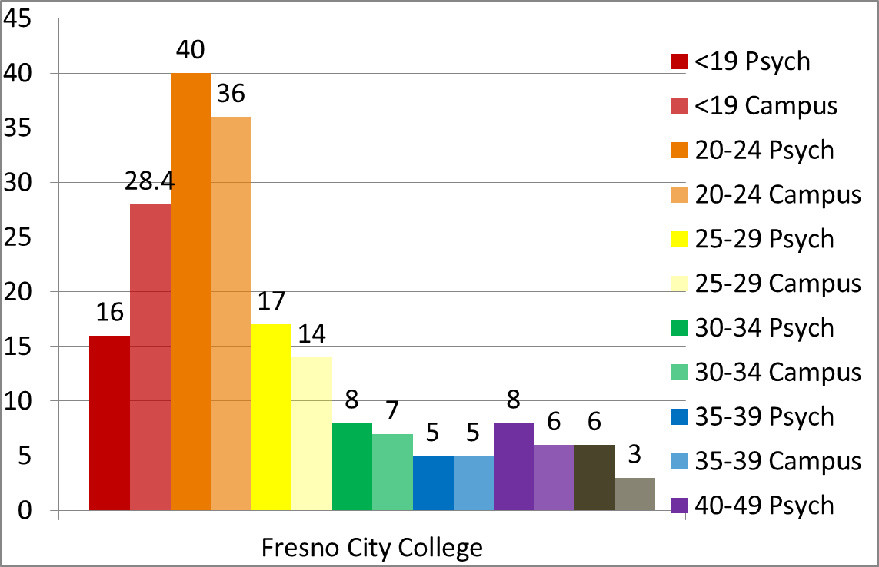
Percentage of Students
<19 20-24 25-29 30-34 35-39 40-49 50+

Ethnicity. As depicted in the table below, the ethnic composition of students served by Psychological Services at the Fresno City College Campus was generally similar to the ethnic composition of the campus at large, although some differences were evident. In terms of historically underserved populations, FCC Psychological Services serves African-American (9% vs. 8.9%), Hispanic (40% vs. 38.5%), and Native American (1% vs. 1%) students at a rate proportional to the general campus population. However, it serves Asian-American / Pacific Islander students at a rate that is disproportionate to the general campus population (5% as opposed to 17%). One reason for this disparity might be a cultural reluctance to seek mental health services or to involve external parties and non-family members in personal problems within the Asian-American / Pacific Islander community.
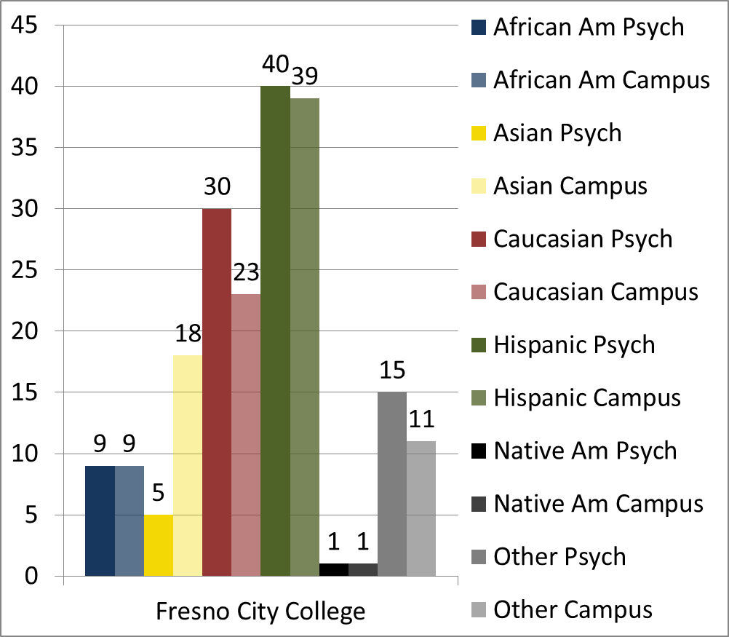
A Comparison of Reported Ethnicity for Students Served by Fresno City College Psychological Services with the FCC Student Population (2009-2010 Academic Year)
Percentage of Students
Reedley College. Gender. At the Reedley College campus, students who were seen by Psychological Services were 64% female and 36% male. This is about 8 percentage points different from the general Reedley population, which is 56% female and 44% male. One hypothesis for this discrepancy is that it is possible that these numbers are impacted by a greater number of people at Reedley College being referred from other school departments, rather than being self-referred. Traditional gender roles may make it more likely that people would refer females to therapy than males, because, in the more conservative and rural town of Reedley, it is possible people would hesitate to refer males for therapy due to a perception that they were demasculating them. Alternatively, it may be less likely that males would follow through with a referral or seek services out on their own because of stigma associated with pursuing psychotherapy.
Age. As depicted in the table below, Reedley Psychological Services served students who were generally proportionate to the ages of students in the general campus population. Although Reedley College in general serves students who are somewhat younger than at FCC, there was a slight tendency to serve a greater proportion of students who were younger than the campus population.
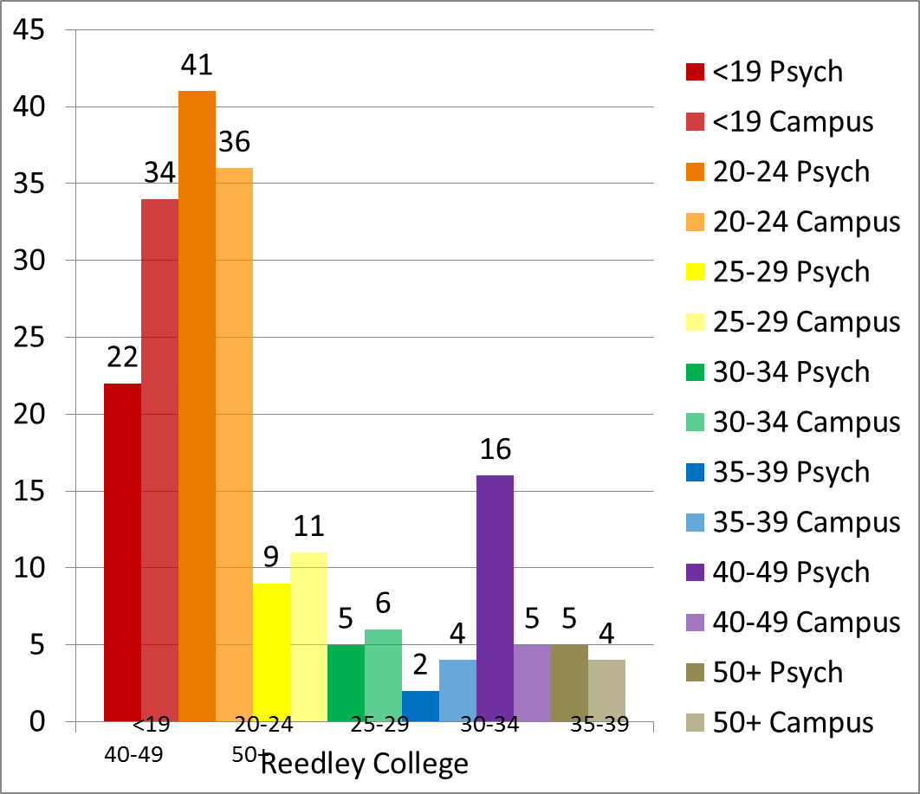
A Comparison of Age for Students Served by Psychological Services at Reedley College
With the Reedley College Student Population (2010-2011)
Percentage of Students

Ethnicity. As depicted in the table below, the ethnic composition of students served by Psychological Services at the Reedley College Campus was generally similar to the ethnic composition of the campus at large, although some differences were evident. In terms of historically underserved populations, Reedley Psychological Services serves African-American, Hispanic, and Native American students at a rate proportional to the general campus population. However, in a similar vein to Fresno City College, it serves Asian-American / Pacific Islander students at a rate that is disproportionate to the general campus population (2% as opposed to 5%). Once again, this disparity may be related to a cultural reluctance to seek mental health services or to involve external parties and non-family members in personal problems within the Asian-American / Pacific Islander community.

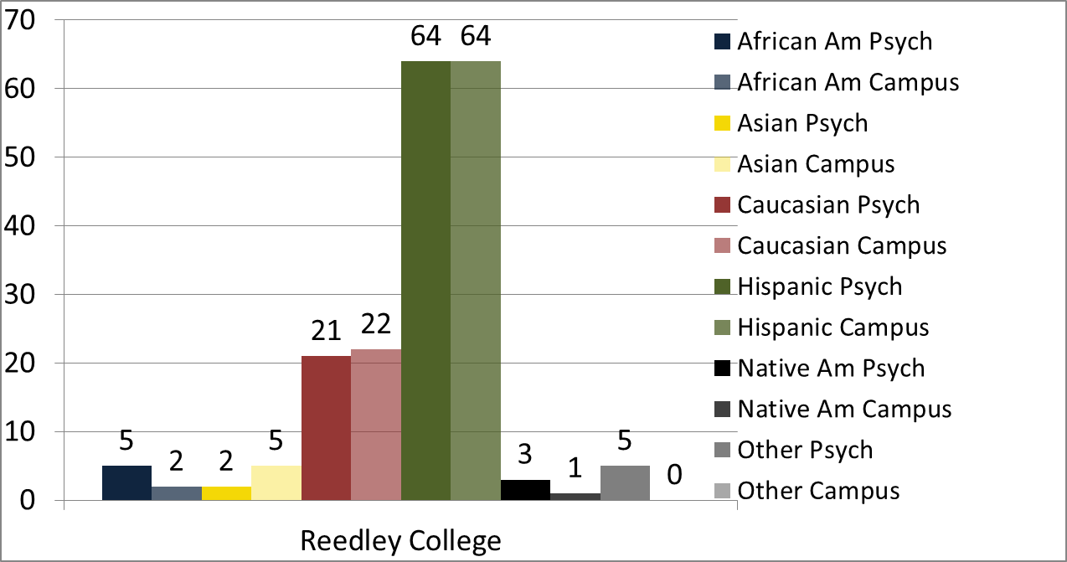
A Comparison of Reported Ethnicity for Students Served by Reedley College Psych-ological Services with the Reedley Student Population (2010-2011 Academic Year)
Percentage of Students

What services did students seek?
It is helpful for Psychological Services to identify what types of services students sought. This information is helpful for the department to understand how students utilize services. It also impacts clinician training, and informs Psychological Services about resources that might be needed in order to meet student needs. This section will review data regarding number of sessions provided, clinical needs, and most frequent diagnoses.
Number of sessions. The table below shows information about the number of sessions used by students on both the Fresno City College and Reedley College Campuses. It is noteworthy that the number of students served on the Fresno City College campus rose by 18% in the 2010-2011 year, while still maintaining a comparable average number of sessions. It is also noteworthy that the number of students served on the Reedley College campus rose by 22% in the 2010-2011 year, while still maintaining a comparable average number of sessions. One explanation for this improvement in service productivity might be the return of the Coordinator of Psychological Services from his medical leave, whereby he was able to directly oversee the operations of the center. Another contributing factor may be the current economic conditions that have caused greater distress in students, perhaps leading an increased number of students to seek services. It is also possible the outreach activities this year were exceptionally effective at recruiting students and increasing client volume. Lastly, the clients seen this year were more frequently terminated by the 8th session, as opposed to last year when clients were seen significantly past the 8th session.

 | 2010-2011 | 2009-2010 | 2008-2009 | 2007-2008
Fresno City College
# students | 180 | 148 | 190 | 169
# sessions | 1139 | 977 | 1193 | 901
Avg # of sessions | 6.33 | 6.60 | 6.28 | 5.33
Reedley College
# students | 58 | 45 | 50 | 54
# sessions | 244 | 213 | 267 | 240
Avg # of sessions | 4.21 | 4.73 | 5.34 | 4.44

Diagnostic Categories. Finally, the table below shows the number of students who were treated for various diagnostic categories. The most frequent problems identified by clinicians were relational problems, phase of life problems, depression, adjustment disorders, personality disorders, addiction, anxiety, and having survived abuse as a child.
 | TOT FCC |  | TOT RC | Total
Relational Problems/Phase of /Life |  | 60 | 22 | 82
Phase of Life |  | 37 | 11 | 48
Depression (Major, Dysthymic, NOS) |  | 26 | 7 | 33
Adjustment Disorders |  | 22 | 11 | 33
Personality Disorders |  | 20 | 4 | 24
Drug/Alcohol/Gambling Abuse/Dependence |  | 17 | 4 | 21
Anxiety |  | 18 | 1 | 19
Abuse of Child |  | 12 | 6 | 18
Bereavement |  | 7 | 5 | 12
Academic |  | 6 | 3 | 9
ADHD |  | 7 | 1 | 8
Bipolar Disorder |  | 6 | 2 | 8
Identity Problem |  | 6 | 2 | 8
PTSD |  | 6 | 1 | 7
Dx deferred on Axis I |  | 6 | 1 | 7
no Dx on Axis I |  | 5 | 1 | 6
Abuse of Adult |  | 2 | 1 | 3
Acculturation |  | 3 | 0 | 3
Sleep Related Disorders |  | 2 | 1 | 3
Schizophrenia/ Schizoaffective/Delusional |  | 2 | 1 | 3
Pain Disorders |  | 1 | 1 | 2
Aspergers, PDD, Retts, Other Early Childhood Psychosis |  | 2 | 0 | 2
Paraphilia |  | 1 | 0 | 1
Learning Disorder |  | 0 | 1 | 1
Eating Disorders |  | 1 | 0 | 1
Mood DO due to Gen Medical Condition |  | 0 | 1 | 1

Conclusion
During the 2010-2011 academic year, Psychological Services saw more students and provided more sessions that in recent years. This was likely due to a combination of factors. One explanation for this improvement in service productivity might be the return of the Coordinator of Psychological Services from his medical leave, whereby he was able to directly oversee the operations of the center. Another contributor may be the current economic conditions that have caused greater distress in students, perhaps leading an increased number of students to seek services. It is also possible the outreach activities this year were highly effective at recruiting students and increasing client volume. Lastly, the clients seen this year were more frequently terminated by the 8th session, as opposed to last year when clients were seen significantly past the 8th session. All of these factors combined to enable Psychological Services to serve an average of 20% more students on the Fresno City College and Reedley College campuses this year.
The current data also reflects differences in the demographics served by each campus location. Whereas Reedley College has served a somewhat younger population of students than Fresno City College in the past, this year the mean average age was 27 years old for both (with a standard deviation of 10 for both). While both campuses served a higher proportion of female than male students, it is noteworthy that Reedley College served even 12% more female than male students as compared with Fresno City College. In general, students served by Psychological Services are representative of the student bodies at each campus. The one consistent exception is that students of Asian descent were underserved on both college campuses. Future outreach activities might do well to focus and tailor efforts at recruiting more Asian-American / Pacific Islander students who might need or want psychological services.

