STEM/Transfer Center
Field Trip

Cal Poly, SLO

Friday, May 7, 2010

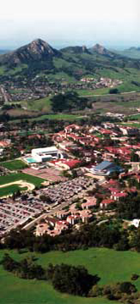
- SEATING IS LIMITED.
- $5.00 fee (non-refundable) is required.
- Signed student contract with emergency information is required.

For more information or to sign up:
At Reedley College, come by or call the Transfer Center at 638-3641 ext. 3234.
At Willow International, contact Tasha Hutchings at 325-5200 ext.5304.
At Madera Center, contact Maria Ensminger at 675-4800.

