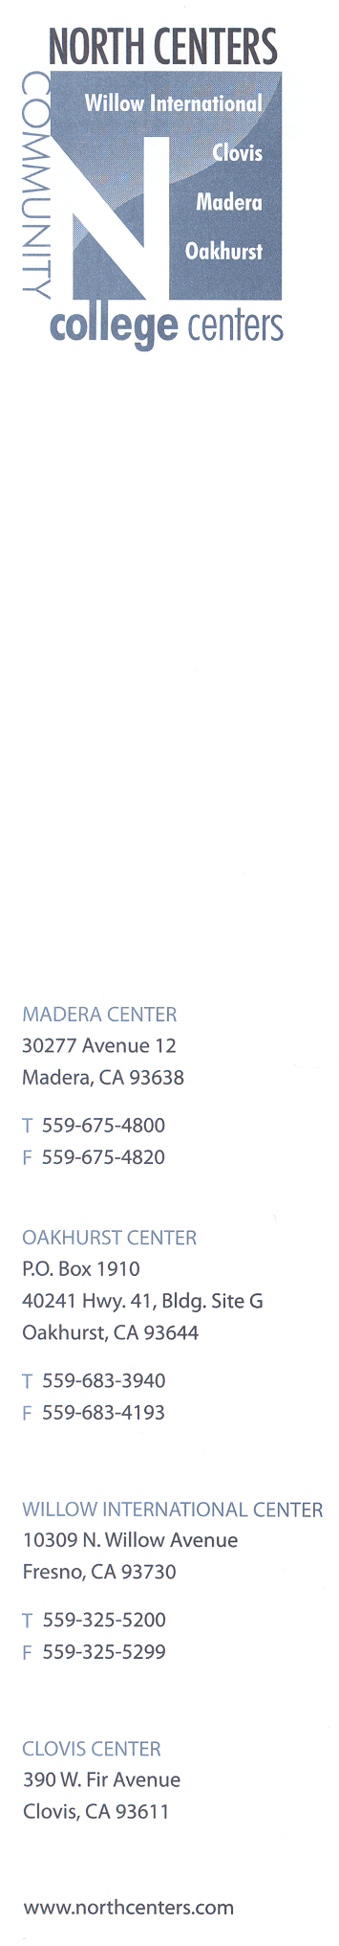

Willow International and Clovis North Monthly Meeting
June 9, 2010
AGENDA

- Student Applications and Paperwork Update – E. Johnson
- Orientation for Fall NCCAP Students and Parents – D. Navarro, E. Johnson
- Textbooks
- Registration Update – D. Griffin
- Other

