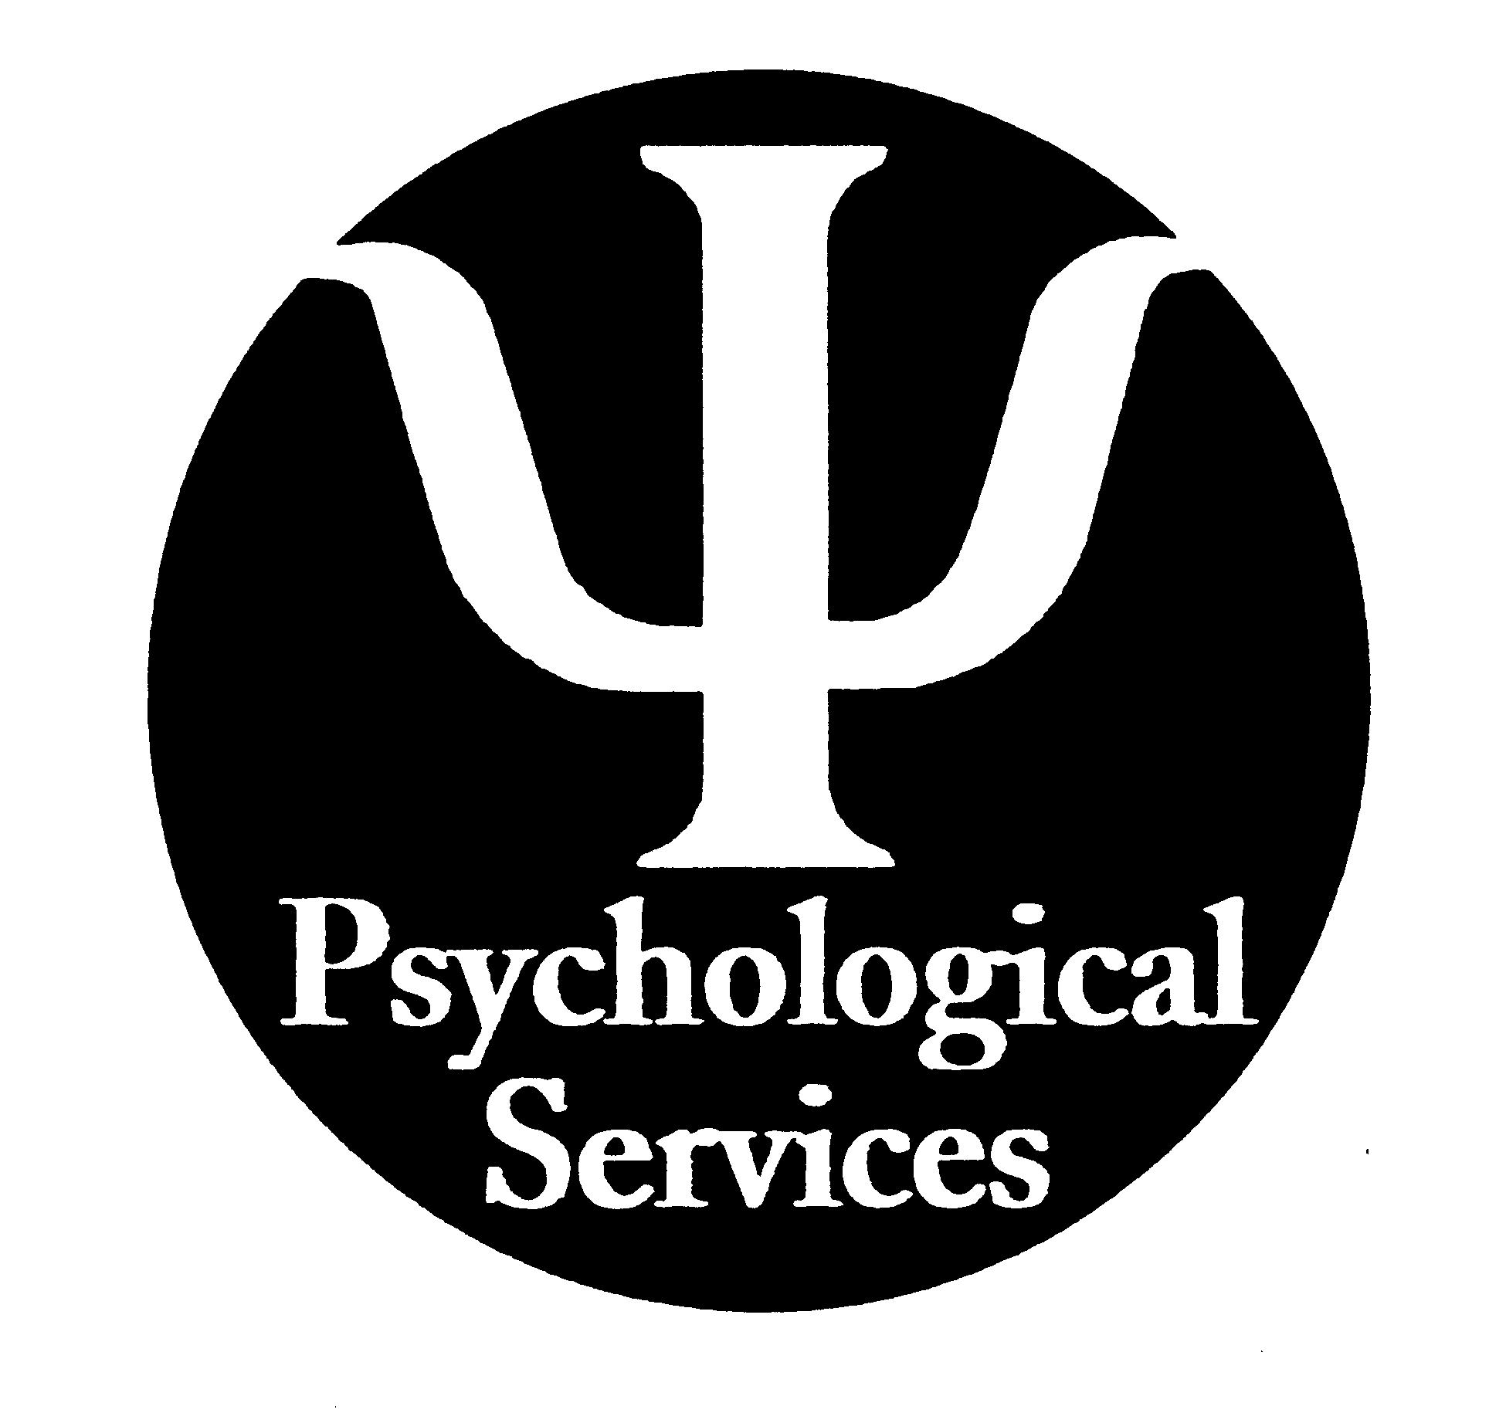

From the desk of Brian Olowude, Ph.D., Coordinator

2010-2011 Reedley Psychological Post Docs and Interns

Individual Brief Therapy Crisis Intervention
Group Therapy Couples Therapy
Psychological Testing Guest Lectures Program and Case Consultation Critical Incident Debriefing

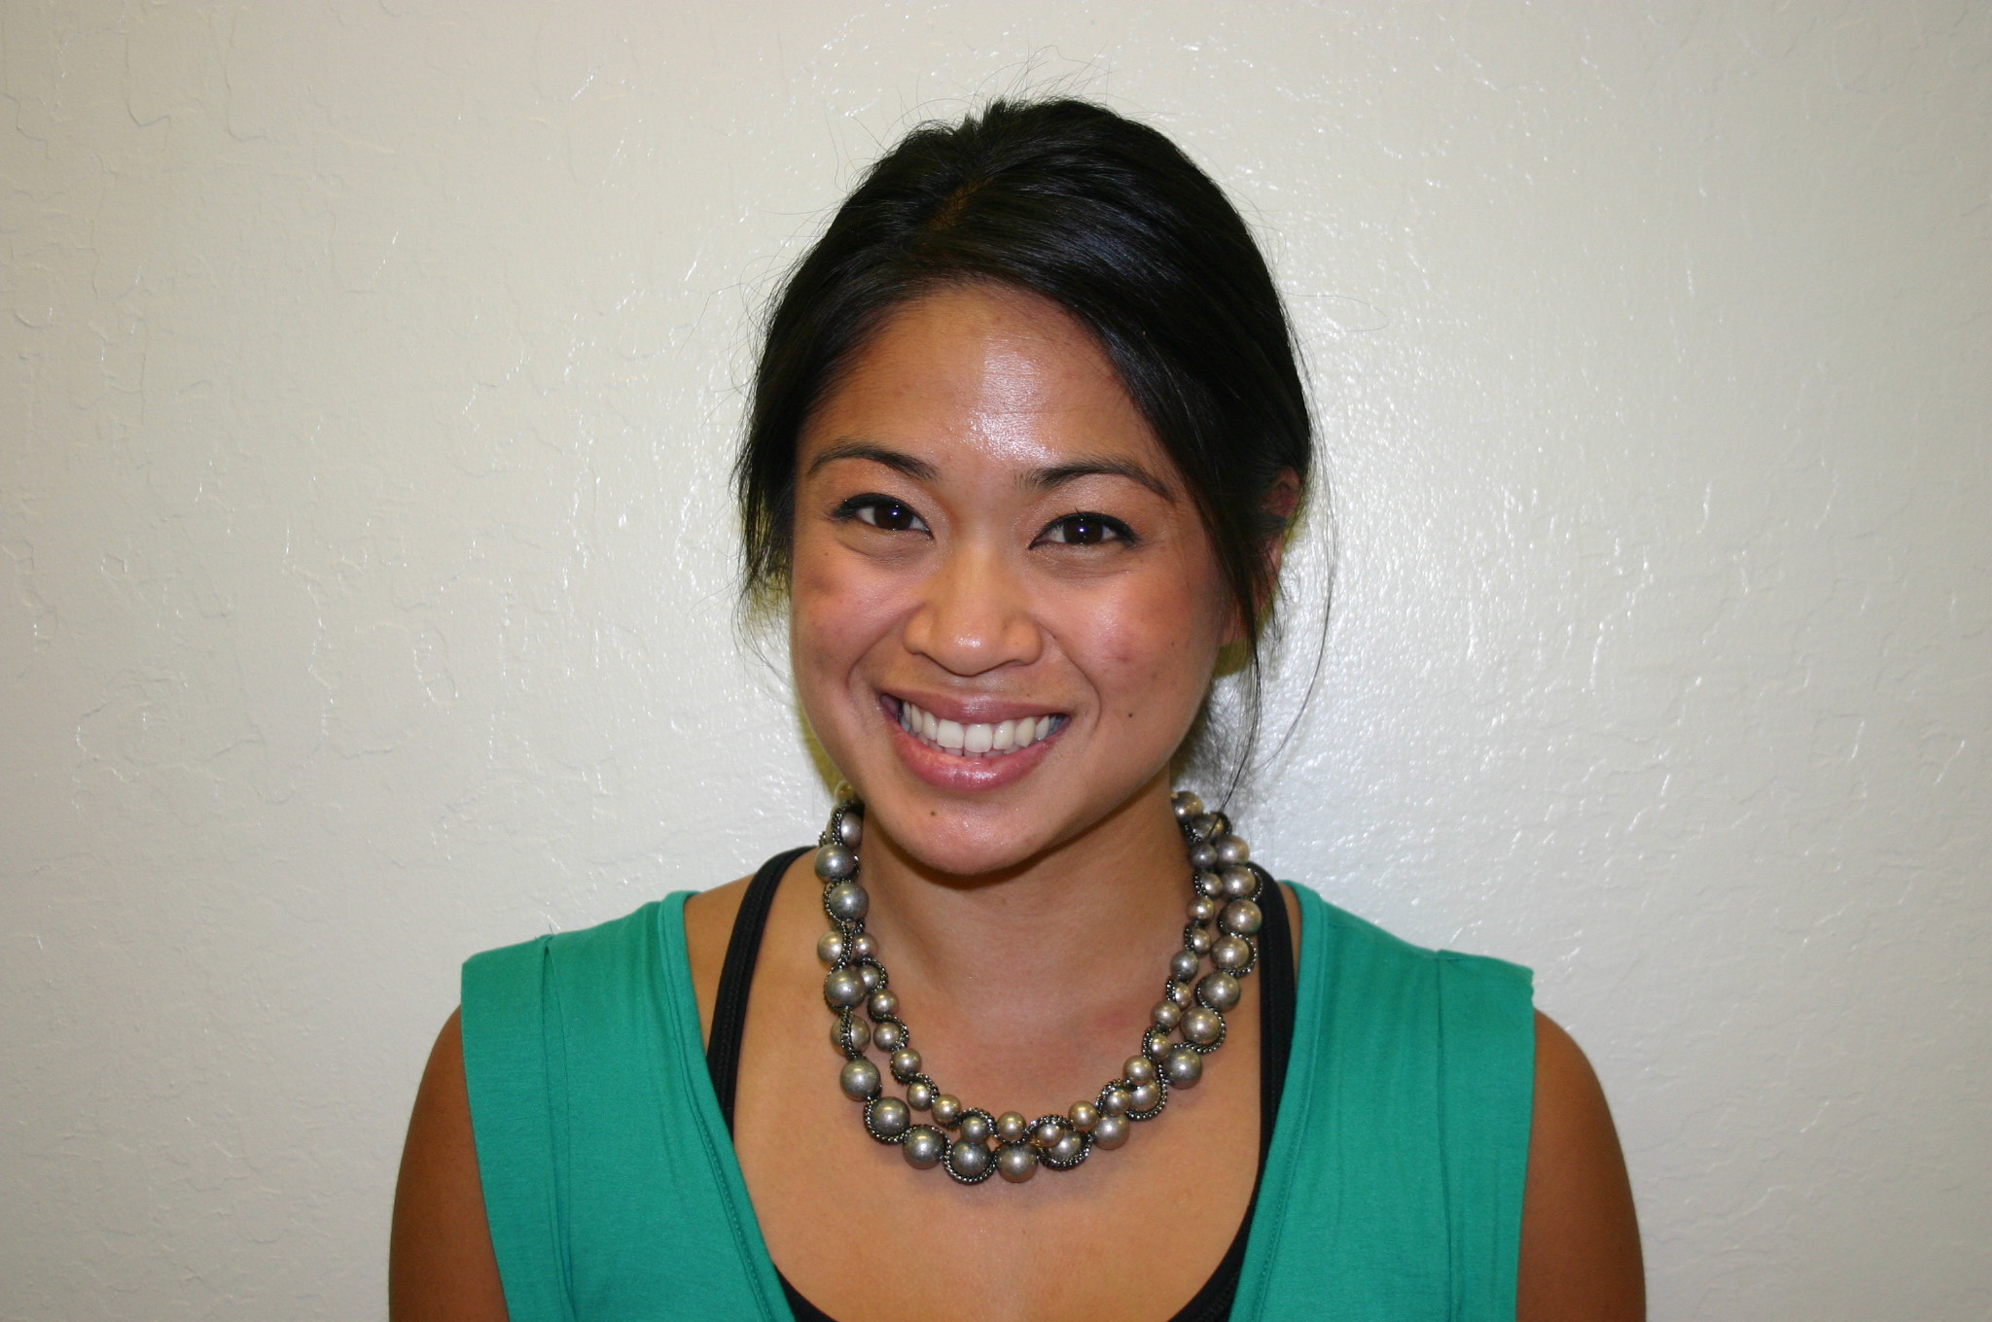Dianne Ey, Psy.D. (Post Doc) Dr. Ey is an alumnus of both Fresno City College and CSU Fresno. She received her doctorate in Clinical Psychology from the California School of Professional Psychology at AIU in Fresno. Her previous clinical experience includes an internship at the W. Gary Cannon Psychological Service Center in Fresno, in addition to clinical work at Wellsprings Academy in Reedley. Clinical interests include Health Psych-specifically eating disorders and body dysmorphia, PTSD, Mood and Anxiety disorders.

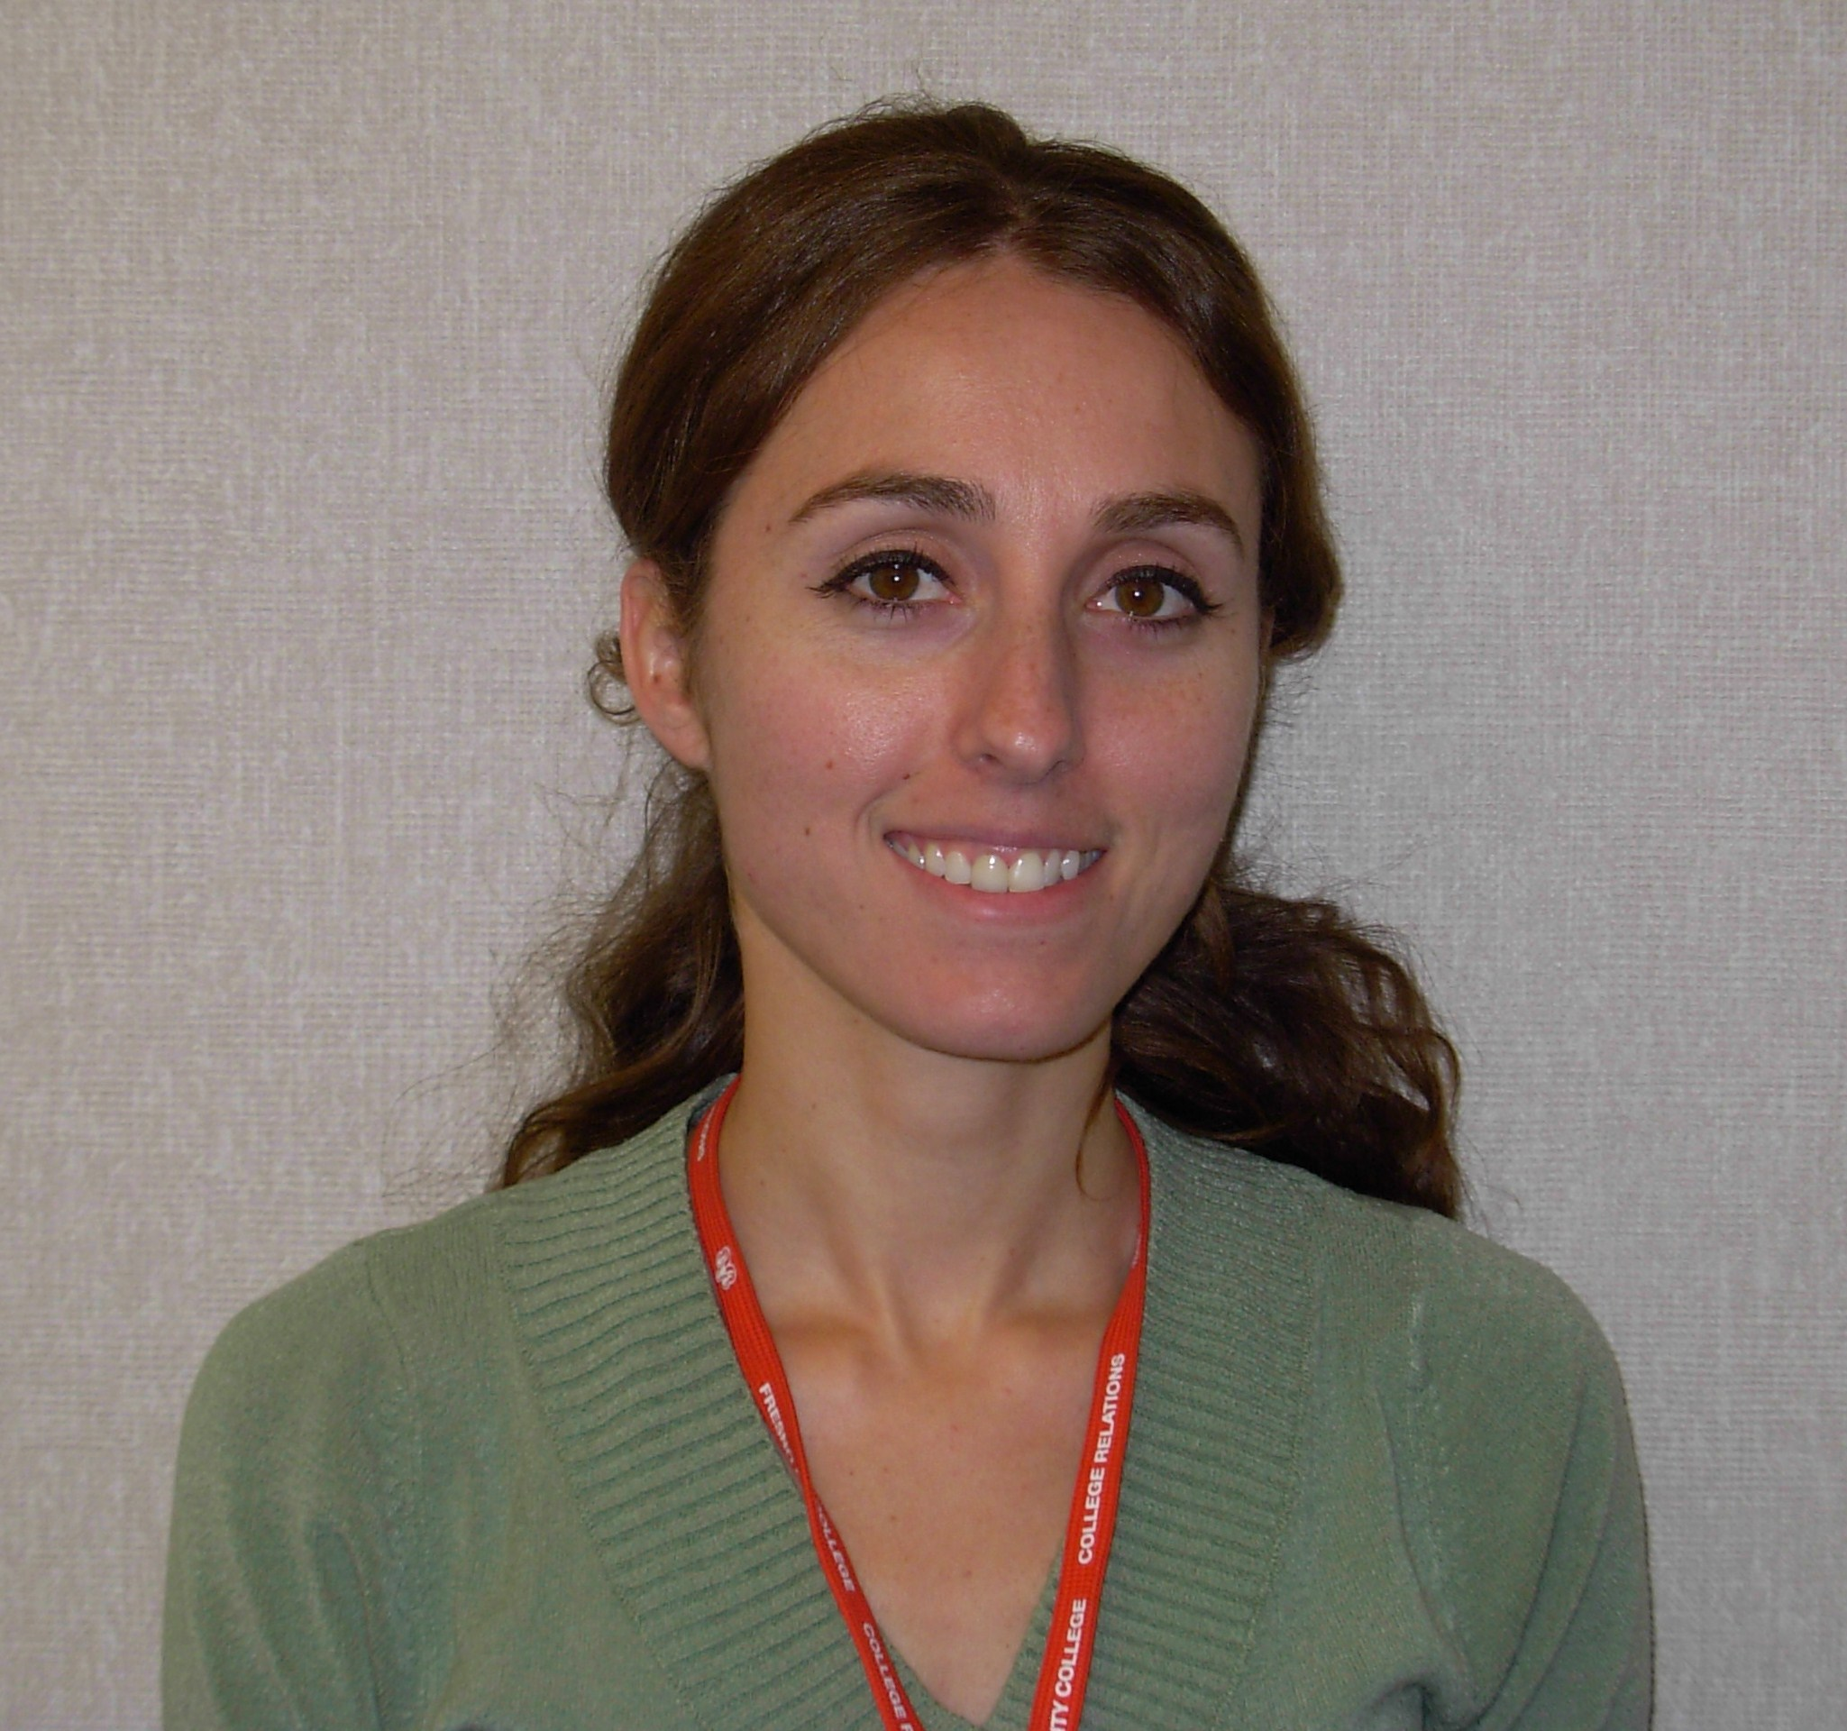
Sharon Muha, Psy.D. (Post Doc) has a doctorate in Clinical Psychology from the California School of Professional Psychology at AIU in Fresno, CA. Dr. Muha has served the Fresno City College community as a counselor, instructor and guest lecturer. Previous clinical experience includes working at the W. Gary Cannon Psychological Service Center in Fresno, CA. and in the Fowler Unified School District. Clinical interests include acculturation, depression, anxiety disorders, obsessive compulsive behavior, eating disorders, stress management, health psychology, bereavement and spirituality.

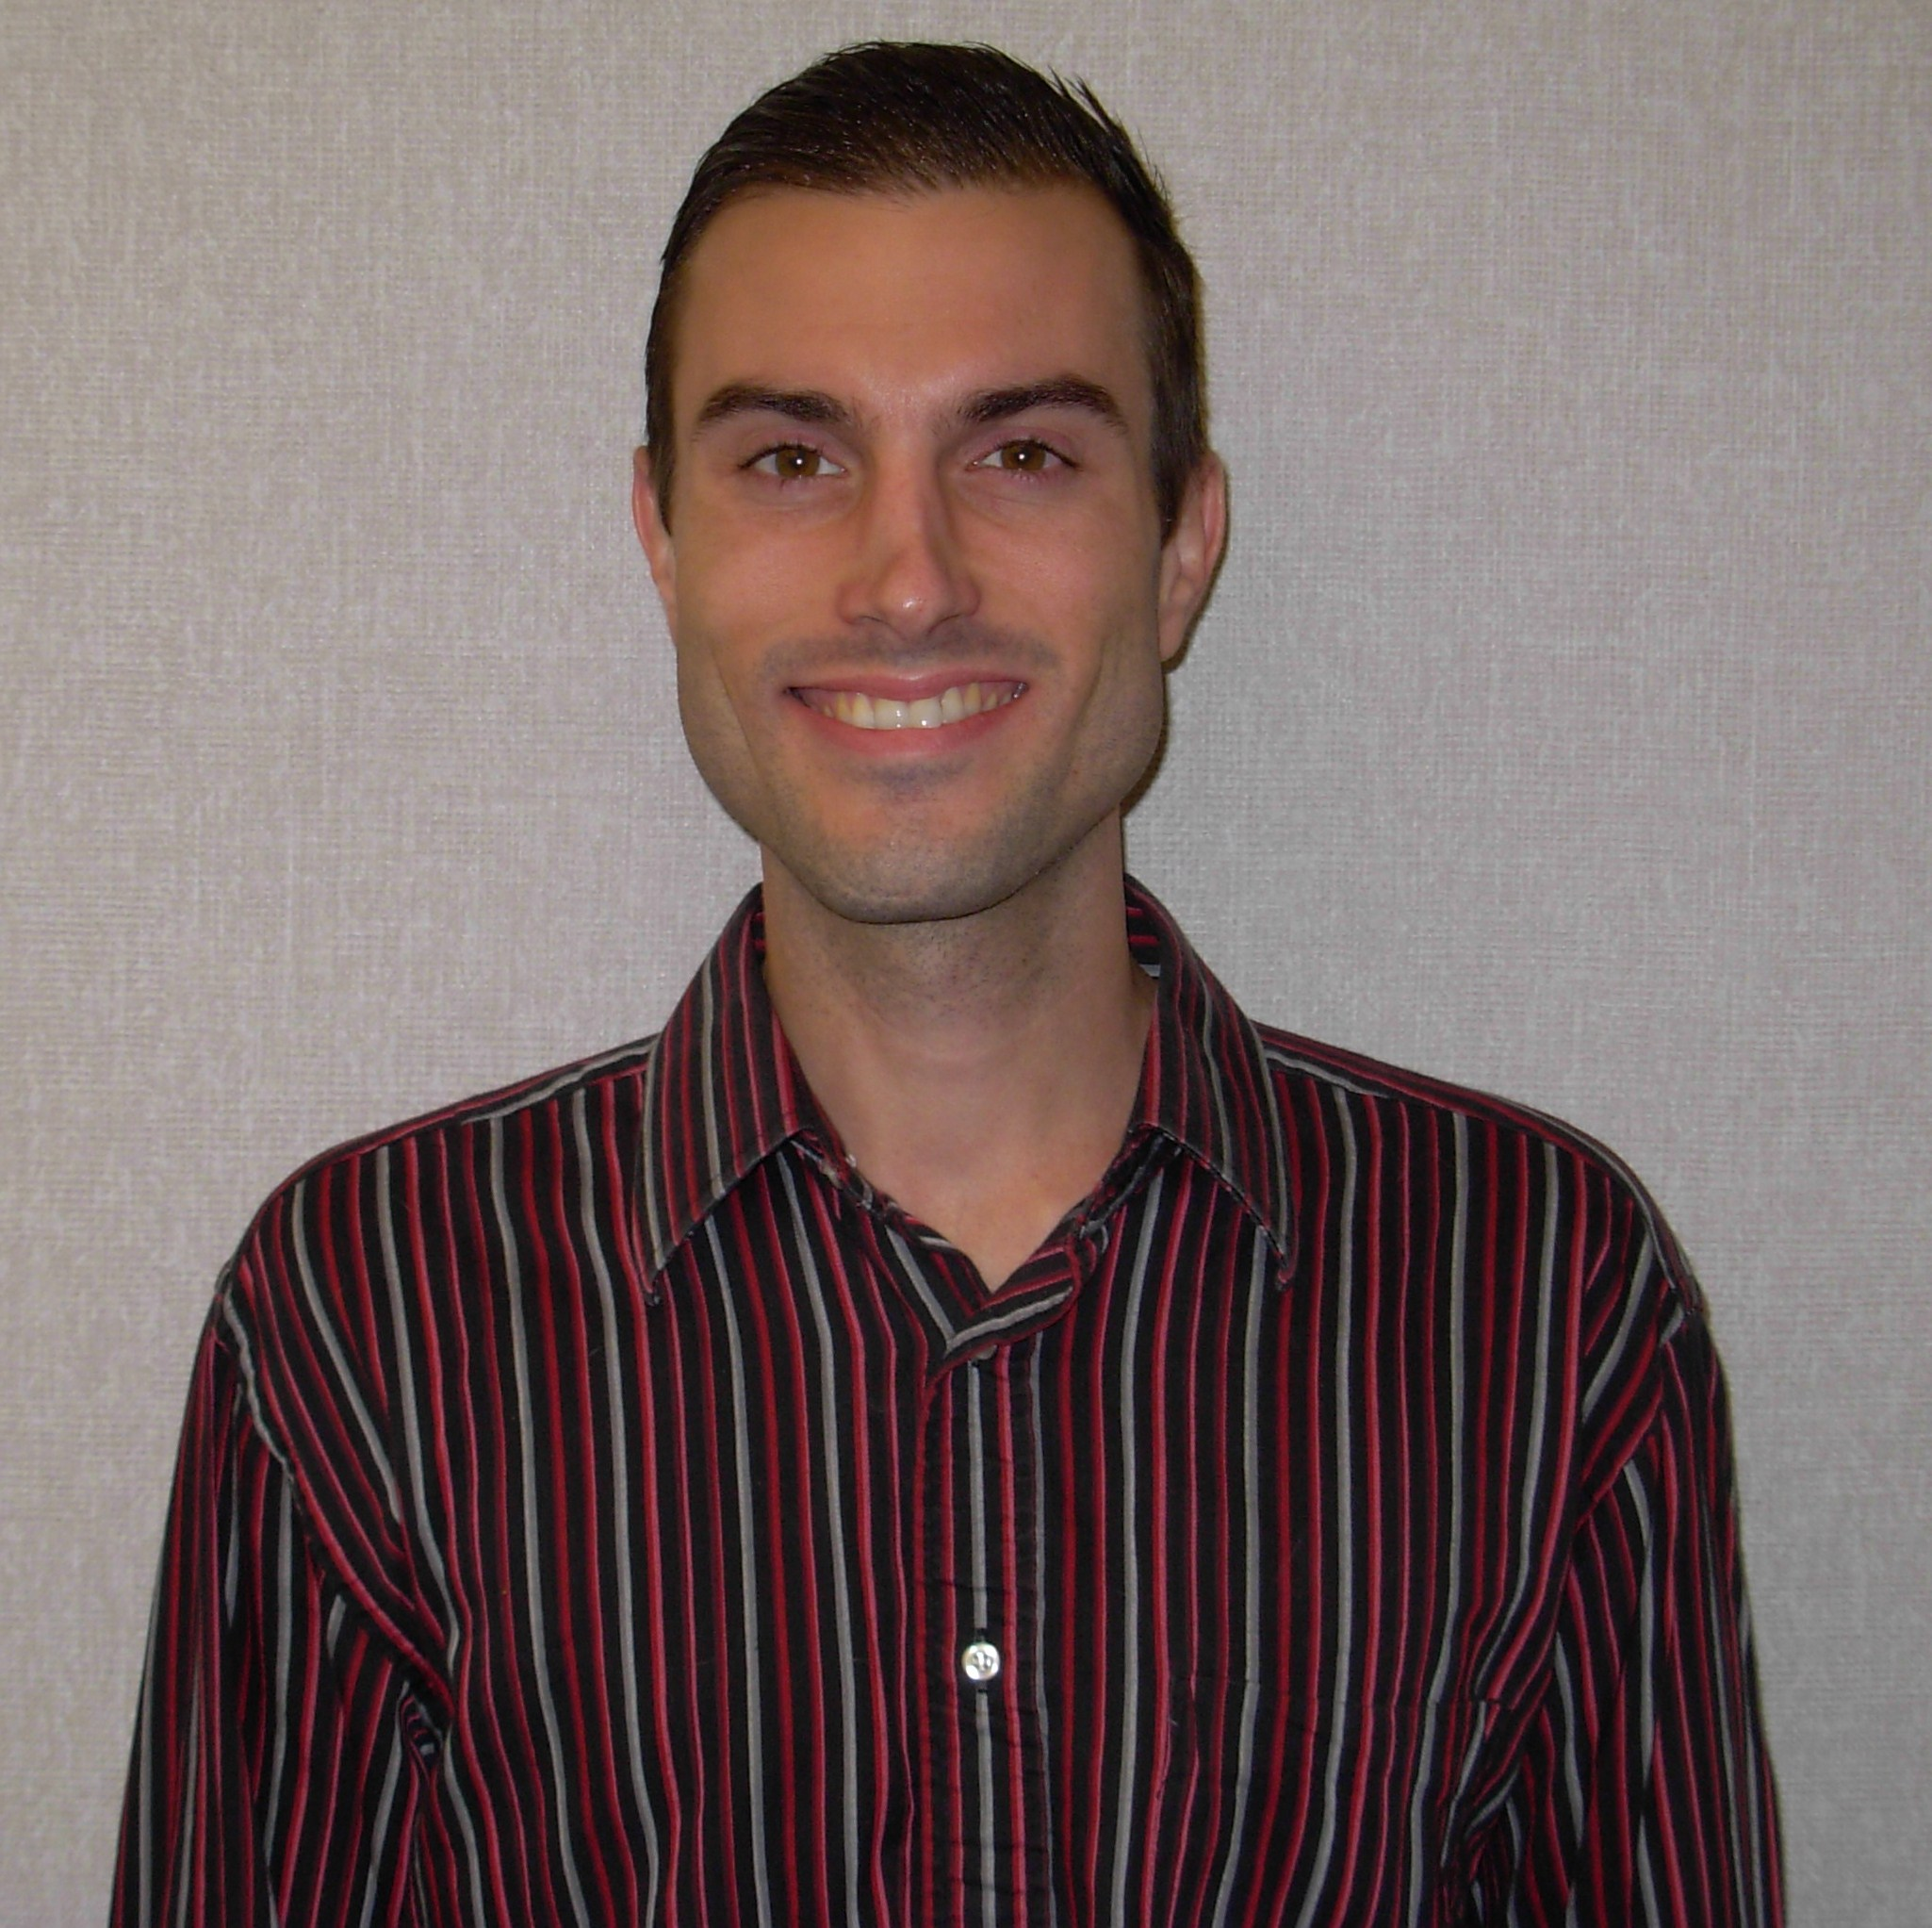
Thomas Huber, M.A., (Intern) is a clinical psychology doctoral candidate at the University of Detroit Mercy in Michigan. His clinical interests include anxiety, depression, abuse & trauma, anger management, fears/phobias, grief & loss, relationship issues, self-esteem, stress/worry, and spirituality. He greatly enjoys helping college student populations and, prior to living in Fresno, worked in College Mental health in both Michigan and Ontario, Canada for a total of Five years. He has trained for 2 years at the Michigan Psychoanalytic Institute and has published on psychotherapy with Columbia University in New York.

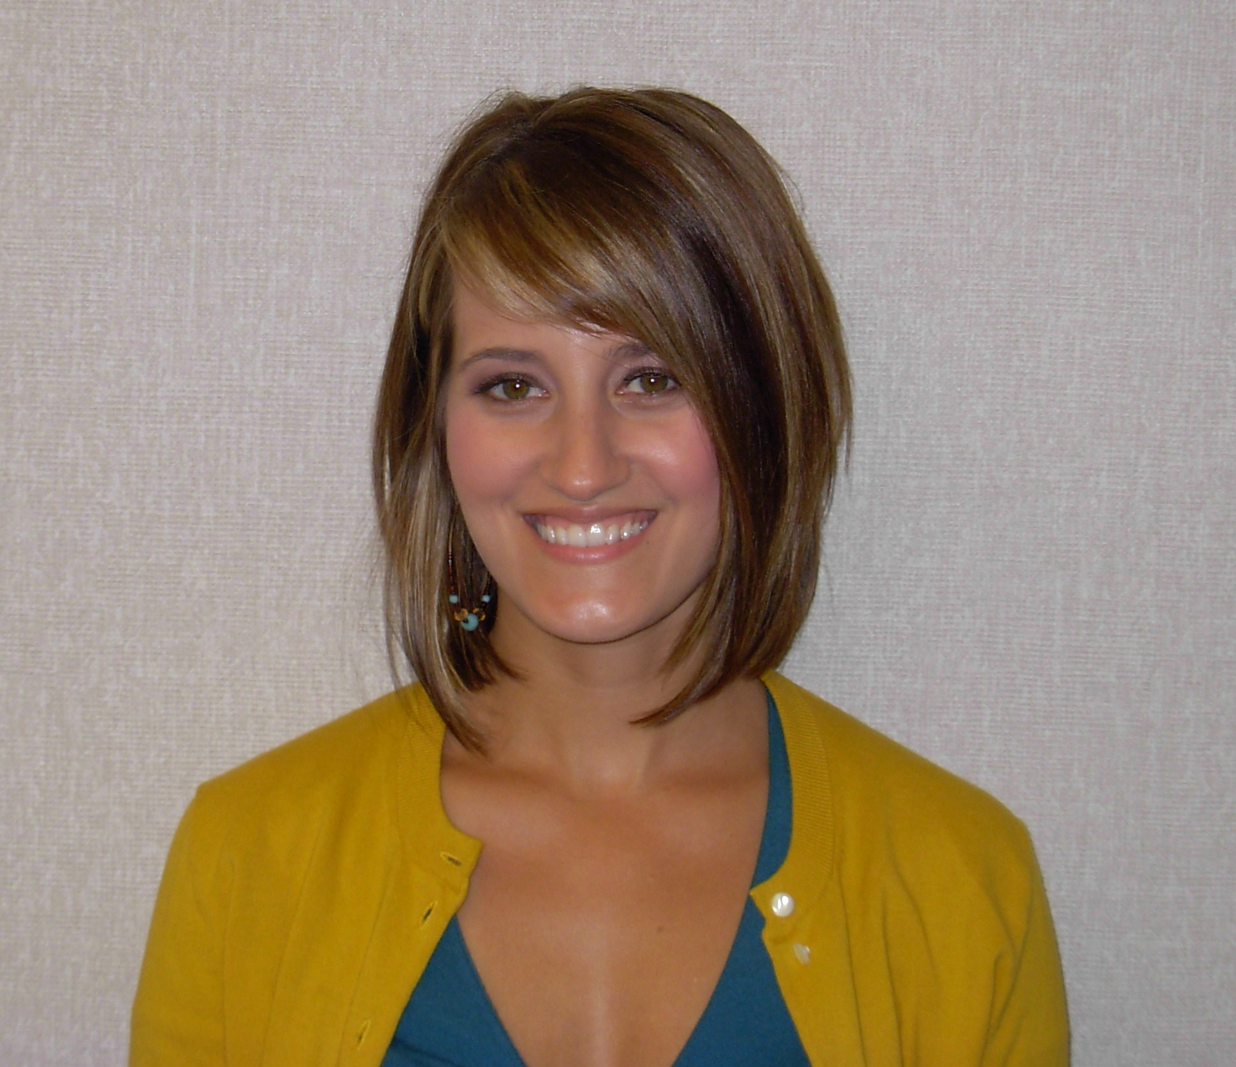Jennifer Leo (Intern) is pursuing a Doctorate of Clinical Psychology from Argosy University in Orange County, CA. Her clinical interests include health psychology, stress and anxiety, depression, self-esteem, acculturation, pain management, brain injuries, relationships and career decisions. Jennifer is a graduate of Modesto Junior College and San Diego State University. Prior to FCC she worked in various settings including a college psychological assessment center, a community clinic, and an acquired brain injury educational program. Jennifer is familiar with many approaches to therapy and is interested in helping students cope with the unique challenges associated with higher education.

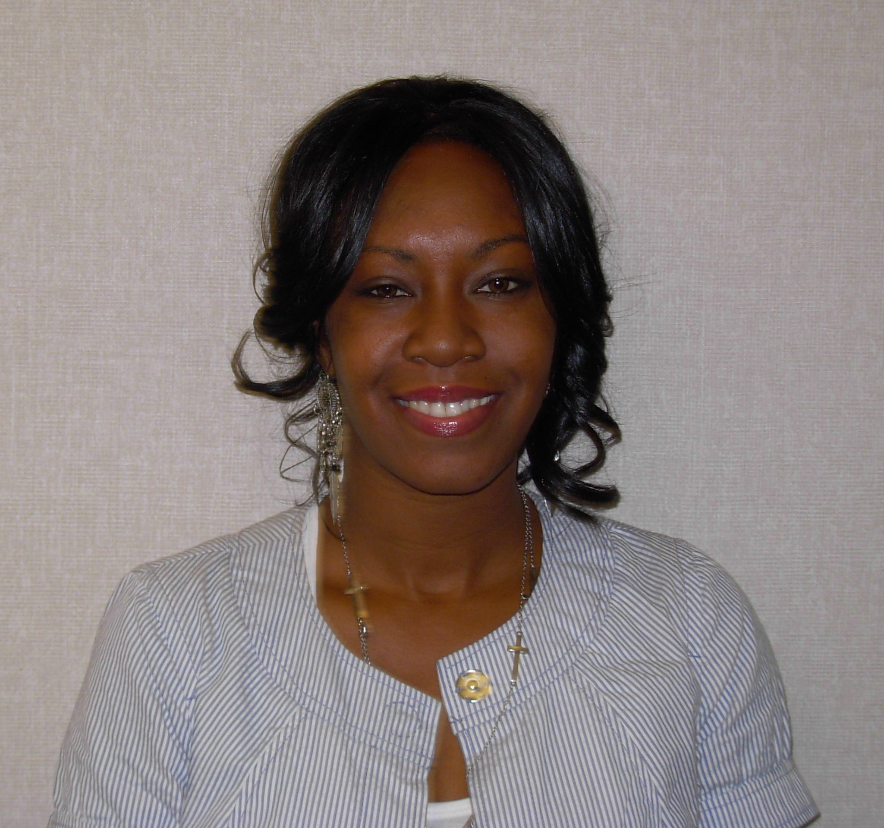
Tikesha Leslie-Jones, M.A. (Intern) is a Clinical Psychology Doctoral candidate at Alliant International University (AIU) in Fresno. A graduate of Fresno City College and California State University, Fresno Tikesha is familiar with the transition from community college student to university student. She has worked in various settings including community mental health agencies and community college mental health. Her clinical interests include cross cultural issues, PTSD, domestic violence, eating disorders, health psychology, relationship issues, anxiety, depression and spirituality. Tikesha believes that wellness is holistic and dynamic, involving a balance of mental, physical and spiritual equilibrium.

