Doris:

Here is a summary of the Clovis HS Placement Test pilot project with numbers and a chart.

The Clovis HS computerized placement test was held January 12 through January 14, 2011 @ Clovis High library.  Each day there were three sessions lasting two hours.  Each session had the ability to accommodate 50 students.  Students checked in at the front door with the high school counselors and were seated.  A brief explanation about the test was given and then students were given test instructions. Students were not given the math portion due to the limited time allotted for the test by the high school.   It was explained to them that math placement would be based on their high school transcript at orientation.

Once students completed the test, they were dismissed to class.  Students were not given a copy of the results, but were referred to the high school counseling office for scores.

Students who missed the placement test will make up their session at Clovis High.  The counseling office will be assigned a user name and password and will be proctoring the placement test on an as needed basis.  I will be managing the test site and reports for the counseling staff.

The test went extremely well.  There were a few minor technical difficulties, but were immediately resolved.  The library was closed for three days and created a near perfect testing environment.  The only concern was to not have the library reserved the week before high school finals.  I spoke with Pam Winter, Clovis High principal, and decided November or December might be better months to reserve the library.  Overall, the counseling staff was very pleased with the process.

David

|  |  |
| --- | --- |
| Eng 125 and 126 | 79 |
| Eng 125 and Eng 1A | 73 |
| Eng 125 and Eng 262 | 23 |
| Eng 126 and Eng 1A | 7 |
| Eng 126 and 252 | 2 |
| English 1A | 56 |
| English 252 and 262 | 11 |

**Total number of students tested: 251**

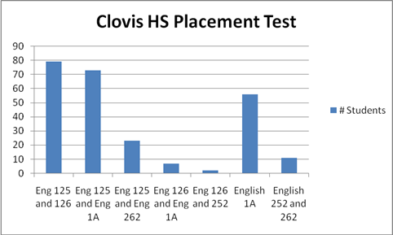

David-Anthony Navarro

College Relations Specialist

Madera, Oakhurst, and Willow International Community College Centers

10309 North Willow Avenue

Fresno, CA 93730

Desk:  (559) 325-5267

Cell and Text Message:  (559) 476-7495

Fax: (559) 325-5299

Email:  [david.navarro@scccd.edu](mailto:david.navarro@scccd.edu)