Teaching Tips Videos from the Basic Skills Committee

Sample email sent to faculty informing them of Teaching Tips videos sent in August 2010:
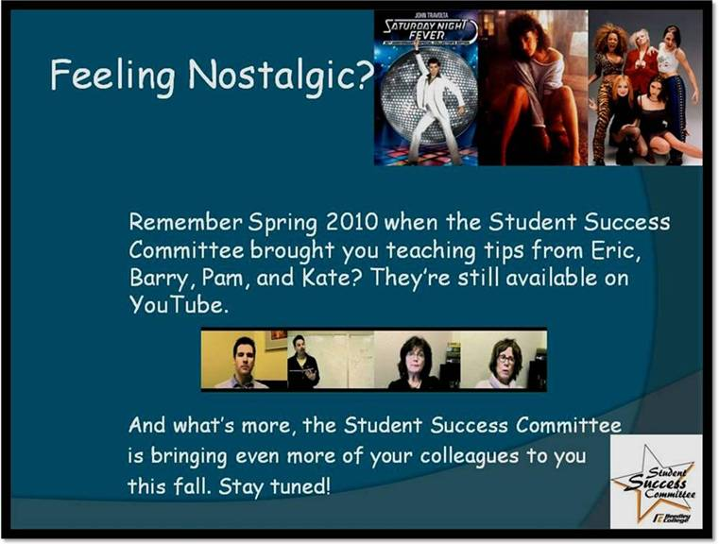

Links to Teaching Tips Videos:
Business Instructor, Eric Naslaroad – “Tips” -- http://www.youtube.com/watch?v=H7K18TyW5tY.
History Instructor, Randy Genera -- “Online Resources” -- http://www.youtube.com/watch?v=1ypaCOET5a4.
English Instructor, Kate Fourchy -- “High Expectations” -- http://www.youtube.com/watch?v=vZytSP3C5v0&feature=related.
Business Instructor, Pam Gilmore -- “A Strong Heart” -- http://www.youtube.com/watch?v=pfHm-SJSLIo&feature=related.
Geography Instructor, Barry Warmerdam – “Independent Students” -- http://www.youtube.com/watch?v=O_FhqVbokGs&feature=related.
Reading Instructor, Natasha Maryanow -- “Keeping Students Active in the Classroom” -- http://www.youtube.com/watch?v=gK-r6e7rGYk&feature=related.
English Instructor, Carey Karle -- “Getting Students to Help Each Other” -- http://www.youtube.com/watch?v=QoC1paqjH0I&feature=related.
Communication Instructor, Anna Martinez – “Student-Centered Activity” -- http://www.youtube.com/watch?v=QoC1paqjH0I&feature=related.

