The Writing Center Reedley College

Course Number Writing Module

Overview

State the purpose of the module and give an overview of the steps/parts.

SAMPLE:
The purpose of the Art 2 Art Appreciation Writing Module is to help the student succeed in class as well as develop a critical understanding and appreciation for art. This module has all the materials you will need.

There are four parts to complete.

- The Language of Art
- How to Look at Art
- Analyzing Art
- Writing About Art

Do all of the work in the order it is presented. Do not skip any assignments. After you complete a section, it must be corrected and approved by a Writing Center tutor or instructor before you may proceed to the next part.

You may earn up to an additional 10 extra points. To receive the extra credit, you must complete the module by Friday, February 26, 2010. If you do not complete the module by the due date, you will not receive any extra credit points.

Part 1: Vocabulary

Provide an overview of the vocabulary you expect the student to utilize in work written for the course. Include illustrations, if relevant.

SAMPLE:
Part 01: The Language of Art

Humans communicate ideas through languages, both oral and written, numbers, music, and, of course, art. For the language of art and architecture, the grammar consists of the formal elements and the principles by which those elements are composed or structured. The basic vocabulary of art is defined below.

ELEMENTS & PRINCIPLES OF ART

These concepts form the foundation of all forms of art. ELEMENTS can be seen as nouns (line, shape, value, form, etc.) while PRINCIPLES can be seen as verbs (contrast, movement, rhythm, etc.). PRINCIPLES are the vehicles by ELEMENTS are arranged to achieve successful designs.

ELEMENTS (nouns)

LINE: Line is defined as an identifiable path of a point moving in space. The quality of a line influences the perception of whatever subject matter is described by it.

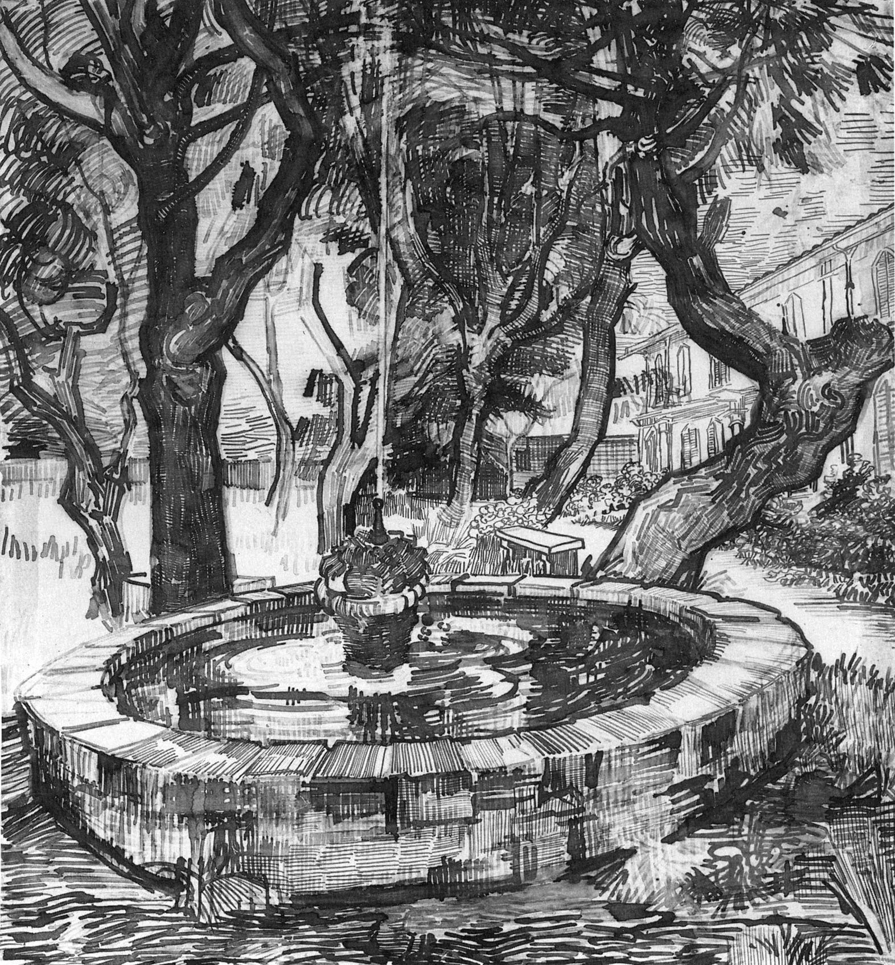
The Fountain in the Hospital Garden. Vincent Van Gogh. 1889. Pen and ink. Vincent Van Gogh Foundation/Van Gogh Museum, Amsterdam.

This is an excellent example of how Van Gogh used line to describe his surroundings while he was confined to a hospital for the mentally ill.
Art01

Part 1 Quiz

Give students a brief quiz on the vocabulary. Students failing the quiz will be asked to watch a video by Writing Center Tutors discussing the answers. They would then be asked to take the quiz again.

SAMPLE:

Directions: Look at each image carefully and decide which elements and principles are present in the art. Check as many as apply.
_____line contrast
_____value balance
_____color repetition/rhythm
_____shape unity & variety
__X__mass or form
_____space scale & proportion
_____time & motion
__X__texture directional forces
focal point/emphasis/subordination

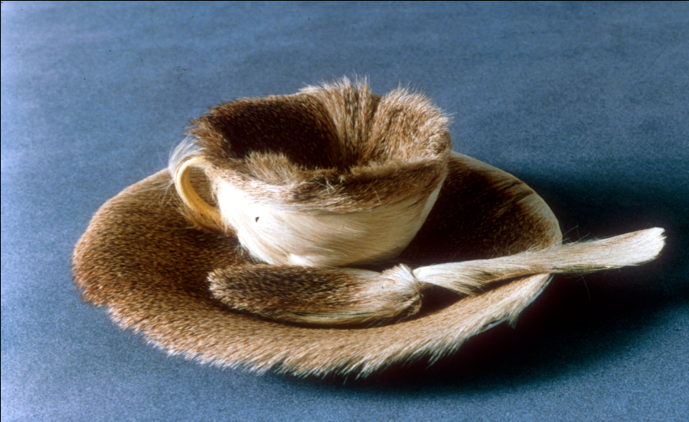
Art10

Part 2: Using the Vocabulary in Complete and Grammatical Sentences

Have the students use the vocabulary in sentences. Provide sample answers for the tutors; a tutor will review the sentences for use of the vocabulary and for grammar. Unless otherwise indicated by the instructor, the tutor will provide feedback, but will not prevent the student from advancing as long as there is adequate effort.

Sample with Sample Answers

Part 02: How to Look at Art

Now that you can identify the elements and principles of art, let’s take a closer look at a few specific works and write a few sentences about them. You must use complete sentences.

Large Reclining Nude. Henri Matisse. 1935. Oil on canvas. Baltimore Museum of Art.
Art22

How does Matisse use LINE? COLOR? SHAPE?
Line defines the figure. Line also defines the background. Matisse uses complementary colors (blue tile, orange/peach flesh). He also used a combination of geometric shapes in the background and organic shapes in the figure.

Part 03: Essay Organization/Elements

Have the student write paragraphs that contain the elements of an essay that would appear in work written for the class. The tutor will review the answers for paragraph content, vocabulary, and correctness. Unless otherwise indicated by the instructor, the tutor will provide feedback, but will not prevent the student from advancing as long as there is adequate effort.

Directions: Read the art historical interpretation for Christina’s World by Andrew Wyeth.

Directions: You are going to write your own analysis of Christina’s World by answering the following questions. Using the questions as a guide, write a paragraph for each question.

- Describe the work. What do you see? List everything you physically see, including small details. For example, describe the woman’s dress (is it old or new, what color is it), her hair, her legs, arms, feet, hands (anything unusual?), the buildings, the road, the sky (what color is it? How much of image is ground, how much is sky?)
- Analyze the work. How is the work arranged? Where does your eye go first in the painting? How does the artist get you to look at this first? (use of line, color, value, shape, emphasis, rhythm, etc). How does the artist get you to look at different parts of the painting and in what order? Use the elements and principles to describe how the artist has directed your viewing of his or her artwork.
- Interpret the work. What is the artist saying? Your interpretation is based on your life experiences and outlook, so it will not be the same as someone else’s interpretation. The slant of the roof of the largest building takes your eye straight to the woman. Why did the artist do this? Why is the ground so much bigger than the sky area? Why did the artist separate the blades of grass? Why are the woman’s legs not carrying any weight? What is the emotional mood of this work?
- Judge the work. Is this a successful work of art? Why or why not? How did you react to it? What was your response to it?

You must submit your analysis to the Writing Center Director for her signature. She will forward it to your Art Appreciation instructor who will approve it before you can move onto the final part of the writing module.

Part 04: The Essay

Have the student write an essay that mimics work written for the class. The tutor will review the answers for essay for content, vocabulary, and correctness. Unless otherwise indicated by the instructor, the tutor will ask the student to revise if she perceives that the essay is unlikely to meet the requirements of an assignment in the class; the instructor may be consulted.

Directions: Read the following information about how to write about art. Then, using that information and what you learned in the previous three parts of this module, choose an artwork and write an essay about it….

You must submit your analysis to the Writing Center Director for her signature. She will forward it to your Art Appreciation instructor who will approve it before you receive the extra credit points.

