Course Syllabus SPRING 2023 : Writing Center Theory and Practice English 72 A (#51333 )
Instructor: Deb Everson Borofka, Ph.D.
Office: LRC 115, and VIRTUAL CONFER ZOOM ROOM https://cccconfer.zoom.us/j/5838541693
STUDENT/Office Hours: Arranged and online M-F 9:00-10:00 am
Cell: (559) 301 6079
E-Mail: deb.borofka@reedleycollege.edu
REQUIRED WEEKLY Class ZOOM meeting Friday:10 am-11 am
“We never know which lives we influence, or when, or why.” -Stephen King
Course description: 1 unit: 1-hour lecture with 2-3 hours of reading, reflection, and writing each week. This course provides instruction and guided practice in peer learning assistance. The course is intended for those interested in helping students with written compositions while also enhancing their own writing skills and for students intending to enter the field of education. Reader-based feedback and active learning strategies are practiced. Areas for study include composition theory, collaboration learning, writing centers, and writing across the curriculum. Successful completion of both ENG 1A and ENG 72 is required.
We will be engaging in weekly reading, writing, and class discussions. You are advised to come prepared. Understand that study time is important even though this is only a one-unit class. For each hour of in-class, you are expected to spend 2-3 hours outside of class studying/reflecting/writing in response to course content.
Course Objectives and Learning Outcomes:
Upon successful completion of this course, students will be able to:
- Guide writers through understanding and completing assignments by applying writing center theory and practices to specific writers' needs.
- Reflect on their own writing processes and growth in their own skills and learning.
- Implement collaborative techniques in their group sessions.
Learning Objectives:
In the process of completing this course, students will:
- Describe writing center philosophy
- Employ interpersonal dynamics in dealing with students’ needs.
- Identify the learning assistant’s role while helping student writers
- Recognize and respond to the diverse needs of various writers
- Use a variety of teaching strategies while helping student writers.
- Know the role of technology in the writing center and writing instruction
- Analyze his/her own written compositions to a greater extent
Canvas Course Site: You will need to be officially enrolled before you will be allowed to enter the site. All communication related to this class will use either our Canvas course site (Announcements, Discussion Board, Canvas messaging, etc.) or your District-supplied e-mail address (dxxxxx1@my.scccd.edu). Please check your district e-mail address regularly or find out how to forward messages from that address to an address you are in the habit of checking.
Necessary programs: In order to do work from home, you should have the following programs (all of which are installed on computers on campus): Internet browser (such as Internet Explorer or Firefox); district e-mail account (my.scccd.edu); word processor (MS Word preferably, see Paper Format below); Adobe Acrobat Reader for research materials
“Students with Disabilities/Special Accommodations: Any student in need of an accommodation due to a disability is encouraged to provide the instructor with their verification of authorized services form and consult with the instructor immediately so that arrangements can be made.”
IMPORTANT DATES:
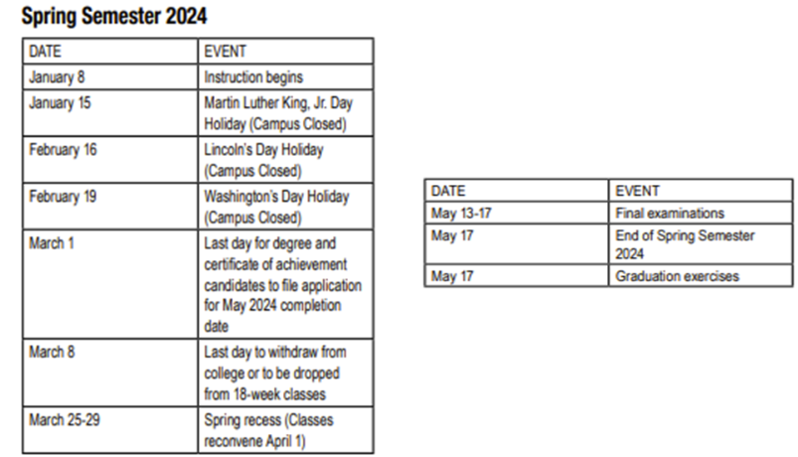

Attendance: You must be present for weekly class meetings. THIS IS VERY IMPORTANT.
NOTE: In order to enroll in Tutor Training Part 2 (ENGL72A) you must complete this course with a B or higher to be considered for re-hire.
Grades You will write 3 short papers, 100 points each, various article annotations, 25-50 points each, monthly pieces for Paper Jam 25 points each, Participation in SCCCD Tutor Expo on March 4. This will involve working with assigned team to create poster board and presentation. a conference Reflection Paper, and an updated Professional Resume, 50 points. No paper seriously deficient in the area of mechanics (spelling, grammar, punctuation) will receive a passing grade. The point and grade scales are listed below. A basic ten percentage point grading scale will be used. Total points by the end of the course may vary depending on the number of weekly assignments.
Plagiarism: Use of another’s work as though it were your own will not be tolerated. In the current Reedley College Catalog, plagiarism is defined as follows:
Plagiarism is a specific form of cheating: the use of another’s words or ideas without identifying them as such or giving credit to the source. Plagiarism may include, but is not limited to: failing to provide complete citations and references for all work that draws on the ideas, words, or work of others, failing to identify the contributors to work done in collaboration ,any use of AI text generator, submitting duplicate work to be evaluated in different courses without the knowledge and consent of the instructors involved, or failing to observe computer security systems and software copyrights. Incidents of cheating and plagiarism may result in any of a variety of sanctions and penalties, which may range from a failing grade on the particular examination, paper, project, or assignment in question to a failing grade in the course, at the discretion of the instructor and depending on the severity and frequency of the incidents.
Paper format: All work must be typed, double-spaced, and in the 12-point type of a standard typeface (Times Roman, preferably). You must submit your work via the Submissions area. You must submit files in one of the following formats: Word documents (*.doc or *.docx) or Rich Text Format files (*.rtf).
Grading Scale
A 100%-90%
B 89%-80%
C 79%-70%
D 69%-60%
F 59%-00%
*Total points may be greater by the end of the semester depending on weekly assignments. In any case, a 10-point scale will be used to calculate the final grade. Please check your grade on Canvas on a weekly basis.
*The instructor reserves the right to modify content and schedules, as she deems necessary during the course of the semester.
ENGL 72A Schedule of Assignments
PRIOR TRAINING WORK DUE at Week 1:
Completed Personality/Learning Profile
Completed Canva Bio and Video
Completed Canvas Page with your personal Embedded Tutor Information
*Please note: Each semester, we participate in at least one Reading/Writing Center or Tutorial Conference. Dates have not yet been set for Fall 22, but team presentations will be part of the course assignments. I will adjust content accordingly which means some of our topics may be pushed to different dates than currently listed.

Week 1
Topic: Introductions and Welcome
Reminder: Copies of The Bedford Guide for Writing Tutors* have been provided by RWC training library, you do not purchase them as these are used every semester by ENG 72 and 72a tutors. You have each already read this text, but you may want to refer to it as you work with students this semester. Please return them to Dr. B. at the end of the semester. You should also have the digital RWC Reading/Writing Center Tutor Handbook bookmarked on your favorites tab on your computer, along with our SharePoint Hub.
Assigned:
- TUTEE or another TUTOR's Learning Styles Reflection Paper assigned end of Week 2. NOW WOULD BE A GOOD TIME TO CHOOSE WHO TO ASK AND GET AN INTERVIEW WITH THAT PERSON SET UP. Due end of Week 4, 100 pts.
- October Paper Jam Article in Canva
Week 2:
Topic: “REVIEWING Learning Styles and Multiple Intelligences”
Assigned:
- Re-View Multiple Intelligences ppt
- Re-View Learning Styles ppt
- Read and annotate the article uploaded to Week 2
WORK DUE:

Week 3
Topic: “REVIEWING Learning Styles and Multiple Intelligences”
Work Assigned:
1. Working on the first PJ article

Week 4
Topic: REVIEWING “Reading” and Personal Literacy of other students
Assigned:
1. Reading Packet: Reading Chapter annotations
2. Tutee/another Tutor Personal Literacy Paper100 pts (due end of Week 8)
WORK DUE:
Paper 1: Tutee/another Tutor Learning Styles Paper, 3 pages
First PJ article
Week 5
Topic: REVIEWING Pedagogy in the RWC
Assigned:
1. Second Paper Jam Article
2. New Pedagogy Article annotation
WORK DUE:
Weekly Reflection on Reading
Reading Packet: Reading Chapter Annotations
Week 6
Topic: Review New Pedagogy article
Assigned:
- Reading/Annotation for an article about Learning Differences and Deaf Students
WORK DUE:
Annotated Pedagogy article

Week 7
Topic: Deaf, Hard of Hearing, and Learning Differences strategies session
Assigned:
- View YouTube video on being a deaf student in college
WORK DUE
Annotation for the article about Learning Differences and Deaf Students
Weekly Reflection
Week 8
Topic: Safe Space and LGBTQ+
- View Safe Space and LGBTQ+ PPT/video
Assigned:
- Mid Term Reflection, two pages (Due Week 10)
WORK DUE:
Paper 2 Personal Literacy Paper, 3 full pages min.
Next PJ article
Week 9 10 11
Topic: Mid-Term and Intro to Cultural Literacy
Assigned:
- Paper 3 Cultural Literacy Reflection Paper on Tutee/another Tutor, 100 pts, due Week 12-13
- Third Paper Jam article
Week 9
Topic: CULTURAL LITERACY
Assigned: TBA
WORK DUE:
Completed Cultural Literacy Packet (Article and Inventory)
Week 10
Topic: MIDTERM
Assigned: TBA
WORK DUE:
MIDTERM CONFERENCE on Zoom or F2F if possible
Mid Term Reflection, 2 pages
Week 11
Topic: CULTURAL LITERACY
Assigned: TBA
WORK DUE:
Working on Tutee Cultural Literacy Paper
Week 12
Topic: TBA
Assigned: TBA
WORK DUE:
Weekly Reflection due
Next PJ Article
Paper 3: Tutee/Another Tutor Cultural Literacy Paper, 3-page min.

Week 13
Topic: TBA
Assigned: TBA
WORK DUE:
Weekly Reflection

Week 14
Topic: Topic: Updating your Professional Resume,
Assigned:
1. Review "How to Create a Professional Resume" contents
2. Personal Professional Resume
WORK Due:
Weekly Reflection

Week 15
Topic: Updating your Professional Resume
WORK DUE:
Professional Resume, 50 points

Week 16
WORK DUE
any outstanding assignments

Week 17
Topic: EQUITY-Final In-Class DISCUSSION
How can we improve ourselves and RWC services?

