English 1A
Reedley College
Jonathan Tabutol
Spring 2024

Class Time: In-Person, Monday through Thursday, Friday Study Hall
Degree/Transfer Status: Transferable to both UC and CSU.
Location: 110
Office Hours: -
Office and Phone: -
Zoom: Tabutol Zoom Link: -
Email: jt048@reedleycollege.edu

Course Objectives:
In this first-year writing course, students compose projects in multiple written genres that address specific rhetorical situations. Uses memory, observation, critical reading and viewing, analysis, and reflection to draft, peer review, revise, and edit projects.

Elaboration of the Catalogue Description:
At the conclusion of this course students should be able to:
- use writing processes to generate, develop, share, revise, proofread, and edit major writing projects.
- produce essays that show structure, purpose, significant content, and audience awareness.
- produce a variety of essay genres.
- understand and integrate others’ texts into their own writing.
- reflect on their own writing process and rhetorical effectiveness.
- demonstrate critical thinking by interacting with diverse perspectives.

Required Text:

- Bullock, Richard, Deborah Bertsch, Maureen Daly Goggin, and Francine Weinburg. The Norton Field Guide to Writing with Readings and Handbook. 6th ed., W.W. Norton & Company, 2022. ISBN 978-0-393-88413-5
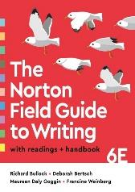

- Orwell, George. 1984. 1949. Signet Classics, 1950.
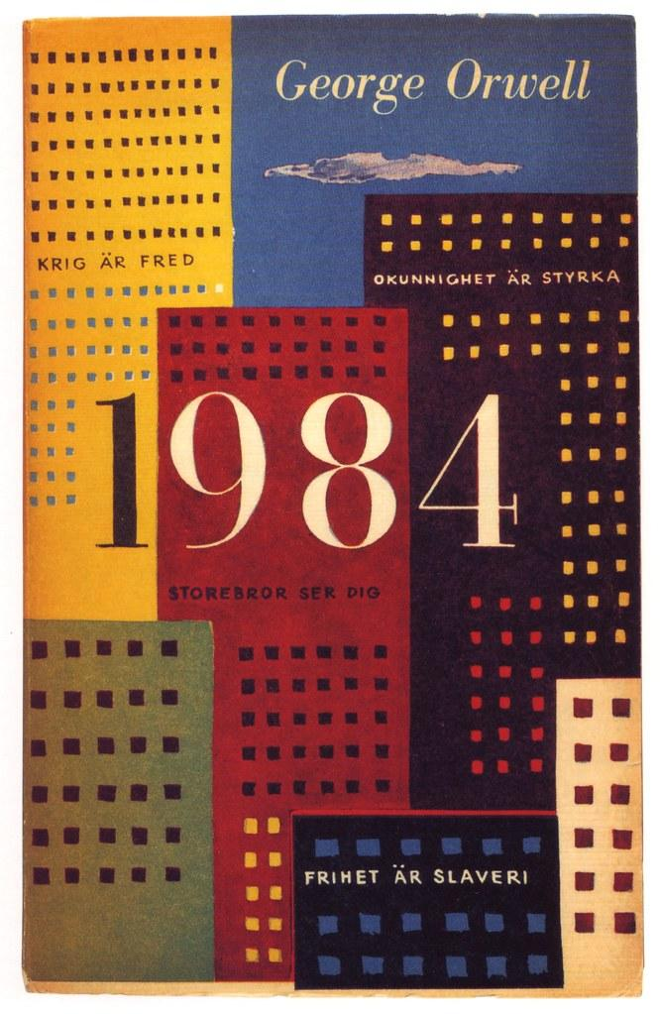

Recommended Text:

- Graff, Gerald. They Say, I Say: The Moves that Matter in Academic Writing. 5th ed., W.W. Norton & Company, 2021. ISBN 978-0393538700

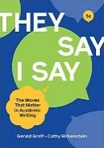

Textbooks can be checked out from the library. However, you may wish to purchase your books from the bookstore, Amazon, or any other seller. Feel free to use print copies, ebooks, or used books. I highly suggest, however, using the edition listed so that page numbers remain accurate.
Grade Distribution:
Assignment Category | Number of Grade Items | Point Value per Item | Total Points
Discussions | 11 | 30 | 330
Journals  (not including Project’s Journals) | 6 | 30 | 180
Midterm | 1 | 150 | 150
Project I Submission (Final Draft) | 1 | 300 | 300
Milestone 1  (Plan) | 1 | 100 | 100
Milestone 2  (First Draft) | 1 | 150 | 150
Milestone 3  (Peer Review) | 1 | 55 | 55
Milestone 4  (Journal) | 1 | 30 | 30
Project II Submission (Final Draft) | 1 | 300 | 300
Milestone 1  (Plan) | 1 | 100 | 100
Milestone 2  (First Draft) | 1 | 150 | 150
Milestone 3  (Peer Review) | 1 | 55 | 55
Milestone 4  (Journal) | 1 | 30 | 30
Project III Submission  (Final Draft) | 1 | 300 | 300
Milestone 1  (Plan) | 1 | 100 | 100
Milestone 2  (First Draft) | 1 | 150 | 150
Milestone 3  (Peer Review) | 1 | 55 | 55
Milestone 4  (Journal) | 1 | 30 | 30
Total: 2,565 pts
*For each assignment/activity, directions, grading guides, posting/participation requirements, and additional deadlines can be found in the assignment guidelines and Rubrics section of the course.
Grading Guides
The grade of A rewards extraordinary, exemplary, outstanding, and very satisfactory
performances, work, and efforts in all aspects of the course work. It sets the high standard of excellence
for the class. B is given to strong, solid, above average, and quite satisfactory work and efforts. C is given
to average work and efforts. D is given to below average, unsatisfactory, yet still passing work. F means
failing. I hope that all of you read, write, research, and think critically to your best abilities.

Due Dates:
To ensure timely feedback, please adhere closely to the due dates listed above. Discussion posts will be due by 11:59 p.m. every Thursday; discussion responses to at least two classmates must be completed no later than 11:59 p.m. every Sunday. All other assignments (Journals, essays, etc.) are due promptly by 11:59 p.m. on Sunday.The exceptions to this rule will be the Final Portfolio. Readings should be done before the class date they are listed to be discussed. Please make sure you have completed the readings before class, as I assume that all students will have done the required as I plan valuable learning experiences.

Late Assignment Policy:
While I realize that all students are also people, with lives outside of school, due dates are necessary so that I can help you meet your goals. Additionally, I am required to grade assignments in a timely manner. Therefore, please alert me of emergency situations so that we may be able to make accommodations. However, if you do not submit an assignment with prior notice, you will have one week to submit it with the knowledge that the grade of that assignment will be reduced by one letter grade. After one week has passed, I will not accept late assignments.

Assignment Descriptions:
Essays: All essays should be 750-1000 words in length (3-4 pages double spaced). Please use size 12 Times New Roman font and format your essay with one-inch margins on all four sides. The heading should be located on the left side of the page and include your name at the top, the course number, the section number, the date it was completed, and then my name. This should be followed by a centered title that is the same size and font as the remainder of the paper. Each essay will be peer-reviewed in class. Therefore, I will remind students to bring a paper print copy of each essay to class on the required day. I will collect these copies to provide comments and feedback; essays will then be returned prior to the due date of each essay to help students revise their work.

- Informative Essay (Project I): The topic of this essay will be a subject of your choice to be selected from recommended prompts. Each prompt will explore socio-political times from the writer George Orwell’s lifetime. The required elements for this informative essay are: a thesis statement, a clear method of organization, body paragraphs, and a conclusion. These are in addition to considerations of style, conventions, formatting, and syntax. The essay should be 750-1000 words in length (3-4 pages double spaced), in size 12 Times new Roman Font with one-inch margins on all four sides.

- Literary Analysis Essay (Project II): The topic of this essay will focus on George Orwell’s novel 1984. The required elements for this literary analysis are: a thesis statement, a close reading of the text, clear organization, and an explanation of the significance of your close reading. These are in addition to considerations of style, conventions, formatting, and syntax. The essay should be 750-1000 words in length (3-4 pages double spaced), in size 12 Times new Roman Font with one-inch margins on all four sides.

- Argumentative Essay (Project III): The topic of this essay will be on a subject of your choice. The required elements for this essay are: a thesis, supporting reasons, mention of a counterargument, and the absence of logical fallacies. These are in addition to considerations of style, conventions, formatting, and syntax. The essay should be 750-1000 words in length (3-4 pages double spaced), in size 12 Times new Roman Font with one-inch margins on all four sides.

Discussion Posts: These are critical thinking responses that will focus on reflection and engagement. All posts will be done online through your Canvas account where you will engage in academic discussion with at least two classmates per week. These exercises will help you prepare for future online/hybrid courses you will take during your academic career.

Final portfolio: Your final portfolio will be a compilation of all three essays and an in-class reflection activity. Please cut and paste all essays and the reflection into one word document in this order: Informative Essay, Literary Analysis Essay, and Argumentative Essay. This specific order will show your growth as a writer over the semester, which is very exciting!

Class Preparation and Participation: Because this course is designed to help you improve your writing to the standards of the college level, your commitment to preparation and participation is necessary. There will be days on which it is imperative that you bring drafts of your work in order to peer-review. If you do not bring a draft, you will be asked to peer-review, but you will lose one percent of your participation grade each time you neglect to bring a draft on that day. Additionally, the readings are designed to elicit discussion during class time. Please do the readings listed for each date before class begins so that we may have a productive discussion.

Weekly Assignment Schedule:
Week/  Module | Readings | Topics and Assignments
1 | The Norton Field Guide to Writing  - pp. 1-56  - pp. 295-324  - pp. 684-693 | College Level Engagement: The Value of Personal Thought and Voice  1-1 Discussion: Introducing Yourself  1-2 Journal: My Writing Practices
2 | The Norton Field Guide to Writing  - pp. 57-74  - pp. 269-279  - pp.542-559  Recommended Reading  - pp. 201-213  - Pp. 403-488 | College Level Engagement: Discovering Voice: Research, Planning, Drafting  2-1 Reading Discussion  2-2 Journal: Research Practices
3 | The Norton Field Guide to Writing  - pp. 140-163  Recommended Reading  - pp. 560-614  Orwell - Selected Readings | College Level Engagement: Reporting Information and Peer Reviewing  3-1 Discussion  3-2 Mock Peer Review: How Do We Give Effective and Tactful Feedback?  3-3 Project Part I: Review Assignment
4 | The Norton Field Guide to Writing  - pp. 327-366  - pp.491-541 | Informational: Historical Background  4-1 Discussion  4-2 Project I - Milestone 1: Working Thesis and Outline
5 | Selected Readings | Informational: Historical Background  5-1 Teacher-Student Conference for Project I  5-2 Project I - Milestone 2: First Draft  5-3 Post First Draft to Peer Review Discussion Board
6 | The Norton Field Guide to Writing  - pp. 367-384  - pp. 391-401 | Informational: Effective Feedback: What to Use and Not Use  6-1 Project I - Milestone 3 Discussion: Peer-review Feedback  6-2 Project I - Milestone 4: Journal: Valuable Peer Feedback
7 | 1984 - George Orwell  - Part 1: 1-104  The Norton Field Guide to Writing  - pp. 223-235 | Informational:  7-1 Project I - Milestone 5: Final Informational Essay Submission
8 | 1984 - George Orwell  - Part 2: 105-224 | Literary Analysis: 1984  8-1 Discussion  8-2 Journal:
9 | 1984 - George Orwell  - Part 3: 225-298 | Literary Analysis: 1984  9-1 Discussion:  9-2 Project II - Milestone 1: Working Thesis and Outline
10 | Selected Readings | Literary Analysis: 1984  10-1 Teacher-Student Conference for Project II  10-2 Project II - Milestone 2: Rough Draft
11 | “Harrison Bergeron”- Kurt Vonnegut, Jr. (Reading for Midterm) | Literary Analysis: 1984  11-1 Discussion:  11-2 Project II - Milestone 3: Discussion: Peer-review Feedback  11-3 Project II - Milestone 4: Journal: Valuable Peer Feedback
12 | The Norton Field Guide to Writing  - pp. 164-195 | Literary Analysis: 1984  12-1 Project II - Milestone 5: Final Literary Analysis Essay Submission  12-2 Midterm - In class Blue Book  12-3 Review Project III
13 | Selected Readings | Argumentative:  13-1 Discussion  13-2 Journal:
14 | Selected Readings | Argumentative:  14-1 Discussion:  14-2 Project III - Milestone 1: Working Thesis and Outline
15 |  | Argumentative:  15-1 Teacher-Student Conference for Project I  15-2 Project III - Milestone 2: Rough Draft  15-3 Post Rough Draft for Peer Review
16 | Selected Readings | Argumentative:  16-1 Project III - Milestone 3: Discussion: Peer-review Feedback  16-2 Project III - Milestone 4: Journal: Valuable Peer Feedback
17 |  | Argumentative:  17-1 Discussion:  17-2 Project III - Milestone 5: Argumentative Final Essay Submission:
18 |  | Reflection: What Are You Leaving With?  18-1 Discussion: Me, Myself, and I: What Am I Taking Away  18-2 Journal: Reflection Document – My Strategies for Dealing with College

Academic Honesty Policy: Each student is expected to exert an entirely honest effort in all academic endeavors. Academic dishonesty in any form is a very serious offense and will incur serious consequences. Cheating is the act or attempted act of taking an examination or performing an assigned, evaluated task in a fraudulent or deceptive manner, such as having improper access to answers, in an attempt to gain an unearned academic advantage. Cheating may include but is not limited to, copying from another’s work or attempting to pass AI-generated work off as your own.
Library Research: For research help, start with the library! The library at Reedley College offers articles, ebooks, databases, print books, music, movies, and much more. Start at the library website to gain access to millions of sources that you can’t find with a Google search. Librarians are also available 24/7 to help you develop research questions, figure out search strategies, locate relevant and reliable information, select the best sources for your paper or project, and get you started with citing your sources. For more information, check out the Ask a Librarian box on the library’s home page at https://www.reedleycollege.edu/campus-life/library/index.html.
The Learning Center The Learning Center offers free drop-in tutoring in multiple subjects including writing, math, sciences, business, and languages, for information about the tutoring schedule and services go to https://www.reedleycollege.edu/academics/tutoring-services/index.html.

