Syllabus for English 1A-53279/Foxes
Reading and Composition
SPRING 2024 (On-Campus Course)
TTh 3:00-4:50 p.m. in CC1-207

Instructor: Elaine G. Stamper
RWC tutors working with my classes: Hannah Kleinkramer, Audrey Bergen, Jack Stewart, and Maddie Dominguez

The information contained in this syllabus is intended to be useful to you and to help you succeed. Please be sure to read it carefully and refer to it throughout the semester.

Contact information:
E-mail address: elaine.stamper@reedleycollege.edu. Please write “English 1A-Foxes” in the subject line of all e-mails to me. (Note: Using Canvas Inbox usually works best for both you and me and, in that case, you don’t need to identify the course.)

Office Hours:

Mondays, 11:00-12:00 in Faculty Annex 4 (and via Zoom by arrangement)
Tuesdays, 5:00-6:00 in Faculty Annex 4
Wednesdays, 11:00-1:00 in Faculty Annex 4 (and via Zoom by arrangement)
Fridays, 11:00-12:00 via Zoom

- If you would like to meet with me via Zoom on a Monday or Wednesday, just email me in advance and I’ll set it up.
- Zoom link and map and video directions are on Canvas under Course Information/Elaine’s Office Hours.
- Please note that you are never bothering me if you email me with a question or come to see me during my office hours; that is what I am here for: to help you to be a more successful reader, writer, and college student.
- You are always welcome to email me to make an appointment for a different day and time. If I can accommodate you, I will.
- I do check my emails regularly, and I will almost always respond quickly.
- There are a few weekend days (such as my birthday in February!) during the semester that I will not be able to reply to you. However, you will know those days in advance, and you will have other resources available to help you with any questions or problems you may have.

Required Texts and Materials

- Chamberlain, Diane. Necessary Lies. St. Martin’s Griffin, 2014.
  - Digital versions are not acceptable.
- If you buy a used copy, please make sure that it is a clean copy (no notes or highlighting).
- A variety of assigned articles that will be posted on Canvas; you will need to annotate (= write on) all readings, either electronically or on a printed copy.
- A method for organizing class notes and anything you choose to print out.
- Sticky notes such as Post-Its for annotating (taking notes in) the book.
- Consistent and reliable access to the Internet and a dependable computer or laptop. You must use Microsoft Word. (Word 365 is available for free for all SCCCD students.)
- Be sure to save your work to a cloud service such as Dropbox (not Google Docs). Remember that computers crash, and you want to have a back-up system. I recommend that in addition to consulting handouts on Canvas regarding MLA format and citations, you use two online resources: Purdue Owl MLA and EasyBib (or you can use Knight Cite or a similar citation generator if you prefer).

NOTE: You will need to have a non-electronic copy of Necessary Lies no later than Friday, January 19th.
- You will be submitting photo proof that you have the novel (and later that you are annotating it).
- Be aware of delivery dates if you choose to order the novel online.
- Note that the RC Bookstore will match Amazon’s price as long as you give the bookstore proof of the lower cost by an Amazon seller (not a 3rd party with Amazon).
- If you’re not much of a reader, you may find that 1) the novel and the articles are fairly short, easy to read, and interesting; and 2) an audio version of the novel can be helpful. Ask me if you need more information.

Course Description

English 1A (Critical Reading and Writing) is a course designed to aid students in the reading, analyzing, and composing of college-level prose. The emphasis will be on studying writing as a process; exploring different composing structures and strategies; editing and revising one's own writing; and conducting research (gathering, organizing, evaluating, integrating, and documenting information) that will culminate in a research paper with an annotated bibliography.

- The work for the week will be due at 11:59 p.m., usually on Friday, Saturday, and Sunday. From time to time, I will ask you to have something ready by the time our class meets.
- The course is set up in weekly modules, and you will need to complete the assignments in the regular modules in the given order. Each assignment is built on previous assignments, and each assignment is designed to help you to be successful with assignments that follow. Therefore, you will not be allowed to skip assignments or to jump ahead. If you have problems with or questions about this, please contact me and/or one of our tutors, and we will help you.

Communication

- I will have on-campus and Zoom office hours.
  - My office hours are optional, but you are strongly encouraged to come see me to talk about assignments or just to introduce yourself.
  - Although I always appreciate it when students have their cameras on during my office hours, having your camera on is never required. If you’re just more comfortable having your camera off, that is absolutely fine with me.
- I check Canvas Inbox regularly (which you should do, too), and I will usually reply to you within a couple of hours (with a few exceptions during the semester). Please make sure that you check for a reply from me if you have

PLEASE NOTE:
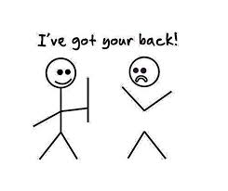

Some of you may feel nervous about doing academic writing, especially if the papers are longer than what you are used to writing. Please don’t worry too much: I don’t expect you to know everything before I teach it to you, and I never expect perfection. We take everything step-by-step, and the tutors and I are here to help you. Just reach out to us.

Writing Assignments
You will be completing three major projects and three related Feedback Assignments during the semester:

- Project #1 takes place during the first four weeks of the semester. You will read and annotate selected pages from The Trials of Nina McCall: Sex, Surveillance, and the Decades-Long Government Plan to Imprison "Promiscuous" Women by Scott W. Stern. You will take quizzes on the reading, and participate in discussion board postings. Essay #1 will require three drafts, each of which must be submitted to Canvas by the specified deadlines. Essay #2 will require three drafts, each of which must be submitted to Canvas by the specified deadlines.
- Project #2 is based on the book Necessary Lies by Diane Chamberlain. You will read and annotate the book, take quizzes on the reading, and participate in Discussion Boards.
- Project #3 asks you to write a 5-page research paper (RP) on a topic related to eugenics. I will give you a choice of possibilities related to the main topic, or you can propose your own idea (related to eugenics), which will need to be approved by me in advance. The paper and your thesis must be supported by 5 academic sources. (We will go over how to do research with library databases). Requirements include short writing assignments, a preliminary annotated bibliography (Pre- AB), and a final annotated bibliography (AB), as well as peer reviews and three drafts of the RP.

- There is also a Feedback Assignment connected to each Project. It will require you to get feedback on each of the three projects. You will choose from the following options:
- Project #1: Meet with me or a tutor (via Zoom or in person) or submit your draft to NetTutor
- Project #2: Meet with me or a tutor (via Zoom or in person) or submit your draft to NetTutor
- Project #3: Choose two: Meet with me and/or a tutor (via Zoom or in person) and/or submit your draft to NetTutor.

Class Policies and Procedures

ATTENDANCE and DROPS:
Even though you don't receive a separate grade for attendance, regular attendance is essential for your success.
  - You will be dropped from the course if you do not attend the first and/or second day of the first week of classes; however, if you contact me as soon as possible with a legitimate reason for missing the first week of class, I will consider the situation and let you know my decision.
  - The grace period of 48 hours for late work does not apply to Module 1.
  - Please carefully note the Drop Date of Sunday, 3/9, which is at the end of Week 9. If you choose to drop the class and receive a “W,” this is the deadline to do so. After that, you will receive a letter grade (A-F) and cannot drop the course.
  - You will very likely be dropped from the class if you have missed four or more classes in the first nine weeks of the semester.
o I will speak to you in person or contact you via email and/or Starfish if I am considering dropping you from the class.
- Students who add or choose to drop the class are responsible for completing the process through Self-Service. Students who do not add by Friday, 1/26, will not be able to add after that.

Participation
This includes, but is not limited to, having the required materials, annotating all readings, taking notes, completing all assignments, contributing to in-class discussions and to discussion board prompts in a thoughtful manner, and completing peer reviews. I will also take into consideration if you have communicated with me or with a RWC tutor about your writing. Students learn not only from the instructor but also from each other. So, be sure to do all of the assigned work and to interact with other students in the class in a meaningful, useful way. (Even asking questions about something that you don’t understand is useful to others. You are almost certainly not the only one who has a question.) All of us are looking forward to hearing your ideas and your “voice.”

Submission of Assignments
- I reserve the right to refuse any paper that is not submitted in the proper format or does not meet other requirements.
- I cannot accept an essay that has been typed on Google Docs. As a Reedley College student, you can access Microsoft Word 365 for free. Need help with this? Ask a tutor, another student, or me during my office hours. (You can also see the January 2023 edition of The Paper Jam.)
- Some assignments will require you to submit photos. Please make sure that all photos are submitted as JPEG or PNG files; I am unable to open photos saved as HEIC files and therefore cannot accept them. (See “How to Airdrop a Photo as a JPEG Instead of HEIC”)
- All annotations must be submitted as indicated in the instructions, not as notes written out on paper or typed up. (You will receive instructions on how to annotate correctly.)

Late Work
All assignments are due either by the start of class or, more commonly, by 11:59 p.m. on the due date.
- Grace Period: you may submit assignments after the due dates, without penalty, up to 48 hours after the due date.
  - You should avoid relying excessively on the grace period; if you are consistently missing official deadlines, you are almost certainly less likely to do well in the class. Think of the grace period as a cushion to use in emergencies, not as an alternative deadline.
  - If you run into problems, let me know as much in advance as possible. I can’t guarantee that I can solve your problem, but I will always listen and, whenever possible, I will try to help you.
  - Exceptions to the Grace Period: All assignments for Module 1 must be submitted on time, and the final three assignments of the semester, RP 1.3, AB 1.2, and the Final Exam, cannot be submitted late.
    - Bonus Time opportunities: you will have the chance to earn 24 hours added to the deadline for RP 1.3 and/or AB 1.2 by attending a Literary Arts Speakers Series event (7:00 p.m. – 8:30 p.m.) on one or more of the following Thursdays: 1/25, 3/14, and 3/21. I will give more information about this later.
- Most assignments will be due on Friday, Saturday, and Sunday; there may be times that I will ask you to turn something in earlier than that.
- Don’t wait until the weekend to begin the work or you will run out of time.
- ALL assignments for the course are required (even the “small” ones). You may not skip anything or submit a “substitution” such as the wrong assignment or a blank sheet of paper.
- All assignments need to be submitted to Canvas; Please don’t email me any assignments; I’m unable to grade them.

Academic Dishonesty
- Academic dishonesty includes cheating, copying, plagiarizing others’ work, or engaging in any other means of deception to complete or bypass an assignment.
  - We will be using aspects of Artificial Intelligence (AI), such as ChatGPT, in class from time-to-time for specific assignments such as brainstorming. Any other use of AI for assignments will be considered academic dishonesty.
  - Any attempt to bypass the requirement of doing an assignment by, for example, submitting a “substitution” (such as the wrong assignment or a blank sheet of paper) will be considered academic dishonesty.
- I use turnitin.com and AI detectors.
- Please note that you will not be allowed to turn in previously submitted work for any assignment in this class. That means that you can’t “recycle” a speech you gave or a paper you wrote for another class. If you are repeating my class, all of the work that you turn in for this semester must be new.
- You are encouraged to get help on your writing from me, a tutor from the Reading & Writing Center (RWC) or the Tutorial Center, and your classmates in this class. No one else—not your parents, siblings, boyfriend, girlfriend, former teacher, ex-boyfriend or ex-girlfriend, siblings’ boyfriend or girlfriend, siblings’ ex-boyfriend or ex-girlfriend, or your dog—may help you with any of your papers.
- Consequences of academic dishonesty may include, but are not limited to, receiving an ‘F’ on the assignment or in the course.
- If you are worried, confused, or overwhelmed by anything in the class, including what academic dishonesty and/or plagiarism is, please don’t resort to dishonesty; instead, come talk to me (or a tutor) and get help.

Students with Disabilities
If you have a verified need for an academic accommodation or materials in alternate media (i.e., Braille, large print, electronic text, etc.) per the Americans with Disabilities Act (ADA) or Section 504 of the Rehabilitation Act, please talk to me as soon as possible. Contact DSP&S at (559) 638-0332 or visit their website for more information.

Some Important Points
- Please check Canvas every day. Make sure that you receive Canvas notifications when I send you announcements or e-mails. If you don’t know how to do something related to technology, you can get help from me, a RWC tutor, or Tech Services.
  - Please contact me by e-mail or through Canvas Inbox if you have any problems or questions about anything. If you have not heard back from me in 24 hours, please check to make sure that I received your message. If you write to me, be sure to check for my response to you.
- Please keep copies of all work submitted to me. As you know, sometimes things go wrong with electronic systems. Protect yourself by keeping everything until the course is finished and your final grade has been recorded.
- Be appropriate, professional, and kind to me, to others in the class, and to yourself.
- Remember that other people’s experiences may be different from your own and that we all, including me, sometimes need to set aside a tendency to be judgmental. Tell me (or a tutor) if there is ever any communication (in class or online) that makes you feel uncomfortable. Repeated incidents of any behavior deemed to be rude or disruptive will result in that student being reported to the Dean of Students.
- My job is to help you to read and write more critically (more carefully and more deeply) and to be more successful in other classes. I really care about my students and will do whatever I can to help you. Let’s work together to help you succeed!

Tips for Success This Semester
- Know your resources
  - Tech services, RWC, NetTutor, counseling and psych services, Canvas Inbox, etc.
- Manage your time well
  - Plan to spend approximately six hours a week doing course assignments.
  - Don’t wait until the day an assignment is due to begin working on it. You won’t have enough time.
  - Whatever assignment you're working on will likely take longer than you thought because of technical glitches, uncertainty about the assignment, because it's college, not high school, etc.
  - Use whatever works for you to help you with getting things done: reminders on your phone, a paper calendar, sticky notes, etc. You must do more than rely on your memory and hope for the best.
- Communicate, communicate, communicate
  - with me. (If I don't know, I can't help you; I can't always say "yes," but I will consider requests, and I may have options you haven't thought of)
  - with my tutors, Hannah, Audrey, Jack, and Maddie. (They love to help students and are very good at their job!
  - with your classmates; not only do they often have answers to your questions, but you'll feel less alone. Furthermore, you can help someone else with their questions, too, which can be surprisingly rewarding.
Grading
A = 100-90 excellent
B = 89.99-80 very good
C = 79.99-70 average
D = 69.99-60 needs improvement (not passing)
F = 59.99-0 fail (not passing)

- I don’t round up.
- I’m happy to talk to you about your assignment grades (Why did you get the grade that you did? What can you do to improve your grade?), and if I’ve made a mathematical error, I will correct it; however, I am unable to negotiate your grade with you at any point in the semester
- If you care about your grade, do something about it EARLY in the semester: Do all of the work, check your grade on Canvas, re-read my comments on your papers, arrange to talk with me, talk to our class tutors, and meet via Zoom with a tutor from the Reading/Writing Center. In a nutshell, put your best effort in and communicate with me.

Course Assignments (subject to change) | Approximate Points Possible | % of Final Grade
Project #1: Readings and Essay on the American Plan | 150 points | 15%
- Annotated reading = 10 pts.
- 1st Draft (Essay 1.1) = 10 pts.
- 2nd Draft (Essay 1.2) = 10 pts.
- NetTutor.com submission = 10 pts.
- Works Cited page = 10 pts.
- Final Draft (Essay 1.3) = 100 pts.
Project #2: Necessary Lies | 250 points | 25%
- Annotated reading = 10 pts.
- In-class essay exam (Essay 2.1) = 50 pts.
- NetTutor.com submission = 10 pts.
- Works Cited page = 10 pts.
- Second Draft (Essay 2.2) = 10 pts.
- Practice AB = 10 points
- Final Draft (Essay 2.3) = 150 pts.
Project #3: AB and RP | 400 points | 40%
- RP 1.1 = 10 pts.
- RP 1.2 = 10 pts.
- Preliminary Annotated Bibliography (AB 1.1) = 50 pts.
- Final Annotated Bibliography (AB 1.2) = 100 pts. (subject to change)
- Research Paper (RP 1.3; 3 drafts required) = 300 pts.
Feedback Assignments (meet with me and/or a tutor and/or submit work to NetTutor)  - Project #1 = 5 pts.  - Project #2 = 5 pts.  - Project #3 = 10 pts.  - Completion of all the above = additional 5 pts. | 25 points | 5%
Discussion Board Posts | 50 points | 5%
Quizzes and Miscellaneous Assignments | 50 points | 5%
Final Exam | 50 points | 5%
TOTAL | 975 points | 100%

Important Dates
Week 1: Monday, 1/8
- Spring 2024 semester begins

Week 2: Monday, 1/15
- Martin Luther King holiday; no classes

Week 2: Friday, 1/19
- Last day to drop with a full refund

Week 3 : Friday, 1/26:
- Last day to register for a Spring 2024 full-term class in person
- Last day to drop a Spring 2024 full-term class in person and avoid a “W”

Week 4: Sunday, 1/28
- Last day to drop a Spring 2024 full-term class online (via Self-Service) and avoid a “W”

Week 6/7: Friday, 2/16 – Monday, 2/19
- Presidents’ Day holiday; no classes.
  - I will be out of town and somewhat unavailable from Friday through Tuesday (2/20)

Week 9: Sunday, 3/9
- Last day to drop and receive a “W”

Spring Break: Monday, 3/25 – Sunday, 3/31
(after Week 11 and before Week 12)

Week 18: Monday-Friday
- Spring 2024 final exams week
  - English 1A-53279 = Thursday, May 16, 11:59 p.m.

Bonus Time Opportunities

Week 3: Thursday, 1/25: Deb Lapp and Dave Borofka
Week 10: Thursday, 3/14: Javier Zamora
Week 11: Thursday, 3/21: As You Like It by the San Francisco Shakespeare Festival

Important points about the theme of the course and the book:
- Throughout the semester, we will be reading, researching, and engaging in class discussions about eugenics, marginalized people, and the value (or lack of value) that society often places on certain people. You may have strong opinions about the topics we cover, and some students in the class may have personal experiences related to some of the ideas brought up in readings and discussions. Some students may find the topics too disturbing to read, talk, and write about and should therefore consider choosing a different class; and 2) students who remain in the class must be willing to be sensitive to other people in the class during class and online discussions.
- REMINDER: You must have a physical copy of Necessary Lies by the end of the 2nd week of the semester; an electronic copy is not acceptable.

The following are department-developed objectives and outcomes for all English 1A students:

Course Objectives
In the process of completing this course, students will:

- Write multiple essays of at least 5000 words, including at least one research paper with documentation that includes:

  - a sophisticated introduction, multiple body paragraphs, and conclusion.
  - a clearly defined, arguable thesis sentence.
  - supporting details that exhibit critical thinking and use credible secondary sources.
  - correct usage of MLA format, including a Works Cited page.
  - sentences which exhibit a command of the complex/compound with minimal comma splices, sentence fuses, and fragments, and which show a command of mechanics.
  - controlled and sophisticated word choice.
  - writing in the third person.
  - an avoidance of logical fallacies.
  - demonstration of an awareness of purpose and audience.
  - appropriate and purposeful use of quotations.
  - correct in-text citations.
  - an annotated bibliography of multiple sources.
  - a lack of intentional and unintentional plagiarism.

- Write one or more organized, independently-written in-class essays with thesis and adequate support.

- Read and understand college-level prose.

Course Outcomes
At the end of the course, students will be able to:

- Write a documented, well-organized research paper of at least 1,500 words [approximately 6 pages] that demonstrates critical thinking and command of the English language.
- Complete a timed essay independently in class.
- Summarize and comprehend college-level prose (will include a full reading).

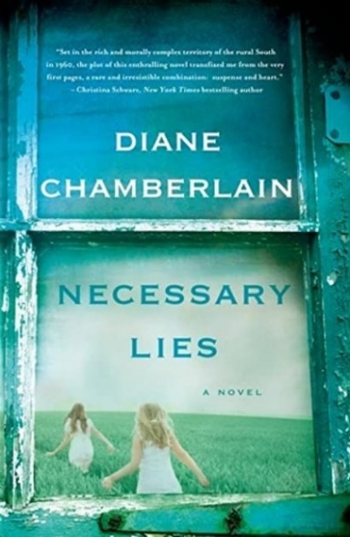 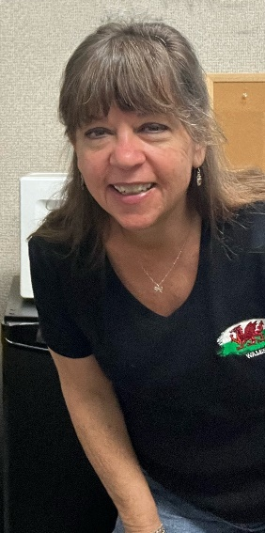 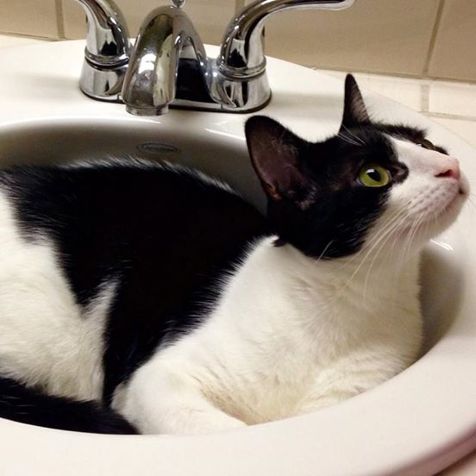 (Hershey)

