Reedley College
Fall 2022 English 1A

English 1A-Reading and Composition Online

Taylor Smith- English Instructor
E-mail: taylor.smith@dinuba.k12.ca.us  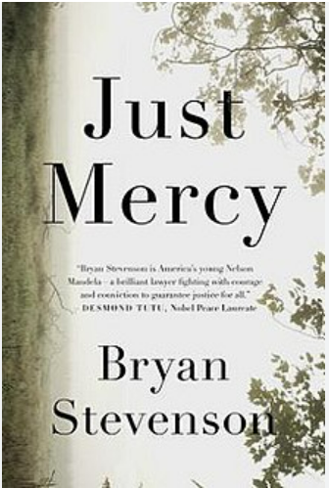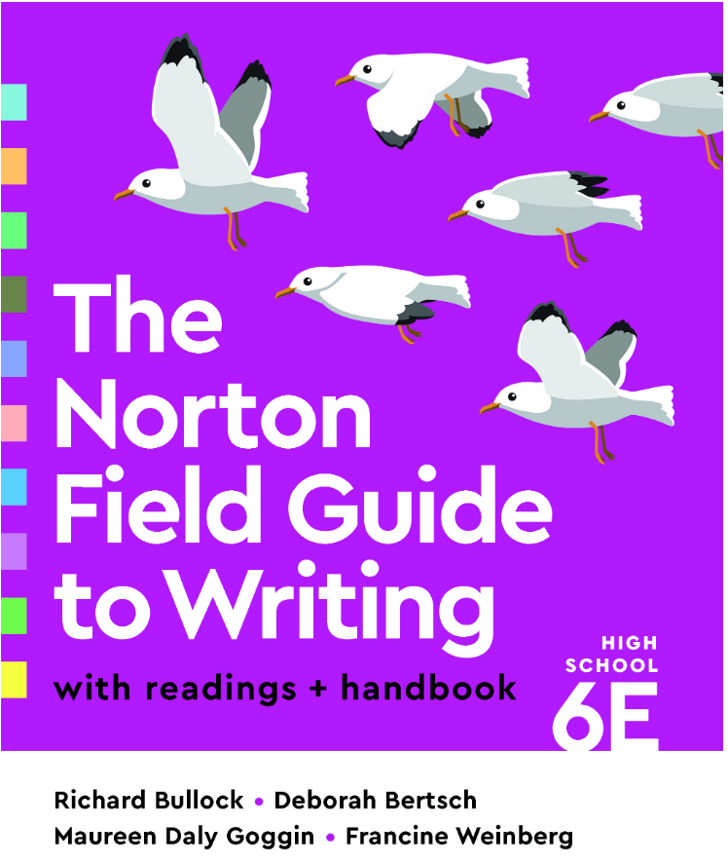  These are the books we will be reading this semester. Do not worry about getting the textbook (Norton Field Guide…). If I cannot provide you a free copy, then materials will be pulled from that text and provided to you. | In person Office Hours  Office hours are the best time to get 1-on-1 time to go over concepts that aren’t quite making sense, getting early feedback on an essay before the submission deadline, as well as getting help on a revision of a previously graded essay.  You can attend either office hours listed below:  Room 110 Wednesday 3:15 - 4:15 PM  (Main Building, upstairs with Mrs. Smith)  Room 222 Thursday 3:15 - 4:15 PM  (Behind science wing, by West Gym with Mr. Franks)
Welcome to English 1A. This class is an 18-week course that will end on 5/19/2023. This course is a dual enrollment course. This means that you are completing this course for both college and high school credit. The purpose of this class is to develop your critical thinking, reading, and writing skills. This course relies on collaboration with others and the social construction of knowledge. This means that we’ll work together on all aspects of thinking, reading, writing, and research. This class provides a mixture of informal and formal writing assignments as well as various forms of group work, all of which are designed to meet the learning outcomes for the course.

Course Communication Policy
I respond best to emails and face-to-face conversations during my office hours. When emailing me, please include your name and what class you are enrolled in (name of class and section or period number) in the subject line of your email. Also, please remember to have a respectful tone in the emails that you send as I will always be sure to show you respect in my replies. You have a right to ask me questions or seek clarification. I check my work email Monday through Friday between the hours of 7:00 AM and 5:00 PM. Anything sent after that time, or sent on weekends or holidays, may take longer to receive a response. If I do not respond within 24 hours, please do not hesitate to send the email again. I am happy to answer any questions during my office hours. It’s a great time to chat about class or assignments with less confusion and misunderstanding that’s more present in email.

As the semester progresses, I may create a Q&A board or a FAQ section on Canvas. That way, we can have a platform to help each other out if I can’t make it to your question in a timely manner or if it has already been answered.

Attendance and Drop Policy
Your attendance matters! Keep in mind that this is a college course - and not just a high school class. College courses run at a different pace and it’s easy to fall behind if you’re not doing your best to keep up with the material on days that you are gone. If you don’t already, get into the habit of texting a close friend in this course on days that you miss to figure out what you can do on your own time to make up for any time out of class.

The last day to drop without a ‘W’ is January 27, 2023.

Because this is a dual enrollment course - and you’re an academy student - dropping the class only means that you are dropped from the college roster. You will still need to pass this class to graduate from Dinuba High School. It’s awkward and clunky, but let that motivate you to work extra hard in this course so that all of the work going in counts for both high school and college. Failing English 1A can have terrible consequences for your college future. Therefore, students will be dropped from this course for failing to do work in the first two weeks of class.

Late Work policy
Students should always strive to turn in their work on the due date listed. College-level work is typically time-consuming and requires critical thinking and depth of thought. Plan accordingly and use ample time to work on assignments and papers well before the submission deadline.

However, life happens and sometimes we need more time to explore our learning. Assignments turned in after the due date will be accepted for one week after the deadline with a 10% penalty. Work will not be allowed one week after the due date and will be graded as a zero in the gradebook. The final research paper cannot be turned in late due to how close the deadline is to the grade submission date.

Catalog Description:
Students will read, analyze, and compose college-level prose, with emphasis on the expository; study writing as a process; explore different composing structures and strategies; edit and revise their own writing; and conduct research (gather, organize, evaluate, integrate, and document information), culminating in a term research paper and annotated bibliography. Students will write a minimum of 5,000 words in formal academic language.

Required Readings & Materials:
Computer and Internet Access. Every assignment will be submitted through Canvas
- Readings available in our class Canvas shell
- Binder or Notebook with paper
- Pens, pencils, and highlighters
- Just Mercy by Bryan Stevenson

Student Learning Outcomes:
Upon completion of this course, students will be able to:
SLO1: Write a documented, well-organized research paper of at least 1,500 words that demonstrates critical thinking and command of the English language at least at a “C” level (70%).
SLO2: Complete a timed essay independently in class at least at a “C” level (70%).
SLO3: Summarize and comprehend college-level prose (will include a full reading) at least at a “C” level (70%).

Course Objectives:
In the process of completing this course, students will:
- Write multiple essays of at least 1,500 words, including at least one research paper with documentation.
- Arrange and integrate ideas in a multiple body essay, complete with topic sentences, supporting data, and background, as necessary
- Indicate an arguable thesis
- Gather, analyze, and synthesize peer-reviewed sources and/or original research, such as interview, survey, or observation
- Employ MLA formatting
- Reduce dependence on the instructor’s guidance; students will ultimately independently and accurately recognize and self-correct errors in sentence construction, punctuation, and mechanics
- Craft increasingly mature and cogent writing while choosing the appropriate tone and academic voice
- Practice sound choices in identifying and avoiding logical fallacies
- Employ appropriate use of third-person universal
- Identify appropriate audiences for their compositions
- Employ quotations, discriminating among sources for accuracy and validity
- Employ MLA formatting guidelines for Work Cited Page and in-text citations
- Develop an annotated bibliography from sources for a research paper
- Recognize the appropriate use of sources, while avoiding intentional and unintentional plagiarism
- Write an organized essay with a thesis and adequate support independently within a class period.
- Read and understand college-level prose, including:
- Identifying the model, summarizing the thesis, and locating supporting information.
- Naming rhetorical devices such as irony and parallelism and translating metaphorical language, so as to determine an author’s intent, both explicit and implicit.
- Answering questions from assigned reading differentiating between an author’s intent and personal reaction.
- Describing, evaluating, and questioning the purpose, audience, organization, and style of assigned readings.

Required Course Work:
- Class Participation  - Formative Work & Weekly Discussion Posts  - Timed Writing Exercise  - Rhetorical Analysis Essay  - Literary Analysis Essay  - Annotated Bibliography  - Research Synthesis Essay | Required  25%  10%  15%  15%  10%  25% | 90 - 100% = A  80 - 89% = B  70 - 79% = C  60 - 69% = D  0 - 59% = F
Class Participation:
You will be successful in my class if you:
- Attend class regularly—not missing more than one week’s worth of assignments
- Meet due dates and writing criteria for all major assignments;
- Participate in all exercises and activities;
- Complete all informal, low-stakes writing assignments (e.g., Dialectical journal writing, annotating);
- Taking thoughtful consideration to all feedback given to improve your writing;
- Sustain effort and investment on each draft of all papers;
- Make substantive revisions to papers—extending or changing the thinking or organization—not just editing or touching up;
- Attend office hours with the teacher to discuss drafts;
- Trying your hardest on all Timed Essay exercises.

Writing Assignments:
Timed Essay One:  Essay One:  Timed Essay Two:  Essay Two:  Annotated Bibliography:  Essay Three: | Rhetorical Analysis  Rhetorical Analysis; Columnist Project  Literary Analysis  Literary Analysis; Just Mercy  *Based on research topic*  Research Paper | Week 3 (January 26, 2023)  Week 6 (February 19, 2023)  Week 9 (March 9, 2023)  Week 12 (April 2, 2023)  Week 15 (April 30, 2023)  Week 17 (May 14, 2023)
*Please see the section, Writing Help, for an important requirement for all three essays*
Paper Format:
In short, MLA format.

All assignments and drafts must be typed and in size 12 font, double spaced, and have your name, course, instructor’s name, and due date at the top of the first page. Don’t forget to number your pages with your last name listed before each page number.

Always remember to SAVE a copy of your work as a .docx file before submitting to Canvas.

Digital Literacy:
Every assignment you will complete in this class will be due online and in Canvas. This means you must memorize your student ID and password so that you can submit your assignment. I acknowledge that this may be the first time you have used this technology in the classroom, so let's work together and make sure you understand how to find our Canvas assignment calendar, how to submit your homework and essays, and how to locate important readings for this course. Be on the lookout for tutorials to assist you.

Classroom Conduct:
Since this is a collaborative classroom in which all are encouraged to participate and share thoughts, it is necessary that we treat each other (and your Professor) with respect. Any disruptive behavior will not be tolerated. You are expected to behave in a manner that is respectful to others and conducive to learning. You are expected to interact with each other respectfully and to work cooperatively and constructively in group and partner activities and assignments.

If the behavior becomes too disruptive, disciplinary steps will be taken, as per Board Policy 5550, “including but not limited to the removal, suspension or expulsion of a student.”

SCCCD Board Policy 5550 (#11) description of disruptive behavior:
“Disruptive behavior, willful disobedience, habitual profanity or vulgarity, or the open and persistent defiance of the authority of, or persistent abuse of, college personnel, including obstruction or disruption of teaching, research, administration, disciplinary regulations, or other college activities, including, but not limited to community service functions or other authorized activities on or off-campus.”

Academic Dishonesty:
Students at Reedley College are entitled to the best education that the college can make available to them, and they, their instructors, and their fellow students share the responsibility to ensure that this education is honestly attained. Because cheating, plagiarism, and collusion in dishonest activities erode the integrity of the college, each student is expected to exert an entirely honest effort in all academic endeavors. Academic dishonesty in any form is a very serious offense and will incur serious consequences.

Cheating:
Cheating is the act or attempted act of taking an examination or performing an assigned, evaluated task in a fraudulent or deceptive manner, such as having improper access to answers, in an attempt to gain an unearned academic advantage. Cheating may include, but is not limited to, copying from another’s work, supplying one’s work to another, giving or receiving copies of examinations without an instructor’s permission, using or displaying notes or devices inappropriate to the conditions of the examination, allowing someone other than the officially enrolled student to represent the student, or failing to disclose research results completely.

Plagiarism:
Plagiarism is a specific form of cheating: the use of another’s words or ideas without identifying them as such or giving credit to the source. Plagiarism may include, but is not limited to, failing to provide complete citations and references for all work that draws on the ideas, words, or work of others, failing to identify the contributors to work done in collaboration, submitting duplicate work to be evaluated in different courses without the knowledge and consent of the instructors involved, or failing to observe computer security systems and software copyrights. Incidents of cheating and plagiarism may result in any of a variety of sanctions and penalties, which may range from a failing grade on the particular examination, paper, project, or assignment in question to a failing grade in the course, at the discretion of the instructor and depending on the severity and frequency of the incidents.

(The above paragraphs were taken from page 48-49 in the Reedley College catalog).

Accommodations for Students with Disabilities:
If you have a learning difference and require accommodations, please discuss your accommodation with me after class or during office hours early in the semester. Please, visit our DSP&S office if you need accommodation. I cannot honor your accommodations if I am not aware of them. This means you need to advocate actively for yourself. Thus . . . if you have a verified need for academic accommodation or materials in alternate media (i.e., Braille, large print, electronic text, etc.) per the Americans with Disability Act (ADA) or Section 504 of the Rehabilitation Act, please contact me as soon as possible. Ask me for more information so that I may help you find the resources you deserve.

Writing Help:
If you engage with the writing process, research proves that your writing will improve. We have a free resource via Tutor.com (log in through Clever). There are two ways you can use Tutor.com to get help with your writing: by connecting with a tutor for a live session (video call or direct messages) and by dropping off a paper for review. Connecting with tutors can help you develop a topic, receive feedback, and get constructive criticism on your drafts.

For this class, all three major writing assignments - essay one, two, and three - require proof of submission to Tutor.com and that feedback was received. This means you will want to get into the habit of completing your drafts earlier than the submission deadline so that you have time to receive feedback and implement needed revisions.

Additionally, you will be required to sign up for a 10-minute time slot to conference with me about each essay before submitting it. One-on-one sessions will be available during class time before the submission deadline and during office hours. This will be a time for me to chat with you about your draft and answer some critical questions you may have before submitting your work.

