Reedley College
Spring 2023 English 1A
9-week Online Reading and Composition
Begins on January 9, 2023-Ends on March 10, 2023

I Professor Anya Connelly-Howland
E-mail: anya.connelly@reedleycollege.edu
Phone: 559-638-0300 ext. 3156

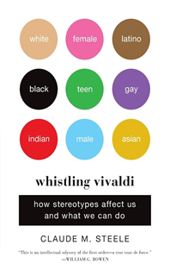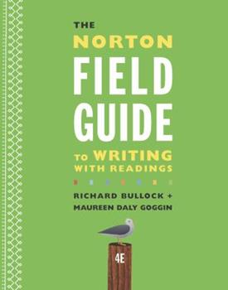  These are the books we will be reading this semester. If you are unable to purchase them you can check them out from the Reedley College Library and the Reedley Reading and Writing Center free of cost! | In-person Office Hours  Faculty Annex Room A6  Monday & Wednesday 11:00 am-11:50 am  Tuesday from 1:00 pm-1:50 pm  Thursday from 10:00 am-10:50 am  Zoom Office Hours  Friday from11:00 am-11:50 am  Or by appointment Just ask!  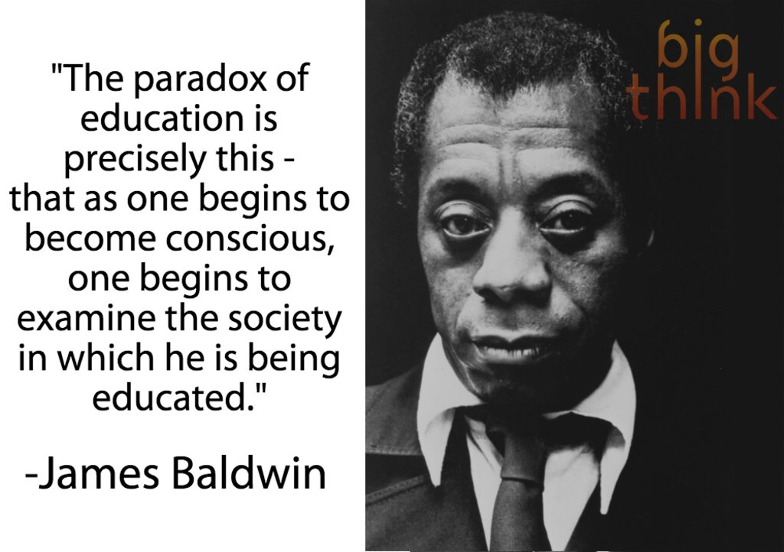
W
elcome to English 1A. The purpose of this 9-week class is to develop your critical thinking, reading, and writing skills. This course relies on collaboration with others and the social construction of knowledge. This means that we’ll work together on all aspects of thinking, reading, writing, and research. This class provides a mixture of informal and formal writing assignments as well as various forms of group work, all of which are designed to meet the learning outcomes for the course. Finally, the course culminates with the submission of your final research project.

Catalog Description:
Students will read, analyze, and compose college-level prose, with emphasis on the expository; study writing as a process; explore different composing structures and strategies; edit and revise their own writing; and conduct research (gather, organize, evaluate, integrate, and document information), culminating in a term research paper and annotated bibliography. Students will write a minimum of 5,000 words in formal academic language.

Required Readings & Materials:
- Computer, Printer, and Internet Access. Every assignment will be submitted through Canvas. It will also benefit you to bring a laptop to class id you have one.
- Weekly Assigned Readings available via Canvas
- Binder or Notebook with paper
- Pens, pencils, and highlighters
- A Blank Journal for Free Writes
- A flash/thumb drive
- The Norton Field Guide to Writing by Richard Bullock ^{4th} or 5th edition
- Whistling Vivaldi by Claude M. Steele

Student Learning Outcomes:
Upon completion of this course, students will be able to:
SLO1: Write a documented, well-organized research paper of at least 1,500 words that demonstrates critical thinking and command of the English language at least at a “C” level (70%).
SLO2: Complete a timed essay independently in class at least at a “C” level (70%).
SLO3: Summarize and comprehend college-level prose (will include a full reading) at least at a “C” level (70%).

Course Objectives:
In the process of completing this course, students will:
- Write multiple essays of at least 1,500 words, including at least one research paper with documentation.
  - Arrange and integrate ideas in a multiple body essay, complete with topic sentences, supporting data, and background, as necessary
  - Indicate an arguable thesis
  - Gather, analyze, and synthesize peer-reviewed sources and/or original research, such as interview, survey, or observation
  - Employ MLA formatting
  - Reduce dependence on the instructor’s guidance; students will ultimately independently and accurately recognize and self-correct errors in sentence construction, punctuation, and mechanics
  - Craft increasingly mature and cogent writing while choosing the appropriate tone and academic voice
  - Practice sound choices in identifying and avoiding logical fallacies
  - Employ appropriate use of third-person universal
  - Identify appropriate audiences for their compositions
  - Employ quotations, discriminating among sources for accuracy and validity
  - Employ MLA formatting guidelines for Work Cited Page and in-text citations
  - Develop an annotated bibliography from sources for a research paper
  - Recognize the appropriate use of sources, while avoiding intentional and unintentional plagiarism
- Write an organized essay with a thesis and adequate support independently within a class period.
- Read and understand college-level prose, including:
  - Identifying the model, summarizing the thesis, and locating supporting information.
  - Naming rhetorical devices such as irony and parallelism and translating metaphorical language, so as to determine an author’s intent, both explicit and implicit.
  - Answering questions from assigned reading differentiating between an author’s intent and personal reaction.
  - Describing, evaluating, and questioning the purpose, audience, organization, and style of assigned readings.

Required Course Work:
- Class Participation/ Free Write Journal  - Quizzes and Homework  - Literacy History Essay  - Annotated Bibliography  - Research Synthesis Essay  - Book Reflection | Required  20%  10%  20%  30%  20% | 90 - 100% = A  80 - 89% = B  70 - 79% = C  60 - 69% = D  0 - 59% = F

Class Participation:

You will be successful in my class if you:
1. attend class regularly—not missing more than 1 weeks’ worth of classes; (2 weeks of homework)
2. meet due dates and writing criteria for all major assignments;
3. participate in all in-class exercises and activities;
4. complete all informal, low-stakes writing assignments
5. give thoughtful peer feedback during class and work faithfully with your group on other collaborative tasks (e.g., sharing papers, commenting on drafts, peer editing, online discussion boards);
6. sustain effort and investment on each draft of all papers;
7. make substantive revisions when the assignment is to revise—extending or changing the thinking or organization—not just editing or touching up;
8. copyedit all final revisions of Essays until they conform to the conventions of edited, revised English;
9. attend conferences with the teacher to discuss drafts;
10. submit your Timed Essay Exam
(adapted from Peter Elbow)

Readings: All short readings for homework will be provided on Canvas. You will be required to annotate each reading to help write your discussion posts.

Discussions Posts: Our class will consist of large class discussions of the readings/chapters that will be assigned and talks surrounding your discussion posts online. You will be expected to use your annotations and homework to contribute to the class discussions forums. This means you must read the readings/books to participate. Your opinion matters and is integral to our socially-constructed learning environment. Also, be aware that we will be discussing controversial issues that may be uncomfortable at times. My goal is to encourage you to think critically in new ways, so always keep an open mind in my class. We are all adults, so let’s use respectful language and be courteous to everyone’s opinions.

Writing and thinking about it:
At points during the semester you will be asked to share your writing with each other, and this can be stressful for some students. Please know that this class is a safe space and I encourage you to be open and yourself. The writing classroom is a place to mess up, take chances, and practice your ideas. While this isn’t a public speaking class, you will be asked to explain your writing in discussion posts and to be objective about it. If you want to grow as a writer and student of the English language, trust me, doing this can help you.

Paper Format and Word: All assignments and drafts must be typed in size 12 font, double spaced, and have your name, course, instructor’s name, and due date at the top of the first page. Don’t forget to number your pages. Always remember to SAVE a copy of your work to a flash drive. Also, every student at Reedley College gets FREE access to Microsoft Word. I will cover how to get free access to this program during class.

Digital Literacy: Every assignment you will complete in this class will be due online and in Canvas. This means you must memorize your student ID and password so that you can submit your assignments. No hard/paper copies will be excepted. I acknowledge that this may be the first time you have used technology in the classroom, so let’s work together and make sure you understand how find our Canvas assignment calendar, how to submit your homework and essays, and how to locate important readings for this course.

COURSE POLICIES

Amnesty and Second Chances:

The due dates for my essays and assignments are final. However, I do offer the following for my students because I acknowledge that sometimes we get sick, we forget something, or we just simply have a bad day.

    - I will drop your lowest discussion board or weekly assignment (not a major essay) at the end of the semester. If you are absent and you miss an assignment I will count it as a dropped assignment, unless it is a major essay.
    - If you receive a “D” or “F” on the Literacy History OR Annotated Bibliography, you may revise the assignment and re-submit it to me for a new grade by February 24 as long as you attempted the assignment and turned the paper in. Your revision must be submitted to the “Revision” Module in Canvas to be accepted. I will not accept files or links sent via email.

Classroom Conduct: Since this is a collaborative classroom in which all are encouraged to participate and share thoughts, it is necessary that we treat each other (and your Professor) with respect. Any disruptive behavior or discussion posts will not be tolerated. You are expected to behave in a manner that is respectful to others and conducive to learning. You are expected to interact with each other respectfully and to work cooperatively and constructively in group and activities and assignments.

If your behavior becomes too disruptive, disciplinary steps will be taken, as per Board Policy 5550, “including but not limited to the removal, suspension or expulsion of a student.”

SCCCD Board Policy 5550 (#11) description of disruptive behavior:
“Disruptive behavior, willful disobedience, habitual profanity or vulgarity, or the open and persistent defiance of the authority of, or persistent abuse of, college personnel, including obstruction or disruption of teaching, research, administration, disciplinary regulations, or other college activities, including, but not limited to community service functions or other authorized activities on or off-campus.”

Plagiarism:
Academic Dishonesty:
Students at Reedley College are entitled to the best education that the college can make available to them, and they, their instructors, and their fellow students share the responsibility to ensure that this education is honestly attained. Because cheating, plagiarism, and collusion in dishonest activities erode the integrity of the college, each student is expected to exert an entirely honest effort in all academic endeavors. Academic dishonesty in any form is a very serious offense and will incur serious consequences.

Cheating:
Cheating is the act or attempted act of taking an examination or performing an assigned, evaluated task in a fraudulent or deceptive manner, such as having improper access to answers, in an attempt to gain an unearned academic advantage. Cheating may include, but is not limited to, copying from another’s work, supplying one’s work to another, giving or receiving copies of examinations without an instructor’s permission, using or displaying notes or devices inappropriate to the conditions of the examination, allowing someone other than the officially enrolled student to represent the student, using Course Hero, LitCharts, or failing to disclose research results completely.

Plagiarism:
Plagiarism is a specific form of cheating: the use of another’s words or ideas without identifying them as such or giving credit to the source. Plagiarism may include, but is not limited to, failing to provide complete citations and references for all work that draws on the ideas, words, or work of others, failing to identify the contributors to work done in collaboration, submitting duplicate work to be evaluated in different courses without the knowledge and consent of the instructors involved, or failing to observe computer security systems and software copyrights. Incidents of cheating and plagiarism may result in any of a variety of sanctions and penalties, which may range from a failing grade on the particular examination, paper, project, or assignment in question to a failing grade in the course, at the discretion of the instructor and depending on the severity and frequency of the incidents. (The above paragraphs were taken from page 48-49 in the Reedley College catalog).

Accommodations for Students with Disabilities: If you have a learning difference and require accommodations, please discuss your accommodation with me after class or during office hours early in the semester. Please, visit our DSP&S office if you need academic accommodations. I cannot honor your accommodations if I am not aware of them. This means you need to advocate actively for yourself. Thus . . . if you have a verified need for academic accommodation or materials in alternate media (i.e., Braille, large print, electronic text, etc.) per the Americans with Disability Act (ADA) or Section 504 of the Rehabilitation Act, please contact me as soon as possible. Ask me for more information so that I may help you find the resources you deserve.

Writing Center: If you engage with the writing process, research proves that your writing will improve. We have a free resource at Reedley College called the Reading and Writing center that can help you develop paper topics, receive peer feedback, and get constructive criticism on your drafts. In my classes, I will offer up to 10 points extra credit, 5 points each visit, for having your work peer-reviewed at the Writing Center. This is an excellent way to boost your grade and reinforce the skills we will be developing in our class.

