ENGLISH 1A - 51205

READING & COMPOSITION

(4 UNITS)

Brandon Baker

Email: brandon.baker@reedleycollege.edu

Reedley College

Spring 2023
January 9th-May 19th

Hybrid
Tuesdays/Online

9-10:50 am

Room: Soc 35

Important Dates for Spring 2023 semester:
January 16th (Martin Luthor King, Jr): No Class (doesn't affect this class)
January 20th: Last day to drop class with a full refund
January 27th: Last day to drop class to avoid a 'W'
February 17th (Lincoln): No Class (doesn't affect this class)
February 20th (Washington): No Class (doesn't affect this class)
March 10th: Last to day to drop to receive a 'W' and not a letter grade
April 3-6th: SPRING BREAK! (no classes)
April 7th (Good Friday): No Class (doesn't affect this class)
May 15-19th: FINALS!

Computer access, Email, & Canvas
This course requires computer use. Please check your email and Canvas every day. Not everything we will be doing is accessible using Canvas on your phone (plus, that generally doesn’t work as well). While I ask you to check your email every day, I often use the "Announcements" tab on your left to communicate to you all as a class.
Please figure out your school email and Canvas right away. I’ve had many students tell me in the final weeks of the semester that they didn’t have computer access or email; not having access to these will make it very difficult to pass the course, know your grade, or get up-to-date information.

I

WHAT IS THIS CLASS?!
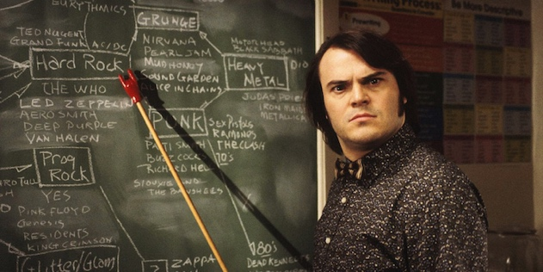

Course Description
Welcome to English 1A! This is a transfer-level theory and practice in reading and composition.
Being able to communicate through the written word is important no matter what your goals are— and reading goes hand-in-hand with composition. In order to pass this class and continue towards your goals, you’ll need to display the ability to understand and analyze various texts, as well as communicate your unique point of view effectively through writing. The basic tenets of reading and writing will be vital to you having a competitive edge when you apply to a university and any job you may aspire to, so these tools are important.
This is about you being able to communicate your message, your story, and your ideas in such a way that others will be able to understand what you mean (and perhaps be changed by it!). While there are ideas and structures required in academic writing, those tools and the ability to follow certain rules will help you better organize your thoughts for future writing. In other words: know the rules before you can break them effectively. :)

Course materials/resources (none require a cost $)
- FREE Online Textbook #1: Writing Spaces: Readings on Writing Volume 2 (Links to an external site.)
- FREE Online Textbook #2: NOPE: The Anti-Textbook
  - these are also available under Files/TEXTBOOK
- Various short stories that I will make available in class and/or online
- Purdue Owl (Links to an external site.) is a free online resource that covers all formatting for what we’ll be doing this semester. Please take advantage of this!

Course Objectives
Students will read, analyze, and compose college-level prose, with emphasis on the expository; study writing as a process; explore different composing structures and strategies; edit and revise their own writing; and conduct research (gather, organize, evaluate, integrate, and document information), culminating in a term research paper. Students will write a minimum of 5,000 words (total- not all at once) in formal academic language.
In the process of completing this course, students will:
- Write multiple essays of at least 1,500 words, including at least one research paper with documentation.
o Arrange and integrate ideas in a multiple body essay, complete with topic sentences, supporting data, and
background, as necessary.
o Indicate an arguable thesis.
o Gather, analyze, and synthesize peer-reviewed sources and/or original research such as interview, survey, or
observation.
o Employ MLA formatting guidelines.
o Reduce dependence on the instructor’s guidance; students will ultimately independently and accurately
recognize and self-correct errors in sentence construction, punctuation, and mechanics.
o Craft increasingly mature and cogent writing while choosing the appropriate tone and academic voice.
o Practice sound choices in identifying and avoiding logical fallacies.
o Employ appropriate use of third person universal.
o Identify appropriate audiences for their compositions.
o Employ quotations, discriminating among sources for accuracy and validity.
o Employ MLA formatting guidelines for Work Cited Page and in-text citations.
o Develop an annotated bibliography from sources for a research paper.
o Recognize the appropriate use of sources, while avoiding intentional and unintentional plagiarism.
- Write an organized essay(s) with thesis and adequate support independently within a class period.
- Read and understand college level prose, including:
o identifying the model, summarizing the thesis, and locating supporting information.
o naming rhetorical devices such as irony and parallelism and translating metaphorical language, so as to
determine an author's intent, both explicit and implicit.
o answering questions from assigned reading, differentiating between an author's intent and personal reaction
o describing, evaluating, and questioning the purpose, audience, organization, and style of assigned readings

Student Learning Outcomes
Upon completion of this course, students will be able to:
- Write a documented research paper of at least 1,500 words that includes:
1. a sophisticated introduction, multiple body paragraphs, and conclusion
2. a clearly defined, arguable thesis sentence
3. supporting details that exhibit critical thinking and use credible secondary sources
4. correct usage of MLA format, including a works cited page
5. sentences that exhibit a command of the complex/compound with minimal comma splices, sentence fuses,
fragments, and mechanics
6. controlled and sophisticated word choice
7. writing in third person/universal
8. an avoidance of logical fallacies
9. demonstration of an awareness of purpose and audience
10. appropriate and purposeful use of quotations
11. correct in-text citations
12. an annotated bibliography of multiple sources
13. an avoidance of intentional and unintentional plagiarism
- Complete a timed essay independently in class
- Summarize and comprehend college level prose (will include a full reading)

Grades
There are 800 points possible in this course. You must get a 'C' or higher to pass this course. A 'D' is not a passing grade for English 1A. The combined total of points you earn will be represented by the following grades:
720-800 | A (90-100%)
640-719 | B (80-89.9%)
560-639 | C (70-79.9%)
480-559 | D (60-69.9%)
0-479 | F (0-59.9%)

For accessibility purposes:
- an A is 90% to 100%, which is 720 to 800 points
- a B is 80% to 89.9%, which is 640 to 719 points
- a C is 70% to 79.9%, which is 560 to 639 points
- a D is 60% to 69.9%, which is 480 to 559 points
- an F is 0 to 59.9%, which is 0 to 479 points

Point distribution:
- QUIZZES/ASSIGNMENTS/DISCUSSION BOARD/PARTICIPATION = 300 POINTS
- TIMED ESSAY/ROUGH DRAFT = 50 POINTS
- JOURNALS = 150 POINTS
- ESSAY #1 (Revised Timed Essay) = 100 POINTS
- ESSAY #2 (Argumentative Research) = 200 POINTS

Percentage Distribution:
- Essays - 38% of grade
- Timed Essay - 6%
- Journals - 19%
- Homework - 37%

Timed Essay
There will be one timed essay in which you receive a prompt and have a limited amount of time to complete the essay. This will be a rough draft for your first essay, which will be graded based on the usual ability to meet the requirements of the prompt.

Core Essays
Each essay should meet the word requirement noted on the prompt. If you fail to meet the word requirements, your grade will be impacted.
You will be submitting your work electronically to a plagiarism detection service. You are required to submit your essay online through Canvas, and I will only accept Microsoft Word Documents (docx) or PDF's— no .txt or links!

Journals
There will be 5 journals worth 30 points each. They may involve (but are not limited to) activities such as short summaries, imitations, analyses, annotated bibliographies, discussion questions, etc. They will all involve a response to some form of text (short stories, poems, movies, shows, etc.). While the subjects and tasks will vary week to week (and hopefully be interesting and fun!), these are considered formal writing exercises and will be graded as such.

II

HOW THIS CLASS IS RUN

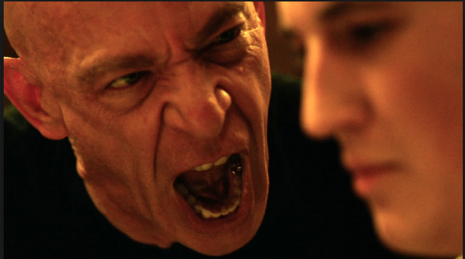

Communication
The best way to communicate with me is to email me at brandon.baker@reedleycollege.edu from your school email.*
*There’s something wrong with the way time is set up in my email account at Reedley; I’ve tried to fix it in the past, but sometimes I won’t get your emails right away. Just know that I always respond to student emails and I check my account multiple times a day during the semester.

Late Work
I won’t accept late work. No exceptions. 😫
I’ve been too lenient on this before, and I find that students tend to do less and less throughout the semester when there is no clear and direct deadline.
What I also worry about with late work is how it piles up; I have an intentional schedule that builds up to each essay/journal/project and should make the completion of each larger assignment fairly simple and rewarding for those who follow along. The more behind you get, the more the work tends to feel like it doesn't relate to anything and thereby doesn't fulfill its purpose.
That being said, please make sure you plan ahead. If you are prone to computer problems, try turning assignments in a day early.

Participation
Attendance is not graded directly; however, participation is. Given that this is (partially) an in-person class, you need to be present for participation points. While I won't have participation points for every single class session, the ones I do have will add up over time. Missing a couple won't hurt, but missing most of them can impact your grade.
Talking to each other while I'm lecturing and using your devices in a distracting way can also disqualify you from these points.

Plagiarism
Plagiarism includes any writing done by anyone but you. Any material that you include in your essay, even if it is only a sentence or two, which is not thought and written by you, must be cited. All work must be original for this class. Submitting writing created for another class, even if you have revised it for ours, is EVIL! (jk, but you get the idea). If you’re not sure if something is allowed, ask me first.
Essays are submitted to Turnitin.com and other plagiarism detection services and you’ll see a percentage when you upload your essay. This number reflects the work that has been found on other sites or in other student papers. There will often be a low percentage for any essay because it recognizes your name or a few phrases— that’s ok. If you’ve quoted and cited your work, that won’t count against you either. If you have a high percentage and there are full sentences highlighted that don’t have quotation marks or an in-text citation, please re-do those sections and re-submit your essay to avoid a very low grade on that assignment (and a low grade on a big essay will negatively effect your total grade).
In other words... don't cheat! Oftentimes, essays are flagged due to problems with quoting and paraphrasing, so make sure to pay attention to those particular lectures and please ask questions if you need help. And please don’t steal directly from the examples we go over in class together… it’s too obvious. Cheat better if you must. :)

P.S. - I WANT YOU TO SUCCEED! I am on your side. The respect I ask of you is mutual. Please reach out to me with anxieties, concerns, etc. Let’s make this interesting and insightful. Please participate actively; I expect to learn from you and I look at this class as a little family. I’m looking forward to getting to know you all! You will pass if you do the work— and you won't if you don't. It's completely up to you (which should be empowering 🙌).

III

RESOURCES

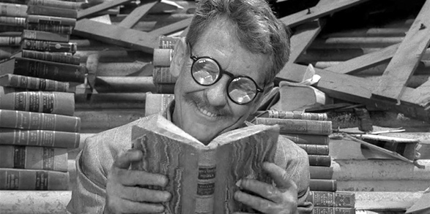

Accommodations for Students with Disabilities
https://www.reedleycollege.edu/student-services/disabled-student-programs-and-services/index.html
Please, visit our DSP&S office if you are need of academic accommodations. I cannot honor your accommodations if I am not aware of them. This means you need to advocate actively for yourself. If you have a verified need for an academic accommodation or materials in alternate media (i.e., Braille, large print, electronic text, etc.) per the Americans with Disability Act (ADA) or Section 504 of the Rehabilitation Act, please contact me as soon as possible.

Procedures for Connecting with All Tutoring Services on Campus
The Math Center, the Reading/Writing Center, and the Learning Center are all using the same online tutor matching service.
Additionally, all Math and English Courses, as well as many other high demand courses should have embedded tutors; that means students may be able to message their embedded tutor via Canvas in each course.
If a student needs to search for a tutor, they should go to www.tutormatchingservice.com/reedley (Links to an external site.) , sign up for a free account, and begin searching for RC tutors from all three Centers.
Here is a tutorial video on how to use Tutor Matching Service: Reedley College Tutor Matching Service Promo

BLANK PAGE REPELLANT (“BABY STEPS”)
- Read Prompt, Read It Again, Read It a Hundred Times
- Freewrite
- Brainstorm
- Create your Thesis Statement
- Outline
- Write

ESSAY CHECKLIST:
- MLA Format? (Times New Roman 12, 1” margins, double-spaced, page numbers, etc.)
- Meets the required word count?
- Answers the prompt?
- Thesis Statement? Clear argument?
- Topic sentences? Transitions?
- Evidence? Examples? Research?
- Clear awareness of opposing argument? (for Argumentative Research Essay)
- Logical Fallacies? (errors in reasoning)
- Pretend your audience can’t read your mind. Show, don’t just tell.

ESSAY RUBRIC:

A: An ‘A’ paper enlightens me. It makes it clear that you’ve read and understood the prompt. It makes it clear that you’ve engaged with the material. It doesn’t waste words. Everything in an A paper feels intentional.
- It follows the prompt.
- It is clearly structured and organized.
- It has a strong thesis statement, topic sentences, and transitions.
- It has few enough grammar/punctuation errors to not distract.
- It makes me think by showing that you are thinking.
- It entertains and enlightens.
- I can read this once and understand your message.

B: A ‘B’ paper may be similar to an ‘A,’ but *may* feel rushed or lack a clear structure. It might also have a distracting amount of grammatical/punctuation errors. It follows the prompt, and maybe all of the relevant information is there, but it lacks the organization or engaged response that is apparent in an ‘A’ paper.
- It may feel rushed.
- It fulfills the assignment, but may not show deep thought.
- It may have a distracting number of grammatical/punctuation errors.
- It may have minor structural issues.

C: A ‘C’ paper meets expectations and is considered passing. However, it may have a number of grammatical errors that make it hard to follow. It may have logical fallacies that distract from the arguments. It may wander and lack organization, using vague language and generalizations instead of specific examples.
- It may be unorganized.
- It may contain sloppy grammar and punctuation.
- I may have to read it two or three times to understand what you are saying.
- It’s often missing a clear thesis statement.

D: A ‘D’ paper is considered not passing. It is missing something asked for in the prompt. It’s generally shorter than it should be. It may feel more like a brainstorm than an essay. It generally has a distracting number of mechanical errors.
- It’s missing something the prompt asked for (e.g. it’s too short).
- It feels like I’m reading an unorganized brainstorm.

F: An ‘F’ paper is better than a 0, but it hardly represents the prompt assigned. Some examples in the past have included papers that are far too short, are organized as lists instead of essays, written in all fragments or run-ons, contain swearing and slang, etc.
- It ignores the prompt.
- It can’t be considered a college essay based on its appearance, grammar, punctuation, etc.
- It shows you don’t care or don’t understand the prompt.

0: A paper that is invisible

Reedley Rubric:
Content | Research Paper
Introduction | A. Uses critical thinking and creativity to introduce the topic in a meaningful way that provides context for the thesis.  B. Introduces the topic and provides context for the thesis.  C. Introduction is good but simplistic. Reader knows what the topic is but there might be a lack of context and/or clarity.  D. Not completely clear what the topic is. There might be irrelevant information or quotations that make the topic confusing.  F. Introduction missing or is off topic.
Thesis | A. Arguable thesis statement, which includes a fresh and original angle on the topic.  B. Arguable thesis statement.  C. Simplistic and obvious but still somewhat arguable thesis statement.  D. Unclear or confused thesis statement. Not arguable.  F. No thesis or does not address the writing prompt.
Topic Sentences | A. Topic sentences that support the thesis and clearly establish the angle and paragraph’s purpose.  B. Topic sentences that often support the thesis and mostly establish the angle and the paragraph’s purpose.  C. Topic sentences in most paragraphs that somewhat relate to the thesis or establish the paragraph’s purpose.  D. Few or unclear topic sentences.  F. No topic sentences.
Essay and Body Paragraph Content and Structure | A. Essay contains a logical progression of ideas and provides context for the audience without repetition. Academic, textual evidence from multiple sources is synthesized to support the thesis and topic sentences. This evidence is established with complete signal phrases and is followed with thoughtful analysis.  B. Essay mostly contains a logical progression of ideas and provides context for the audience with little repetition. Academic, textual evidence from multiple sources is synthesized and mostly supports the thesis and topic sentences. This evidence is established with mostly complete signal phrases and is followed with analysis.  C. Essay needs some attention to the following: the logical progression of ideas; context for the audience; repetition; academic, textual evidence from multiple sources to support the thesis and topic sentences; synthesis; analysis; and/or signal phrases.  D. Essay needs significant attention to the following: the logical progression of ideas; context for the audience; repetition; academic, textual evidence from multiple sources to support the thesis and topic sentences; synthesis; analysis; and/or signal phrases.  F. Essay requires significant revision of content.
Conclusion | A. Completes the essay’s ideas in a meaningful way without repeating the thesis and main points of the essay. Leaves the reader with something to think about.  B. Completes the essay’s ideas, but repeats the thesis or the main points of the essay.  C. Underdeveloped conclusion, repeating the thesis and main points.  D. Conclusion is present but does complete the essay. Might be confusing. Leaves the reader feeling that the essay is incomplete, unfinished.  F. No conclusion.
Sentence  Control | A. Academic language used with appropriate level of formality (3rd person). Few spelling, grammar, and punctuation errors.  B. Accurate language used with appropriate level of formality (3rd person). Some spelling, grammar, and punctuation errors that do not prevent understanding.  C. Language errors with adequate level of formality; some first and second person used. Some spelling, grammar, and punctuation errors that occasionally prevent understanding. Some proofreading is needed.  D. Significant language errors that prevent understanding; first and second person used often. Significant spelling, grammar, and punctuation mistakes. Proofreading is needed.  F. Numerous and significant language errors that obscure meaning; first and second person used throughout. Major problems with  spelling, grammar, and punctuation that prevent understanding. Significant proofreading is needed.
MLA Format | A. MLA formatting followed correctly for source titles and citations, Works Cited, and paper format.  B. MLA formatting followed nearly correctly for source titles and citations, Works Cited, and/or paper format.  C. MLA formatting followed but has multiple errors for source titles and citations, Works Cited, and/or paper format.  D. MLA formatting has significant errors for source titles and citations, Works Cited, and/or paper format.  F. No MLA formatting.
Plagiarism | No evidence of plagiarism intentional or unintentional.  Elements of Unintentional Plagiarism  Unintentional plagiarism is the use of original ideas or text without proper citation or paraphrasing.  Paper will be awarded minimal points or require revision if it contains significant unintentional plagiarism.  Evidence of Intentional Plagiarism  Intentional plagiarism is the deliberate use of ideas and text without citation.  The paper may receive a zero and a report may be submitted to the Behavioral Intervention Team, the VP of student services and/or the dean.

