SPANISH 1~ BEGINNING SPANISH-59026
Welcome to class! ¡Bienvenidos a la clase de español!
FALL 2023 / 5 Units/ T, TH 8:00 am – 9:45
Instructor: Mireya Alcaraz
E-mail: mireya.alcaraz-miranda@reedleycollege.edu
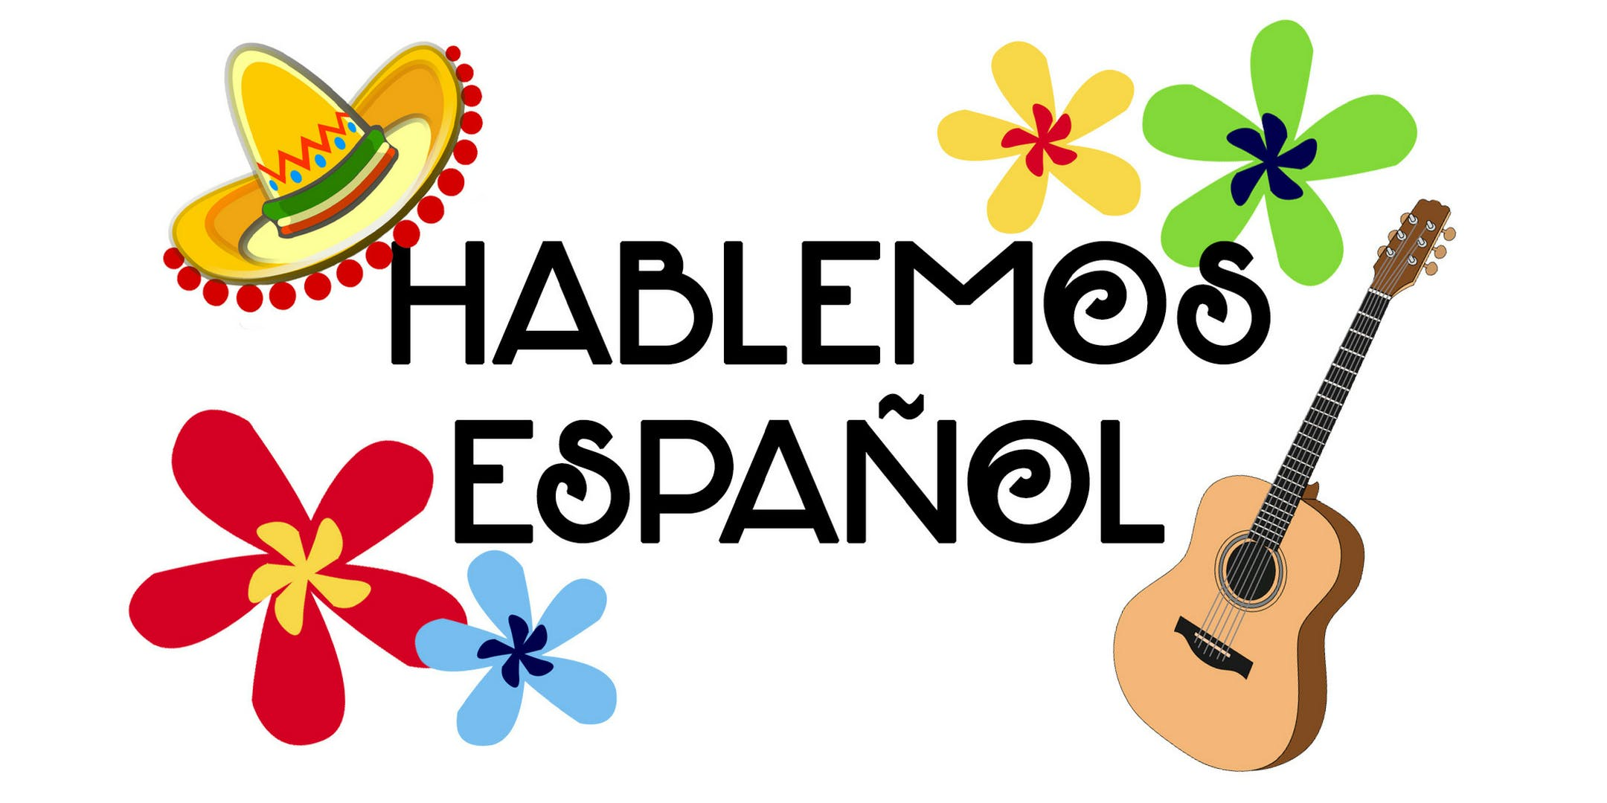
COURSE OVERVIEW
This is a beginning course in conversational and written Spanish for non-native speakers; intended for students without previous exposure to Spanish. Students will gain an introduction to pronunciation, vocabulary, idioms, grammar, basic composition, and they will explore the cultures of Spain, Latin America and Hispanic cultures of the US. ADVISORIES: English 1A or 1AH. (A, CSU-GE, UC, I) (C-ID SPAN 100)

What You Will Learn
Throughout the course, you will develop language skills in Spanish, will gain a sensitivity to differences and similarities in cultural issues, and by the end of the semester, you will be able to:
- When shown a drawing of several actions, describe what is happening.
- Discuss your habits, vacation plans, describe your home, friends/family.
- Interview other students to find out their experiences.
- Tell about your daily routine: the 20-30 things you do in a normal day.
- Describe other persons and things using appropriate adjectives.
- Tell some important things you did yesterday, or last summer.

Method of instruction:
Every effort will be made to make this class student-centered. That is, an activity will be modeled, and then you will work in pairs and small groups to assimilate the vocabulary and structures under consideration. You should make every effort to speak only Spanish and to prepare for the classroom learning activities. Partners who speak English will be separated. For this course, we will be working with Vista Higher Learning System, and Canvas as well. Some of the assignments such as discussion boards will be due on Canvas.
- Announcements will be posted on Canvas on regular basis. Please make certain to check the announcements regularly, as they will contain any important information about upcoming projects, homework, assignments, quizzes or class concerns. I will post the assignments in Modules
- If you need to contact me, email me at mireya.alcaraz-miranda@reedleycollege.edu or use Canvas Inbox. I will try to respond to your email within 24 hours.
  - When submitting messages, please do the following:
- Put a subject in the subject box that describes the email content with your name, class, and assignment. For example: Mireya, SPAN 1- 59076- Syllabus quiz
- Make certain to check your email and Canvas frequently. If you contact me on Saturday or Sunday, I will reply on Monday.

Required Materials
- Computer (desktop or laptop). iPad or smartphones support the audio/video exercises as well but are difficult to use for some exercises.
- E-MATERIALS: VISTAS: Introducción a la lengua española (6th Edition. Blanco & Donley, Vista Higher Learning, Boston, MA, 2020) Volume 1 + Supersite Code w/ WebSAM (online e-Text & workbooks).
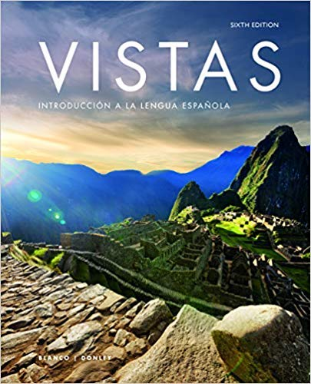
- E-MATERIALS: VISTAS: Introducción a la lengua española (6th Edition. Blanco & Donley, Vista Higher Learning, Boston, MA, 2020) Volume 1 + Supersite Code w/ WebSAM (online e-Text & workbooks).
- Purchase the materials at the college bookstore (some of you have to: EOPS, etc.) OR for a discounted price, go the publishing's company website.
- You will be prompted to create an account; be sure to remember your username and password as you will need these to access all of the course materials.
- Here are the pricing options: CHOOSE THE DIGITAL FORMAT
  - 6-month code: $115 per semester (1 Spanish class only (Spanish 1)).
  - 12-month code: $75 per semester (2 Spanish classes (Spanish 1 & Spanish 2) in a 1-year period: $150 upfront)
- You will also need to check Canvas for class announcements, links, and resources.
- Do not buy a used code from an outside source; these codes can only be used once by one student. Do not waste your money.
- Once you have the materials, follow the instructions on Canvas for enrolling in the course.

COMPUTER READINES: This Spanish course requires you to watch videos, record videos, make voice recordings and many other things that require an updated computer. The last thing I want is for you to be frustrated by technology, so before beginning this course, please go to Computer Requirements to see whether your computer meets the requirements for using VISTAS, our online e-text.

Grading and Evaluation: Your final grade will be based on five elements.

Assignment | Percentage of Total Grade
Homework | 20%
Oral performance/ Discussion Boards/ Participation/ Attendance | 20%
Portfolios | 10%
Tests | 40%
Final Exam | 10%
TOTAL | 100%
Table 1 percentage

Grading scale
A = 90-100% | B = 80-89% | C = 70-79% | D = 60-69% | F = 59% and below

Homework 20%
Homework will be assigned daily, and it represents 20 percent of your final grade. It is due the next session at the beginning of class and will not be accepted late. NO EXCEPTIONS! In addition, you will be working with the Vistas: Introducción a la lengua Española Supersite daily. Each lesson in VHL Central will have formative activities that will assess your listening, reading, and writing assignments. You will also watch cultural videos and read articles, and you will answer comprehension questions.

Oral Performance/Discussion Boards/ Participation/ Attendance 20%
Participation in class is necessary to obtain an “A” or “B” grade. Since the emphasis is on development of oral abilities in Spanish, the student must be an active participant. Points are determined by active, on task participation in paired or group activities, arriving in class with homework prepared, volunteering and being prepared when called on, arriving to class on time, etc. Points will be deducted when students are not on task (i.e.: using the cellphone, using English etc.) In addition, Discussion Boards will be assigned in Canvas throughout the semester. Your grade will be based on the breadth and accuracy of grammar and vocabulary, and your correct use of punctuation and accents. IMPORTANT! The use of machine translators for graded assignments is prohibited and constitutes academic dishonestly unless expressly allowed for a particular assignment by the instructor.
Portfolio Assignments 10%
Portfolio assignments will be assigned in Canvas throughout the semester. These may include creating a booklet describing and illustrating a passage from your daily life, writing an essay, illustrating a poem or short story, researching, and presenting to class an aspect of the Hispanic culture or writing a movie critique etc. Deadline dates as well as further instructions will be provided throughout the course. No late portfolios will be accepted unless there is an excused absence.

Lesson Tests (written and oral) 40%
You will be taking four tests at the end of each lesson, approximately every two to three weeks. (See tentative schedule). These are designed to match the objectives and student outcomes, and may include listening comprehension, vocabulary, grammar, reading comprehension, culture, and/or writing. Pop quizzes may also be given as part of this grade and may not be announced in advance.

Final Exam 10%
At the end of the semester, you will complete a final exam that will cover all Lessons (Lesson 1-6). The exam may be written or oral or a combination of both- this will be announced ahead of time. It is your responsibility to be in class to receive this information. I do not allow students to make up the Final Exam. Check full semester schedule for dates.

Class attendance: Since the emphasis of this class is in development of oral abilities in Spanish, you must be in class to acquire those skills. Regular attendance is required. Roll will be taken at the beginning of each class period. The teacher reserves the right to drop a student if he/she has excessive absences. More than three absences are considered excessive absences.

Tardies: Since the emphasis of this class is in development of oral abilities in Spanish, you must be in class to acquire those skills. Regular attendance is required. Roll will be taken at the beginning of each class period. The teacher reserves the right to drop a student if he/she has excessive absences. More than three absences are considered excessive absences.

Late Work Policy
You will know the due dates of assignments and exams for this class well in advance. All work, however, must be completed on time. Extra work or makeup work will not affect your grade. For VHL Central Assignments only you have a one-day grace period. You may submit those assignments one day late but will receive a 5% deduction on those grades. Assignments on Canvas such as Discussions postings and Portfolios that are submitted after the due date will received a 0. After that date, grades will be entered on Canvas. No exceptions. Please do not ask. No late Quizzes, Exams or Final Exam accepted. If you have an emergency, contact me before the due date. Examples of emergencies constitute a car accident or a heart attack. A planned vacation or a birthday party do not fall into an emergency category.

Classroom expectations
- No cellphones allow during class. Make sure to turn off all cellphones and/or pagers. They are an interruption during class time. Points will be deducted from your participation grade (oral performance grade) if you are using your cellphone during class. In case of an emergency, inform me prior to the beginning of class.

In need of a tutor?
You may always talk to me by email, Canvas Inbox or Zoom (by appointment only). I am here to help you learn, but you can also work with a tutor from the Learning Center. Watch this video on information about online tutoring. This is the Tutor Matching Service that connects you with online tutors. Check it out! We are here to help you.

Disabilities
If you have special needs as addressed by the Americans with Disabilities Act (ADA) and/or need course materials in alternate formats, notify me immediately. We have Disabled Student Programs and Services on campus. Reasonable efforts will be made to accommodate your special needs.

General Notes on Assignments and Academic Honesty
- Usage of English: For assignments, you should only use English when it is EXPLICITLY requested. If a language is not specified, use Spanish.
- Accented Characters: Make sure to use accents marks when needed. They are within the VHL Central exercises and they constitute an important part of the language.
- Original Work: The assignments represent opportunities for you as a student of Spanish to demonstrate your acquired knowledge of the material we have covered. Your work should be wholly original, and only your instructor should provide feedback and corrections on it. While you may use online dictionaries to look up words and expressions, you may NOT use online translators to translate whole sentences. Assignments that contain​ structures that have not been covered in the course or phrases that have been ​copied from elsewhere will only receive partial credit. In some cases, if appropriate, you will be asked to redo the assignment. Academic dishonesty also includes cheating or using unauthorized devices during quizzes, exams or the preparation of writing projects. Egregious cases will be forwarded for disciplinary action. Penalties for academic dishonesty range from an “F” on an assignment to dismissal from the course and/ or the college.
Important dates
- August 16 (W) Start of Fall 2023 semester
- August 18 (F) Last day to drop a Fall 2023 full-term class for full refund
- August 25 (F) Last day to register for a Fall 2023 full-term class in person to avoid a “W”
- September 4 (M) Labor Day Holiday (no classes held)
- October 6 (F) Last Day to drop a full-term class (letter grades assigned after this date)
- November 1 (W) No school
- November 11 (F) Veterans Day (no classes held)
- November 20-24 (M- F) Thanksgiving break, no classes held
- December 4-8 (M-F) Fall 2023 final exams week for Reedley College
- December 11-15 (M-F) Finals week

Equity Is Important
Outside of instructional requirements, there are two key goals for me with this class. My first goal is to celebrate the diverse nature of our college and community. I will do my best to present materials and activities that are respectful and celebratory of this diversity including: gender identify, sexual orientation, ability, age, socioeconomic status, residence status, ethnicity, race, nationality, religion, linguistic background, and culture.
My second goal is that all students feel welcome, have their needs met, and feel respected both in and outside of this class. I will work to create a classroom atmosphere of trust and safety to meet this goal. But I will need your help in this work. It is critical that each of us show respect for all worldviews expressed in class whether it be by a classmate or via class materials, even and especially when we may not agree or may not feel comfortable with those views. Please let me know if something is said or done in or out of the classroom, by myself or other students, that is troubling or causes discomfort or offense. We should never ignore these situations and in some cases, we can use these situations as a learning experience. If you’re not comfortable talking with me directly, please feel free to email or message me through Canvas or contact your counselor or another trusted faculty member to help with the conversation.

Please remember that this does not mean that this is a safe place for hate speech, racism, prejudice, stereotyping, sexism, ablism, ageism, or other comments/actions that intentionally hurt people. These comments will not be tolerated and may be reported.

We have some great resources on campus to help make Reedley College as welcoming as possible, please take advantage:
- Contact Todd Davis, Title IX Coordinator, if you feel you have been discriminated against based on sex, experienced sexual harassment, or sexual violence. (Find website for Title IX link here!)
  - Todd.davis@reedleycollege.edu or 559-494-0359
- Contact Darlene Murray, Student Equity Coordinator:
  - Darlene.murray@reedleycollege.edu
- Complete the Student Complaint form: used by students to report on an unauthorized or unjustified act by an employee. This form can be cumbersome, feel free to reach out to me or a counselor for help.
  - Student Complaint Form
- Visit Reedley College’s Racial Equity and Anti-Racism website to view Reedley College’s Anti-Racism Statement and resolutions passed by Reedley College’s Academic and Classified Senates, and access equity resources.

SPANISH 1 COURSE OUTCOMES:
After the completion of this course the student will be able to:
- recognize and comprehend basic spoken Spanish within a limited range of contexts at the low beginner level of competency.
- orally produce comprehensible sentences and phrases in Spanish to respond appropriately to questions, initiate and sustain simple conversations, or describe people, places and activities at the low beginner level of competency.
- read, identify and comprehend specific pieces of information from selected short readings and authentic, graphically represented text such as ads or short magazine articles.
- construct simple sentences and compose basic paragraphs applying correct usage of basic grammatical structures to express ideas at a low beginner level of competency.
- demonstrate knowledge and appreciation of the diversity of Hispanic cultures and the products of these cultures.

SPANISH 1 COURSE OBJECTIVES:
In the process of completing this course the student will:
- comprehend and interact in simple spoken Spanish within the range of vocabulary topics and structures covered in this course. These topics include meeting people; describing oneself and others; talking about family, friends, daily activities and pastimes; and making plans.
- recognize and employ new vocabulary and apply the correct usage of basic grammatical structures in order to communicate ideas, describe events, ask simple questions, and respond, both orally and in writing, to questions in the present tense.
- comprehend basic written texts using contextual clues, vocabulary recognition, grammar knowledge, cognates, and inference.
- review, recall and use previously learned vocabulary and grammatical structures while continuing to augment and expand this base of knowledge.
- compare and contrast the target language and cultures with the language and cultures of the U.S.
- demonstrate a low beginner level of competency in the five skills as mandated by the proficiency guidelines of the American Council on the Teaching of Foreign Languages (ACTFL): listening comprehension, speaking, reading, writing and a basic knowledge and appreciation of the people and cultures of Spanish-speaking countries.
TENTATIVE SCHEDULE (below): Schedule is subject to change. Test date changes will be announced. Be sure that your Notification settings are correct in your Canvas account so that you will be notified when I make an announcement in this course.

Week | Lessons | Material covered | Hw/ Test/ Portfolios/ Final
Week 1  August 17th |  | Overview: Course information  - Syllabus  - Introductions  - Questionnaire  - Create a VHL Central account and register for this course  - Meet and greet discussion
Week 2:  August 22-24 | Lesson 1:  “Hola, ¿qué tal?” | Vocabulary  - Greetings and leave-takings  - Expressions of courtesy  1.1 Nouns and articles
Week 3:  August 29, 31 |  | 1.2 Numbers 0–30  1.3 Present tense of ser
Week 4:  Sept. 5,7 |  | 1.4 Telling time  Panorama: Estados Unidos y Canadá | - Lesson 1 Test
Week 5  Sept. 12,14 | Lesson 2:  “En la Universidad” | Lesson 2  Vocabulary  - The classroom and academic life  - Academic subjects  - Days of the week  -Fotonovela  2.1 Present tense of -ar verbs
Week 6  Sept. 19,21 |  | 2.2 Forming questions in Spanish  2.3 Present tense of estar  2.4 Numbers 31 and higher
Week 7  Sept. 26,28 | Lesson 3  “La familia” | Panorama: España  *Vocabulary: the family, people, and professions and occupations  3.1 Descriptive adjectives | - Lesson 2 Test  - Portfolio 1 (essay)
Week 8  Oct.3, 5 | Lesson 3  “La familia” | 3.2 Possessive adjectives  3.3 Present tense of -er and -ir verbs
Week 9  Oct.10, 12 |  | 3.4 Present tense of tener and venir  Panorama: Ecuador | - Lesson 3 Test
Week 10  Oct. 17, 19 | Lesson 4:  “Los pasatiempos” | *Vocabulary  - Pastimes and sports  - Places in the city  4.1 Present tense of ir
Week 11  Oct. 24, 26 |  | 4.2 Stem-changing verbs:  e >ie, o>ue  4.3 Stem-changing verbs: e > i
Week 12  Oct. 31, Nov. 2 |  | 4.4 Verbs with irregular “yo” forms  Panorama: México | - Lesson 4 Test  - Essay 2
Week 13  Nov.7, 9 | Lesson 5  “Las vacaciones” | *Vocabulary:  - Travel, Months of the year, Seasons, and weather  - Ordinal numbers  5.1 Estar with conditions and emotions
Week 14  Nov. 14, 16 |  | 5.2 The present progressive  5.3 Ser and estar  5.4 Direct object nouns and pronouns
Week 15  Nov. 20-24 |  | THANKSGIVING BREAK
Week 16  Nov. 28, 30 | Lesson 6 | Puerto Rico  Vocabulary Lesson 6  6.1 Saber y conocer | Project due: Presentations
Week 17  Dec. 5, 7 |  | - Preterite  Review for final exam | Project due: Presentations
Week 18  Dec. 12, 14 |  | Review for final exam | Final exam – Dec 14th

