SPANISH 3NS~ SPANISH FOR SPANISH SPEAKERS
Welcome to class! ¡Bienvenidos a la clase de español!
Spring 2022 / Section: 59190 / 5 Units / Instructor: Stephanie Alarcón

COURSE OVERVIEW
This is a first-semester course in Spanish for bilingual or monolingual native speakers designed to develop reading and writing skills. Students will expand their vocabulary, improve their orthography and their use of grammatical structures of standard Spanish, both oral and written. Readings and discussions of topics relating to Hispanic cultures are an essential part of the course. PREREQUISITES: a basic speaking knowledge of Spanish as determined by an oral interview. ADVISORIES: English 1A or 1AH.

What You Will Learn: Student Learning Outcomes
Upon satisfactory completion of this course, the student should be prepared to:
- Recognize and comprehend Spanish spoken by native speakers of the language at the low intermediate level.
- Produce accurate and clear language that demonstrates standard usage of vocabulary, grammar and idioms of native speakers.
- Paraphrase or summarize to demonstrate comprehension of a variety of written works, such as short stories, poetry, novels, magazines, newspapers, and multi-media materials.
- Construct and compose paragraphs and/or short essays in standard Spanish that express ideas in a coherent and logical manner, by applying the correct usage of grammatical structures, vocabulary and idioms used by native speakers.
- Identify and distinguish differences and similarities between Hispanic cultures and demonstrate an understanding and appreciation of these cultures and their products.

SPANIHS 3NS COURSE OBJECTIVES
In the process of completing this course, students will:
- read, comprehend, and analyze stories, poems and essays in Hispanic and U.S. Latino literature.
- compose and organize in a variety of modalities in Spanish: simple paragraphs, personal letters, and reflective and research essays.
- obtain a deeper understanding and appreciation of historic and contemporary Hispanic culture.
- understand what “standard” Spanish means and when it is used.
- identify interference from English.
- develop the analytical and thinking skills appropriate to analyzing essays and evaluating research by discussing readings and outside sources.
- demonstrate a low-intermediate level of proficiency in the five skills as mandated by the competency guidelines of the American Council of the Teaching of Foreign Languages (ACTFL): listening comprehension, speaking, reading, writing and an understanding of the people and cultures of Spanish-speaking countries.

Computer Readiness
- To be successful in this course, you need to have basic computer skills: know how to access email, download/upload files, download software programs, and navigate the Internet with ease, working with more than one web page/tab open at a time. More importantly, you should be able to search for solutions or contact the help desk if technical difficulties arise.
- This course requires that you watch videos, listen to recordings, record videos of yourself speaking in Spanish, and interact with other students, and me, using synchronous (real time) software. Your computer should: be no more than 6 years old, have an updated operating system, and have a web browser that is compatible with Canvas.

Required Materials
- Computer (desktop or laptop – preferred method), iPad or smartphones could work as well, for most exercises.
- Webcam, microphone, and speakers or earphones/pods
Paperback 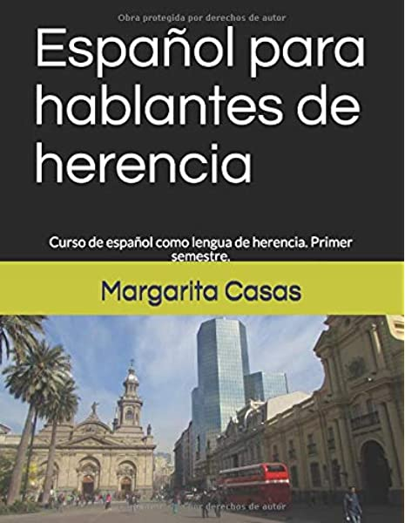 OR Kindle Edition 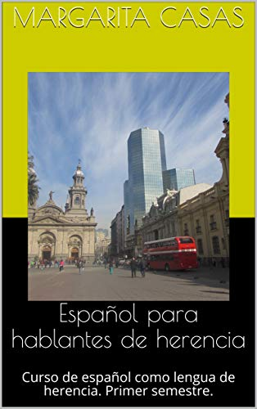

Paperback OR Kindle Edition of “Español para hablantes de herencia,” Curso de español como lengua de herencia. Primer semestre. Spanish Edition, Margarita Casas, Independently published, 2018 (Paperback) or 2019 (Kindle Edition). Buy either the paperback OR the Kindle version, NOT both versions. They have the same material.
- You may purchase the materials at the college bookstore OR for a discounted price at Amazon, where the price will be $16.50 (Paperback -LINK) or $9.99 (Kindle Edition-LINK), before taxes and shipping. If you buy any materials through the campus bookstore, they will be about $10 extra.

Grading and Evaluation
This course is not self-paced. All assignments, discussions, oral activities, quizzes, etc. are to be completed no later than 11:59pm PST/PDT on the date indicated.

Amount of Work
This is a 5-unit course, and the workload reflects that. For every unit, about three hours of work are required. You will be reviewing grammar tutorials and completing various activities to reinforce what you are learning. You will also spend time completing compositions, discussions, modules quizzes, and preparing for oral presentations, the final exam, etc. This will require on average about 15 hours a week. Depending on your computer skills and understanding of the materials, the amount of time spent on the class may vary, as you become acquainted with the information and the online procedures.
Course Management
Canvas will be the main way of contact between us. Make sure you have continuous access to it.
*Always login to Canvas first and look through your homepage for weekly updates.
Tareas & Quia Activities
- Most of the Module Activities (Tareas) required in this course will be completed using the materials from Español para hablantes de herencia, and with the help of the free website: Quia. You will be assigned weekly activities such as readings, vocabulary, grammar, translation, research, essays, and (free access) Quia exercises. All assignments will be either completed directly on Canvas or uploaded by the assigned date. All instructions and due dates will be posted well in advance.
Exams, Discussion Boards, and Compositions
- Module Exams: Exams will be completed on Canvas after the end of each module (about every three weeks—check Full Semester General Schedule). These exams will be timed (45 mins-1 hour) with one attempt only. Late submissions will not be accepted.
- Discussion Boards: Every week, students must post a response to the Weekly Discussion Board (Foros de discusión) and then respond to the posts of two classmates. An initial post is due by Wednesday at Midnight, and responses to two classmates are due by Sunday, Midnight. Look for ways to connect with your classmates. A quality post is one that moves the discussion forward in which conversation goes back and forth. One-liners do not constitute a quality post. Specific details will be given in each discussion board as well as the rubric to be used. Some oral discussion board responses will be completed and posted using Flipgrid. Detailed instructions will be given with plenty of notice. Late submissions will not be accepted.
- Compositions: There will be written compositions assigned throughout the semester. They will help improve your writing skills in Spanish. You will have the opportunity to submit your essays to receive feedback and improve them, before being given a final grade. More details will be provided in Canvas. Late submissions will not be accepted.
- Final Written Exam: The Final Exam will be scheduled in advance. Be flexible on this day. Late submissions will not be accepted.
Oral Assessment
- Oral presentations: Your oral proficiency will be assessed in the form of oral presentations. You will be assigned an oral presentation (15% of grade) to be posted on Canvas. In addition, you will also be posting your Introductions Video and some oral discussion boards using the free video discussion experience Flipgrid. Topics and more specific details and requirements will be posted on Canvas well in advance.
Overall Engagement
- In order to be successful in this class, it is essential for you to engage actively in all the class activities.
- This is a “student-centered” class. Active engagement involves completing all activities on time, using Spanish AT ALL TIMES, participating appropriately in discussion boards, treating all classmates with respect, asking questions as needed, and maintaining a positive and cooperative spirit throughout the course.
- Your class engagement will be assessed at the end of each MODULE by checking to see that you completed the online class activities assigned on Canvas and Quia and discussion posts. Be advised that, on Canvas and Quia, I can see when you log on, what work was completed/viewed, and how long it took you to complete it.
- Subscribe to the Cyber Café Discussion Thread and ask or answer questions on there about the material we cover in class. I will be moderating this discussion thread and will provide guidance and answers when needed. If you have a personal question, contact me via Canvas Inbox.

Grading and Evaluation
Assignment | Percentage of Total Grade
Tareas & Quia Activities | 20%
Module Exams | 15%
Oral Presentation | 15%
Compositions | 20%
Written Final Exam | 10%
Engagement/Discussion Boards | 20%
TOTAL | 100%
Table 1 Grading Scale

Grading scale
A = 90-100% | B = 80-89% | C = 70-79% | D = 60-69% | F = 59% and below

Communication Policy
There are three ways to contact me:
- Email I’ll try to respond to your email within 24 hours.
- Canvas Inbox. Like email, I’ll respond to you within 24 hours, usually less.
- During class or after class.
If you contact me on Saturday or Sunday, I will reply on Monday.

Drop and Attendance Policy
Most of the work in this class will be completed on Canvas and Quia. If you don’t engage in the course work for more than a week, you will be considered absent and will be dropped from class. Please communicate with me if you have concerns about your attendance.

Late Work Policy
You will know the due dates of assignments and exams for this class well in advance. All work, however, must be completed on time. Extra work or makeup work will not affect your grade. No late Quizzes, Compositions/Discussion Boards or Final Exam accepted. For Quia Activities only you have a one-day grace period. You may submit those assignments one day late, but will receive a 3% deduction on those grades. After that date, grades will be entered on Canvas. No exceptions. Please do not ask. If you have an emergency, contact me before the due date. Examples of emergencies constitute a car accident or a heart attack.

In need of a tutor?
You may always talk to me during office hours, but you can also work with a tutor from the Learning Center. Watch this video on information about online tutoring. This is the Tutor Matching Service that connects you with online tutors. Check it out! We are here to help you.

Disabilities 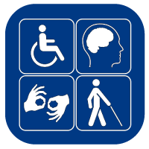
If you have special needs as addressed by the Americans with Disabilities Act (ADA) and/or need course materials in alternate formats, notify me immediately. We have Disabled Student Programs and Services on campus. Reasonable efforts will be made to accommodate your special needs.

General Notes on Assignments and Academic Honesty
- This class will be conducted in Spanish and you are expected to read, write, and comment in Spanish AT ALL TIMES. The goal of the class is to improve your reading and writing skills en español.
- Accented Characters: Make sure to use accents marks when needed, as they constitute an important part of the language You will find them available within the Quia exercises. Profesora Alarcon will also provide instructions on how to include them on other assignments.
- Original Work: The assignments represent opportunities for you as a student of Spanish to demonstrate your acquired knowledge of the material we have covered. Your work should be wholly original, and only your instructor should provide feedback and corrections on it. While you will be required to read outside research, you are to write your work using your own language. In some cases, if appropriate, you will be asked to redo the assignment. Academic dishonesty also includes cheating or using unauthorized devices during quizzes, exams or the preparation of writing projects. Egregious cases will be forwarded for disciplinary action. Penalties for academic dishonesty range from an “F” on an assignment to dismissal from the course and/ or the college.
- Make sure to turn off all cell phones and/or pagers. They are an interruption during class time. Points will be deducted from your participation grade (oral performance grade) if you are using your cell phone during class. In case of an emergency, inform me prior to the beginning of class.

Important dates

January 17 (M) Martin Luther King, Jr. Holiday (No classes)
January 21 (F) Last day to drop a Spring 2022 full-term class for full refund
January 28 (F) Last day to register for a Spring 2022 full-term class in person
January 28 (F) Last day to drop a Spring 2022 full-term class to avoid a “W” in person
January 30 (SU) Last day to drop a Spring 2022 full-term class to avoid a “W” on WebAdvisor
Feb 18-21 (F-M) Presidents’ Day Holiday (Lincoln and Washington) (No classes)
March 11 (F) Last day to drop a Spring 2022 full-term class: (letter grades will be assigned after this date)
April 11-15 (M-F) Spring Recess (no classes, campus open)
May 16-20 (M-F) Spring 2022 final exams week

¡Bienvenidos! Mejorarán su escritura en español y aprenderán más acerca de la rica cultura hispana.
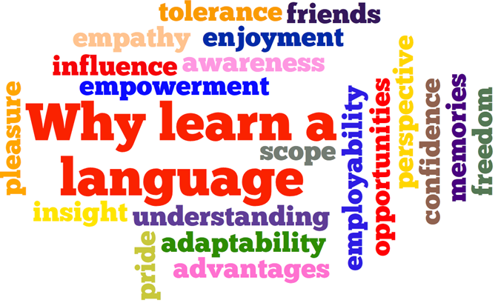

General Tentative Schedule—See Individual Modules for Detailed Assignments Due Dates
Week | Chapter | Material covered | Exams/ Assignments/Holidays
January. 10-14  Week 1 | ¡Bienvenidos! | Course Information &  Student Resources  ¡A conocernos!  ¿Eres hispano o eres latino?  Hablar de identidad  El alfabeto, los números | Presentación, Syllabus review & comenzar Capítulo 1
January. 17-21  Week 2 | CAPÍTULO 1  Nuestra identidad | La oración y las partes del idioma Género/número  Las sílabas  La oración  El idioma dominante | January 17: Martin Luther King, Jr. Holiday (No classes)
January. 24-28  Week 3 |  | Cambio de código  Las consonantes dobles  Mayúsculas y minúsculas (diferencias)  Dolores Huerta y Jorge Ramos  El español en el mundo | Examen Cap. 1
January. 31- Feb. 4  Week 4 | CAPÍTULO 2 Raíces hispanas y el idioma español | Los orígenes hispanos de EE. UU.  La conjugación (presente del indicativo)  Los verbos regulares, irregulares y con cambio en el radical  Verbos reflexivos y pronominales  España
Feb. 7-11 Week 5 |  | El lenguaje coloquial y el concepto de registro  Evitar coloquialismos  La organización de un texto (parte 1)
Feb. 14-18  Week 6 |  | Cognados falsos y el espanglish  La acentuación (parte 1)  El idioma español  Rita Moreno  Datos históricos sobre el idioma español | Exam Cap. 2
Feb. 21-25  Week 7 | CAPÍTULO 3  Comida e identidad | Comida e identidad  Vocabulario para hablar sobre comida  El presente progresivo/ el gerundio | Feb.18-21(F-M): Presidents’ Day Holiday (Lincoln and Washington) (No classes)
Feb. 28- March. 4  Week 8 |  | Afijos: Prefijos y sufijos  La historia del alfajor  La puntuación y la ortografía
March. 7-11  Week 9 |  | Empleos relacionados con la comida  Calcos y anglicismos (parte III)  Homófonos (diversos)
March. 14-18  Week 10 |  | La dieta y la cultura  Sonia Sotomayor  Los platillos del mundo hispano | Examen Cap. 3
March. 21-25  Week 11 | CAPÍTULO 4  ¿Que la historia los absuelva? | Los héroes y los villanos de la historia  Vocabulario para hablar de política y de personalidades históricas.  El pretérito
March 28. – April 1.  Week 12 |  | La diéresis  La Malinche  Otros personajes de la historia  La organización de un texto
April. 4-8  Week 13 |  | Embajador cultural  Más cognados falsos  Verbos preposicionales  Homófonos (parte II)
April. 11-15  Week 14 |  | SPRING RECESS | April. 11-15: (M-F) Spring Recess (no classes).
April. 18-22  Week 15 |  | Una biografía  Sandino y Somoza (Nicaragua)  Voto femenino e independencia de Países hispanoamericanos  Memes | Examen Cap. 4
April. 25- 29  Week 16 | CAPÍTULO 5  Mitos y leyendas | La Llorona  El pretérito y el imperfecto  Preposiciones: Por y para; Pero /sino/ sino que  Cognados falsos
May. 2- 6  Week 17 |  | Del modernismo al Boom  Autores hispanos  Reglas de acentuación (parte 2) Pequeñas y grandes diferencias en el uso de artículos | Presentaciones
May. 9- 13  Week 18 |  | ¿Intérprete o traductor?  Un cuento o narración en el pasado  Pablo Neruda  Citas de escritores  Traducciones, acentos y ortografía | Presentaciones
May. 16- 20 | FINALS WEEK |  | EXAMEN FINAL: MAY 17:
*Schedule is subject to change. Test date changes or any modification to the course will be announced. It is your responsibility to read any announcements posted on Canvas.

Spanish 3NS – Spring 2022 Semester – Prof. Stephanie Alarcon– Reedley College

