Engl 3 Critical Reading and Writing
Ms. Jamie Barker
Fall 2021
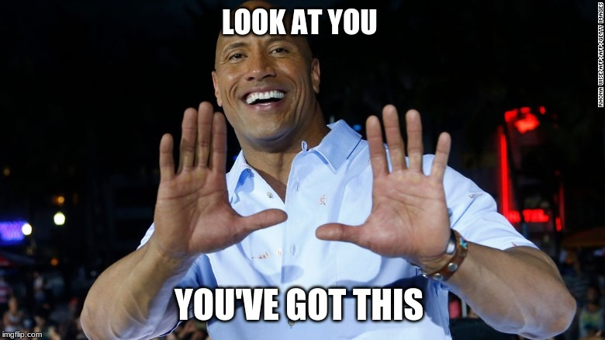

Dear English 3 scholar,

Welcome to my classroom, and into this English course in which you have the opportunity to develop your critical reading and writing skills and prepare you for the kinds of writing you will do in future academic courses, and in your career beyond school.
My advice to you as you start out on this academic journey: see yourself as a scholar. Not merely as a student--but a scholar. A scholar’s focus is on learning, including the entire learning process, which sometimes means getting it wrong. Allow yourself to fail. Learn from it and do it better next time. A scholar’s end goal is to become a more educated, well-rounded, informed, and interesting person. It’s not just about passing the course; it’s about improving yourself as a human, and in turn making our world a better place.
See yourself as a scholar, and you will become one.
Please feel free to contact me by email if you have any questions, or would like to set up a Zoom office appointment, or meet up after class. I am here to help you in your scholarly progress, and am honored to be your professor.

Ms. Jamie Barker

You are responsible for all the information in this syllabus.

Writing Assignments
Summary/responses: You will be given articles, essays, or short stories to read, annotate, summarize, and respond to in writing.
Essays: Essays will be written in response to a question (the “prompt”) about the assigned reading.
Participation: Participation means not only completing assignments, but also engaging by leaving comments on announcements, emailing me if you have questions, involving yourself in classroom discussions, being a good group member, and in general just being engaged.
Grading: Your final grade will be determined by the number of points you have accumulated by the end of the semester. The grading scale will be as follows: A 90-100%, B 80-89%, C 70-79%, D 60-69%, F 59% and below.
Submitting work
All work must be typed in Times New Roman, 12 point, and double-spaced. In the upper left hand corner, put your name, class (English 3/Summer), professor’s name, type of assignment, and date. Title your paper and center it.

Example:

Jesse Pinkman
Eng 3 Summer 2018
Jamie Barker
Personal Essay
July 21st, 2021

What I Learned from My Chemistry Teacher
The body of your papers will go here, and will be double-spaced, in 12 point Times
New Roman font. All of your assignments should look like this. Be sure to indent the
first line of each paragraph with five spaces.
Required Materials for Course:
The Good Earth by Pearl S. Buck

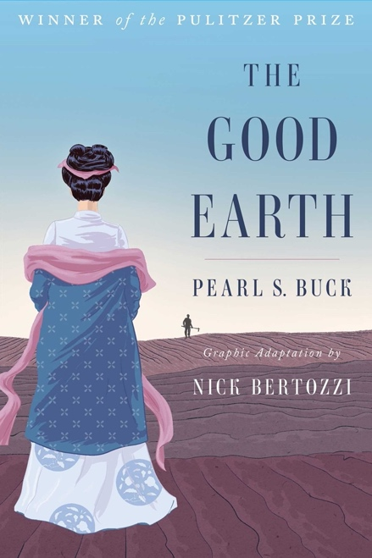

This is the GRAPHIC NOVEL edition. Be sure to use this ISBN:
978-1501132773

Academic Dishonesty
Cheating, copying, or plagiarizing others’ work may, according to the Reedley College Catalog, result in anything from a failing grade on the paper or assignment, to a failing grade in the course, or expulsion from Reedley College.

STUDENTS WITH DISABILITIES:
If you have a verified need for an academic accommodation or materials in alternate media (i.e., Braille, large print, electronic text, etc.) per the Americans with Disabilities Act (ADA) or Section 504 of the Rehabilitation Act, please talk to me as soon as possible. Contact Disabled Student Programs and Services (DSP&S) at (559) 638-0332 or visit their website for more information: http://www.reedleycollege.edu/services/dsp/LD.htm (Links to an external site.)Links to an external site. (Links to an external site.)

Important Stuff:
You must use the school e-mail account and check it on a regular basis. If you don’t know how to set up or use e-mail, please get help from me; there is also a video tutorial on Web Advisor.
Please contact me by e-mail (jamie.barker@reedleycollege.edu) if you have any problems or questions about anything. If you have not heard back from me in 48 hours, please check to make sure that I received your e-mail.
I use Canvas, and you are responsible for the information posted there. If you need help with Canvas, please let me know and I can put you in touch with someone to help you.
Please keep all of your work saved to the cloud (I recommend Google Drive). Sometimes Canvas freezes for no apparent reason and it erases whatever you were working on. You will be glad you have it saved elsewhere if that happens. And it always happens; every semester. Also, I am very careful with your work, but I sometimes make mistakes. Protect yourself by keeping everything until the course is finished and your final grade has been recorded.

GRADING
A = 100-90 excellent
B = 89.99-80 very good
C = 79.99-70 average
D = 69.99-60 needs improvement (not passing)
F = 59.99-0 fail (not passing)

In the process of completing this course, you will:
Write multiple synthesized and documented, critical analysis papers of at least 1800 words which includes:
- sophisticated introduction, multiple body paragraphs, and a conclusion
- an arguable claim that aims to contribute to or alter pre-existing ideas on the subject matter
- supporting details that exhibit critical thinking and use credible, multiple secondary sources
- researched and evaluated sources for use in the development of their own writing
- correct usage of MLA format with correct use in-text citations and a works cited page
- appropriate and purposeful use of quotations
- causal analysis, advocacy of ideas, definition, persuasion, evaluation, refutation, and interpretation effectively in college-level prose
- an annotated bibliography of multiple sources
- correct citations (therefore avoiding plagiarism)
- identification of logical fallacies in others’ writing and avoid them in their own writing
- details related to main point and with complex analysis
- evidence of self-editing for errors and revise compositions
- use of third person/universal
- awareness of writing for a scholarly audience
- controlled and sophisticated word choice
- sentences that exhibit a command of the complex/compound with minimal comma splices, sentence fuses, and fragments
- use of denotative and connotative aspects of language

Course Summary:
Date | Details | Due
Fri Jan 14, 2022 | Assignment Who I Am and What I Need | due by 11:59pm
Sun Jan 23, 2022 | Assignment Read "Good Country People" | due by 11:59pm
Sun Jan 30, 2022 | Assignment Read: Chapters 1 & 2 in The Good Earth | due by 11:59pm
 | Assignment SSCC Critique "Good Country People" | due by 11:59pm
Sun Feb 6, 2022 | Assignment Read chapter 3 The Good Earth | due by 11:59pm
Mon Feb 7, 2022 | Assignment Group Collaboration TGE chap 3 | due by 11:59pm
Fri Feb 11, 2022 | Assignment In-class assignment: SSCC "Kitbull" Rapid Writing Exercise | due by 8:50am
Sun Feb 13, 2022 | Assignment Read chapter 4 The Good Earth | due by 11:59pm
Sun Feb 20, 2022 | Assignment Read "Lather and Nothing Else" | due by 11:59pm
 | Assignment Read chap 6 The Good Earth | due by 11:59pm
 | Assignment Read chapter 5 The Good Earth | due by 11:59pm
Mon Feb 21, 2022 | Assignment SSCC Critique: "Lather and Nothing Else" | due by 11:59pm
Wed Feb 23, 2022 | Assignment The Other ESSAY DUE | due by 11:59pm
Sun Mar 6, 2022 | Assignment Finish The Good Earth | due by 11:59pm
Mon Mar 14, 2022 | Assignment Current Event Exercise | due by 11:59pm
Sun Apr 3, 2022 | Assignment Read "Cat Person" by Kristen Roupenian | due by 11:59pm
Wed Apr 20, 2022 | Assignment "Cat Person" essay | due by 11:59pm
Sun Apr 24, 2022 | Assignment Thesis Statement due | due by 11:59pm
Sun May 1, 2022 | Assignment Annotated Bibliography DUE | due by 11:59pm
Wed May 18, 2022 | Assignment Final Paper DUE--NO LATE PAPERS ACCEPTED | due by 11:59pm
 | Assignment Roll Call Attendance
 | Assignment The Good Earth Final Discussion questions

