Reedley College
Fall 2022 English 1A

English 1A-Reading and Composition Online

Anya Connelly-English Instructor
E-mail: anya.connelly@reedleycollege.edu  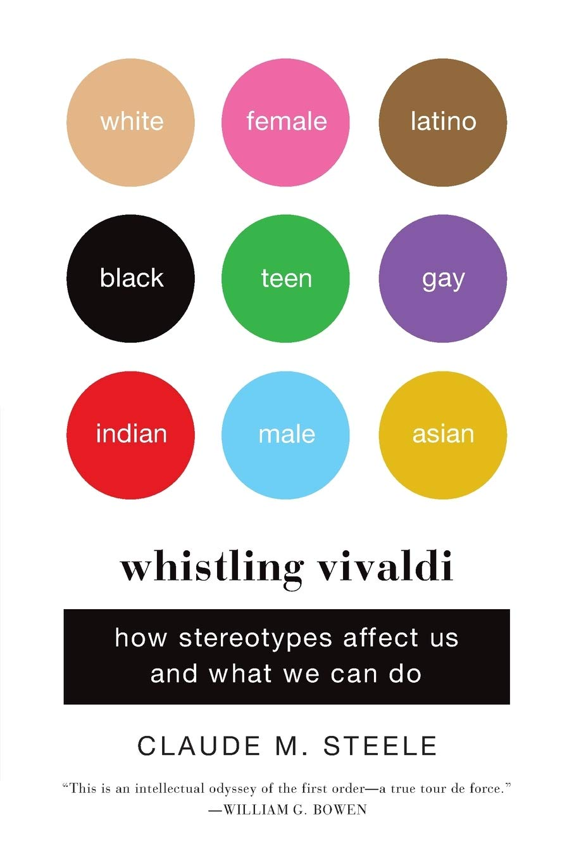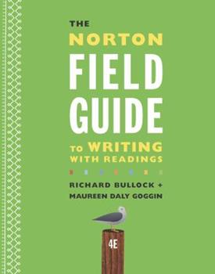  These are the books we will be reading this semester. If you are unable to purchase them you can check them out from the Reedley College Library free of cost! | Zoom Office Hours  Tuesday’s-1:30pm-2:30pm,  Thursday’s 12:30pm-2:30pm  In person Office Hours  Faculty Annex Room A6  Monday & Wednesday 11:45 am-12:45pm  Or by appointment Just ask!  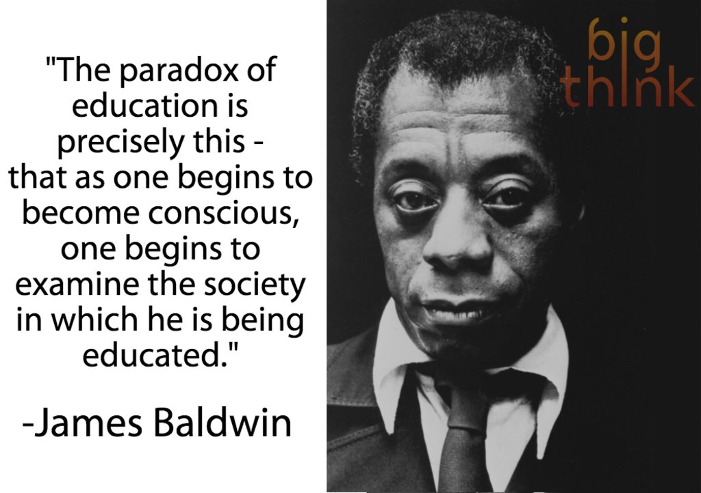
W
elcome to English 1A. This class is a 18-week course that will start on 8/8/22 and end on 12/9/22. This course is completely online, and does not require any weekly class meetings, which means that you get to work at your own pace to complete each weekly modules. Each module will be due Friday at 11:59 pm.The purpose of this class is to develop your critical thinking, reading, and writing skills. This course relies on collaboration with others and the social construction of knowledge. This means that we’ll work together on all aspects of thinking, reading, writing, and research. This class provides a mixture of informal and formal writing assignments as well as various forms of group work, all of which are designed to meet the learning outcomes for the course.

Course communication policy

My preferred method of communication is email. Please include your name and what class you are enrolled in (Name of class and section number) in the subject of your email. Also, please remember to have a respectful and curtious tone in the emails that you send me. You have a right to ask me questions or seek clarifications. I will show you respect when I communicate with you, so I ask that you show me the same respect. I will respond to emails Monday through Friday between the hours of 7:00 am and 7:00 pm. If you email me during this time frame, please allow 24 hours for a response. If I do not respond within 24 hours, please don’t hesitate to send the email again. Also, I am happy to answer any questions that you may have during my Zoom student hours. This is a wonderful opportunity to have a chat and have your questions answered.

Please consider using our course Coffee Shop Q&A board for general questions that are not time sensitive. Feel free to help your classmates and answer their questions if you know the answer. Let’s collaborate and support each other.

Attendance and Drop Policy

Your participation matters! Remember to keep in mind that this is an online class and simply logging into Canvas is not enough to be marked present. This means that you need to complete weekly assignment as well as the essays. If you do not post and contribute to the weekly assignments and discussions boards you will be marked absent for that week. During the first week of class you must complete the following to remain enrolled in this course. Failure to complete these first two assignments will mean that you will be dropped from this course.

1.Discussion post-Introduction
2.Syllabus Quiz

After the first week, you will be marked absent for each weekly assignment that you miss.

Weekly Discussion posts
Every week you will have a 250-300 word discussion post that due on Friday at 11:59pm. These discussion posts will include topics from our weekly lessons and readings. You will always be required to respond to at least one classmate for full credit on these posts. Discussion post will be the main way you interact with your classmates, so plan your posts carefully. A good discussion post takes a few days to write, so begin them early in the week. Also, I will attach a rubric to each discussion post so thay you know what I am lookingfor specically. Pay attention to the rubrics because they are there to help you succeed.

Late Work policy

Instead of accepting Late Work, I have created Amnesty and Second Chances.

I do not accept any late work in my class. The due dates for my essays and assignments are firm, and all of the week’s work will be due each Friday at 11:59pm. I will reserve the right to extend deadlines if I feel the class needs more time. However, I do offer the following for my students because I acknowledge that sometimes we get sick, we forget something, or we just simply have a bad day. Every student gets one “Freebie Discussion post”. This means you do not have to do one weekly discussion post.Please save this for a week you are feeling sick, need a mental health break, or simply just need a rest. You must post “Freebie” for the discussion that week so that I know which assignment you are missing. After you do this I can give you full credit. Please note that this only counts for discussion posts, not major essays.
***** Please remember, the assignments that are due within the first week must be completed and do not qualify as a “Freebie”.
2.If you receive a “D” or “F” on the Literacy History OR Annotated Bibliography, you may revise the assignment and re-submit it to me for a new grade by Friday, November 12, 2021 at 11:59 pm, as long as you attempted the assignment and turned the paper in. Please be advised that you should meet with me to discuss your rewrite BEFORE you resubmit it. If you rewrite a paper it is not guaranteed that you will get an “A” or a better grade.

Catalog Description:
Students will read, analyze, and compose college-level prose, with emphasis on the expository; study writing as a process; explore different composing structures and strategies; edit and revise their own writing; and conduct research (gather, organize, evaluate, integrate, and document information), culminating in a term research paper and annotated bibliography. Students will write a minimum of 5,000 words in formal academic language.

Required Readings & Materials:

Computer and Internet Access. Every assignment will be submitted through Canvas
- Weekly Assigned Readings available in our class Canvas shell
- Binder or Notebook with paper
- Pens, pencils, and highlighters
- A flash/thumb drive to save your work.
- The Norton Field Guide To Writing by Richard Bullock
- Whistling Vivalidi by Claude M. Steele

Student Learning Outcomes:
Upon completion of this course, students will be able to:
SLO1: Write a documented, well-organized research paper of at least 1,500 words that demonstrates critical thinking and command of the English language at least at a “C” level (70%).
SLO2: Complete a timed essay independently in class at least at a “C” level (70%).
SLO3: Summarize and comprehend college-level prose (will include a full reading) at least at a “C” level (70%).

Course Objectives:
In the process of completing this course, students will:
- Write multiple essays of at least 1,500 words, including at least one research paper with documentation.
  - Arrange and integrate ideas in a multiple body essay, complete with topic sentences, supporting data, and background, as necessary
  - Indicate an arguable thesis
  - Gather, analyze, and synthesize peer-reviewed sources and/or original research, such as interview, survey, or observation
  - Employ MLA formatting
  - Reduce dependence on the instructor’s guidance; students will ultimately independently and accurately recognize and self-correct errors in sentence construction, punctuation, and mechanics
  - Craft increasingly mature and cogent writing while choosing the appropriate tone and academic voice
  - Practice sound choices in identifying and avoiding logical fallacies
  - Employ appropriate use of third-person universal
  - Identify appropriate audiences for their compositions
  - Employ quotations, discriminating among sources for accuracy and validity
  - Employ MLA formatting guidelines for Work Cited Page and in-text citations
  - Develop an annotated bibliography from sources for a research paper
  - Recognize the appropriate use of sources, while avoiding intentional and unintentional plagiarism
- Write an organized essay with a thesis and adequate support independently within a class period.
- Read and understand college-level prose, including:
  - Identifying the model, summarizing the thesis, and locating supporting information.
  - Naming rhetorical devices such as irony and parallelism and translating metaphorical language, so as to determine an author’s intent, both explicit and implicit.
  - Answering questions from assigned reading differentiating between an author’s intent and personal reaction.
  - Describing, evaluating, and questioning the purpose, audience, organization, and style of assigned readings.

Required Course Work:
- Class Participation  - Weekly Discussion posts  - Unit Reflections  - Timed Writing exercise  - Literacy History Essay  - Annotated Bibliography  - Research Synthesis Essay | Required  20%  15%  10%  15%  15%  25% | 90 - 100% = A  80 - 89% = B  70 - 79% = C  60 - 69% = D  0 - 59% = F

Class Participation:

You will be successful in my class if you:
1. attend class regularly—not missing more than one week’s worth of assignments
2. meet due dates and writing criteria for all major assignments;
3. participate in all exercises and activities;
4. complete all informal, low-stakes writing assignments (e.g., Dialectical journal writing, annotating);
5. give thoughtful peer feedback during workshops (About 4) and work faithfully with your group on other collaborative tasks (e.g., sharing papers, commenting on drafts, peer editing, online discussion boards);
6. sustain effort and investment on each draft of all papers;
7. make substantive revisions when the assignment is to revise—extending or changing the thinking or organization—not just editing or touching up;
8. copyedit all final revisions of Essays until they conform to the conventions of edited, revised English;
9. attend online Zoom conferences with the teacher to discuss drafts;
10. submit your Timed Essay exercise
(adapted from Peter Elbow)
Paper Format: All assignments and drafts must be typed and in size 12 font, double spaced, and have your name, course, instructor’s name, and due date at the top of the first page. Don’t forget to number your pages. Always remember to SAVE a copy of your work to a flash drive.

Digital Literacy:
Every assignment you will complete in this class will be due online and in Canvas. This means you must memorize your student ID and password so that you can submit your assignment. I acknowledge that this may be the first time you have used technology in the classroom, so lets work together and make sure you understand how find our Canvas assignment calender, how to submit your homework and essays, and how to locate important readings for this course.
Classroom Conduct: Since this is a collaborative classroom in which all are encouraged to participate and share thoughts, it is necessary that we treat each other (and your Professor) with respect. Any disruptive behavior will not be tolerated.You are expected to behave in a manner that is respectful to others and conducive to learning. You are expected to interact with each other respectfully and to work cooperatively and constructively in group and partner activities and assignments.
If the behavior becomes too disruptive, disciplinary steps will be taken, as per Board Policy 5550, “including but not limited to the removal, suspension or expulsion of a student.”

SCCCD Board Policy 5550 (#11) description of disruptive behavior:
“Disruptive behavior, willful disobedience, habitual profanity or vulgarity, or the open and persistent defiance of the authority of, or persistent abuse of, college personnel, including obstruction or disruption of teaching, research, administration, disciplinary regulations, or other college activities, including, but not limited to community service functions or other authorized activities on or off-campus.”

Academic Dishonesty:
Students at Reedley College are entitled to the best education that the college can make available to them, and they, their instructors, and their fellow students share the responsibility to ensure that this education is honestly attained. Because cheating, plagiarism, and collusion in dishonest activities erode the integrity of the college, each student is expected to exert an entirely honest effort in all academic endeavors. Academic dishonesty in any form is a very serious offense and will incur serious consequences.

Cheating:
Cheating is the act or attempted act of taking an examination or performing an assigned, evaluated task in a fraudulent or deceptive manner, such as having improper access to answers, in an attempt to gain an unearned academic advantage. Cheating may include, but is not limited to, copying from another’s work, supplying one’s work to another, giving or receiving copies of examinations without an instructor’s permission, using or displaying notes or devices inappropriate to the conditions of the examination, allowing someone other than the offcially enrolled student to represent the student, or failing to disclose research results completely.

Plagiarism:
Plagiarism is a specifc form of cheating: the use of another’s words or ideas without identifying them as such or giving credit to the source. Plagiarism may include, but is not limited to, failing to provide complete citations and references for all work that draws on the ideas, words, or work of others, failing to identify the contributors to work done in collaboration, submitting duplicate work to be evaluated in different courses without the knowledge and consent of the instructors involved, or failing to observe computer security systems and software copyrights. Incidents of cheating and plagiarism may result in any of a variety of sanctions and penalties, which may range from a failing grade on the particular examination, paper, project, or assignment in question to a failing grade in the course, at the discretion of the instructor and depending on the severity and frequency of the incidents. ( The above paragraphs were taken from page 48-49 in the Reedley College catalog).

Accommodations for Students with Disabilities: If you have a learning difference and require accommodations, please discuss your accommodation with me after class or during office hours early in the semester. Please, visit our DSP&S office if you are in need of academic accommodations. I cannot honor your accommodations if I am not aware of them. This means you need to advocate actively for yourself. Thus . . . if you have a verified need for academic accommodation or materials in alternate media (i.e., Braille, large print, electronic text, etc.) per the Americans with Disability Act (ADA) or Section 504 of the Rehabilitation Act, please contact me as soon as possible. Ask me for more information so that I may help you find the resources you deserve.

Writing Center: If you engage with the writing process, research proves that your writing will improve. We have a free resource at Reedley College called the Reading and Writing center that can help you develop paper topics, receive peer feedback, and get constructive criticism on your drafts. In my classes, I will offer up to 20 points extra credit, 5 points each visit, for having your work peer-reviewed at the Writing Center. This is an excellent way to boost your grade and reinforce the skills we will be developing in our class.

