SYLLABUS
Fall 2022 Beginning Drawing Art 7 51483 Instructor: T. Carrera
Phone: 559-638-0300 ext. 3250
Office: Art 154
Office Hours: 8-9 am M-F
Email: tracy.carrera@reedleycollege.edu
Safety is a top priority for all of us on campus. Students are expected to distance accordingly and wear proper masks.
If class needs to be cancelled students are to utilize Canvas online.
If a student is sick they need to email me and let me know and I will work with them online via Canvas
Art 7 SLOs:
- Create a portfolio of artwork demonstrating an intermediate level of proficiency in course medium addressing issues of form and content.
- Critique works of art
- Demonstrate a visual comprehension of the visual vocabulary through the creation of artwork.

In the process of completing this course students will:
- Free hand draw three- dimensional, representational imagery with accurate proportions on a two- dimensional surface
- Identify discuss and integrate the elements and Principles of Design into the drawing process
- Identify discuss and use historical and contemporary rendering techniques and media
- Create the illusion of space and volume on a 2-dimensional surface using various rendering techniques and perspective.
- Differentiate between representational, abstract, non-objective, and conceptual drawings.
- Draw in representational, abstract, non-objective and conceptual ways
- Think of creative solutions to drawing and design exercises and problems
- Make aesthetic decisions autonomously
- Use vocabulary specific to the drawing process
- Discuss the functions of drawing
- Critique formal and subjective aspects of drawings individually and in groups
- Express oneself through the drawing process

COURSE REQUIREMENTS:
Attendance and participation in all class projects & critiques:
Sketchbook Exercises
Class work- in class and homework
Create own imagery by using cell phone to take reference photos outside of class or camera and printing out imagery at RC Library for drawing reference

CLASSWORK: Students will take care of drawings so they are free from distracting rips, smudges, stains, wrinkles, etc. If work looks un-kept and sloppy it will most definitely have a negative effect on assignment grade. Students will legibly print name on back of each project or exercise, date on the back in the upper left corner and keep all projects in a protective portfolio. Students should keep every project they create in this course until the end of the semester. LATE WORK IS NOT ACCEPTED. All drawing assignments are due on the assigned dates. Instructor approval is required for any exceptions. If permission is given, late work results in a letter grade reduction. This means if the work is 'A' quality work, the best grade which can be earned is a B. Class projects may be re-worked for a potentially improved grade, so long as the project is completed and turned in on time. One week after the work is returned, the revised drawing is due. If the re-worked project is not turned in or is incomplete, the original grade will stand.

CRITIQUES: A critique is a discussion of the objective and subjective properties of a drawing. Critiques will occur regularly during class and for each project. Participation is required of all students. Not participating when called upon will have a negative effect on your overall grade. Participating in critique teaches you how to make decisions about where to take your drawing next. Please speak up with conviction and confidence in critique or at least stand up straight and speak loudly and clearly for the class to hear. When I am addressing the class or another student is speaking about their or another work during critique, all other students will be SILENT, phones put away and silenced and show respect to the student who has the floor. Disrupting critique is disrupting an important pat of the learning process in a studio art course. Students who choose to impede learning of other students will be referred to our Dean of Students (Dr. Solis) in the Administration building STS-22.
Critiques can be a challenge for students who are not yet comfortable with speaking in public or who are shy. I understand this is a challenge for some students. I try my best to create a light hearted, supportive critique environment. Critical thinking is required for this course. This means looking at images in formal, technical terms. If something can be improved on it’s up to me as your instructor to not only assist you in recognizing where improvements to your drawing could be made but also to teach the class as a whole how to learn from each others work hitting the mark as well as missing the mark) and discuss visual imagery using the vocabulary of art and design principles (through critique).
It’s not a competition. Every student, regardless of drawing skill, when they enter is here to grow and improve their own formal drawing skills through practice. Remember, it’s what you are learning in the class which is precious. The drawings are only evidence of your growth. I encourage students to take some pride in their presentation and their work. This is expressed through keeping drawing smudge free, writing name and course section printed legibly.

REASEARCH IMAGES: We must train our eye not only to look, but also to SEE. This means mindful observation. Students will see many drawings by accomplished historical artists. Looking at multiple Images and understanding why the images are compelling and visually successful will help students create visually impactful drawings. As we move through the various drawing media throughout this course you will be shown examples of artists who work in various mediums as well as imagery relating to Design principles and elements. Students are required to take time outside of class to research images as part of ‘homework’. Instructions will be given to students on what types of images to research. Example: Find an example of a high key drawing and submit it to discussion board for the week.
CLASSROOM ETIQUETTE: We all need to work together to have a safe and productive classroom environment. To that end, the following rules will be adhered to:

1. When Professor C is addressing the class all students are paying attention. Eyes up, mouth closed, body facing forward, attentive.
2. Students cell phones will be on mute/vibrate mode, put away out of sight during class. Cell phones are a disruptive distraction in a studio art course. Students should consider dropping this course and finding a better suited alternative if they are incapable or unwilling to follow this rule. For example, they may choose to take Art 7 online (asynchronous) with one of our sister colleges (Madera, Clovis, Fresno City College) all these colleges offer Art 7 and 9.
In this face to face Art 7 course students can use their cell phones during the two 10 minute breaks during class. They can use their cell phones OUTSIDE THE CLASSROOM. Once they enter the 2 D area (both Art 159 and/or 155) cell phones are muted and put away.
3. Students who choose to disrupt their own learning (and the learning of others) will be given a Dean of Students referral and will have to leave class immediately. They will go to Building STS 22 and make an appointment to speak with Dean of Students Shannon Solis. Student will not be allowed to return to Art 7/17 until they have met with Dr. Solis. When a student is referred to Dean of Students by me, for disruptive behavior which is impeding learning for others they will automatically sit out for a class session. Example: On a Monday, if a student is instructed to see Dr. Solis immediately, they are to leave class, immediately walk over to STS m 22 and make an appointment with Dean of Students. This student would also not return to class the following Wednesday. They will be marked absent and will have to find out what they missed from another student. Students who choose to disrupt class must accept the outcome of their choice. The point I'm trying to make here is please respect the learning process of others. No one student has the right to impede learning for the entire class or impede my effectiveness as an instructor. Consider this a first warning. Sometimes a second warning is required. We all make mistakes. But if a disruptive behavior persists, action will be taken to resolve that issue so classroom learning for all is achieved.
4. Students might be asked to speak to me in my office (with door open) if it is necessary (discussion regarding grades or other personal things - in order to respect and protect students privacy). If student is not comfortable in that setting the conversation can take place outside (near the fountain for example).
5. Students will not write or draw on dry erase/chalkboard. Save it for your projects!
6. Students who have learning challenges need to meet with DSP&S office to get assistance from/through a counselor who will then email me a referral form. Students who require extra assistance (note taking, testing assistance, etc) are encouraged to work those things out directly with DSPS services as needed.
7. This is a college level beginning drawing course. Regardless of what kind of art you prefer, there are set criteria for understanding and learning how to draw in a formal way at the college level. And although we all are moved and inspired by the anime, comics genre, there will be no anime or comic book related assignments in this course. Students are free to enjoy that type of drawing outside the classroom in their free time. It has been my experience some students are so enamored with this one genre of image making to the exclusion of all other art forms and classical technical methods which are crucial to learning the foundational basics of drawing (realism). Sometimes when a student discovers they won’t be doing this type of image making for credit in this class they take it quite hard and this resentment impedes learning for them and other students in the class. Students need to get honest with themselves and decide sooner than later if this course at this time is their best option. If a student is not open to learning classical, drawing fundamentals they should probably drop this course. There’s plenty of wonderful courses to take here at Reedley College and our sister colleges. Also keep in mind instructors are different even though they may teach the same course. Read reviews or get feedback from other students or speak with our Academic Advisor counselors to get some help selecting your courses- finding your pathway and making n academic plan for yourself.
I teach this course as if students have never drawn before. We start with the basics and move slowly- practicing drawing techniques with various dry media and gradually we progress throughout the semester. Learning new things can be challenging to our ego. It is uncomfortable to ‘not know’. I understand this feeling and I empathize. I do my best to help students feel supported and guided. But let me be clear. The learning is in the actual DOING. There are no easy ‘hacks’ or cheats’ like you find online. The challenge of learning is part of the challenge of learning. The frustration of not knowing cannot be removed. Instead, I suggest we acknowledge it and help each other get through the challenging times.
This course is homework dense. It requires students spend between 2-6 hours on each assignment. This means 6 hours a week should be set aside for you to do the required homework projects for this course. If you are too strapped for time please consider taking an alternative course and consider taking a studio art course when you have the time it takes to learn how to draw. It takes practice, which means it takes time. There is no way to avoid this fact. If you don’t make the time to complete projects you will not pass this course. Failing a course can effect your GPA and your chances for financial aid so please take what I am saying seriously. Be an active designer in your educational pathway. Make an appointment with our wonderful counselors if you need help. They want to help you!

I’d like to remind my students I am not here to take anything away from you. I am here to tell you the truth and to teach students to draw at the college level which includes both realism and non objective drawing.
I will say that instructions might be written within the Assignment description on Canvas (if we need to meet online or I'm sick and face to face class session is cancelled). My instructions in class are usually very clear and direct. For example : Drawing will be done with 2 B Pencil only, 5x5" 1" border, Due next Wednesday". I will write instructions on the board at the front of the class. Students have plenty of time to copy the assignment parameters down or take a photo of the instructions with their phone (photo taken and immediately put back away and out of sight).
'Contrary' remarks... being negative for the 'sake of being negative' is not something that facilitates creativity in the classroom environment. If a student has a serious concern or challenge and is in need of help or guidance, speak to me directly, in my office, during office hours or during class. I am here to help you and I will help you resolve it. Please remember, although this is an art course, the study is serious and requires mindfulness and discipline to meet the learning objectives. This is not an 'entertainment' class. There must be a level of seriousness, engagement and focus, like any other college level class (engineering, Political-Science, English, etc).
Students are encouraged to get to know each other through verbal conversation during work time in class. Light, humanities related conversation (movies, tv, theater, dance, music, culinary arts, nature, design, literature, architecture, and the creative process, video games, pop culture, travel, school related, etc... these are all great topics. Part of the college experience is getting a chance to enjoy socializing and practicing the art of communication. This is a 'soft skill' which we need to be successful in the work force and with interpersonal relationships. When conversation gets too rowdy and has taken priority over the drawing task at hand, I will let individuals or the class as a whole know. I encourage students to make friends. If I see certain seating arrangements are not conducive to learning, I will re-arrange seating for students who are having a challenging time focusing and staying on task. I might move a student to the adjacent classroom if/when necessary so they are not distracted/distracting others and can focus on their work and completing assigned learning objectives successfully.
Students are expected to verbally communicate with me (unless they have submitted the proper documentation form DSPS Services to me). If I ask a student a direct question/instruction and they refuse to answer/comply there is a huge communication breakdown and the Dean of Students will be contacted and student will be asked to leave the class, make an appointment with Dr. Solis and will not return to class until they have done so and the miscommunication issue is resolved.
Students need to be engaged in the learning process to remain in the class. Students who are not engaged in learning/drawing and are who are not fully engaged in the exercise of that session will be asked to leave the class. When a student is asked to leave the class it is up to them to find out what instructions they may have chosen to miss from other students. This is the natural outcome of choosing to not be engaged in learning in Art 7. Unscholarly, disruptive student behavior is not ‘rewarded’ with ‘coddling’.
If a student is too ill to engage in learning they should check in with RC nurse and/or go home.
Students who sit idle in class who are distracting or disengaged inhibit learning of other students. It is up to each student to be responsible for their own choices and accept those choices have consequences which can negatively effect your overall grade in the class.

GRADING: Final grades are earned. They reflect the amount of energy, effort and thought you put into class, your work. Projects are typically worth 20 points using the following formula:
Creativity 5
Technique 5
Compositional strength 5
Craftspersonship 5

GRADING SCALE: 100-90 A; 89-80 B; 79-70 C; 69-60 D; 59 and below F.

1. Class Work /homework 90%
2. Quizzes/Discussion Board Posts on Canvas 10%
There is no ‘extra credit’ in this course. Typically extra credit assignments have been used to sort of fill in assignment gaps students have not turned in or assignments they have not met the minimum criteria to earn a passing grade. Extra credit muddies the water of classroom grading and expectations. I want to make it clear up front students overall grades are earned each week with every assignment building on the last. There must be a sustained commitment to earn an ‘A’ grade in this course if a students GPA is important to them. A student must be focused, disciplined and do exemplary work consistently to earn an ‘A’ grade. They must put their best effort forth every time. There is no guarantee a student will earn an ‘A’ grade even if they try their best they may only earn a B grade. There is no shame if a student truthfully gives it their best. Remember I am willing to work with students. If a student reworks an assignment and I see room to improve it, I’m happy to work with that student to get that assignment as strong as possible. They may re-work that assignment 5 times over. I’m am happy to assist and guide students who are passionate about improving their drawing.
Effort = Evidence of effort, concentration and thinking in class exercises. This includes making mistakes, using your imagination, taking risks and not giving up. A subjective assessment is a part of this aspect of your grade.

A = Exemplary, using course content to truly explore and discover
B = Basic understanding +
C = Basic understanding
D = Basic understanding –
F = Punitive, Not turning work in, consistently disrespectful/disinterested behavior, etc.

ATTENDANCE: Students are required to attend all scheduled classes, be on time and come prepared, and stay through the entire class. I will often give demonstrations, instructions, and assignments during class and it is your responsibility to obtain this information if you miss class (for whatever reason).
4 absences prior to Final Drop Deadline and you will be dropped from the class. 2 absences in the first 3 weeks and you will be dropped from the class. Show up to class on time!

MATERIALS: (See materials list included in this syllabus) I encourage you to explore and experiment with materials. Look for and collect tools that you enjoy drawing with, both materials from the art supply store and non-traditional tools like crayon or charcoal from your fireplace. Try things that look interesting or things that make you nervous. Replenish supplies as soon as you run out! You cannot learn to draw without supplies. Put your name on all your supplies.
Recommended Art Supply Store: ALLARDS on Blackstone Ave in Fresno, Blick.com, Utrecht.com or Amazon. RC Bookstore carries some items as well.
GENERAL COURSE OUTLINE:
Graphite Pencil
Week 1: Introduction, Understanding materials and safety
Week 2: Contour Line, Gesture
Week 3: Sighting, Angling, Measurement
Week 4: Geometric Simplification,
Week 5: Positive/Negative Space (Submit 1st set of research images along with paragraph)
Charcoal
Week 6: Linear Perspective
Week 7: Expressionism
Week 8: Chiaroscuro/shadow shapes
Week 9: High Key/low Key
Week 10: Energy and Dynamism of Human Form in Charcoal
Ink /Experimental drawing media
Week 11: Composition
Week 12: Tandem drawing
Week 13: Texture/Surface (Draw from AG animals)
Week 14: Color
Week 15: Experimental ground (submit images on Canvas and paragraph)
Week 17: In Class Work on Final Project/Clean Up Day
Week 18: Final Critique

If any student has a verified physical, medical, psychological, or learning disability or feels that he or she has any disability that might impact the ability to carry out assigned course work, the student should contact the Disabled Students Programs & Services (DSP&S) ((559) 675-4864), DSP&S staff will review the student’s needs and determine the accommodations that are necessary and appropriate. All information and documentation is confidential.
Art 7 Materials List Carrera
- Graphite Drawing Pencils 2B, 4B, 6B
- Canson XL Mixed Media sketchbook
- Charcoal pencil (soft) and vine charcoal stick
- Masonite Drawing board 13 x 17
- Micron pens black waterproof: 01, 03, 05
- Crappy paper sketchbook for note taking and thumbnail sketches
- Pink Pearl eraser
- Small pencil sharpener (with a container to catch shavings)
- 1 black standard sharpie
- 18” cork backed steel ruler
- (2) Tortilion/stumps (variety of sizes)
- A cardboard shoebox or some other box to hold your supplies
- (optional) spray fixative (Krylon)

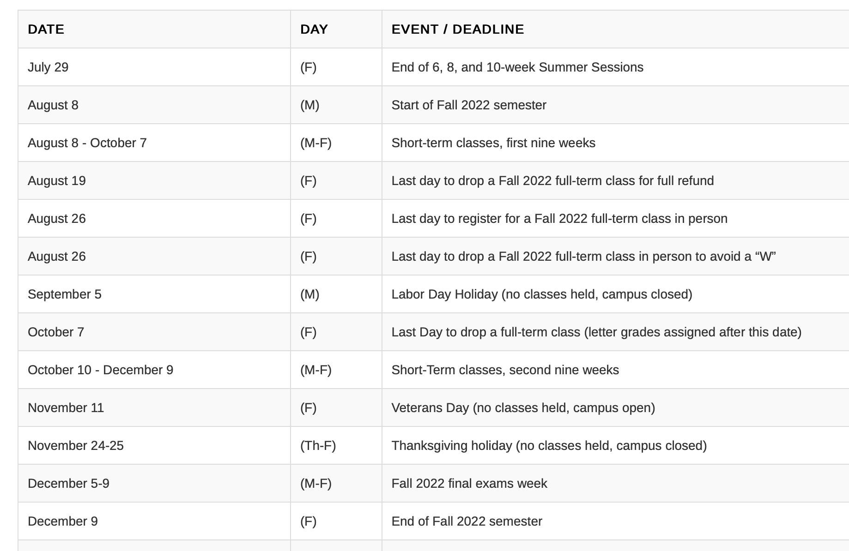

Tips for Success in any course taught by Professor Carrera:
1. Communicate with me clearly. Address me as Professor Carrera. Some faculty want you to call them by their first name. That’s fine. Every instructor is different.
When you email me it should look something like this:
“Professor Carrera, this is so and so from Beginning Drawing Mon/Wed.
I have a question about the assignment etc…

I check my email twice daily and I respond as soon as I can. If you have a question or concern about an assignment the best time to ask me is right away. If an assignment is assigned on Wednesday and its due Monday and you wait until midnight Sunday to email me- chances are I’m not going to read it in time and you will have outed yourself that you waited until the last minute to do the assignment which is a red flag to me this assignment was done rushed. Students need the right amount of sleep to stay sharp and productive. Start assignments as soon as you can and get them done. Do not wait until the last minute.
If you are going to be absent- let me know ahead of time if possible (like for a family vacation which was planned months ago). A doctors appointment is not an emergency. A car accident is an emergency. A broken leg is an emergency. If a student has children and they have to leave early all the time it’s unfortunate but I can’t favor students who are parents who choose to leave class early. Occasionally things happen but if a student is showing up late or cutting out early constantly, that’s going to severely impede their learning and it is also a distraction to the class as a whole.
If a student chooses to schedule a doctors appointment during class time that is a choice. If a student chooses to leave class early to pick up siblings from school or whatever the reason is… again, this is a choice and one cannot be two places at once. So once again, I ask students to get real with themselves if they can commit to this course fully. I don’t see how a student can leave 30 minutes early each session and expect to pass the course. It’s not the end of the world by any means to miss a class here and there. Sometimes in life we just need a day off. I get it. But be smart about it. Get half way through the semester and have good standing in the class- B- A rang- then yeah, take day. You’ve earned it. If you need to submit a project to me and you can’t come to class because you are sick-simply email the assignment to me in time for critique so it won’t be counted late. When a student need misses class its their responsibility to find out what they missed. I highly recommend you get the email/ phone numbers of two fellow students who seem to be responsible to find out what they missed that day.
Communication and participation is crucial in this class. Students need to be committed mentally. Leaving on jackets in 100 degree weather, sitting in class with backpacks on, twitching legs, are examples of non verbal communication of lack of commitment to being physically and mentally present. A bit of uncomfortableness and anxiousness is

2. Communicating clearly when you need my assistance. I’m happy to speak to you in my office or on Zoom if you are more comfortable with that. I don’t want my students to be afraid of me. I want to help them. I may fall short sometimes and when I make a mistake I am the first to admit it and do my best to make it right.

