Reedley College
Spring 2021 English 1A

English 1A-53307-Reading and Composition Online

Anya Connelly-English Instructor
E-mail: anya.connelly@reedleycollege.edu  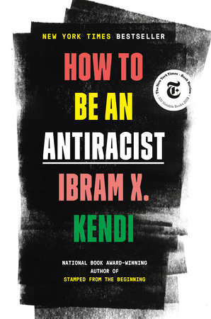This is the book we will be reading this semester. If you are unable to purchase it you can check it out from the Reedley College Library free of cost. | Zoom Student Hours  Monday- 10:00am-11:30am  Tuesday- 10:00am-11:30am  Wednesday-10:00am-12:00pm  Or by appointment Just ask!  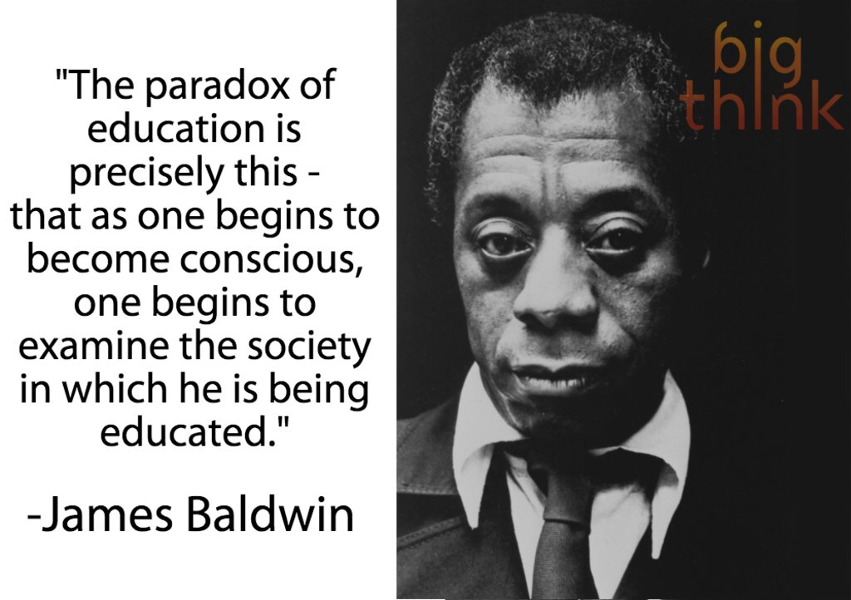
W
elcome to English 1A. English 1A is an 18-week course. This course is completely online, and does not require any weekly class meetings, which means that you get to work at your own pace to complete each weekly modules. Each module will be due Friday at 11:59 pm.The purpose of this class is to develop your critical thinking, reading, and writing skills. This course relies on collaboration with others and the social construction of knowledge. This means that we’ll work together on all aspects of thinking, reading, writing, and research. This class provides a mixture of informal and formal writing assignments as well as various forms of group work, all of which are designed to meet the learning outcomes for the course.

Course communication policy

My preferred method of communication is email. Please include your name and what class you are enrolled in (Name of class and section number) in the subject of your email. Also, please remember to have a respectful and curtious tone in the emails that you send me. You have a right to ask me questions or seek clarifications, but I will report any angry or threatening responses to the Dean right away. I will show you respect when I communicate with you, so I ask that you show me the same respect. I will respond to emails Monday through Friday between the hours of 7:00 am and 7:00 pm. If you email me during this time frame, please allow 24 hours for a response. If I do not respond within 24 hours, please don’t hesitate to send the email again. Also, I am happy to answer any questions that you may have during my Zoom student hours. This is a wonderful opportunity to have a chat and have your questions answered.

Please consider using our course Coffee Shop Q&A board for general questions that are not time sensitive. Feel free to help your classmates and answer their questions if you know the answer. Let’s collaborate and support each other.

Attendance and Drop Policy

Your participation matters! Remember to keep in mind that this is an online class and simply logging into Canvas is not enough to be marked present. This means that you need to complete weekly assignment as well as the essays. If you do not post and contribute to the weekly assignments and discussions boards you will be marked absent for that week. During the first week of class you must complete the following to remain enrolled in this course. Failure to complete these first two assignments will mean that you will be dropped from this course.

1.Discussion post-Introduction
2.Syllabus Quiz

After the first week, you will be marked absent for each weekly assignment that you miss.

Weekly Discussion posts
Every week you will have a 250-300 word discussion post that due on Friday at 11:59pm. These discussion posts will include topics from our weekly lessons and readings. You will always be required to respond to at least one classmate for full credit on these posts. Discussion post will be the main way you interact with your classmates, so plan your posts carefully. A good discussion post takes a few days to write, so begin them early in the week. Also, I will attach a rubric to each discussion post so thay you know what I am lookingfor specically. Pay attention to the rubrics because they are there to help you succeed.

Late Work policy

Instead of accepting Late Work, I have created Amnesty and Second Chances.

I do not accept any late work in my class. The due dates for my essays and assignments are firm, and all of the week’s work will be due each Friday at 11:59pm. I will reserve the right to extend deadlines if I feel the class needs more time. However, I do offer the following for my students because I acknowledge that sometimes we get sick, we forget something, or we just simply have a bad day. Every student gets one “Freebie Discussion post”. This means you do not have to do one weekly discussion post.Please save this for a week you are feeling sick, need a mental health break, or simply just need a rest. You must post “Freebie” for the discussion that week so that I know which assignment you are missing. After you do this I can give you full credit. Please note that this only counts for discussion posts, not major essays.
***** Please remember, the assignments that are due within the first week must be completed and do not qualify as a “Freebie”.
2.If you receive a “D” or “F” on the Literacy History OR Annotated Bibliography, you may revise the assignment and re-submit it to me for a new grade by Friday, April 30 by 11:59pm as long as you attempted the assignment and turned the paper in. Please be advised that you should meet with me to discuss your rewrite BEFORE you resubmit it. If you rewrite a paper it is not guaranteed that you will get an “A” or a better grade.

Catalog Description:
Students will read, analyze, and compose college-level prose, with emphasis on the expository; study writing as a process; explore different composing structures and strategies; edit and revise their own writing; and conduct research (gather, organize, evaluate, integrate, and document information), culminating in a term research paper and annotated bibliography. Students will write a minimum of 6,000 words in formal academic language.

Required Readings & Materials: Computer and Internet Access. Every assignment will be submitted through Canvas
- Weekly Assigned Readings available via Canvas. This a zero cost materials course!
- Binder or Notebook with paper
- Pens, pencils, and highlighters
- A flash/thumb drive to save your work.
- How To Be An Antiracist by Ibram X. Kendi

Student Learning Outcomes:
Upon completion of this course, students will be able to:
- Write a documented research paper of at least 1,500 words that includes:
  - a sophisticated introduction, multiple body paragraphs, and conclusion
  - a clearly defined, arguable thesis sentence
  - supporting details that exhibit critical thinking and use credible secondary sources
  - correct usage of MLA format, including a works cited page
  - sentences that exhibit a command of the complex/compound with minimal comma splices, sentence fuses, fragments, and mechanics
  - controlled and sophisticated word choice
  - writing in third person/universal
  - an avoidance of logical fallacies
  - demonstration of an awareness of purpose and audience
  - appropriate and purposeful use of quotations
  - correct in-text citations
  - an annotated bibliography of multiple sources
  - an avoidance of intentional and unintentional plagiarism
- Complete a timed essay independently
- Summarize and comprehend college-level prose (will include a full reading)

Course Objectives:
In the process of completing this course, students will:
- Write multiple essays of at least 1,500 words, including at least one research paper with documentation.
  - Arrange and integrate ideas in a multiple body essay, complete with topic sentences, supporting data, and background, as necessary
  - Indicate an arguable thesis
  - Gather, analyze, and synthesize peer-reviewed sources and/or original research, such as interview, survey, or observation
  - Employ MLA formatting
  - Reduce dependence on the instructor’s guidance; students will ultimately independently and accurately recognize and self-correct errors in sentence construction, punctuation, and mechanics
  - Craft increasingly mature and cogent writing while choosing the appropriate tone and academic voice
  - Practice sound choices in identifying and avoiding logical fallacies
  - Employ appropriate use of third-person universal
  - Identify appropriate audiences for their compositions
  - Employ quotations, discriminating among sources for accuracy and validity
  - Employ MLA formatting guidelines for Work Cited Page and in-text citations
  - Develop an annotated bibliography from sources for a research paper
  - Recognize the appropriate use of sources, while avoiding intentional and unintentional plagiarism
- Write an organized essay with a thesis and adequate support independently within a class period.
- Read and understand college-level prose, including:
  - Identifying the model, summarizing the thesis, and locating supporting information.
  - Naming rhetorical devices such as irony and parallelism and translating metaphorical language, so as to determine an author’s intent, both explicit and implicit.
  - Answering questions from assigned reading differentiating between an author’s intent and personal reaction.
  - Describing, evaluating, and questioning the purpose, audience, organization, and style of assigned readings.

Required Course Work:
- Class Participation  - Weekly Discussion posts  - Unit Reflections  - Timed Writing exercise  - Literacy History Essay  - Annotated Bibliography  - Research Synthesis Essay | Required  20%  15%  10%  15%  15%  25% | 90 - 100% = A  80 - 89% = B  70 - 79% = C  60 - 69% = D  0 - 59% = F

Class Participation:

You will be successful in my class if you:
1. attend class regularly—not missing more than 2 week’s worth of assignments
2. meet due dates and writing criteria for all major assignments;
3. participate in all exercises and activities;
4. complete all informal, low-stakes writing assignments (e.g., Dialectical journal writing, annotating);
5. give thoughtful peer feedback during workshops (About 4) and work faithfully with your group on other collaborative tasks (e.g., sharing papers, commenting on drafts, peer editing, online discussion boards);
6. sustain effort and investment on each draft of all papers;
7. make substantive revisions when the assignment is to revise—extending or changing the thinking or organization—not just editing or touching up;
8. copyedit all final revisions of Essays until they conform to the conventions of edited, revised English;
9. attend online Zoom conferences with the teacher to discuss drafts;
10. submit your Timed Essay exercise
(adapted from Peter Elbow)
Paper Format: All assignments and drafts must be typed in Times New Roman size 12 font, double spaced, and have your name, course, instructor’s name, and due date at the top of the first page. Don’t forget to number your pages. Always remember to SAVE a copy of your work to a flash drive.

Digital Literacy:
Every assignment you will complete in this class will be due online and in Canvas. This means you must memorize your student ID and password so that you can submit your assignment. I acknowledge that this may be the first time you have used technology in the classroom, so lets work together and make sure you understand how find our Canvas assignment calender, how to submit your homework and essays, and how to locate important readings for this course.
Classroom Conduct: Since this is a collaborative classroom in which all are encouraged to participate and share thoughts, it is necessary that we treat each other (and your Professor) with respect. Any disruptive behavior will not be tolerated.You are expected to behave in a manner that is respectful to others and conducive to learning. You are expected to interact with each other respectfully and to work cooperatively and constructively in group and partner activities and assignments.
If the behavior becomes too disruptive, disciplinary steps will be taken, as per Board Policy 5550, “including but not limited to the removal, suspension or expulsion of a student.”

SCCCD Board Policy 5550 (#11) description of disruptive behavior:
“Disruptive behavior, willful disobedience, habitual profanity or vulgarity, or the open and persistent defiance of the authority of, or persistent abuse of, college personnel, including obstruction or disruption of teaching, research, administration, disciplinary regulations, or other college activities, including, but not limited to community service functions or other authorized activities on or off-campus.”

Plagiarism: Plagiarism refers to using a source of information of which you are not the author and not giving proper credit to the author. In other words, do not copy other people’s words and claim them as your own. You must properly cite any outside sources that you use in your writing. For a student tutorial on how not to plagiarize visit The Purdue Owl Online Writing Lab. If it is discovered that you have cheated or plagiarized on an assignment—at any point during the semester—you will receive a zero on that assignment and perhaps a failing grade in the class. Additionally, a plagiarism report will be filed with the administration. Plagiarizing any part of the final research essay will result in a failing grade.

Accommodations for Students with Disabilities: If you have a learning difference and require accommodations, please discuss your accommodation with me after class or during office hours early in the semester. Please, visit our DSP&S office if you are in need of academic accommodations. I cannot honor your accommodations if I am not aware of them. This means you need to advocate actively for yourself. Thus . . . if you have a verified need for academic accommodation or materials in alternate media (i.e., Braille, large print, electronic text, etc.) per the Americans with Disability Act (ADA) or Section 504 of the Rehabilitation Act, please contact me as soon as possible. Ask me for more information so that I may help you find the resources you deserve.

Writing Center: If you engage with the writing process, research proves that your writing will improve. We have a free resource at Reedley College called the Reading and Writing center that can help you develop paper topics, receive peer feedback, and get constructive criticism on your drafts. In my classes, I will offer up to 20 points extra credit, 5 points each visit, for having your work peer-reviewed at the Writing Center. This is an excellent way to boost your grade and reinforce the skills we will be developing in our class.

