CRIMINOLOGY 4
Course #57344
Principles & Procedures of the Justice System (3 units)
SPRING 2021
DISTANCE LEARNING EDUCATION (ONLINE COURSE)
Instructor: Delilah Schuller, J.D.
Email: delilah.schuller@reedleycollege.edu

IMPORTANT INFORMATION
- The course start date is JANUARY 11, 2021. End date is MAY 19, 2021.
- No shows will be dropped by JANUARY 13, 2021 11:59 pm.
- Add Codes will be distributed by email.
- On the start date, access the course via Canvas.
- Pre scheduled live meetings will be held via Zoom.
- Regular and effective substantive contact between instructor and student will be initiated through any of the following means:
  - Canvas discussion board
  - Synchronous zoom meetings
  - Announcements
  - Assignment feedback
  - Asynchronous activity (video lectures)
  - Emails
- Regular and effective contact between students will occur via:
  - Canvas discussion board
  - Assign students to Canvas groups
- Video content will be closed-captioned or transcriptions will be available, documents and online pages will meet accessibility requirements.

Student Learning Outcomes:
By the end of the semester you will:
- Have the ability to arrange the various components of the court system in proper sequence.
- Discuss and describe the various stages in the trial process.
- Understand and correctly use the vocabulary of the courtroom.
- Describe the history and application of the exclusionary rule in shaping criminal procedures.

Learning Objectives:
In the process of completing this course, you will:
- Demonstrate an understanding of various historical and developmental concepts of federal and state criminal court procedures.
- Critically analyze the hierarchy of the court systems, and key components.
- Demonstrate the ability to use legal terminology, definitions, and theories of criminal law.
- Demonstrate an understanding of the adversarial nature of the American courtroom.
- Identify the elements of a crime, the seriousness of the offense and the defendant’s capacity to commit such crimes.
- Convey an understanding of various criminal defenses, legal
justifications, and burdens of proof.

Class Format:
In an online course, the majority of our communication takes place in the course forums visible to all. However, when we have a need for communication that is private, whether personal, interpersonal, or professional, we will use individual email.
Netiquette:
In an online classroom, our primary means of communication is written. The written language has many advantages: more opportunity for reasoned thought, more ability to go in-depth, and more time to think through an issue before posting a comment. However, written communication also has certain disadvantages, such a lack of the face-to-face signaling that occurs through body language, intonation, pausing, facial expressions, and gestures. As a result, please be aware of the possibility of miscommunication and compose your comments in a positive, supportive, and constructive manner.
Required Texts:
Assignments and all information necessary for quizzes are embedded in the required textbook. You are encouraged to purchase or familiarize yourself with the campus resources available. Acquisition of the required materials will increase the likelihood of successfully completing the course. While I do understand that the cost of textbooks can be significant, the text selected for this course will afford you a greater opportunity to develop an appropriate understanding of the course learning objectives and therefore strengthen your learning and retention of the material.
- “America’s Courts and the Criminal Justice System” 13th edition.
Authors: David W. Neubauer and Henry F. Fradella. Cengage Publishing, ISBN 978-1-337-55789-4 (available at campus bookstore).
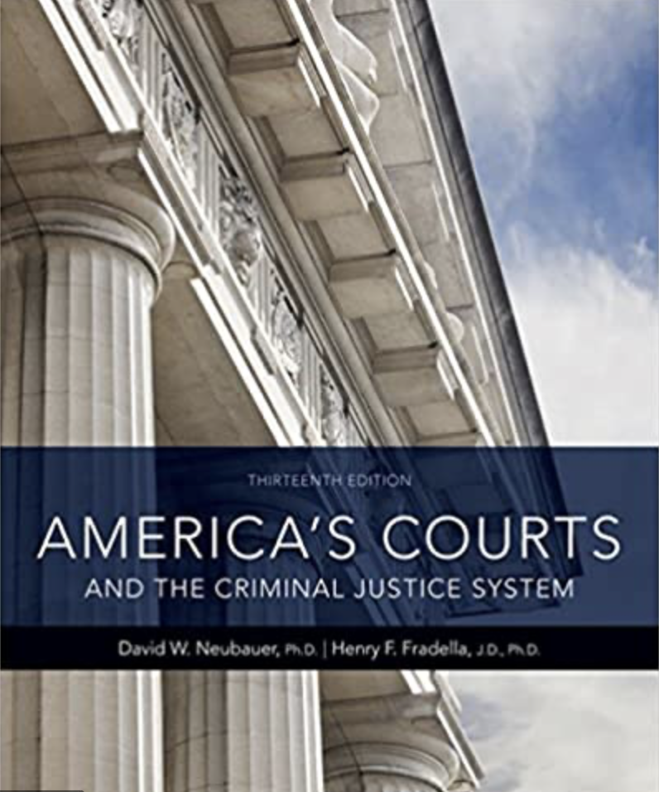

Grading:
Each Module, at the conclusion of each Chapter, will contain the following:
1. Quiz valued at 5 points.
2. Short Answer Questions valued at 5 points.
3. Group Discussion valued at 10 points
MIDTERM EXAM: 25 points
FINAL EXAM: 30 points

Grade Scale:
90 – 100% = A
80 – 89% = B
70 – 79% = C
60 – 69% = D
00 – 59% = F

Reading:
All assigned reading is required. Text reading is due each week.
Class Drop Policy:
The student is responsible for dropping the class. Be aware of deadlines for dropping courses.
Academic Integrity:
Students are expected to submit work that is based upon the student’s individual effort alone. Please see the Code of Student Conduct for details. Students who plagiarize (cheat) will receive a grade of 0 on the relevant quiz, assignment, or project.
Disabilities:
Students with disability or medical conditions or concerns which require an accommodation should notify the instructor. Students should also contact the Access and Ability Center for additional information as soon as possible.
Course changes:
As the instructor, I reserve the right to make changes on this syllabus, but will discuss any changes and their implications to you before they are implemented. Please review this course in Canvas and check your e-mail daily as I regularly use these methods to communicate information to students.
If for ANY reason you are having trouble in this class (i.e., change in life circumstance, not understanding material, etc.) please contact me immediately. There are a number of services available to assist you at College of the Sequoias. Your success in this class is very important to me and I will work with you to assist you in succeeding in this course. However, you must remember that success in this course cannot happen without you doing everything you need to do to succeed.
Disclaimer:
Due to the nature and reality of work in the criminal justice system, real life examples, verbal and non-verbal expression and role-playing by the instructor may be used to demonstrate to students important learning points. These examples are not meant to demean or insult any group or individual, but simply to give students an understanding of the reality that exists in this profession and prepare them to deal with different types of people and situations in a professional manner.

