Communication ~~ Reedley College ~~ Spring 2021
Communication 1: Public Speaking

Instructor: James Bartram

Cell Phone: 559-978-2154
E-mail: james.bartram@reedleycollege.edu
Virtual Office Hours are on Zoom Monday 5-6 and Thursday 9 AP

Required Materials Textbook: We will be using an open-source textbook. It is on canvas in the first module

Course Description

Fundamentals of public speaking utilizing theories and techniques of communication enhance public speaking skills. Particular emphasis will be on the organization and criticism of public discourse. This will be achieved through research, reasoning, presentations, and the evaluation of various types of speeches which include informative and persuasive speeches. Communication 1 fulfills the General Education Requirement in Oral Communication (G.E. Foundation A1). C-id designation Comm 110.
(Note: subject advisory eligibility for English 1A)

Online Class

Because this is an online course all communication and work will be conducted online. You will be expected to keep track of due dates and submit your work on time. I will review and grade your work offering constructive and timely feedback. However, this is a communication course and one of the primary focuses of the class is presentations. While some of your presentations will be recorded and uploaded, others such as Impromptu, Informative and Persuasive speeches will be held in real-time on Zoom. I will also hold topic discussions that I strongly encourage each of you to log in for. These discussions will be recorded on Zoom and the recording posted for students who were unable to attend.

My Policy Regarding Communication
If you have questions about the class you can always ask on the Q & A Discussion Board for Course Details, or message me on Canvas (See blue Arrow below for location on Canvas), in general Canvas messages are preferred to email and I will usually respond within 24 hours. I check the messages and discussion boards daily M-F. If you have specific questions you can either drop into the Confer Zoom meeting for my office hours, or request a Zoom conference for another time. In addition, if you need my help right away you can call M-F 9-5. I do not pick up leave a message and I will get back
to you within a few hours. My preferred method for discussion is zoom, or phone. Email and messages are inefficient an often fail to clarify issues that may only take a short chat to clear up.
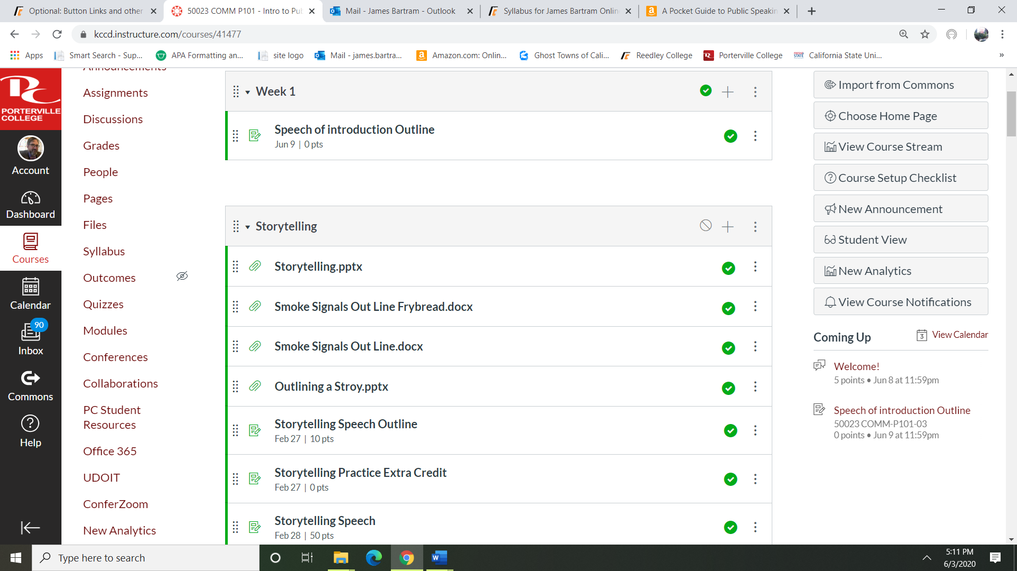
Messages

Student Rights

Students are encouraged to become familiar with the “Campus Policies” section of the Schedule of Courses. This material includes information regarding cheating and plagiarism, disruptive classroom behavior, and other instructional issues. Students caught cheating or plagiarizing in my class will receive a zero on the assignment and any assignment connected to that assignment (e.g. cheating or plagiarism on a speech will result in a zero on the speech, the outline, the reference page, and on all audience evaluations). Any student caught cheating or plagiarizing will also forfeit any participation points, all audience evaluation points and will not be allowed to take the final, will not be allowed any extra credit points and a referral to the Dean of Instruction WILL be made. In the case of plagiarism if it is determined by the instructor that written work contains uncited portions of works contained in the Reference page, the student will be allowed to rewrite the work with corrections but they will lose 50% of their points on the assignment.
Students with disabilities: If you have a verified need for an academic accommodation or materials in alternate media (i.e., Braille, large print, electronic text, etc.) per the Americans with Disabilities Act (ADA) or Section 504 of the Rehabilitation Act, please contact the instructor as soon as possible.

Student Learning Outcomes

Upon completion of this course, students will be able to:

- Construct and deliver dynamic and competent presentations that are adapted to the purpose and audience.
- Utilize organizational patterns and research materials that incorporate sufficient, credible, and relevant evidence.
- Explain the principals of human communication by critically evaluating public speeches through constructive critique and self-analysis.

At the completion of the course the student will be able to:

- Gain communicative competence and confidence as a result of the preparation, presentation, and analysis of oral messages.
- Gain an understanding of the communicative process.
- Develop skill in informative, persuasive and ceremonial speaking.
- Recognize the need for clear and concise organization of ideas.
- Use supporting materials effectively.
- Analyze and adapt messages to address audience attitudes, needs and demographics.
- Recognize the role of culture in the production and management of spoken interaction.
- Develop skill in extemporaneous speaking; students will present a minimum of three graded speeches in front of an audience.
- Enhance vocal skills (projection, diction, inflection and volume).
- Improve listening skills.
- Critique and analyze their own and other speeches.
- Utilize practical assignments and exercises that will reinforce the theoretical concepts studied in class.
Present a variety of speeches and will be expected to present for approximately 25 minutes each during the course of the semester.

This schedule and syllabus are subject to change at the discretion of the instructor – it is the responsibility of the student to check on announcements made during any absence.

“Per Title V Regulation 58170(e), students must be referred to academic support services by counselors or instructors. With this statement on my course syllabus, I am referring any students in my class in need of academic support to tutorial services. Tutorial services may include: the tutorial center, writing center or the communication lab. Referral reason: Mastering the content, study skills, and basic skills of this course is aided by the use of trained peer tutors.”

Assignments

Graded Item | Points Possible | Score
Introduction speech | 10
Professional Online Meeting Presentation | 10
Rough Draft of Storytelling Outline (Outline is 5 points Peer Reviews are 20 Points) | 25
Storytelling Outline Final Draft | 10
Storytelling Presentation (Signature assignment) | 50
Impromptu Speech 25 each x 2 | 50
Ceremonial Speech (no outlines) (Signature Assignment) | 50
Rough Draft of Informative Speech Outline (Outline is 5 points Peer Reviews are 20 Points) | 25
Final Draft Informative Outline | 25
Final Draft Informative Reference Page | 25
Informative Speech Presentation (Signature Assignment) | 125
Persuasive Speech Topic Discussion | 5
Rough Draft of Persuasive Outline (Outline is 5 points Peer Reviews are 20 Points) | 25
Final Draft Persuasive Outline | 25
Final Draft Persuasive Reference Page | 25
Persuasive Speech Presentation (Signature Assignment) | 150
Rough Draft Professional Speech Critique (Outline is 5 points Peer Reviews are 20 Points) | 25
Professional Speech Critique (Signature Assignment) | 65
Listening Reflection Paper | 25
4 Quiz’s (dropping lowest score) | 150
Final | 100
Total Points Possible | 1000
Introduction speeches | 5
Storytelling or Autobiographical Speech (Signature assignment) | 50
Rough draft of Storytelling Outline | 5
Storytelling Outline | 10
Informative Speech (Signature Assignment) | 125
Rough Draft Informative Speech Outline | 5
Informative Outline | 25
Informative Reference Page | 25
Persuasive Speech (Signature Assignment) | 150
Persuasive Outline Rough Draft | 5
Persuasive Outline | 25
Persuasive Reference Page | 25
Ceremonial Speech (no outlines) | 50
Listening Reflection Paper | 25
Rough Draft Professional Speech Critique | 5
Peer Reviews 25 points each x 4 | 100
Professional Speech Critique (Signature Assignment) | 65
Impromptu Speech 25 each x 2 | 50
4 Quiz’s (dropping lowest score) | 150
Final | 100
Total Points Possible | 1000

The instructor reserves the right to increase points for students who are on the margin; this will be done on the basis of attitude and participation throughout the semester and is solely at the discretion of the instructor

The following numerical guidelines will be used in the assignment of final grades.

900-1000 = A
800-899 = B
700-799 = C
600-699 = D
599- 0 = F

Grade Checks and Canvas

Grades are kept as current as possible and you may check them with me before or after class or my email. I post a second set of grades on Canvas. Canvas will also be used for course documents and announcements.

Attendance
What does it mean to attend an online class? Normally in a face to face class attendance simply means “to be present”. But what does that mean for us in an online course? If we look deeper the root for the word attendance is “attend”. To attend goes
well beyond just being present. It also means “to look after,” “to be with,” or “to apply one’s self”. In this richer meaning of the word your attendance in this class is mandatory, you simply get to choose WHEN you will be with us, look after your work and to apply yourself. You will be expected to engage with the course throughout each week by completing assignments, responding to discussion boards and announcements. The first introductory assignment is due by midnight the first day of class. If you do not respond you will be considered a NO SHOW and dropped
from the class. If you do not complete the work for Week 1 and Week 2 modules you will also be dropped for non-attendance.

Late and Missed Assignments
• All assignments MUST be turned in on Canvas, I will NOT accept any emailed papers
.
• You must complete all of your presentations. Only one missed speech can be made up on Speech Development Day.
• I have a very strict policy on late work. Outlines must be turned in or you will
not be allowed to give your speech/Debate. Simply put outlines are your preparation for the assignment. If you are not prepared you will not be allowed to waste your classmates time by “winging it.”
• Outlines, and Papers submitted after the due date/time will lose 1% per hour. These points are automatically deducted by Canvas. No papers will be accepted after the last day of instruction.
• Quizzes and the Final Exam are given on Canvas. You will have a 4 day window in which to take them. Once they close you will not be allowed to take the quiz or final. As a reminder Canvas will drop your lowest quiz score.

Additional Point Assignments

In addition to the listed assignments I will be offering limited extra credit assignments. They will be posted on Canvas. It is the student’s responsibility to look them up and turn them in by the deadline posted on Canvas. Extra credit assignments submitted by students who have missed signature assignments (see list of assignment for *signature assignment designation) will not be accepted. The sole purpose of extra credit assignments is to enhance learning not to take the place of assignments.

Brief Descriptions of Major Assignments:

Speeches: This class fulfills the ORAL component for the general education requirements – I take this very seriously. NO ONE will pass my class if you miss a speech, it is mathematically impossible!! Missing a speech means a zero on the speech, outline, reference page, participation points, listening paper and extra credit. Also, students who miss a speech will not be allowed to take the final. I do not allow anyone to give their speech on a day other than their selected date. Do not ask for an extension. If you are unable to present on your selected date you will be given a 0 on that speech. The only way to pass my class is to make up the missed speech on “Speech Development Day” - See “Speech Development Day” section for details on make ups. Students who are late for their assigned speaking slot will NOT be allowed to speak. Speeches will be recorded and posted on Canvas for peer review and listening reflection paper. Students are encouraged to watch and score all the students speeches as you will need to reference speeches in your reflection paper.

Outlines: Outlines must be submitted on Canvas prior to the first assigned speech date for all students. Speeches submitted with out and outline will receive a zero.

Reference Pages: I only require reference pages for two speeches, the informative and the persuasive speech. They must be typed and in APA style format. These speeches are to be properly researched with the use of appropriate sources. Final versions will be submitted via Canvas.

Additional Point Assignments: In addition to the assignments there will be limited extra credit assignments. They will posted on Canvas. It is the student’s responsibility to look them up and turn them in by the deadline posted. Extra credit assignments submitted by students who have missed a signature assignment will NOT be accepted. Extra credit points can only be earned by students who have attempted all signature assignments. Extra credit can bolster grades it cannot replace them.

Quizzes: Quizzes are available on Canvas for 4 days. Once they close you will receive a zero and will not be allowed to make up the quiz. I will drop your lowest quiz socre.

Professional Speech Critique: This is an essay paper critiquing a famous presentation. Details will be provided in class but note this is a signature assignment. Final submissions will be via Canvas.

Finals: The final is 100 question cumulative examination you will take on Canvas. Students with 810 points (an A in the course) will not be required to take the final exam.

Speaking Skills Development Day

The purpose of this course is to develop public speaking skills. Often times after giving a speech the speaker will wish they had an opportunity to make changes and give the speech again. Also, occasional circumstances prevent us from making class on an speech day, so in an effort to be fair and to encourage student development, I will have one assigned development day. If you have missed ONE speech this is your chance to make it up. If you would like to re-do one speech this is your opportunity to give the speech again in hopes of an improved grade.

The BAD NEWS: all make up speeches will suffer a 20 percent reduction from the original points possible. I will only listen to late speeches on this day.

Make Up Speeches
NO ONE CAN PASS THIS CLASS IF THEY MISS A SPEECH ~ PERIOD!!
You will be allowed to make up that ONE speech on the Speech Development Day but you will be at the mercy of time constraints and some basic rules. If a missed speech is not made up you will receive Zero on extra credit assignments and will not be awarded any points for the final exam.

First you can only make up ONE speech from the semester. (If you missed two speeches you have officially failed the class.)
Second you must have turned in your outline and reference page before class.
Third you must be ON TIME –.
Fourth all speeches will be given only during the speaking slots on the Development Day.

How it works: I will open up 10 min time slots on the sign-up discussion board. Anyone with a speech to make up or do over may sign up for one of those slots. If you miss you sign in time you are out of luck. Log in early; if you are late I will skip you.

The GOOD NEWS: if you have given all of your speeches and do not have any to make up, consider this a free day – take the time to study for the final or sleep in after all you have earned it.
.
Students with 810 points or more in the course will not need to take the final.
Signature Assignments: Assignments designated as signature assignments must be completed in order to earn extra credit, participation points or take the final exam. Students who do not earn a grade on any signature assignment will not be allowed to take the final exam and will not be allowed to earn extra credit. These assignments are also used to assess Student Learning Outcomes

