NR32A – Museum Taxidermy
Course Syllabus for Spring 2021 – Section #56452
Thursday 6-8:50pm (FEM 8)

Instructor: Louie M Long Jr
Office , Phone 4F : (559) 638-3641 Ext. 3268
Office Hours: Tues: 11:00am-11:50am, Wed: 2:00pm – 3:00pm
Email: louie.long@reedleycollege.edu
Supplies: (students must purchase)
Dissecting kit
Forms for aesthetic mounts
Course Description: To introduce students to the basic techniques for the preservation and display of wildlife skins. Students will learn to properly prepare both mammal and bird skins for display in a museum collection.

Course Objectives: Upon completion this course you will:
- Safely use appropriate chemicals and tools.
- Learn and use appropriate methods to preserve and prepare animal skins for display in a museum collection.
- Learn and use appropriate methods to preserve and prepare a life-like taxidermy mount for display.

Student Learning Outcomes: Upon completion this course students will:
- Employ appropriate safety procedures when preparing taxidermy specimens.
- Properly preserve and prepare a life-like mount of a bird or mammal.
- Properly preserve and prepare birds skins and mammal skins for study and display.

Attendance and Grading Policy:
If you miss a lecture or lab, you are responsible for obtaining notes from a classmate. The success of any class depends on the presence and active participation of each student; therefore, you are expected to attend every class. If you miss class >3 times during the semester you may be dropped from the course. Individual exam grades may be curved and final grades will be assigned based on a straight percentage system according to the following scale:

Course Grade Cumulative Percent  A 90-100  B 80-89  C 70-79  D 60-69  F < 59 | Breakdown of Grades Percentage  Mammal round skin 33%  Bird round skin 33%  Aesthetic mount-bird or mammal 33%  Total 100%

Always come prepared for class. My definition of “Being Prepared” means to bring your equipment with you. Wear clothes that you will not be afraid to get dirty as taxidermy can be a messy job. Frozen specimens take 5 – 6 hours to defrost when whole (depending on size) and 2 – 3 hours to defrost when just skins. Remove your specimens from the freezer on Thursday mornings so that they will be thoroughly defrosted when class starts. If you will not be on campus in the morning, make arrangements with me so that I can take your specimen out of the freezer for you.

Important Dates:
January 18 – MLK Day – No Class
January 22 – Last day to drop a Full-Term class for a full refund.
January 29 – Last day to register for a Full-Term class in person.
January 29 - Last day to drop a Full-Term class to avoid a “W” in person
January 31 – Last day to drop a Full-Term class to avoid a “W” on WebAdvisor
February 12 – Lincoln Day – No Class
February 15 – Washington Day – No Class
March 12 - Last day to drop a full-term class (letter grades assigned after this date)
March 29 – April 2 – Spring Break

Accommodation Needs:
If you have a need for an academic accommodation or materials in alternate media (i.e., Braille, large print, electronic text, etc.) per the Americans with Disabilities Act(ADA) or Section 504 of the Rehabilitation Act, please contact me as soon as possible.

Tentative Schedule:
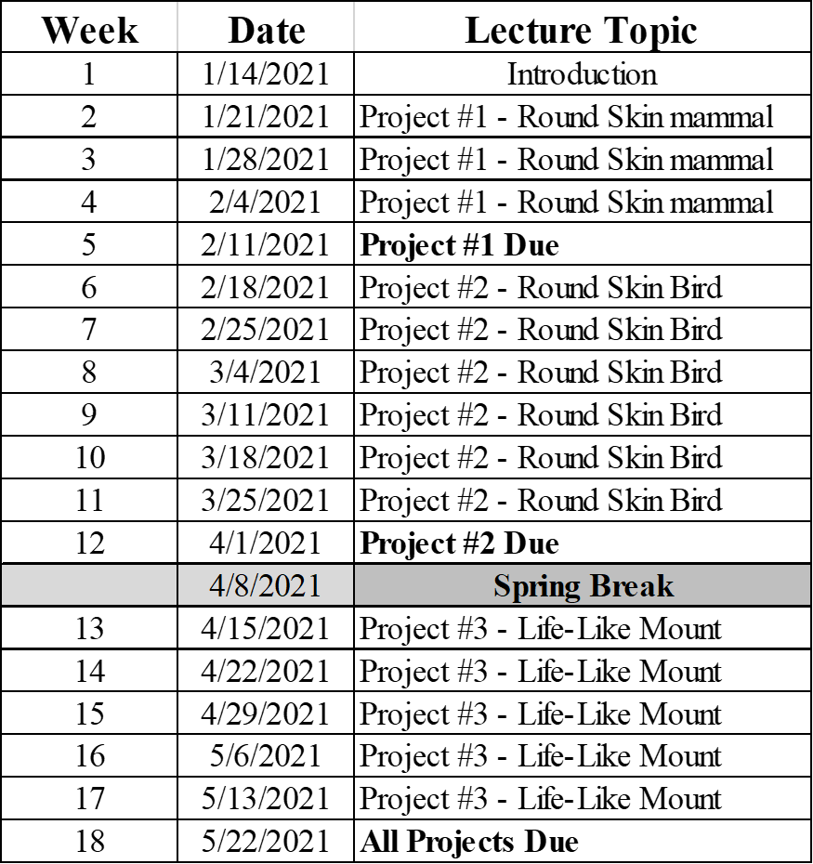

COVID19 and the Fall Semester:
Attendance Policies
Students should evaluate their own health daily and must complete the online health screening available daily: https://scccd.az1.qualtrics.com/jfe/form/SV_3IO880HybZg7ajX
If they have any of the following symptoms, they should not attend class. Students are encouraged to contact the nurse or healthcare provider for further guidance. Common COVID-19 symptoms include, but are not limited to:
- cough
- sore throat
- shortness of breath
- runny nose (not due to seasonal allergies)
- fever (100.4 degrees or more)
- and/or chills
Students should also not attend class if they have had close contact with anyone who has had these symptoms in the last 14 days.
Students may be dropped if they miss more than two consecutive class meetings without explanation before week 4.

COVID 19 Safety Practices

Facial Coverings: Students and instructors are required to wear facial coverings or masks that cover and fit the face against the nose and mouth when entering, exiting, and throughout class. Students who have a documented medical condition that prevents them from using a snugly fitting facial covering can use face shields as an alternative.
The wearing of facial coverings is Reedley College policy. Refusal to wear facial coverings will result in you being removed from the class for the day.

“Removal from Class by Instructor Reedley College’s Student Code of Conduct Policy (Board Policy 5520 and Educational Code 76032) authorizes an instructor to remove a disruptive student from his or her class for the day of the removal and the next class meeting. The instructor shall immediately report the removal to the Vice President of Student Services. During the period of removal, a student shall not be returned to the class from which he or she was removed without the concurrence of the instructor of the class.”

Handwashing: Students are required to wash their hands or use hand sanitizer prior to class. Hand sanitizer is available in the classroom for their use.

Social Distancing: Students are required to stay at least 6 feet apart while on campus. In the classroom, maintain social distance and sit in seats as designated by the seating chart.
Classroom Cleaning: Students will wipe down their seating/work area with disinfectant before and after class.

Safety procedures are subject to update.

