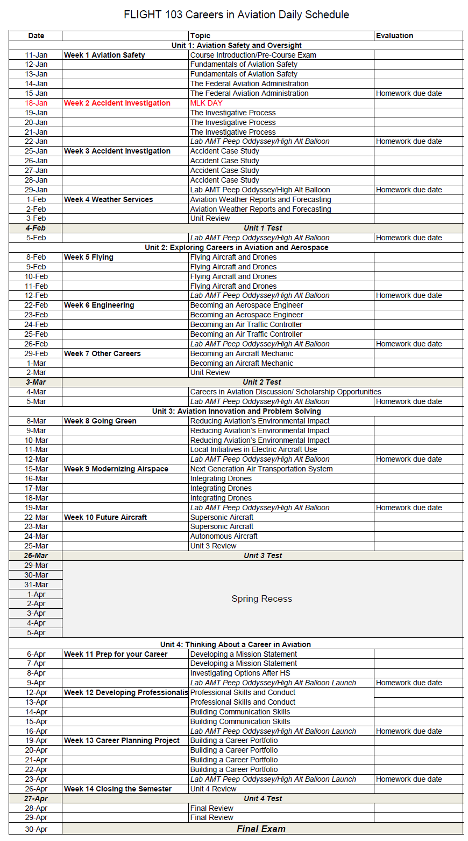
FLGHT-103 CAREERS IN AVIATION Section #59431 Spring 2021

Instructor: Jaime Luque e-mail:jaime.luquemontes@reedleycollege.edu
Office Location: Reedley College, Aero building, room 5
Cell Phone: (510) 387-5404 Office Hours: M-F noon- 1:20:00 pm or by appointment
CLASS LOCATION: Aero building, Room 5

DAILY SCHEDULE: M-F. Jan. 11 – May. 21, 1:20–2:10 PM
Final Exam – Friday, Mar. 13, 1:20 – 2:10 PM

HOLIDAYS (NO CLASS): | Jan. 18  Feb. 12  Feb, 15  Mar 29-Apr 02 | MLK Jr. Day  Lincoln Day  Washington Day  Spring Recess
IMPORTANT DATES: | Jan 22  Jan 29  Jan 31  Mar 12  May 21 | last day to drop for full refund  last day to add a class  last day to drop and not receive a “W” (Drop Online)  last day to drop but will still receive a “W” grade  last day of finals week/last day of the semester
COURSE DESCRIPTION: The Careers in Aviation lecture course provides an understanding of the available careers in aviation. Topics discussed in the course will include Air Transport Pilot, Charter Pilot, Flight Instructor, Aircraft Mechanic, Airport Management, Fixed Base Operations, Air Traffic Controller, and Airport Operations. ADVISORIES: Eligibility for Mathematics 201. (A)

Learning Outcomes and Objectives

Course Objectives
Identify the various career fields within aviation.
Select an appropriate career path option.

CSLOs
FLGHT-103 SLO1: Assess the differences between ground and flight based career paths.
FLGHT-103 SLO2: Compare available career paths within aviation.
FLGHT-103 SLO3: Create a viable career plan.
FLGHT-103 SLO4: Identify potential careers in the aviation industry.

Course Outline

I. Airline and Airport Operations
A. Career Field
1. Airport Directors or Managers
2. Flight Dispatchers, Scheduling Coordinators
3. Air Traffic Control Specialists
4. Ramp Service Personnel, Aircraft Fuelers
5. Flight Attendant
B. Educational requirements
C. Certification requirements
D. Experience requirements
E. Follow-up training and educational requirements
F. Salary range and benefits
G. Opportunity for advancement (career ladder)
H. Typical work environment

II. Aircraft and Systems Maintenance
A. Career Field
1. Aircraft / Aerospace Engineering
2. Airframe & Powerplant Maintenance Technician
3. Aviation Electronics Technician
B. Educational requirements
C. Certification requirements
D. Experience requirements
E. Follow-up training and educational requirements
F. Salary range and benefits
G. Opportunity for advancement (career ladder)
H. Typical work environment

III. Pilot Careers
A. Career Field
1. Agricultural Pilot
2. Major/National Airline Pilot
3. Air Freight/Cargo Pilot
4. Corporate Pilot
5. Air Taxi or Charter Pilot
6. Flight Instructor
B. Educational requirements
C. Certification requirements
D. Experience requirements
E. Follow-up training and educational requirements
F. Salary range and benefits
G. Opportunity for advancement (career ladder)
H. Typical work environment

Grading Policy:

Presentations (all combined) 30 points
Research Projects (all combined) 30 points
Essays (all combined) 30 points
Class participation 10 points
COURSE TOTAL 100 points
Grading Scale: 90% and above = A
80% and above = B 70% and above = C 60% and above = D Below 60% = F

Scores will not be rounded up - i.e. 89.99% = B There is no extra credit in this course.

GRADING SYSTEM:
Presentations – There will be two Presentations. See handout for instructions and grading rubric.

Essays - There will be approximately 29 Essays. See handout for instructions and grading rubric.

Research - There will be approximately 29 Research projects. See handout for instructions and grading rubric.

Class Participation - Class Participation will be assessed every class meeting using: Syllabus standards
Obvious non-learning behavior Points each day

ATTENDANCE POLICY:

The intent of this attendance policy is to ensure:

- The student gains the most from the learning experience of this course and is present to learn.
- The student learns the typical attendance responsibilities when employed as a pilot.

Graded activity will occur nearly every class meeting. Students are expected to meet in the classroom for roll call no later than 1:20 pm each class day. Each late arrival (tardy) which is not excused will reduce the student’s overall grade by 1%. An unexcused absence on any day will reduce a student‘s overall grade by 1%.

For VROP students, only a school official or parent may excuse an absence or tardy. Any late arrival to class or absence from class will result in a phone call from the instructor to the student’s parent(s) to discuss the ramifications of that and future occurrences. Absences will be electronically reported to the student’s respective high school.

Reading assignments, homework, test dates, etc. may be verbally changed and announced during any class meeting. Students are expected to attend all scheduled class meetings, be punctual, write down verbal directions, and then follow all verbal and written directions. It is the student’s responsibility to find out what was missed if the student is late or absent.
If a late arrival or absence occurs and is excused, the student has 7 calendar days to make-up all graded activity or a zero will be assigned to that activity. If it was an unexcused late arrival or unexcused absence, then the student has 7 calendar days to make up the work at half (50%) credit. It is the student’s responsibility to ask the instructor to accomplish make-up graded activity.

STUDENT PARKING: Reedley College parking permits are required for all vehicles on the Reedley College campus. Students will park only in non-staff designated parking areas. An overflow parking lot on the west side of the campus is also available for parking. Students may purchase a parking permit from the business office in the Student Services building for each semester while attending class. Any violation of the above rules may result in a ticket.

STUDENT CONDUCT STANDARDS: Respect for the rights of others and for the College and its property are fundamental expectations for every student. The “Student Conduct Standards” outlines behavioral expectations, and explains the process for responding to allegations of student misconduct. Students who do not comply with the “Student Conduct Standards” are subject to the College disciplinary actions. The Student Conduct Standards can be found at http://www.reedleycollege.edu/index.aspx?page=233

BEHAVIOR: Any behavior which disrupts other student learning will not be tolerated. Here are some examples of inappropriate in-class behavior:

- Eating of any kind in class or lab. Covered drinks are allowed in class and in the designated area in lab only
- Using foul language
- Total of student voices being louder than the instructor
- Cell phones ringing or texting during class
- Horseplay

- Discriminatory or harassing remarks based on gender, age, national origin, race, or religion, or disability.

ACADEMIC DISHONESTY: Students at Reedley College are entitled to the best education that the college can make available to them. Students, their instructors, and their classmates share the responsibility to ensure that this education is honestly attained. Because cheating, plagiarism, and collusion in dishonest activities erode the integrity of the college, each student is expected to exert an entirely honest effort in all academic endeavors. Academic dishonesty in any form is a very serious offense and will incur serious consequences.

Cheating is the act or attempted act of taking an examination or performing an assigned, evaluated task in a fraudulent or deceptive manner, such as having improper access to answers, in an attempt to gain an unearned academic advantage. Cheating may include, but is not limited to, copying from another’s work, supplying one’s work to another, giving or receiving copies of examinations without an instructor’s permission, using or displaying notes or devices inappropriate to the conditions of the examination, allowing someone other than the officially enrolled student to represent the student, or failing to disclose research results completely.

Plagiarism is a specific form of cheating: the use of another’s words or ideas without identifying them as such or giving credit to the source. Plagiarism may include, but is not limited to, failing to provide complete citations and references for all work that draws on the ideas, words, or work of others, failing to identify the contributors to work done in collaboration, submitting duplicate work to be evaluated in different courses without the knowledge and consent of the instructors involved, or failing to observe computer security systems and software copyrights. Incidents of cheating and plagiarism may result in any of a variety of sanctions and penalties, which may range from a failing grade on a particular examination, paper, project, or assignment in question to a failing grade in the course, at the discretion of the instructor and depending on the severity and frequency of the incidents.

DOING WELL IN THIS COURSE: To learn the most from this course, the instructor suggests the following techniques:
- Maintain punctual and perfect attendance.

- Show up prepared (having read text, studied for tests/final exam, and brought equipment (notepaper, lecture notes, pencils, pens, erasers) to class.
- Study alone and participate in a study group three times per week (every week) to do practice questioning for each test/exam.
- Read and follow all verbal & written (syllabus, exams, homework, project) instructions.

- Use a day planner and refer to schedule of class activities.

- Get a good night’s sleep, eat healthy, exercise, and stay hydrated.

- Ask the instructor for additional help.

PROBLEMS: Personal problems that affect your academic performance must be brought to the attention of the instructor immediately. Problems must be worked out in advance. Doing poorly on a graded activity or not showing up for a graded activity cannot be fixed “after the fact.”

CELL PHONE, TABLETS, LAPTOPS: No use of Personal Electronic Devices (PED) (such as cell phones, tablets) in class (laptops/tablets may be used to take notes in class) or in lab without prior instructor permission.

STUDENTS WITH DISABILITIES/SPECIAL ACCOMMODATIONS: Any student in need of an
accommodation due to a disability is encouraged to provide the instructor with their notification of authorized services form from DSP&S and consult with the instructor immediately so that arrangements can be made.

Reedley College is committed to creating accessible learning environments consistent with federal and state law. To obtain academic adjustments or auxiliary aids, students must be registered with the DSP&S office on campus. DSP&S can be reached at (559) 638-3332. If you are already registered with the DSP&S office, please provide your Notice of Accommodation form as soon as possible.

GRIEVANCE PROCEDURE: Every effort is made to treat all students the same. If you feel you have been treated unfairly, please inform the instructor immediately so appropriate corrections can be made. If you have a problem with the instructor or the way this course is conducted, please talk to the instructor immediately.

I certify that I have read and understand the syllabus for FLGHT 103.

Printed name of STUDENT signature date phone number

