SPANISH 1~ BEGINNING SPANISH (5 UNITS) SCHD# 59774~ FALL 2021
REEDLEY COMMUNITY COLLEGE /
SANGER HIGH SCHOOL DUAL ENROLLMENT
PROFESSOR: SILVIA MEJIA

E-mail: silvia_mejia@sangerusd.net
silvia.mejia@reedleycollege.edu
Classroom: 1207. School phone: 875-7121 Ext. 7327

Spanish 1 Course Description (Catalog):
Beginning course in conversational and written Spanish for non-native speakers; intended for students without previous exposure to Spanish. Introduction to pronunciation, vocabulary, idioms, grammar, basic composition, and exploration of the cultures of Spain and Latin America and the Hispanic cultures of the US. (See pg. 4 of this syllabus for Student Learning Outcomes and Objectives as per the Reedley College Credit Course Outline, Spanish 1.)

Spanish 1 Course Description (for this particular section):
This course stresses communication skills in Spanish. Much of the practice work will be done in pairs. The goal is for beginning students to acquire minimal conversational ability in Spanish. By the end of the semester you will have studied the present and past tenses. In the process, you will learn certain cultural details. For example, you will learn that there are two ways of saying "you" in Spanish, and they are not interchangeable. It is assumed that you are in this class because you want to learn how to communicate in Spanish. You will not have developed that ability completely by the end of the semester, but you will be surprised at how many communicative skills you will have acquired!

Specific course goals and objectives:
1. To develop your "survival" language skills.
2. To develop sensitivity to differences and similarities in cultural issues.
3. By the end of the semester, you will be able to:
a. when shown a drawing of several actions, describe what is happening
b. discuss your habits, vacation plans, describe your home, friends/family
c. interview other students to find out their experiences
d. tell about your daily routine: the 20-30 things you do in a normal day
e. describe other persons and things using appropriate adjectives
f. tell some important things you did yesterday, or last summer.
Course management:
- You will find our entire semester organized into Week Modules that follow the semester calendar. Each week will have detailed information about the learning objectives and instructions for all assignments.
- Your first assignment will be to personalize your Canvas account and upload a picture of you.

Required text and materials
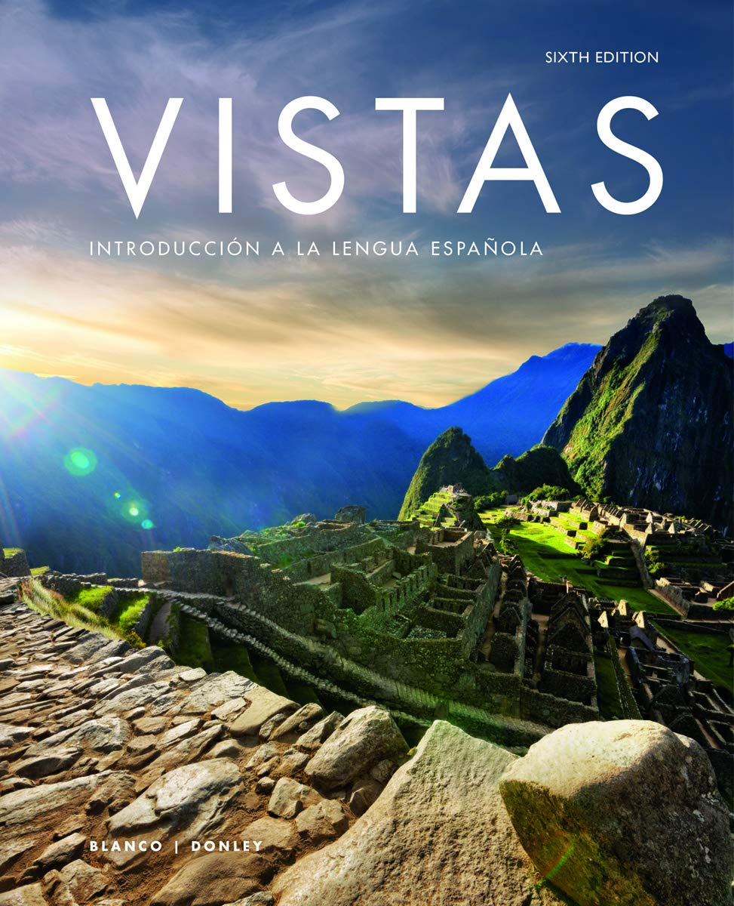

Vtext: Vistas 6 Edition (vtext)+Supersite Plus
code+WebSAM for Internet access.

The Vistas vtext we will be using in the class offers a great Supersite Plus. Go to www.vhlcentral.com, register, and you will find a wide range of online resources including interactive activities, audio, and videos. Be sure to remember your user name and password as you will need these to access all of the course materials.

Attendance Policy
You are required to attend regularly and punctually all classes. Attendance will be taken daily at the beginning of class. You are expected to actively participate in the discussion boards, collaborate with classmates, and complete and submit assignments in Vista Higher Learning System and Canvas. You are expected to seek feedback, ask for help and offer help to others. Participation and attendance in this class is not only important to your success in this class, but also to the success of the entire class. You are enrolled in this course to participate in it on a regular basis and if you are unable to attend because of a serious medical condition or personal situation you must contact me promptly regarding any attendance/participation problems.

Late work policy

You will know the due dates of assignments and exams for this class well in

advance. All work, however, must be completed on time. Assignments submitted

after the due date will receive a 5% deduction per day. Work submitted after one week past the original due date will not be accepted. If you have an emergency, contact me before the due date. Examples of emergencies constitute a car accident or a heart attack. A planned vacation or a birthday party do not fall into an emergency category.

Grading and Evaluation
All assignments, discussions, oral activities, quizzes, etc. are to be completed no later than 11:59pm PST/PDT on the date indicated.

Grading scale: 90-100%= A 80-89%= B 70-79%= C 60-69%= D below 60%= F

Your grade will be determined by the following:
Class activities (Canvas & VHL) 20%
Written & Oral exams 50%
Portfolio 10%
Engagement 10%
Final Exam 10%

Activities on Canvas & VHL Central 20%: There will be activities on Canvas such as practice assignments, discussion boards and/or videos to watch. In addition, there will be assignments to be completed on the Vistas Higher Leaning System (www.vhlcentral.com). These online activities involve reading, audio, and video-based materials. You must complete the work and submit it on the day it is due in order to get all the points. Assignments must be submitted no later than 11:59 pm on the day indicated.
Written & Oral exams 50%: At the end of each lección you will be assessed in the form of a Lesson Test. Each test will cover all the material for the Lección. It may include vocabulary, grammar, listening comprehension and/or writing. The tests will be TIMED and with only one attempt. Pop quizzes may also be given as part of this grade and may not be announced in advance.

Portfolio Assignments 10%: Throughout the semester, you will be given portfolio assignments. These may include creating a booklet describing and illustrating a passage from your daily life, writing and illustrating a poem or short story, researching and presenting to class an aspect of the Hispanic culture, writing a movie critique etc. Deadline dates as well as further instructions will be provided throughout the semester. Please refer to the policy for late assignments regarding any late work.

Engagement/Participation 10%: Since learning another language requires active and frequent practice, it is essential for you to engage actively in all the class activities. Language learning involves four basic skills – reading, writing, listening, and speaking. One of the best ways to assess your language skills is through class engagement. Active engagement involves completing all activities on time, using Spanish whenever possible, participating appropriately in group/partner work, treating all classmates with respect, asking questions as needed, and maintaining a positive and cooperative spirit throughout the course.

Final Exam 10%: The final exam is not comprehensive; it will only cover Lección 5. The exam may be written or oral or a combination of both- this will be announced ahead of time.

Study Hints
1. Whenever you study, do it orally. Pronunciation will improve if you practice aloud.
2. Don't feel you have to sit at a desk to study. Try using the new words to describe people and things you see as you walk or drive.
3. As you prepare for class, get to the point where you can say the utterances without looking at the book.
4. Where possible, study with a classmate. Also, at the beginning of the semester you can register for tutorial help.

Other:
- If you have special needs as addressed by the Americans with Disabilities Act (ADA) and/or need course materials in alternate formats, notify me immediately. Reasonable efforts will be made to accommodate your special needs.
- Make sure to turn off all cell phones. They are an interruption during class time. Points will be deducted from your participation grade if you are using your cell phone during class. In case of an emergency, inform me prior to the beginning of class.
- The VISTAS work-text we will be using in the class offers a great Supersite. Go to www.vhlcentral.com, register, and you will find a wide range of online resources including interactive activities, audio, and video.

ACADEMIC DISHONESTY STATEMENT:
“Because cheating, plagiarism, and collusion in dishonest activities erode the integrity of the college, each student is expected to exert an entirely honest effort in all academic endeavors. Academic dishonesty in any form is a very serious offense and will incur serious consequences.” (RC Catalog page 44)

Course ID: SPAN 1 |  | Course Title: Beginning Spanish

STUDENT LEARNING OUTCOMES
SPAN-1 SLO1: recognize and comprehend basic spoken Spanish within a limited range of
contexts at the low beginner level of competency.

SPAN-1 SLO2: orally produce comprehensible sentences and phrases in Spanish to respond
appropriately to questions, initiate and sustain simple conversations, or describe people, places and activities at the low beginner level of competency.

SPAN-1 SLO3: read, identify and comprehend specific pieces of information from selected
short readings and authentic, graphically-represented text such as ads or short magazine articles.

SPAN-1 SLO4: construct simple sentences and compose basic paragraphs applying correct
usage of basic grammatical structures to express ideas at a low beginner level of competency.

SPAN-1 SLO5: demonstrate knowledge and appreciation of the diversity of Hispanic
cultures and the products of these cultures.

COURSE OBJECTIVES
1. comprehend and interact in simple spoken Spanish within the range of vocabulary topics and structures covered in this course. These topics include meeting people; describing oneself and others; talking about family, friends, daily activities and pastimes; and making plans.
2. recognize and employ new vocabulary and apply the correct usage of basic grammatical structures in order to communicate ideas, describe events, ask simple questions, and respond, both orally and in writing, to questions in the present tense.
3. comprehend basic written texts using contextual clues, vocabulary recognition, grammar knowledge, cognates, and inference.
4. review, recall and use previously learned vocabulary and grammatical structures while continuing to augment and expand this base of knowledge.
5. compare and contrast the target language and cultures with the language and cultures of the U.S.
6. demonstrate a low beginner level of competency in the five skills as mandated by the proficiency guidelines of the American Council on the Teaching of Foreign Languages (ACTFL): listening comprehension, speaking, reading, writing and a basic knowledge and appreciation of the people and cultures of Spanish-speaking countries.

