ENGL1A: COLLEGE READING AND COMPOSITION
  - Fall 2021 Course Syllabus

Course Information
Instructor: Gilliann Kenerly
Instructor Email: gilliann.hensley@reedleycollege.edu
Class Meeting Time: Tuesdays and Thursdays 10AM – 11:50AM
Room: Social Science 35
Office Hours: Tuesdays 9-9:30AM (Soc 35), Thursdays 1-1:30PM (Online through Zoom)

Course Overview
English 1A is designed to engage students in the kind of critical thinking and analysis required at the college/university level. As noted in the course catalogue, you will read, analyze, and compose college-level prose, with emphasis on the expository; study writing as a process; explore different composing structures and strategies; edit and revise your own writing; and conduct research (gather, organize, evaluate, integrate, and document information), culminating in a term research paper. Over the course of the semester, you can expect to write a minimum total of 6,000 words in formal academic language.

Required and Recommended Texts and Materials
You, Writing: A Guide to College Composition by Glynn, Hallsten-Erikson and Swing
Writing Spaces: Readings on Writing, Volumes 1-3 ** Note: We will not be reading every essay in each volume, you’ll be informed in each weekly module which essays we will be working with.
Supplemental Materials (posted to Canvas or as printed handouts)
Access to a computer (with word processing capabilities) and internet connection in order to complete classwork (digital and printed)

Course Content
Since the course is designed to cultivate critical thinking and analysis through reading and writing, emphasis is placed on exposition: studying writing as a process, exploring different composing strategies and structures, editing and revising, conducting research, and learning to critique peer writing.
Writing is not simply a demonstration of one’s ability to write. Writing is a tool: a strategy for generating ideas, for analyzing information, for inventing responses, critiquing your own thoughts (or the thoughts of others), or for creating a record of your thinking. In this class, writing will serve many purposes. Because of this, you will be asked to write for many different reasons, in a variety of genres. Using research strategies, you will also be expected to incorporate material from outside sources to support your own position.
Reading and writing are very similar meaning-making performances. Class discussions about the reading will enhance your ability to write responses to what you read. Through the reading assignments, you will learn to model your approach to writing and develop a better understanding about form, rhetorical framework, and the use of evidence in writing.

Course Objectives
Upon completion of this course, students will be able to:
Write a documented research paper of at least 1,500 words that includes:
A sophisticated introduction, multiple body paragraphs, and conclusion.
A clearly defined, arguable thesis statement.
Supporting details that exhibit critical thinking and use of credible sources.
Correct usage of MLA format, including a Works Cited page.
Sentences that exhibit a command of the complex/compound, with minimal sentence-level errors (splices, fragments).
Controlled and sophisticated word choice.
An avoidance of logical fallacies.
Demonstration of an awareness of purpose and audience.
Appropriate and purposeful use of quotations.
Correct in-text citations.
An annotated bibliography of multiple sources.
An avoidance of intentional and unintentional plagiarism.
Complete a timed essay independently online.
Summarize and comprehend college-level prose.

Course Requirements
Below you’ll find the main requirements of the class that make up the work that you will be assessed on over the semester.

Writing Projects
Since this is a class about strengthening our skills as writers, Writing Projects will make up a major portion of the work that you do over the semester. You’ll write a total of three major essay projects—a Personal Essay/Literacy Narrative (200 pts), a Rhetorical Analysis (200 pts), and a longer Research Essay (200 pts). Each of these projects will require revision across multiple drafts and mandatory participation in workshops. Failure to turn in a draft will result in my refusal to accept your final draft—and may result a grade of ZERO for the final draft.
The writing that I ask you to do across these projects will emerge from the concepts, processes, and issues that we discuss as a class. All these projects will encourage you to choose topics and texts that are important to you and that connect to the theme of each unit. I will provide prompts for each project so that you have a clear idea about what you are required to do. Keep in mind that as we move through the semester, each writing project will challenge you to add more knowledge, skills, and practices to what you already know from the previous project.

Project Proposal + Annotated Bibliography
In connection with the research paper, I will ask you to complete a small collection of preparatory work that will help you to generate ideas and will act as the foundation for your research paper later in the semester. It will include such activities as a project proposal/discovery draft, an outline of tasks you’ll need to accomplish, and an annotated bibliography. You will have access to a prompt with more details.

Reading Responses
Reading and writing go hand in hand. The reading that we do in class will be necessary for our topics of discussion, for modeling approaches to writing, and for developing a better understanding about form, rhetorical approach, and the use of evidence in writing. As a result, over the semester I will assign reading responses for a number of essays and articles. I expect that when a reading assignment is due, that you will have read the text actively. That means that you have annotated your text, will have questions to ask, and will be ready to engage in discussion with others about the reading through in-class discussions. Generally, you can be expected to read between 50 and 70 pages a week.

Quizzes
Throughout the semester, I will assign small (generally weekly) quizzes on the reading and concepts that we discuss. These quizzes will be completed online, on Canvas. They will allow me to gauge how well you understand the reading and concepts, how you respond to them, and if you are keeping up with the reading and module work in general.

Participation
Participation in the class is mandatory and will be a necessary part of your success in the. Graded participation aspects of the course will include small-group work, peer workshops, in-class and online discussions, and other small learning activities (both in-class and online) that don’t fall under any of the other categories.
Workshopping is an important part of this class. It gives you the opportunity to get audience feedback on your writing. It is also an opportunity to get ideas for approaching writing tasks, for understanding the range of rhetorical components—beyond grammar—that are available for revision, and for assessing a piece of writing for its rhetorical effectiveness. Participating in these group workshops is mandatory and will help you to read and revise your own work with more fluency and expertise.

Final Reflection Essay
At the end of the semester, rather than a traditional final exam, I’ll ask that you complete a final in the form of a reflective text, in which you talk about your learning over the semester, referencing strategies and concepts, as well as talking about what the work you’ve done reflects about your understanding of what you’ve learned. You will receive a prompt with more information within the course modules.

Grading and Evaluation
Since our course is focused so heavily on academic writing, most of your class grade will revolve around the longer essays that you will produce over the semester. It is vital that you do not ignore these writing projects, or else your grade will be impacted severely. The breakdown below explains how your letter grade will be calculated and how each requirement category is weighted.

Grade Breakdown
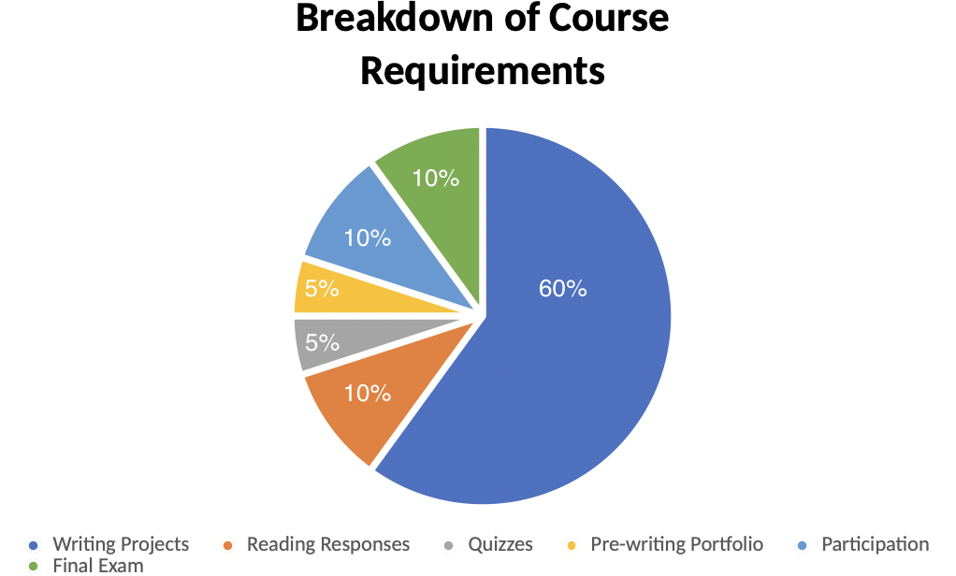
1mage 1 Breakdown of Course Requirements

Grade Scale
A | B | C | D | F
100 – 90% | 89 – 80% | 79 – 70% | 69 – 60% | 59% and below
Table 1 Grade Scale

How Grading Works
Work that you submit will be graded in a couple of different ways. Some work will be Credit/No Credit, such as learning activities that we do within the course modules, as well as first drafts of essays. This is because I believe that what is most important is that you are at least trying to engage with the work of the course. Therefore, you will get credit for doing the work if that work meets the expectations outlined in the assignment instructions.
Other course work will be given a more traditional score and will be graded through rubrics. This type of work includes reading responses, discussion boards, and major writing project final drafts.

Late Work
It is important to turn in work on time. Much of the work in this course will have a “best by” date. This is the initial due date and is, of course, the best time to submit your work by. This ensures that you will be able to get feedback and comments on the work you submit. However, I know that, especially during a pandemic, things can happen. Therefore, you will be able to submit work up to three days after the best by date has passed without any penalty. After these three days, however, you will no longer be able to submit the assignment.
Additionally, you are required to submit a rough draft of your essay before you submit a final draft. All missed or ignored rough drafts will receive a zero, and you will not be able to get any feedback from me. Drafts must be submitted on time, since you need them to be able to participate in the peer workshop process. If you do not have your draft on workshop day, you will not be able to get participation credit for that day.

Extra Credit
You will be able to earn extra credit in this course by working with our embedded tutor or another RWC tutor. You will need to be sure to let the tutor know that you will need proof of meeting. For each meeting you will be given one choice for how you will use that extra credit. Extra credit can be used in the following ways: 1) You can apply it once to a final essay draft (and receive 5 extra points added to your final score), 2) you can use the extra credit to turn in an assignment after the three day late work period (does not apply to rough essay drafts), or 3) you can use the extra credit to be excused from completing a C/NC activity online. You need to be sure to tell me how you want to use your extra credit.

Course Policies

Attendance and Drop Policy
Participation in the work of the course is very important. This means that you need to be a present and active member of our learning community and engage in the class activities and discussions.
During the first week of class, it is particularly important to attend. Any student that does not attend the first week of class will be given a “no show” drop and can even be dropped after missing the first day of class.
Participation (in class discussions/activities, workshops and other group work), and thus regular attendance, is important to your success in this course. This means not only showing up to class, but also being prepared each day by completing the writing and reading homework assignments—as much of what we learn and do takes place in the classroom. As such, missing more than 4 classes total (two full weeks of contact-hours) can result in your inability to pass the class. **If there are extenuating circumstances (for example, a serious accident/injury or COVID-19 infection) you need to be sure to get in contact with me sooner rather than later so any arrangements can be made.
If you are absent, it is your responsibility to check the schedule (as well as any announcements or adjustments to the schedule) and make sure that you keep up with the work that you missed.
It is also important that you show up to class on time, as coming in late is disruptive to class. You will receive a tardy each time you are 15 minutes late, with three tardies equating to an absence. Remember, too, that each day you receive Participation credit for work that we do in class, and so regularly missing large portions of the class will begin to seriously affect your grade in that category.

COVID-19 Policy
As a student on campus, you are required to take the Daily Online Health Screener, regardless of vaccination status. If you (or anyone in your household) are experiencing possible symptoms of COVID-19, you are asked to please stay home. Please be sure to monitor yourself daily for possible symptoms.
As per the Campus Safety Guidelines, you are required to wear a facial covering that always covers your mouth and nose (regardless of vaccination status) unless you have a note from a physician excusing you from wearing a face covering. In this event, you must provide the note to the college nurse and obtain clearance before you can attend class. You will be asked to wear a face shield with a drape along the bottom edge. Refusal to wear a mask can result in your being asked to leave the class.

Communication Policy
Communication in a class is important, and there may be times you need to contact me outside of class. Please familiarize yourself with the communication policies for this course, as they are important for our ability to contact each other.

Email Policy
Many questions about the course can be answered by referencing the course syllabus and information on Canvas, however, there may be occasions when you will need to contact me by email. When sending an email, please be sure to include your name and course number in the subject line. Students should only send emails using their Reedley College email address, or through the Canvas Inbox. I will respond to emails Monday through Friday (8AM -7PM), but do not expect responses to emails over the weekend. Once you send an email, please allow at least 24 hours to get a response. If you have not received a response within 24 hours, assume the email is lost and resend.

Methods of Communication
We will use several methods of communication over the semester, in addition to email and the Canvas messaging system. One of those ways will be through the Announcements feature, so please be sure to check Canvas regularly. It might even be a good idea to turn on notifications, so you know when new Announcements have been posted.
There will also be a Course Q & A board. This will be a pinned discussion board where you can pose questions that you have at any time over the semester, and where you can even respond to the questions of your classmates in order to help them out.

Disruptive Behavior
Do not use class time to prepare for or complete assignments for your other classes. Do not talk about things irrelevant to the subject matter of this course when you are assigned for group activities in class. When working in groups, while I understand that the urge to socialize and get off topic is always there, this can be distracting to other groups trying to get work done, and so staying on track and on task is important. Also, we will have a number of class discussions, and while we all have different opinions and beliefs, it is important to always treat each other respectfully. Please avoid talking during lectures or allotted reading time. For more on appropriate classroom behavior, please see the Student Code of Conduct. If necessary, campus security will be contacted for any behavior that warrants it.

Use of Technology/Personal Electronics
As a courtesy to myself and your fellow classmates, please turn off your phones and other devices. If you prefer to use a laptop or tablet for notetaking that’s fine, but please do not use your device for things irrelevant to the class or task at hand. There may be times, for example, when we use the class set of laptops for research and other activities. Additionally, it is important to note that you will need access to a computer, the internet, and a Reedley College email outside of the classroom environment, for the purpose of completing assignments (in .DOCX format, please), or for communicating with me and your fellow classmates.
NOTE: If phones and other devices become a problem, the entire class will be required to keep their phones at the front of the classroom until break time or until the end of class. If you have a dedicated need to have a phone out, like an emergency, let me know.

Accommodations
If you have a verified need for an academic accommodation or materials in alternate media (i.e., Braille, large print, electronic text, etc.) per the Americans with Disabilities Act (ADA) or Section 504 of the Rehabilitation Act, please contact me or DSP&S as soon as possible.

Plagiarism and Cheating
Cheating is the actual or attempted practice of fraudulent or deceptive acts for the purpose of improving one's grade or obtaining course credit, which can include assisting another student to do so. Typically, such acts occur in relation to examinations. However, it is the intent of this definition that the term 'cheating' not be limited to examination situations only, but that it includes all actions by a student that are intended to gain an unearned academic advantage by fraudulent or deceptive means. This includes plagiarism—the miss use (whether intentional or accidental) of the published and/or unpublished works of others by misrepresenting the material (their intellectual property) used as one's own work. Please be sure that you use MLA format when citing the words and ideas of others, and if you aren’t sure, ask.
And please remember, as a member of this class, you join a community that requires intellectual integrity. When you put your name on an assignment, you take credit for the work contained, whether that be an entire text or only a sentence. Plagiarism, cheating, and other forms of academic dishonesty demonstrate a disrespect of the community and will not be tolerated. Violation of this policy will result in serious harm to your learning, to your grade, to your standing in class, and perhaps to your standing at the college. Keep in mind that you will be required to submit essays (rough drafts and final drafts) to Turn It In.

Tutorial Resources
There will be a couple of embedded tutors available to all members of the class. Our embedded tutors will be able to help you as you engage with the work of the class. I highly encourage you to make use of this tutorial service. It is my experience that students who meet regularly with a tutor, especially for major writing projects, tend to be more successful in the course. Tutors can help you in several ways: with breaking down a prompt to help you understand your writing task, with brainstorming ideas to write about, with feedback to help you revise across drafts, and with proofreading and polishing your paper once it is close to done. They can also help you navigate using and citing sources.

