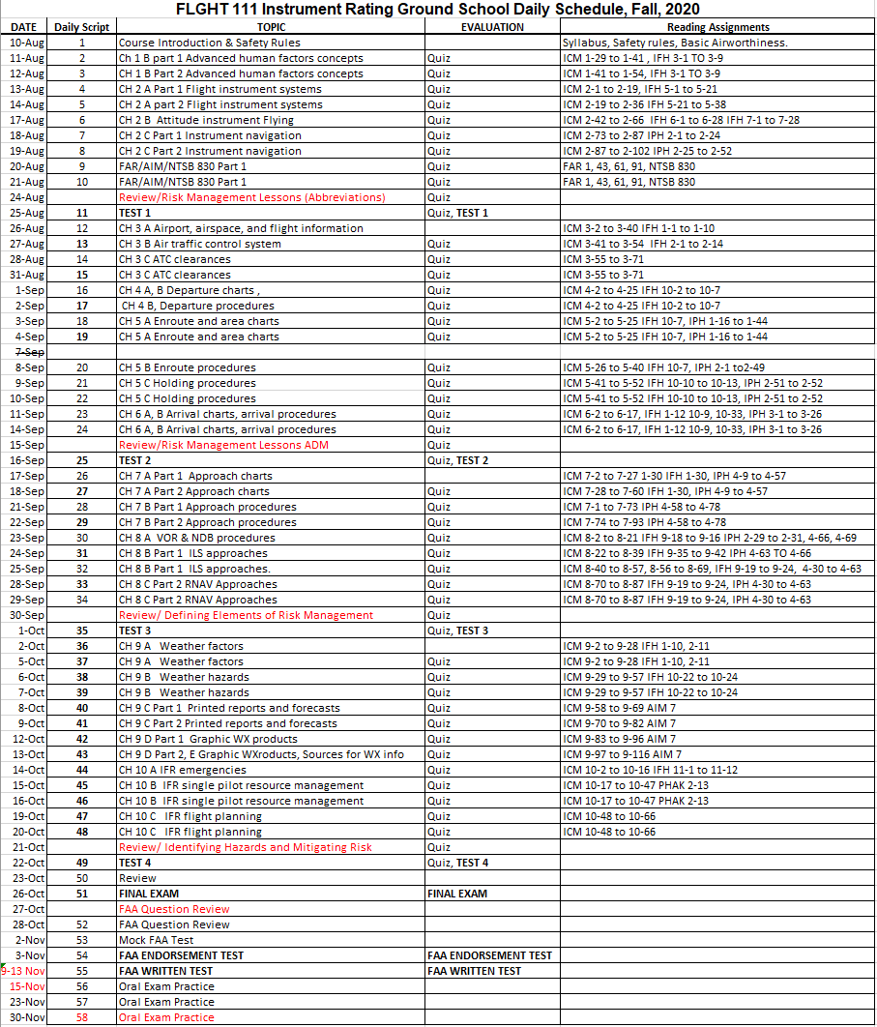
FLGHT 111 Instrument Rating Ground School (53959) Fall, 2020

Instructor: Jaime Luque-Montes e-mail: jaime.luque-montes@reedleycollege.edu

Office Phone: (559) 638-0300 ext. 3734 Office Location: Reedley College, Aero building, room 7

Office Hours: Mon-Fri 12:00 to 1:00 PM
CLASS LOCATION: Aero building, room 5

DAILY SCHEDULE: 08/10/2020-10/28/2020: M-F 10:00AM - 11:50AM, then…
11/02/2020-11/30/2020: Mondays only 10:00AM - 11:50AM,

HOLIDAYS (NO CLASS): Sep. 7 Labor Day
Nov. 11 Veterans Day
Nov. 26/27 Thanksgiving

IMPORTANT DATES: Aug 21 last day to drop for full refund
Aug 28 last day to add a class (Aug 23 for FLGHT courses)
Aug 28 last day to drop and not receive a “W” grade
Oct 9 last day to drop but will still receive a “W” grade

REQUIRED TEXTBOOKS/EQUIPMENT:
- Uniform shirt(s)
- Pencils, pens, paper, 8½ by 11 binder, simple calculator (add, subtract, multiply, divide)
- Jeppesen Textbook ISBN 978-0-8847-130-9 printed 2016 (Instrument and Commercial) (Jeppesen part number 10001784-005)
- Instrument Rating Practical Test Standards for Airplane, Helicopter, and Powered Lift (FAA-S-8081-4E with Changes 1, 2, 3, 4, & 5) (electronic version is acceptable)
- FAR/AIM, current (recommend Jeppesen brand)
- Instrument Flying Handbook (FAA-H-8083-15B) (plus errata sheet plus addendum) (electronic version is acceptable)
- Instrument Procedures Handbook (FAA-H-8083-16B) (electronic version is acceptable)
- Plotter
- E6-B
- PA-28 Warrior II POH (provided by Reedley College)
- AC 00-6B Aviation Weather
- AC 00-45H Weather Services (with change 1)
- Aeronautical Chart User’s Guide (electronic version is acceptable)
- Aeronautical Decision Making (AC 60-22) (electronic version is acceptable)
- Unreliable Airspeed Indication (AC 91-43) (electronic version is acceptable)
- Effect of Icing on Aircraft Control and Airplane Deice and Anti-Ice Systems (AC 91-51) (electronic version is acceptable)
- Pilot Guide: Flight in Icing Conditions (AC 91-74) (electronic version is acceptable)
- IPad with cellular capability (but no paid cell phone plan) or WiFi only capability with an external GPS and ForeFlight "Pro Plus" ($199/year)
Or

Chart Supplement, U.S. SouthWest, valid
Instrument Approach Procedure Charts (Terminal Procedures) for California, valid
STARs – Standard Terminal Arrival Charts for California, valid
Departure Procedure Charts for California, valid
Low Altitude Instrument Charts for California, valid
IT IS HIGHLY RECCOMMENDED students use an iPad with ForeFlight Pro Plus.
COURSE DESCRIPTION: This course covers the aeronautical knowledge required to earn an instrument rating. Some of the topics covered will include principles of instrument flight, flight instruments, instrument navigation systems, IFR departure-enroute-arrival procedures, analyzing weather information and conditions, IFR flight planning, and IFR emergency procedures. 5 credits.

PREREQUISITE: FLGHT 108.
COURSE CONTENT:
Student Learning Outcomes:
Upon completion of this course, students will be able to:
- Analyze how the aircraft instruments provide information regarding the airplanes attitude, direction, altitude, and speed.
- Describe the use of various instrument navigation systems.
- Explain IFR departure, enroute, and arrival operations.
- Describe the use of instrument navigation charts for proper cross country flight planning.
- Exhibit proper emergency procedures decision making skills.
Objectives:
In the process of completing this course, students will:
1. Discuss the use of various instrument navigation systems.
2. Discuss how and why Federal Aviation Regulations affect decision making while operating under instrument flight rules.
3. Compare approach procedures and the decision making process in appropriate procedure selection.
4. Identify appropriate route selection criteria.

Lecture Content:
A. Discovering New Horizons
1. building professional experience
2. training & opportunities
3. advanced human factors
4. principles of instrument flight
5. flight instrument systems
6. attitude instrument flying
7. instrument navigation
8. the flight environment
9. airports, airspace, flight information
10. air traffic control
11. ATC clearances
B. Instrument Charts and Procedures
1. departure charts and procedures
2. enroute charts and procedures
3. holding patterns
4. arrival charts and procedures
5. approach charts and procedures
6. instrument approaches
a) VOR and NDB approaches
b) ILS approaches
c) RNAV approaches
C. Aviation Weather and IFR Operations
1. Meteorology
2. Weather factors
3. Weather hazards
4. Printed reports and forecasts
5. Graphic weather products
6. Sources of weather information
7. IFR flight considerations
8. IFR emergencies
9. IFR decision making
10. IFR flight planning

GRADING POLICY:

Quizzes and Assignments (all combined) -------------------------------------------------------------- 30 points
Test 1 ------------------------------------------------------------------------------------------------------------ 10 points
Test 2 ------------------------------------------------------------------------------------------------------------ 10 points
Test 3 ------------------------------------------------------------------------------------------------------------ 10 points
Test 4 ------------------------------------------------------------------------------------------------------------ 10 points
Final Exam ---------------------------------------------------------------------------------------------------- 20 points
FAA Written Test Results --------------------------------------------------------------------------------- 10 points
COURSE TOTAL ------------------------------------------------------------------------------------------- 100 points
Grading Scale: 90.0% and above = A
85.0% and above = B
80.0% and above = C
75.0% and above = D
Below 75.0% = F

Scores will not be rounded up - i.e. 89.99% = B
There is no extra credit in this course.
GRADED ACTIVITIES:
Quizzes - All Quizzes are “Open-Note” in that students may use any set of notes during the quiz. It is NOT open-book. Quizzes typically have 5-8 questions and are not typically multiple choice. Quizzes will typically be administered at the beginning of every class when the previous day included lecture. Quiz questions will be from lecture, textbook end-of-chapter summary, textbook end-of-chapter key terms, textbook end-of-chapter questions, and FAA questions.

Tests - The tests are “Closed-Book” in that students may not refer to any document during the test. All answers must come from memory. Test questions will be multiple-choice, fill-in, labeling, explanations, multiple sentences, and scenario based questions. All questions will be from lecture, textbook end-of-chapter summary, textbook end-of-chapter key terms, textbook end-of-chapter questions, and FAA questions.
Final Exam - The final exam is “Closed-Book” in that students may not refer to any document during the test. All answers must come from memory. Test questions will be multiple-choice, fill-in, labeling, explanations, multiple sentences, and scenario based questions. All questions will be from lecture, textbook end-of-chapter summary, textbook end-of-chapter key terms, textbook end-of-chapter questions, and FAA questions.
FAA Written Test – The instructor must endorse the student prior to taking this test. A score of 85% must be achieved on the in-class FAA Endorsement Test to be endorsed. It is highly recommended students use professional FAA test preparation software to get ready for this test.
The FAA Written Test must be taken at the scheduled day/time. The first attempt score on this test will be used to calculate the course grade. A subsequent attempt may be taken if needed to pass the corresponding Flight Lab course. All FAA testing costs are the responsibility of the student.
UNIFORM SHIRT: Starting on the second class meeting of the semester, all students must wear the official Aeronautics uniform shirt during class. An Aero club t-shirt may be worn on the same day as an Aero Club meeting. Failure to wear uniform shirt will reduce student overall course grade by 1% per occurrence.
DAILY CLASS SCHEULE OF EVENTS: See Daily Schedule for calendar of topics, quizzes, tests and final exam.

HOMEWORK: Homework typically consists of reading assignments from multiple sources, answering textbook end-of-chapter summary, textbook end-of-chapter key terms, textbook end-of-chapter questions, and FAA questions. Homework also includes study for studying for tests, the final exam, and the FAA written test.

ATTENDANCE POLICY: The intent of this attendance policy is to ensure:
- The student gains the most from the learning experience of this course and is present to learn.
- The student learns the typical attendance responsibilities when employed as a pilot.

Graded activity will occur nearly every class meeting. Students are expected to be in the classroom and ready to take the daily quiz (or test or final exam) no later than the official start time of the class.

Reading assignments, homework, test dates, etc. may be verbally changed and announced during any class meeting. Students are expected to attend all scheduled class meetings, be punctual, write down verbal directions, and then follow all verbal and written directions. It is the student’s responsibility to find out what was missed if the student is late or absent.
Documented circumstances out of the student’s control will be considered for an excused absence. If students know in advance that they are going to miss a class meeting or be absent for any length of time, submit an email or written request in advance to the instructor with name, reason for absence, and a proposed make-up date/time. Provide appropriate documentation. Students will typically be allowed to accomplish the graded activity early, not late. Requests for absences for personal reasons will be taken under consideration and have the same advance request requirements.
If an event is missed for a reason out of the control of the student, the student must call the instructor at least 30 minutes prior to the start of the event if possible, but preferably, as soon as it is apparent that a class meeting will be missed. The student will then need to provide hard copy documentation proving the absence was outside of the student’s control.
If students have no appropriate documentation that proves the circumstances were out of their control or students fail to call the instructor 30 minutes prior to the class meeting in case of an illness, it will be considered an unexcused absence.
If a late arrival or absence occurs and is excused, the student has 7 calendar days to make-up all graded activity or a zero will be assigned to that activity. If it was an unexcused late arrival or unexcused absence, then the student has 7 calendar days to make up the work at half (50%) credit.

It is the student’s responsibility to ask the instructor to accomplish make-up graded activity.

STUDENT PARKING: Reedley College parking permits are required for all vehicles on the Reedley College campus. Students will park only in non-staff designated parking areas. An overflow parking lot on the west side of the campus is also available for parking. Students may purchase a parking permit from the business office in the Student Services building for each semester while attending class. Any violation of the above rules may result in a ticket.

STUDENT CONDUCT STANDARDS: Respect for the rights of others and for the College and its property are fundamental expectations for every student. The “Student Conduct Standards” outlines behavioral expectations, and explains the process for responding to allegations of student misconduct. Students who do not comply with the “Student Conduct Standards” are subject to the College disciplinary actions. The Student Conduct Standards can be found at https://www.reedleycollege.edu/about/about-us/policies-and-procedures/student%20conduct%20standards.html
BEHAVIOR: Any behavior which disrupts other student learning will not be tolerated. Here are some examples of inappropriate in-class behavior:

1. Eating of any kind in class or lab. Covered drinks are allowed in classrooms and in the designated area in lab only. No drinks of any kind are ever allowed in any computer lab or simulator lab.
2. Using foul language
3. Total of student voices being louder than the instructor
4. Cell phones ringing or texting during class
5. Horseplay

6. Discriminatory or harassing remarks based on gender, age, national origin, race, or
religion, or disability.

ACADEMIC DISHONESTY: Students at Reedley College are entitled to the best education that the college can make available to them. Students, their instructors, and their classmates share the responsibility to ensure that this education is honestly attained. Because cheating, plagiarism, and collusion in dishonest activities erode the integrity of the college, each student is expected to exert an entirely honest effort in all academic endeavors. Academic dishonesty in any form is a very serious offense and will incur serious consequences.

Cheating is the act or attempted act of taking an examination or performing an assigned, evaluated task in a fraudulent or deceptive manner, such as having improper access to answers, in an attempt to gain an unearned academic advantage. Cheating may include, but is not limited to, copying from another’s work, supplying one’s work to another, giving or receiving copies of examinations without an instructor’s permission, using or displaying notes or devices inappropriate to the conditions of the examination, allowing someone other than the officially enrolled student to represent the student, or failing to disclose research results completely.

Plagiarism is a specific form of cheating: the use of another’s words or ideas without identifying them as such or giving credit to the source. Plagiarism may include, but is not limited to, failing to provide complete citations and references for all work that draws on the ideas, words, or work of others, failing to identify the contributors to work done in collaboration, submitting duplicate work to be evaluated in different courses without the knowledge and consent of the instructors involved, or failing to observe computer security systems and software copyrights. Incidents of cheating and plagiarism may result in any of a variety of sanctions and penalties, which may range from a failing grade on a particular examination, paper, project, or assignment in question to a failing grade in the course, at the discretion of the instructor and depending on the severity and frequency of the incidents.

While in possession of quizzes or tests (either during the exam or during review), student may not take pictures or take notes of any kind on the testable material

DOING WELL IN THIS COURSE: To learn the most from this course, the instructor suggests the following techniques:
1) Maintain punctual and perfect attendance.
2) Show up prepared (having read text, accomplish homework assignments, studied for tests/final exam, and brought equipment (homework, notepaper, lecture notes, pencils, pens, erasers) to class.
3) Study alone plus participate in a study group three times per week (every week) to do practice questioning for each test/exam.
4) Read and follow all verbal & written (syllabus, exams, homework, project) instructions.
5) Use a day planner and refer to schedule of class activities.
6) Get a good night’s sleep, eat healthy, exercise, and stay hydrated.
7) Ask the instructor for additional help.

PROBLEMS: Personal problems that affect your academic performance must be brought to the attention of the instructor immediately. Problems must be worked out in advance. Doing poorly on a graded activity or not showing up for a graded activity cannot be fixed “after the fact.”

CELL PHONE, TABLETS, LAPTOPS: No use of Personal Electronic Devices (PED) (such as cell phones, tablets) in class (laptops/tablets may be used to take notes in class) or in lab without prior instructor permission.

STUDENTS WITH DISABILITIES/SPECIAL ACCOMMODATIONS: If you have a verified need for an academic accommodation or materials in alternate media (i.e. Braille, large print, electronic text, etc.) per the Americans with Disabilities Act (ADA) or section 504 of the Rehabilitation Act, please contact me as soon as possible.

GRIEVANCE PROCEDURE: Every effort is made to treat all students the same. If you feel you have been treated unfairly, please inform the instructor immediately so appropriate corrections can be made. If you have a problem with the instructor or the way this course is conducted, please talk to the instructor immediately.

I certify that I have read and understand the syllabus for FLGHT 111.

____________________________ ____________________________ ________________
Printed name of student signature date

