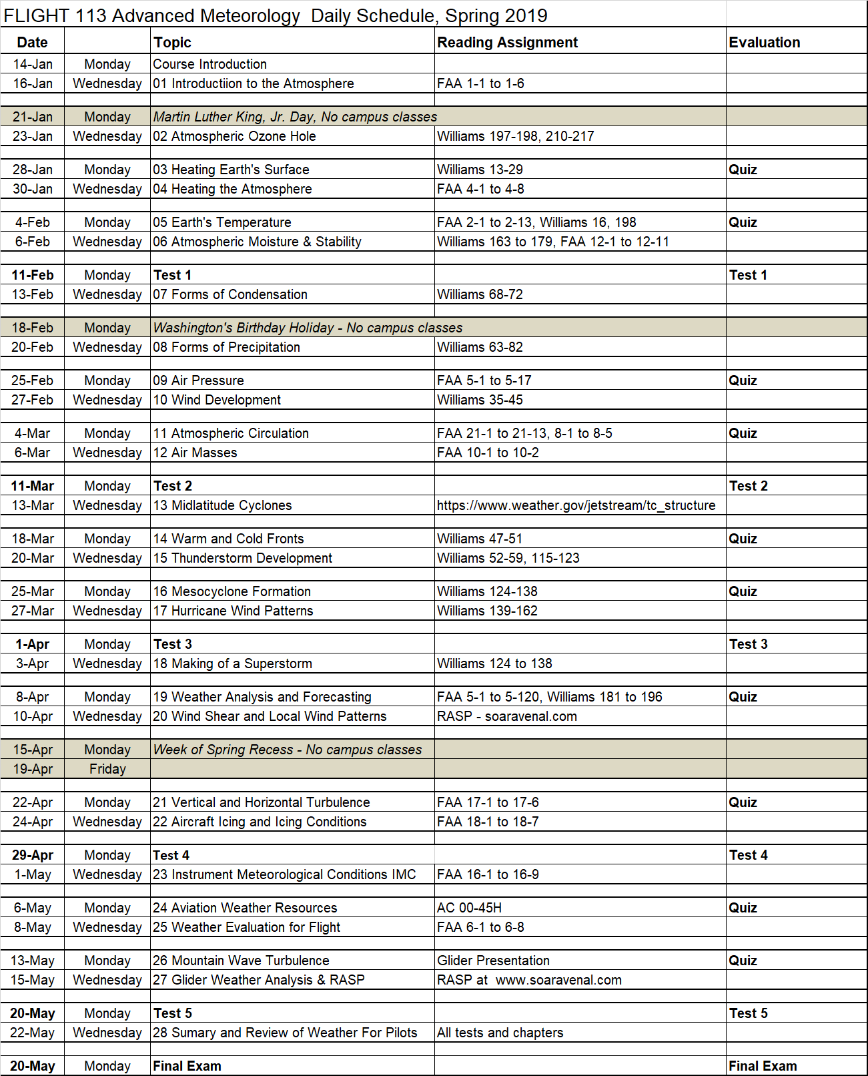

FLGHT 113 Advanced Meteorology (52815) Spring 2019

Instructor: Harold Gallagher e-mail: harold.gallagher@reedleycollege.edu

Office Phone: (559) 638-3641 ext. 3734 Office Location: Reedley College, Aero building, room 8

Cell Phone: (559) 269-7979 Office Hours: M-W-F 11:00 am - Noon or by appt
CLASS LOCATION: Aero building, room 5

DAILY SCHEDULE: MW, Jan 14 – May. 24; 9:00–9:50 am

Final Exam – Monday, May 20, 2019, 9:00 – 10:50 AM

HOLIDAYS (NO CLASS): Jan. 21 Martin Luther King Jr. Day
Feb. 15 Lincoln’s Birthday
Feb. 18 Washington’s Birthday

IMPORTANT DATES: Jan 25 last day to drop for full refund
Feb 1 last day to add a class in person Feb 1 last day to drop in person and not receive a “W” grade
Feb 3 last day to drop in Web Advisor and not receive a “W”
Mar 8 last day to drop but will still receive a “W” grade
May 24 last day of finals/last day of semester

REQUIRED TEXTBOOKS/EQUIPMENT:
- Uniform shirt(s)
- Pencils, pens, paper, 8½ by 11 binder, simple calculator (add, subtract, multiply, divide)
- Williams, Aviation Weather
- AC 00-6B Aviation Weather
- AC 00-45H Weather Services (with change 1)

COURSE DESCRIPTION: Advanced Meteorology is designed to provide an in-depth look at weather and how weather relates to aviation. Some topics of discussion will be weather basics, circulation systems, weather hazards, and applying weather knowledge. This course will prepare the student for more advanced levels of aviation training. 2 credits.

Course Advisories: English 125 & 126, or English 128 & 130, or English 132, & Mathematics 201.
COURSE CONTENT:
Student Learning Outcomes:
Upon completion of this course, students will be able to:
- Describe the effects of vertical motion and stability of the atmosphere
- Classify weather hazards and their impact on aviation
- Analyze air masses and their impact on weather
Objectives:
In the process of completing this course, students will:
1. Describe the effects of pressure on aviation
2. Differentiate the various levels of icing.
3. Evaluate various weather conditions and make a safe Go/No go decision
Lecture Content:
A. Atmosphere
1. Heating, Temperature, Moisture, Stability
2. Precipitation, condensation, air pressure
B. Global Wind Development
1. Atmospheric Circulation
2. Air Masses, Frontal Systems, Cyclones
C. Thunderstorm Development
1. Mesocyclones
2. Hurricane Weather Patterns
3. Making of a Superstorm
D. Weather Analysis
1. Forecasting for Pilots
2. Wind shear and local wind patterns
3. Turbulence, icing, and IFR conditions
4. Mountain Wave analysis and depiction
5. Weather Resources for analysis and flight
6. RASP and Convergence anomalies
E. Pilot Information Management
1. Submit written assignments which include complete sentences, correct capitalization, and spelling.
2. Appropriately use academic language and descriptive vocabulary in written assignments.
3. Complete writing assignments that are free from plagiarism.
4. Apply a variety of vocabulary skills for increased comprehension during reading of flight science texts.
5. Apply pre-reading and active reading strategies to increase success with and comprehension of flight science textbooks.
6. Analyze flight science texts to determine explicit/implicit main ideas and logical support.

GRADING POLICY:

Quizzes (all combined) ------------------------------------------------------------------------------------ 20 points
Test 1 ----------------------------------------------------------------------------------------------------------- 10 points
Test 2 ----------------------------------------------------------------------------------------------------------- 10 points
Test 3 ----------------------------------------------------------------------------------------------------------- 10 points
Test 4 ----------------------------------------------------------------------------------------------------------- 10 points
Test 5 ----------------------------------------------------------------------------------------------------------- 10 points
Final Exam ----------------------------------------------------------------------------------------------------- 30 points
COURSE TOTAL ------------------------------------------------------------------------------------------- 100 points
Grading Scale: 90.0% and above = A
80.0% and above = B
70.0% and above = C
60.0% and above = D
Below 60.0% = F

Scores will not be rounded up - i.e. 89.99% = B
There is no extra credit in this course.
GRADED ACTIVITIES:
Quizzes - All Quizzes are “Open-Homework” in that students may use their hard-copy homework answers notes to answer the quiz questions during the quiz. Quizzes typically have 3-8 questions and are not typically multiple choice. Quizzes will typically be administered at the beginning of every class when that day includes lecture.

Tests - The tests are all “Closed-Book” in that students may not refer to any document during the test. All answers must come from memory. Test questions will be multiple-choice, fill-in, labeling, explanations, multiple sentences, and scenario based questions. All questions will be from homework material and lecture.
Final Exam - The final exam is all “Closed-Book” in that students may not refer to any document during the test. All answers must come from memory. Test questions will be multiple-choice, fill-in, labeling, explanations, multiple sentences, and scenario based questions. All questions will be from homework material and lecture.
UNIFORM SHIRT: Starting on the third Monday of the semester, all students must wear the official Aeronautics uniform shirt during class. An Aero club t-shirt may be worn on the same day as an Aero Club meeting. Failure to wear authorized shirt will reduce student overall course grade by 1% per occurrence.
DAILY CLASS SCHEULE OF EVENTS: See Daily Schedule for calendar of topics, quizzes, tests and final exam.

HOMEWORK: Homework typically consists of reading assignments from multiple sources, answering homework questions from an instructional video streaming on Canvas and from other written sources, plus studying for tests and the final exam.

ATTENDANCE POLICY: The intent of this attendance policy is to ensure:
- The student gains the most from the learning experience of this course and is present to learn.
- The student learns the typical attendance responsibilities when employed as a pilot.

Graded activity will occur nearly every class meeting. Students are expected to be in the classroom and ready to take the daily quiz (or test or final exam) no later than the official start time of the class.

Reading assignments, homework, test dates, etc. may be verbally changed and announced during any class meeting. Students are expected to attend all scheduled class meetings, be punctual, write down verbal directions, and then follow all verbal and written directions. It is the student’s responsibility to find out what was missed if the student is late or absent.
Documented circumstances out of the student’s control will be considered for an excused absence. If a student knows in advance that they are going to miss a class meeting or be absent for any length of time, submit an email or written request in advance to the instructor with name, reason for absence, and a proposed make-up date/time. Provide appropriate documentation. Students will typically be allowed to accomplish the graded activity early, not late. Requests for absences for personal reasons will be taken under consideration and have the same advance request requirements.
If an event is missed for a reason out of the control of the student, the student must call the instructor at least 30 minutes prior to the start of the event if possible, but preferably, as soon as it is apparent that a class meeting will be missed. The student will then need to provide hard copy documentation proving the absence was outside of the student’s control.
If a student has no appropriate documentation that proves the circumstances were out of their control or the student fails to call the instructor 30 minutes prior to the class meeting in case of an illness, it will be considered an unexcused absence.
If a late arrival or absence occurs and is excused, the student has 7 calendar days to make-up all graded activity or a zero will be assigned to that activity. If it was an unexcused late arrival or unexcused absence, then the student has 7 calendar days to make up the work at half (50%) credit.

It is the student’s responsibility to ask the instructor to accomplish make-up graded activity.

STUDENT PARKING: Reedley College parking permits are required for all vehicles on the Reedley College campus. Students will park only in non-staff designated parking areas. An overflow parking lot on the west side of the campus is also available for parking. Students may purchase a parking permit from the business office in the Student Services building for each semester while attending class. Any violation of the above rules may result in a ticket.

STUDENT CONDUCT STANDARDS: Respect for the rights of others and for the College and its property are fundamental expectations for every student. The “Student Conduct Standards” outlines behavioral expectations, and explains the process for responding to allegations of student misconduct. Students who do not comply with the “Student Conduct Standards” are subject to the College disciplinary actions. The Student Conduct Standards can be found at https://www.reedleycollege.edu/about/about-us/policies-and-procedures/student%20conduct%20standards.html
BEHAVIOR: Any behavior which disrupts other student learning will not be tolerated. Here are some examples of inappropriate in-class behavior:

1. Eating of any kind in class or lab. Covered drinks are allowed in classrooms and in the designated area in lab only. No drinks of any kind are ever allowed in any computer lab.
2. Using foul language
3. Total of student voices being louder than the instructor
4. Cell phones ringing or texting during class
5. Horseplay

6. Discriminatory or harassing remarks based on gender, age, national origin, race, or
religion, or disability.

ACADEMIC DISHONESTY: Students at Reedley College are entitled to the best education that the college can make available to them. Students, their instructors, and their classmates share the responsibility to ensure that this education is honestly attained. Because cheating, plagiarism, and collusion in dishonest activities erode the integrity of the college, each student is expected to exert an entirely honest effort in all academic endeavors. Academic dishonesty in any form is a very serious offense and will incur serious consequences.

Cheating is the act or attempted act of taking an examination or performing an assigned, evaluated task in a fraudulent or deceptive manner, such as having improper access to answers, in an attempt to gain an unearned academic advantage. Cheating may include, but is not limited to, copying from another’s work, supplying one’s work to another, giving or receiving copies of examinations without an instructor’s permission, using or displaying notes or devices inappropriate to the conditions of the examination, allowing someone other than the officially enrolled student to represent the student, or failing to disclose research results completely.

Plagiarism is a specific form of cheating: the use of another’s words or ideas without identifying them as such or giving credit to the source. Plagiarism may include, but is not limited to, failing to provide complete citations and references for all work that draws on the ideas, words, or work of others, failing to identify the contributors to work done in collaboration, submitting duplicate work to be evaluated in different courses without the knowledge and consent of the instructors involved, or failing to observe computer security systems and software copyrights. Incidents of cheating and plagiarism may result in any of a variety of sanctions and penalties, which may range from a failing grade on a particular examination, paper, project, or assignment in question to a failing grade in the course, at the discretion of the instructor and depending on the severity and frequency of the incidents.

While in possession of quizzes or tests (either during the exam or during review), student may not take pictures or take notes of any kind on the testable material

DOING WELL IN THIS COURSE: To learn the most from this course, the instructor suggests the following techniques:
1) Maintain punctual and perfect attendance.
2) Show up prepared (having read text, accomplish homework assignments, studied for tests/final exam, and brought equipment (homework, notepaper, lecture notes, pencils, pens, erasers) to class.
3) Study alone plus participate in a study group three times per week (every week) to do practice questioning for each test/exam.
4) Read and follow all verbal & written (syllabus, exams, homework, project) instructions.
5) Use a day planner and refer to schedule of class activities.
6) Get a good night’s sleep, eat healthy, exercise, and stay hydrated.
7) Ask the instructor for additional help.

PROBLEMS: Personal problems that affect your academic performance must be brought to the attention of the instructor immediately. Problems must be worked out in advance. Doing poorly on a graded activity or not showing up for a graded activity cannot be fixed “after the fact.”

CELL PHONE, TABLETS, LAPTOPS: No use of Personal Electronic Devices (PED) (such as cell phones, tablets) in class (laptops/tablets may be used to take notes in class) or in lab without prior instructor permission.

STUDENTS WITH DISABILITIES/SPECIAL ACCOMMODATIONS: If you have a verified need for an academic accommodation or materials in alternate media (i.e. Braille, large print, electronic text, etc.) per the Americans with Disabilities Act (ADA) or section 504 of the Rehabilitation Act, please contact me as soon as possible.

GRIEVANCE PROCEDURE: Every effort is made to treat all students the same. If you feel you have been treated unfairly, please inform the instructor immediately so appropriate corrections can be made. If you have a problem with the instructor or the way this course is conducted, please talk to the instructor immediately.

This page intentionally left blank.

I certify that I have read and understand the syllabus for FLGHT 113 Advanced Meteorology.

____________________________ ____________________________ ________________
Printed name of student signature date

