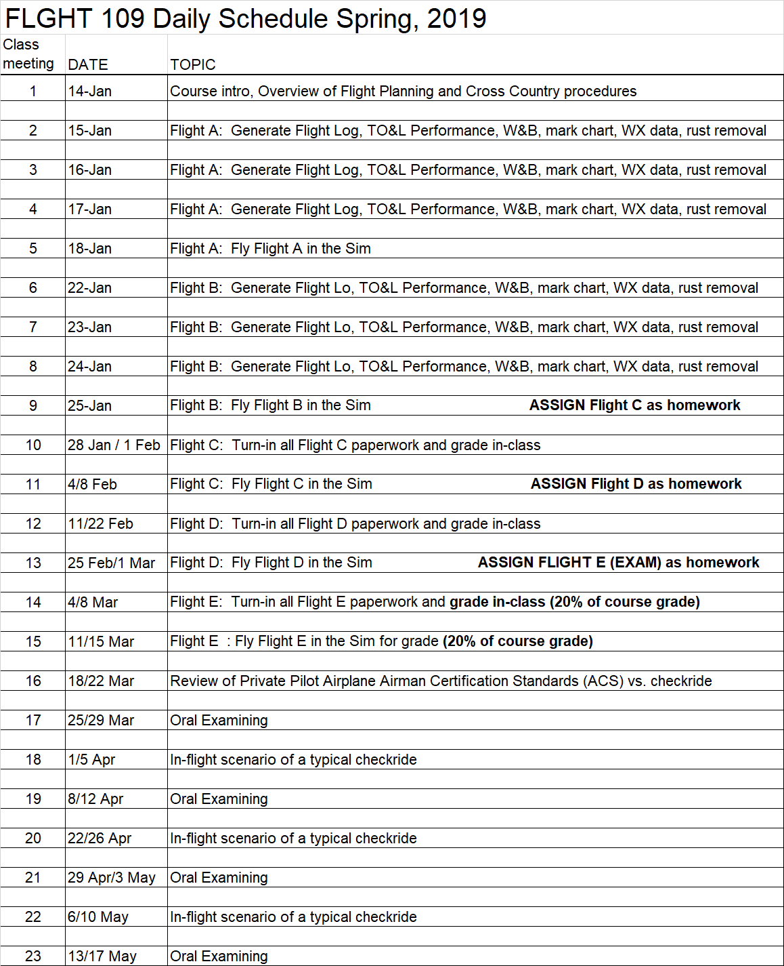

FLGHT 109 Private Pilot 2 Simulation Lab (552695, 55698) Spring 2019

Instructor: Robert Wiens e-mail: robert.wiens@reedleycollege.edu

Office Phone: none Office Location: none

Cell Phone: (559) 960-1194 Office Hours: by appointment only
CLASS LOCATION: Aero building, room 2

DAILY SCHEDULE:

55695 Jan 14-Jan 25: Monday - Friday 10:00AM - 11:20AM and
Jan 28-May 24: Mondays only 10:00AM - 11:20AM

55698 Jan 14-Jan 25: Monday – Friday 11:30AM - 12:50PM and
Jan 28-May 24: Fridays only 09:00AM - 10:20AM

NO CLASS: Jan. 21 DMLKJ Holiday
Feb 15 Lincoln Holiday
Feb 18 Washington Holiday
Apr 15-19 Spring Break

IMPORTANT DATES: Jan 25 last day to drop for full refund
Feb 1 last day to add a class in person
Feb 1 last day to drop in person and not receive a “W” grade
Feb 3 last day to drop in WebAdvisor and not receive a “W”
Mar 8 last day to drop but will still receive a “W” grade
May 24 last day of finals/last day of semester

REQUIRED TEXTBOOKS/EQUIPMENT:
- Uniform shirt(s)
- Pencils, pens, paper, 8½ by 11 binder
- Plotter
- E6-B
- PA-38 Tomahawk or PA-28 Warrior II POH
- Simple calculator
- Chart Supplement
- FAR/AIM
- Private Pilot ‒ Airplane, Airman Certification Standards, June, 2018 - electronic version is okay: https://www.faa.gov/training_testing/testing/acs/media/private_airplane_acs.pdf
COURSE DESCRIPTION: This is the second course using simulation for private pilot flight training. Students will practice post-solo airplane pilot maneuvers in Aviation Training Devices (simulators). Topics covers include cross country navigation and advanced flight maneuvers for the private pilot. 0.5 credits.

PREREQUISITES: Flight Science 107

COREQUISITES: Flight Science 108

COURSE CONTENT:
Student Learning Outcomes:
Upon completion of this course, students will be able to:
1. Perform cross country procedures
2. Perform ground reference maneuvers
3. Perform stalls and slow-flight maneuvers
4. Describe post-solo aeronautical knowledge for the private pilot
Objectives:
In the process of completing this course, students will:
1. Practice cross country procedures
2. Practice ground reference maneuvers
3. Practice stalls and slow-flight maneuvers
4. Practice explaining aeronautical knowledge for the private pilot
Lab Content:
1. Cross country planning procedures
2. Cross country navigation procedures
3. Turns about a point
4. S turns across a road
5. Power on stalls
6. Power off stalls
7. Slow flight
8. FAA regulations
9. Private Pilot limitations and responsibility

GRADING:

X-Country Flight Log Exam (Flight # 5 - homework) ……………………………………………….. 20%
X-Country In-Class Flight (skill demonstration for Flight # 5) …………………………………....... 20%
Average of all other in-class events (skill demonstrations or lab exams – one per day) ............. 60%
TOTAL …………………………………………………………………………………………..……....100%

Overall Course Grading Scale: 90.0 % and above = A
80.0 % and above = B
70.0 % and above = C
60.0 % and above = D
below 60.0% = F
i.e. 89.99% = B (Scores will not be rounded up)

Grades are updated approximately twice a month in Canvas.

If a student earns less than a “C” grade in this course (less than 70% overall), it will not count towards the AS degree in Flight Science, will not count as a prerequisite to another course, and must be re-taken.
ATTENDANCE: This absence policy will be strictly adhered to.

Graded activity will occur every class meeting.

Documented circumstances out of the student’s control will be considered for an excused absence. If a student knows in advance that they are going to miss a class meeting or be absent for any length of time, submit an email or written request in advance to the instructor with name, reason for absence, and a proposed make-up date/time. Provide appropriate documentation. Students will typically be allowed to accomplish the graded activity early, not late. Requests for absences for personal reasons will be taken under consideration and have the same advance request requirements.
If an event is missed for a reason out of the control of the student, the student must call (not text) the instructor at least 30 minutes prior to the start of the event if possible, but preferably, as soon as it is apparent that a class meeting will be missed. The student will then need to provide hard copy documentation proving the absence was outside of the student’s control.
If a student has no appropriate documentation that proves the circumstances were out of their control or the student fails to call the instructor 30 minutes prior to the class meeting in case of an illness, it will be considered an unexcused absence.
If a late arrival or absence occurs and is excused, the student has 7 calendar days to make-up all graded activity or a zero will be assigned to that activity. If it was an unexcused late arrival or unexcused absence, then the student has 7 calendar days to make up the work at half (50%) credit.

It is the student’s responsibility to ask the instructor to accomplish make-up graded activity.

COURSE ACTIVITIES:

The first few weeks of this course are designed to practice and gain skill in cross country flight planning and execution. In-class practice of flight planning forms will be accomplished then that planned flight will be flown on the simulator.

The fifth flight counts for 40% of the grade for this course. Half of this grade is for flight planning documents generated as homework. The other half is for skills displayed during the flight in the simulator.

The remaining class meetings will consist of preparing for and simulating the private pilot checkride. Some labs will be mock oral exams and some labs will be in-flight scenarios of typical checkrides.

It is the student’s responsibility to ask questions concerning any activity. Students are responsible for taking good notes, asking questions if anything is unclear, getting assignments done on time, requesting help if performance in this class is less than what they would expect, deciding on the amount of time and effort spent towards this course, and on study methods used to pass this course.

STUDENT CONDUCT STANDARDS: Respect for the rights of others and for the College and its property are fundamental expectations for every student. The “Student Conduct Standards” outlines behavioral expectations, and explains the process for responding to allegations of student misconduct. Students who do not comply with the “Student Conduct Standards” are subject to the College disciplinary actions. The Student Conduct Standards can be found at https://www.reedleycollege.edu/about/about-us/policies-and-procedures/student%20conduct%20standards.html

BEHAVIOR: Any behavior which disrupts other student learning will not be tolerated. Here are some examples of inappropriate in-class behavior:

1. Eating of any kind in class or lab. Covered drinks are allowed in classrooms and in the designated area in lab only. No drinks of any kind are ever allowed in any computer lab.
2. Using foul language
3. Total of student voices being louder than the instructor
4. Cell phones ringing or texting during class
5. Horseplay

6. Discriminatory or harassing remarks based on gender, age, national origin, race, or
religion, or disability.

7. See attached simulator lab rules

ACADEMIC DISHONESTY: Students at Reedley College are entitled to the best education that the college can make available to them. Students, their instructors, and their classmates share the responsibility to ensure that this education is honestly attained. Because cheating, plagiarism, and collusion in dishonest activities erode the integrity of the college, each student is expected to exert an entirely honest effort in all academic endeavors. Academic dishonesty in any form is a very serious offense and will incur serious consequences.

Cheating is the act or attempted act of taking an examination or performing an assigned, evaluated task in a fraudulent or deceptive manner, such as having improper access to answers, in an attempt to gain an unearned academic advantage. Cheating may include, but is not limited to, copying from another’s work, supplying one’s work to another, giving or receiving copies of examinations without an instructor’s permission, using or displaying notes or devices inappropriate to the conditions of the examination, allowing someone other than the officially enrolled student to represent the student, or failing to disclose research results completely.

Plagiarism is a specific form of cheating: the use of another’s words or ideas without identifying them as such or giving credit to the source. Plagiarism may include, but is not limited to, failing to provide complete citations and references for all work that draws on the ideas, words, or work of others, failing to identify the contributors to work done in collaboration, submitting duplicate work to be evaluated in different courses without the knowledge and consent of the instructors involved, or failing to observe computer security systems and software copyrights. Incidents of cheating and plagiarism may result in any of a variety of sanctions and penalties, which may range from a failing grade on a particular examination, paper, project, or assignment in question to a failing grade in the course, at the discretion of the instructor and depending on the severity and frequency of the incidents.

DOING WELL IN THIS COURSE: To learn the most from this course, the instructor suggests the following techniques:
1) Maintain punctual and perfect attendance.
2) Show up prepared (having read text, accomplish homework assignments, studied, and brought equipment (homework, charts, flight planning documents, plotter, E6-B, notepaper, pencils, pens, erasers) to class.
3) Study alone plus participate in a study group three times per week (every week) to do practice questioning for each test/exam.
4) Read and follow all verbal & written (syllabus, exams, homework, project) instructions.
5) Use a day planner and refer to schedule of class activities.
6) Get a good night’s sleep, eat healthy, exercise, and stay hydrated.
7) Ask the instructor for additional help.

PROBLEMS: Personal problems that affect your academic performance must be brought to the attention of the instructor immediately. Problems must be worked out in advance. Doing poorly on a graded activity or not showing up for a graded activity cannot be fixed “after the fact.”

CELL PHONE, TABLETS, LAPTOPS: No use of Personal Electronic Devices (PED) (such as cell phones, tablets) in class (laptops/tablets may be used to take notes in class) or in lab without prior instructor permission.

STUDENTS WITH DISABILITIES/SPECIAL ACCOMMODATIONS: If you have a verified need for an academic accommodation or materials in alternate media (i.e. Braille, large print, electronic text, etc.) per the Americans with Disabilities Act (ADA) or section 504 of the Rehabilitation Act, please contact me as soon as possible.

GRIEVANCE PROCEDURE: Every effort is made to treat all students the same. If you feel you have been treated unfairly, please inform the instructor immediately so appropriate corrections can be made. If you have a problem with the instructor or the way this course is conducted, please talk to the instructor immediately.

Simulator Lab Room Use Policy

The Flight Simulator Lab is in room 2 of the Aeronautics (AERO) building. The lab equipment consists of seven Fly This Sim TouchTrainer VX BATDs (Basic Aviation Training Devices). This lab is typically open only during scheduled lab class times and as posted on the lab entrance door.

- The simulator lab room (sim lab) is only authorized for use during a scheduled sim lab class or when supervised by a college employee.

- Students shall only use the sim lab for flight training purposes. Entertainment, playing computer games, surfing the internet, accomplishing homework, or other purposes are not authorized at any time.

- Students shall not change settings in X-Plane. Students may use the lower right small touch screen to change aircraft location, weather, time, etc.

- With instructor permission, a student may change which model airplane will be flown (PA-28 instead of a PA-38) and will change it back to original at end of each lab period.

- Students shall not change any computer setting, including the bios, Windows 10, or SimAvio settings.

- Students shall not install any software on simulator computers.

- Food and/or drinks (including water bottles) are not allowed in the sim lab at any time.

- Use of cell phones is prohibited when other students are flying a simulator.

- Pets are not allowed, except for properly documented Service Animals.

- Directions must be followed when given by any instructor concerning equipment/facilities or student conduct that may cause damage to lab equipment or to people or degrades the learning experience of the other students. Failure to do so may result in student disciplinary action, as described in the Reedley College catalog.

This Page intentionally left blank.

I certify that I have read and understand the syllabus for FLGHT 109 Private Pilot 2 Simulation Lab.

____________________________ ____________________________ ________________
Printed name of student signature date

