Fall 2019 English 1A ONLINE

English 1A-50052 and 50053: Reading and Composition

WELCOME!

This class is all about reading and writing. We will be doing a lot of both! I hope you enjoy the texts we will be using. They are some of my favorites as they touch upon many themes such as awareness, choices, responsibility, and thinking critically.

TABLE OF CONTENTS |  |  |  | I hope that you actively participate in class because I have found it to be the best way to learn . . . and it makes the class more enjoyable for all and makes each class go by much faster! --Ms. Karle  INSTRUCTOR:  Professor Carey Karle  E-mail: carey.karle@reedleycollege.edu  Phone: 559-638-0300 ext. 3421  Office Hours – CC1 214  Monday 10:00-10:50  Tuesday 12:00-12:50  Wednesday 10:00-10:50  Friday – Virtual Office Hour 10:00-10:50  Virtual Office Hour is arranged through Zoom
Catalogue Description . . . . . . . . . . . . . . . . . . . . |  | 2
Course Objectives . . . . . . . . . . . . . . . . . . . . . . . . |  | 2
Required Materials . . . . . . . . . . . . . . . . . . . . . . . . |  | 3
Grades, Time Bank, and More . . . . . . . . . . . . . . | 3-4
Attendance . . . . . . . . . . . . . . . . . . . . . . . . . . . . . . |  | 5
Conduct . . . . . . . . . . . . . . . . . . . . . . . . . . . . . . . . . |  | 5
Accommodations . . . . . . . . . . . . . . . . . . . . . . . . |  | 6
Plagiarism and Cheating . . . . . . . . . . . . . . . . . . . |  | 6
Computer Requirements . . . . . . . . . . . . . . . . . . |  | 7
Email . . . . . . . . . . . . . . . . . . . . . . . . . . . . . . . . . . . . |  | 8
Time Commitment / Essential Information . . . |  | 9
Helpful Hints . . . . . . . . . . . . . . . . . . . . . . . . . . . . . |  | 10
Important Dates . . . . . . . . . . . . . . . . . . . . . . . . . . |  | 11
Paper Policy . . . . . . . . . . . . . . . . . . . . . . . . . . . . . |  | 12
Weekly/Semester Schedule . . . . . . . . . . . . . . . . |  | 14

CATALOG DESCRIPTION

Students will read, analyze, and compose college-level prose, with emphasis on the expository; study writing as a process; explore different composing structures and strategies; edit and revise their own writing; and conduct research (gather, organize, evaluate, integrate, and document information), culminating in a term research paper and annotated bibliography. Students will write a minimum of 6,000 words in formal academic language.

COURSE OBJECTIVES

In the process of completing this course, students will:

- Write multiple essays of at least 1,500 words, including at least one research paper with documentation.
  - Arrange and integrate ideas in a multiple body essay, complete with topic sentences, supporting data, and background, as necessary
  - Indicate an arguable thesis
  - Gather, analyze, and synthesize peer-reviewed sources and/or original research, such as interview, survey, or observation
  - Employ MLA formatting
  - Reduce dependence on the instructor’s guidance; students will ultimately independently and accurately recognize and self-correct errors in sentence construction, punctuation, and mechanics
  - Craft increasingly mature and cogent writing while choosing the appropriate tone and academic voice
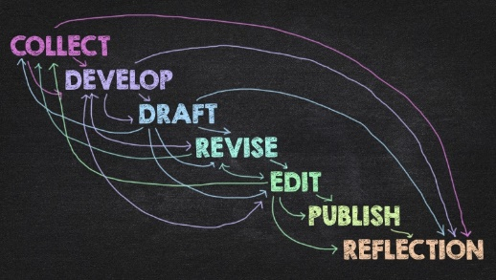
  - Practice sound choices in identifying and avoiding logical fallacies
  - Employ appropriate use of third person universal
  - Identify appropriate audiences for their compositions
  - Employ quotations, discriminating among sources for accuracy and validity
  - Employ MLA formatting guidelines for Work Cited Page and in-text citations
  - Develop an annotated bibliography from sources for a research paper
  - Recognize the appropriate use of sources, while avoiding intentional and unintentional plagiarism

- Write an organized essay with thesis and adequate support independently within a class period.

- Read and understand college level prose, including:
  - Identifying the model, summarizing the thesis, and locating supporting information.
  - Naming rhetorical devices such as irony and parallelism and translating metaphorical language, so as to determine an author’s intent, both explicit and implicit.
  - Answering questions from assigned reading differentiating between an author’s intent and personal reaction.
  - Describing, evaluating, and questioning the purpose, audience, organization, and style of assigned readings.

Required Materials and Texts
- Atwood, Margaret. The Handmaid's Tale. Random House Inc, 2017. (ISBN-13: 978-0385490818)
- Bradbury, Ray. Fahrenheit 451. Simon & Schuster, 2013. (ISBN-13: 978-1451673319)
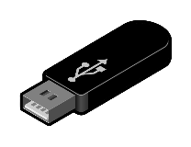
- Flash drive
- Ream of Paper
- Access to a printer

Grading Scale |  | Class participation is truly important and I do hope you will participate. Learning occurs best through participation. To participate, complete assigned reading, writing, and in class assignments; join in the exchange of opinions in group and/or whole class discussion; start appropriate new items for discussion; and, perhaps most important of all, ask questions.
90-100% = A
80- 89% = B
70- 79% = C
60 - 69% = D
0 - 59% = F

I do not accept late work, nor do I allow for make-up work. This means you need to do the work as assigned. However, I do understand that many of you are taking more than one class, have jobs outside of going to school (which I consider a job), have family, etc. Therefore, we have a Time Bank. Everyone begins with four (4) days in his/her Time Bank. These four days can be used all at once or split—as follows:
- one four-day grace period for submitting an essay;
- a three-day grace period for one essay and a one-day grace period for a second essay;
- two (2) two-day grace periods for two essays.

The time bank CANNOT be used for the final Research Synthesis Paper.

Remember, I do not allow for make-up work. This means you need to complete readings and more each week as directed, stay focused, and do the work.

Checking Grades
- Grades are available on Canvas. You should check your grade regularly.
- It is important to understand that grades are based on percentages—not points.
- If a grade has not been recorded, first check with me to see if the assignment (such as a paper) has been graded. Please, do not ask or email a day or two after a paper has been submitted asking for the grade. It does take a week or more to grade papers.
- Also, do not email or ask me “what do I need to get on an assignment to pass the class." You can play the "what if / what score" game on your own through Canvas. As long as an assignment has been created in Canvas, through Grades you can play with scores.

Attendance
- Roll is taken every week through your participation in discussion boards, completion of quizzes, and more.
- I do not distinguish between excused and unexcused absences.
- It is your responsibility to stay informed concerning any changes of assignment due dates, readings, etc.…
- IMPORTANT:
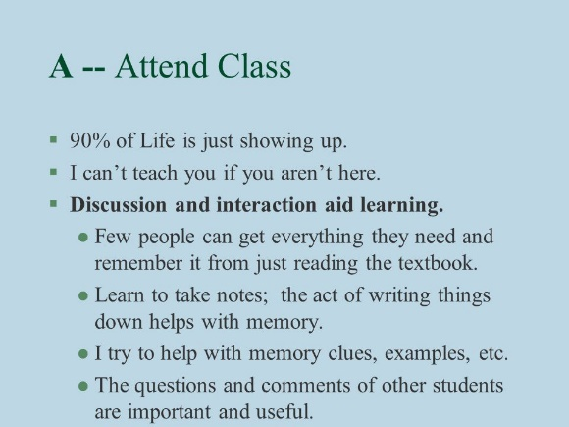
- If you do not complete the work for the first day of the semester, you will be dropped.
- If you complete the first day’s work but not ALL work for the first week—you will be dropped.
- If you have four absences by the end of the ninth week, you will be dropped from the course at my discretion.
- Logging in each week and completing all assignment each week is essential. It does not guarantee a passing grade; however, it is definitely a step on the road to success!

CONDUCT
In order for us all to grow as writers, we need to work together. This can be scary; I understand this. However, in order to learn we need to share our writing. This happens by posting writing to discussion boards when asked, completing writing asked, and reading and discussing our writing. We also need to listen to one another and be respectful of one another.

If you continually disrupt class online, you will be asked to “leave” and, thus, counted as absent for that particular week. If the behavior becomes too disruptive, disciplinary steps will be taken, as per Board Policy 5550, “including but not limited to the removal, suspension or expulsion of a student.”

SCCCD Board Policy 5550 (#11) description of disruptive behavior:
“Disruptive behavior, willful disobedience, habitual profanity or vulgarity, or the open and persistent defiance of the authority of, or persistent abuse of, college personnel, including obstruction or disruption of teaching, research, administration, disciplinary regulations, or other college activities, including, but not limited to community service functions or other authorized activities on or off campus.”

You will get out of this class as much as you put in to it. My job is to help you gain a stronger appreciation for reading and writing and to become a stronger reader and writer. I truly care about your success and will do whatever I can to help you. However, the final responsibility is ultimately yours.

Accommodations for Students with Disabilities
Please, visit our DSP&S office if you are need of academic accommodations. I cannot honor your accommodations if I am not aware of them. This means you need to advocate actively for yourself. Thus . . . if you have a verified need for an academic accommodation or materials in alternate media (i.e., Braille, large print, electronic text, etc.) per the Americans with Disability Act (ADA) or Section 504 of the Rehabilitation Act, please contact me as soon as possible.

Plagiarism and Cheating
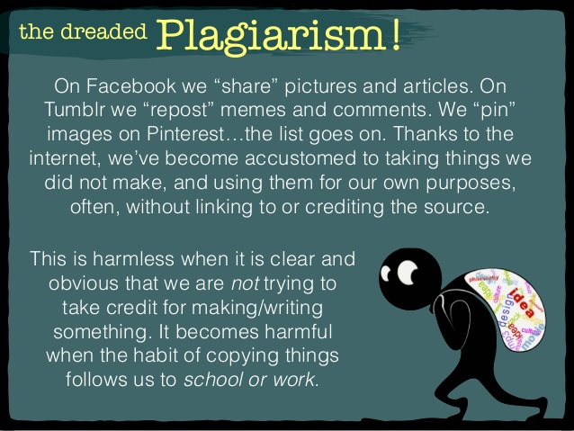
- Plagiarism means to pass off the work of others as your own. Plagiarism is dishonest and represents an attempt to obtain the benefits of a college degree without doing the work
- If it is discovered that you have cheated or plagiarized on an assignment, including discussion boards—at any point during the semester—you will receive a zero on that assignment and perhaps a failing grade in the class. Additionally, a plagiarism report will be filed with the administration. Plagiarism of the final paper for the semester will result in a failing grade in the class.
- For more information about plagiarism and cheating, refer to the Current Class Schedule (Campus Policies).
- Bottom line: Do not copy someone else’s words or ideas without giving him/her credit. Do not use another student’s paper as your own. Do not use a paper you wrote from another class in this class. Do not use a paper you wrote for this class in a previous semester. Do not have another person write the paper for you. All of these are forms of cheating. You will receive a zero on the assignment (whether it is something plagiarized on your papers or on the discussion board) and a report will be filed with the college administration for their review. Please be advised that you will submit the final drafts of your papers through Turnitin.com (through links on Canvas), so if you do plagiarize, you will be caught.
Computer Requirements
This is an online class, so technology is IMPORTANT. You MUST also have a back-up plan for problems with technology. Know where you can go for free Wi-Fi. Know who you can go to for computer use if yours should malfunction. Know where labs are on campus and when they are open. Back up all work in progress and final assignments through email, the Cloud, a flash drive, etc. Review the COMPUTER REQUIREMENTS carefully.

Skills Needed:

Know basics of word processing (saving files, using spell check, using grammar check, moving text, inserting page numbers, creating page breaks, using the Help function, etc.).
- Know how to access and navigate the Internet (use a browser, utilize search engines, save and or print from the Internet).
- Know how to send e-mail and attachments.

Hardware Needed:
- Pentium (PC) or Mac equivalent.

Home Internet access is desirable. You can use the computers on campus, but they are not always available. You need to know when each lab is open and available for drop-in use. Also, know if your local library has computers available with Internet access.
- If your home computer crashes, is in need of repair, or you lose Internet access, you must find an alternative way to complete the required work on time for this class. This means, of course, that you need to constantly back up the work from your hard drive to a flash drive or other source. This also means avoiding completing assignments at the last minute.

Software Needed:
- The most common word processing format is Microsoft Word. If you use another word processing program, you will need to learn to save your work in Rich Text Format (RTF).
- Adobe Reader. This can be downloaded for free. Papers may be returned to you in PDF form. Most handouts will also be uploaded as PDFs.

DO NOT:
- DO NOT send me links to a Google Doc. If you use Google Docs, you MUST copy/save your file in WORD before uploading the file to TURNITIN.
- DO NOT use Pages, Word Pad or Microsoft Works. These programs are not powerful enough AND I cannot read these files.
- DO NOT submit PDF versions of your work! I need to be able to use the Comments function in Word to respond to your papers and other assignments.

EMAIL
- An e-mail address is essential. The college uses college email accounts. You must use your college account for this and any Reedley College class. You can set your scccd.com email to forward to another email account if you do not want to check your scccd.com email regularly

- I use e-mail to communicate with the class as a whole, with groups, and with individuals. Whether you have Internet and e-mail access at home or on campus, you should plan on checking your e-mail at least every other day—once a day is preferred. DO NOT use your cell phone as the primary means of checking/reading email. Phone screens are too small; therefore, you are not easily able to view the whole picture when reading email. Additionally, many phone programs do not allow for spell check on email messages, so refrain from using your phone as a primary means of communication with me.

- When you send an email, you must be specific in the message and always sign your name. Your email address does not necessarily identify who you are unless you are using your scccd account. I do not read or respond to email if I do not know the sender.

- In the subject line, include the class and section number. I teach multiple classes as well as serve as department chair, so I received quite a few emails each day. In order to respond quickly, I need to match you to the correct class—which means you need to add the section number as well (i.e., English 1A-50052 or English 1A-50053).

- In addition, remember, when you email me, your instructor—your English instructor—you are not text messaging or emailing a friend. You need to run spell check and think about the way you are writing, for example, do not use lower case i’s when using the first person pronoun “I”.

- After sending an email, look for a response! This might sound like common sense, but I am always surprised by students who send an email with an urgent question or an important question about a paper or grade, to which I reply in a timely manner with a question or further information, and it takes three or four days for a response from the student, or I see the student in class and he/she states, “Oh, I didn’t check my email for a response.”

- DO NOT use the Inbox system in Canvas to email me as this system does not keep email threads active. If we end up replying back and forth, the original conversation is lost. You can use this function for a quick comment—but not one where an ongoing conversation is likely to take place.

- DO NOT leave questions for me in Grades on Canvas (I know—this one isn’t about email). You can leave a comment in Grades if it is something that can wait until I am actually grading the assignment. If you are asking a question that needs a response BEFORE you complete an assignment and BEFORE I grade said assignment, use your school email account!

- One more note about email—do not send email out of anger or frustration. Do not send an email immediately after seeing a grade if the grade was not what you expected. If you have a question about a grade or comments made on a paper, take some time to think carefully about what you want to ask.

Time Commitment and Essential Information
- English 1A is a four unit class. The average amount of homework for a unit hour is two-three hours. This means that the time needed outside of this class, for this class, is about EIGHT to TWELVE (8-12) hours per week during the eighteen-week semester. NOW, this is an online class, so we need to add the four hours that would be on campus to the EIGHT to TWELVE (8-12) hours per week, bringing the total time to TWELVE to SIXTEEN (12-16) hours needed per week.
- It is important to understand the time commitment necessary to be successful in this or any class.
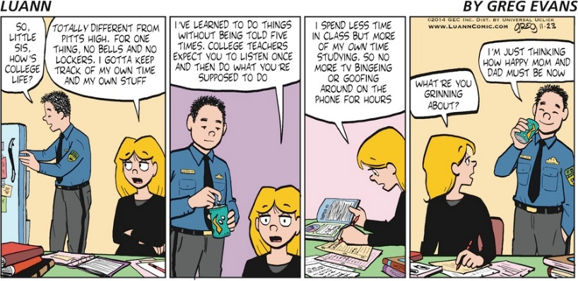
- It is your responsibility to stay informed concerning any changes of assignment due dates, readings, etc. This means you need check email and Canvas regularly. Be aware.
- It is your responsibility to officially withdraw from this and/or any course. Failure to do so may result in an "F" grade being awarded.
- As this is an online class, it is important to understand proper Netiquette. Rules for Netiquette apply in all emails, journals, discussion boards, etc. To review rules, copy and paste this link: http://www.albion.com/bookNetiquette/0963702513p32.html

Helpful Hints
- Keep a copy of each of your papers. This protects you if I should happen to lose one of your papers. You should save your work on your hard drive and back up your work to a USB or other storage device.
- Keep track of your work. You should save all of your work until the end of the semester so you can double check your final recorded grade. Of course, check your grade regularly throughout the semester.
- Should you discover that you are unable to regularly attend class (log in for a week or more) for whatever reason, it is imperative that you discuss this with me as soon as possible. I will do my best to make appropriate accommodations if possible. Telling me of work schedule changes, illness, family emergencies, etc. after missing several days/weeks is unacceptable. The window to make accommodations at that point has closed.

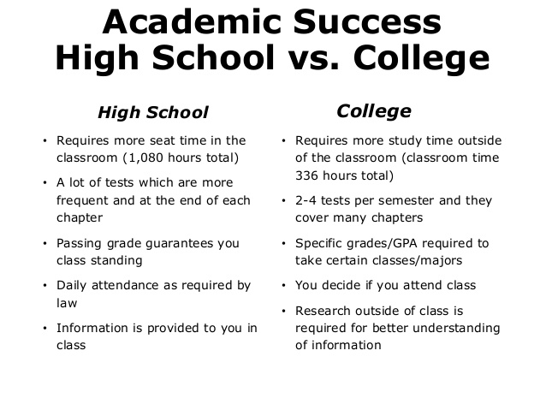
IMPORTANT DATES
August 12 (M) | Start of Fall 2019 semester
August 23 (F) | Last day to drop a Fall 2019 full-term class for full refund
August 30 (F) | Last day to register for a Fall 2019 full-term class in person
August 30 (F) | Last day to drop Fall 2019 full-term class to avoid a “W” in person
September 2 (M) | Last day to drop a Fall 2019 full-term class to avoid a “W” on WebAdvisor
September 2 (M) | Labor Day (no classes held, campus closed)
September 20 (F) | Last day to change a Fall 2019 class to/from Pass/No-Pass grading basis
October 11 | Last Day to drop a full-term class (letter grades assigned after this date)
November 11 (M) | Veterans Day observed (no classes held, campus open)
November 28-29 (Th-F) | Thanksgiving Holiday (no classes held, campus closed)
December 9-13 (M-F) | Fall 2019 final exams week

OUR FINAL: MONDAY, December 9th 11:00 PM

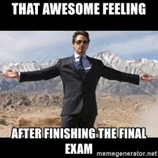
Paper Policy
All papers must be typed, saved as WORD files, and follow MLA guidelines. Read and review the PAPER POLICY below carefully.

- All papers must be revised and typed in accordance with MLA guidelines. It is expected that you learn various functions in WORD to format your papers correctly. Watch the MLA format video carefully, use the HELP function in WORD, and google “how to X” as needed. MLA guidelines will also be taught in class.

- All work leading to your final paper must be kept—for example, all prewriting, rough drafts, peer responses, and any other work produced. There are no exceptions to this policy.

- Word Processing Formats: The most common word processing format is Microsoft Word. If you use another word processing program, you will need to learn to save your work in Rich Text Format (RTF). Do not use Microsoft Works or any other program that does not allow for easy conversion. Using WordPad is unacceptable. If you have Pages, you must learn to convert files to WORD so they can be submitted to TURNITIN and read by others. I do not accept Pages files, Google Docs, or PDF files!!!

- If a paper is due and you cannot access Canvas, probably Canvas is down. Don’t stress—wait a little bit and try again. When this happens, watch for email messages from me. Of course, if a paper is due and the Canvas is down, I will not hold you to the original due date. I will email and post to Canvas (once it is up again) the revised deadline.

- All papers will be turned in through TURNITIN through links on Canvas. TURNITIN is a website that detects plagiarism. This means that if you copy and or copy/paste writing from a website, another published source, or from a previous student of mine, without properly quoting and citing the source or sources, the plagiarism will be detected. You will be “caught.”

- Should I discover while reading your paper that you have not run spell check or sufficiently proofread and edited your work, I will discontinue reading and return the paper to you. You will then have until the following week to revise the paper (the return date will be clearly marked for you). The highest grade such a returned paper can receive is a “C.”

- You will be required to share some of your papers in progress for peer review. We will have at least one type of Writer’s Workshop for each paper. All students are required to share or post a rough draft or outline (as directed) for each Writer’s Workshop (with minimum writing completed as announced). The Writer’s Workshop will take place in class and/or on the discussion board in a forum set up specifically for each paper.

- We will be doing various types of writing assignments this semester—and each paper will be based on a reading. Before beginning a paper, a discussion will be completed. The discussion boards receive a grade separate from the paper.

- With all our writing assignments, process will be focused upon as well as final product.

- At my discretion, sentences and/or paragraphs may be taken from papers or other assignments and shared with the class to help illustrate grammar concepts, writing concepts, MLA guidelines, and more.

- Graded papers are returned to you through the GRADES section of Canvas as quickly as possible. It is expected that you open, print, and read all comments on all returned papers. They contain comments about the paper and about writing to help you grow and improve as a writer.

- If something happens to your computer and/or Internet and a paper (or other assignment) is due, email me, of course, using another computer or your phone. Do not wait until everything is back up before contacting me. Moreover, you need to back up your work on a moveable storage device. Public libraries have computers with Internet access—work can be completed in places and on computers other than those we have at home!

- One final note: NEVER submit a paper through grades. I will not grade papers found there. All essays/papers must go through the TURNITIN link. NEVER leave questions in grades as you will not get a response until I am actually grading said assignment.

Semester Overview
The schedule below is an overview of assignments and due dates for the semester.
All assignments and due dates are subject to change.
This overview does NOT include all assignments.
Pay attention to announcements in class for more, more, and more!

Week 1 | Syllabus – Writing Questions - Group Work - Introductions  Purchase Texts  Quiz-1: Syllabus Quiz and Paper Policy Quiz  Timed Writing | Week 10 | Read Atwood (pages 1-99)
Week 2 | Weekly individual schedules  Plato “The Allegory of the Cave”  Summary – Part One | Week 11 | Read Atwood (pages 100-195)  Group AWC
Week 3 | Continue Plato  Summaries Parts Two and Three | Week 12 | Read Atwood (pages 196-295)  Class—skim “Historical Notes (299-311)
Week 4 | Plato – Comparison Paragraphs  Putting it all together | Week 13 | Writing Workshop  Essay-3 due  Reflection (timed writing #4)
Week 5 | Writing Workshop  Essay-1 Due  Reflection (timed writing #2) | Week 14 | Research Synthesis guidelines  Prospectus due  Research sharing
Week 6 | Read Bradbury (1-65) | Week 15 | AWC work – AWC due
Week 7 | Read Bradbury (67-106) | Week 16 | Final Revision Due  Thursday NO CLASS / Thanksgiving
Week 8 | Read Bradbury (107-158) | Week 17 | Writing Workshop  Research-Synthesis Paper Due – Late work NOT accepted
Week 9 | Writing Workshop  Essay-2 Due  Reflection (timed writing #3) | Week 18 | Finals Week – Our Final:  Monday, December 9 11:00 PM

