English 1A: College Reading and Composition

Summer 2018
Instructor: Ms. Huertaz/Prof. Huertaz
Email: Jacqueline.huertaz@reedleycollege.edu
English 1A, CRN: 73635-2018SU
Office Hours: (by appointment)
Room: Humanities Room 62
Class time: MTWTH 11:00-1:50

Prerequisites: Successful completion of English 125 and 126 with a “C” or better or an equivalent college course; or eligibility determined by the Reedley College Placement Procedures.

Course Overview
This course is designed to cultivate critical thinking skills through reading, writing, and analyzing rhetorical compositions at the college level. Emphasis will be placed on exposition: studying writing as a process, exploring different composing structures and strategies, editing and revising, conducting research, and learning to critique peer writing. Students must successfully complete written course work to the spirit and letter of what is expected in this class to receive credit.

Writing is not just a demonstration of one’s ability to write. Writing is a tool, a strategy for generating ideas, for analyzing information, for inventing responses, critiquing your own thoughts, or creating a record of your thinking. In this class writing will serve many purposes. Consequently, you will be asked to write for many different reasons; thus, your writing will not simply be a reflection of your competence, it will be a representation of your engagement in the class. Using research strategies, you will also be expected to incorporate material from outside sources to support your own position in a persuasive argument essay.

Required Texts/Materials:

Bullock, Richard, Goggin, Daly, Maureen, The Norton Field Guide to Writing 4th edition ISBN# 978-0393617375

Gay, Roxane Bad Feminist ISBN# 9780062282712

Optional: Hacker, Diana and Nancy Sommers. A Pocket Style Manual 7th. Edition. ISBN# 9781319083526

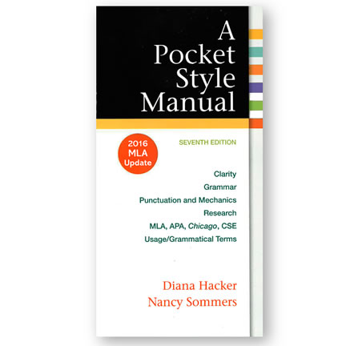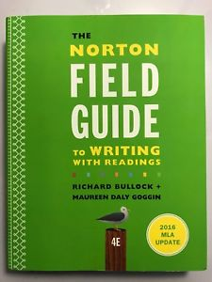

- Handouts (provided by instructor, and must be brought to class.
- Money set aside to copy individual writing projects, readings, and other copies.
- Flash/jump/thumb drive for saving assignments during lab hours
- Access to Canvas (CV) and SCCCD email account.
- A notebook/journal for taking down lecture notes, taking quizzes, etc.
- A folder for all passed out handouts (bring to class always)
- Access to a home/library computer and printer.

Course Content
This course will focus on analyzing readings from the textbook, a longer work, and your own research. The course will be divided into three major writing projects and a final essay exam. There will also be lots of in-class activities and a midterm exam. The focus for this course will be analysis of the rhetorical framework of both visuals and texts. Each final paper will be preceded by drafts, and all writing assignments must be completed to pass the class. You will be expected to participate in a workshop for each essay. Also, you will need to contribute to class discussions in the classroom. Growth comes from practice; therefore, all assignments are used to calculate the final grade.
Course Objectives
Upon completion of this course, students will be able to:
- Write a documented research paper that includes:
- A sophisticated introduction, multiple body paragraphs, and conclusion
- A clearly defined, arguable thesis sentence
- Supporting details that exhibit critical thinking and use credible secondary sources
- Correct usage of MLA format, including a works cited page
- Sentences that exhibit a command of the complex/compound with minimal comma splices, sentence fuses, fragments, and other mechanic problems
- Controlled and sophisticated word choice
- An avoidance of logical fallacies
- Demonstrating an awareness of purpose and audience
- Appropriate and purposeful use of quotations
- Correct in-text citations
- An annotated bibliography of multiple sources
- An avoidance of intentional and unintentional plagiarism
- Complete a timed essay independently in class
- Summarize and comprehend college level prose (will include a full reading)

Course Requirements
Homework: Your homework will consist of writing assignments that will improve your skills as a writer. Most homework assignments, unless specified, will be uploaded to Canvas and will be due at a designated time before class. All assignments must be turned in on time for credit. Late assignments will not be accepted, and the canvas thread will close at 11:59pm the night before an assignment is due. I will only accept late assignments if your extenuating circumstance was approved by me.
Small Groups, Class Discussions, Workshops: Class participation is mandatory and will be a necessary part of your success in this class. Therefore, you will need to come to class prepared with homework done and ideas to share – everyday. Graded class participation will include small group activities, small group workshopping, and large group discussions. You will be placed in group that you will work with all semester. However, from time to time I will have you work in new groups to gain new insight and perspective. I reserve the right to do random book checks and surprise quizzes.

Writing Projects: Writing is not just a demonstration of one’s ability to write. Writing is about thinking on paper. It is about learning something new. It is about expressing important ideas and making your own meaning from the ideas expressed by others. It is about connecting to an audience. The writing I will ask you to do will emerge from the concepts, processes, and issues that we will read and discuss in this class. All of these writing projects will encourage you to choose topics that are important to you that connect to the texts we will read in class. This semester you will write three major papers. Each of these papers will involve multiple drafts and writing workshops. I will give you writing prompts at the beginning of each project so that you have a clear idea about what you are required to do in these papers.

As we move through the course, each writing project will challenge you to add more knowledge, skills, and practices of writing to what you already know from the assignment before.

Specifications: All writing projects must be formatted with one-inch margins with 12-point, Times New Roman font. The length of these writing projects will vary from 4 to 10 pages. Work will be turned in on Canvas and class. **A Works Cited page is mandatory for all essays and an annotated bibliography will be required for the research essay. All writing must adhere to MLA guidelines. If your paper does not have a work cited page it will be marked as incomplete and you will not receive credit.

Reading: Reading and writing go hand in hand. The reading we will do in this class will be necessary for our topics of class discussion, for modeling approaches to writing, and for developing a better understanding about form, rhetorical approach, and the use of evidence in writing. I will expect that when a reading assignment is due that you will have read the text actively; that is, you will have annotated your text, will have questions to ask, and will be ready to engage in conversation with others about the reading. You will participate in small group and whole class discussions of the reading.

Breakdown of points for assignments

Cultivate Community Project 50 points
Group Work 50 points
Mid-term presentation 50 points
Book Critique 50 points
Annotated bibliography 50 points
Self-Motivation essay 50 points
Journals 75 points
Reading Responses 75 points
Quizzes 100 points
Citizenship and Attendance 100 points
Workshop 100 points
Pop Culture Argument essay 100 points
Research argument essay and plans 200 points
Final Timed Essay in Class 100 points

= 1000 points

Grading Scale
90-100% A
80-89% B
70-79% C
60-69% D
0 -59% F

Warning:
*You will need a “C” to pass this course and to count as transfer credit.

You must complete all required writing to receive credit for the course. Completing all the major essays, short writings, drafts, and peer responses to the best of your ability will help improve your writing—and therefore your final grade. There may be opportunities for revisions for extra credit. As with any college class, grades can change significantly due to a single missed assignment or project. **Do not presume if you are receiving a certain letter grade on most your assignments that it will be reflected in your final grade for the class. The point system and your overall performance in class will be strictly enforced.
**Rules for Essays: For every day your papers are late, you will receive a 10-point deduction on your essay grade. Again, not turning in your essays is NOT an option in the class if you want to receive credit for this course. Keep in mind, every ten points is a letter grade. More importantly, the points will be deducted after I determine your earned grade.
**Attendance: Attendance is highly important and if you fall behind in the daily assignments you cannot make them up. You will be required to do daily writing assignments in class and points will be given. You will be expected to come to class prepared to discuss the homework assignment.

To note: I understand that this is an early morning class, let’s do our best to be on time. Make sure to prep yourself for fog and bad weather. Feel free to bring coffee. If you are late please take a seat in the back of the classroom and to wait to sign in during break.

ABSENCES
Students absent the first day of class will be dropped, unless prior arrangements have been made. Students who miss two classes the first week will also be dropped, no exceptions.

You are allowed One excused absence for our summer session. Use these absences wisely and sparingly. If you are absent beyond your allotted excused absences your overall grade will drop by one letter grade. Keep in mind that I will not tally up your absences until the end of the session. It is up to you to keep track. For example if you have a solid “C” grade in this course by the end of the session, and have exceeded your number of absences, your grade will still drop and you will not pass this course. In addition you will also receive citizenship points. If you are absent, disruptive, on your phone you will not receive these points. These points will be added to your overall grade at the end of the semester.

To note: If you decide to use your “excused absences” on a workshop day or a day when a major project or essay is due you are not exempted from the work. You still have to turn in on time or make arrangements to turn in the work beforehand.

Pay Attention:
If you are absent it is your job to touch base with someone from class and collect the notes from that day. It is not my job to give a second lecture via email because you decided not to come to class. More importantly, this is your education and your responsibility. If you want a re-cap of a lecture, I will ignore your email.

**If you are absent from class, it is your responsibility to check on announcements and changes made to the schedule.
Tardiness/Leaving Early: Arriving more than 10 minutes late or leaving more than 10 minutes before the end of class will constitute an absence.

Additionally, every three tardies (lateness less than 10 minutes) will constitute an absence. You are to write a “T” for tardy next to your name when you sign in. Please be honest and make sure to do so.
On days that the weather is bad, such as fog, and rain, I will not penalize you. I imagine the majority of students commute from out of town, so safety first. I do not want anyone to stress, and emphasize that everyone drives responsibly. There will be a grace period for bad weather days.

NOTE IMPORTANT DATES:
The deadline to drop for a refund is June 18th.
The deadline to add a class is June 18th.
The deadline to drop a class to avoid a “W” is June 25th (in person)

Please Note: If any changes are made to the syllabus or class schedule it is your responsibility as a student to make sure you are on top of all changes. Keep an eye out for emails, announcements, and/or ask a classmate.

Writing Assignments

Low-Stake: 50 points each

Create Community project: In your assigned groups you will develop three ideas to cultivate community in our classroom. Your ideas must be reasonable. As a group you will write a one-page letter describing your ideas, along with either a poster board or power point.

Essay One: Self -Motivation Letter: You will write a two-page letter addressed to yourself that outlines a plan for your success in this class and in college. (hardcopy)

Book Critique: You will write a two-page critique on your leisure book. In the critique you will summarize, quote passages, and bring in multiple conversations that speaks to your larger conversation. (hardcopy)

High stake: 100-200 points each

Essay Two: Pop Culture Argument: You will write a 4 page essay that opens, develops, and closes an argument about popular culture. You must use a minimum of three outside sources to have a conversation about your argument. (Electronic submission)

Research Essay, Discourse Community Argument: You will open, develop, and close an argument about an issue within a discourse community that you belong to. Must be at least 8-12 pages and make use of at least 6 credible sources. At least one of these sources must be a peer-reviewed journal article. Typed, double-spaced, Times New Roman 12pt. font. MLA Format. Must include Works Cited Page. Each essay should have a 1-page cover letter that explains your journey writing this paper. (Electronic submission)

Research plan includes:
1) working thesis statement
2) six quotes from text,
3) annotated bibliography with one peer reviewed source
4) three specific things you plan to work on.

Discourse Community Argument Research Essay
1) 8-12 pages
2) 6 credible sources (at least one peer reviewed)
3) Work Cited Page
4) 1-page cover letter that explains your writing journey and process.
5) MLA format

**Final: Timed Essay on “Bad Feminist” Open Book

100 points

In preparation for your Discourse Community research essay, you will submit a plan that demonstrates your writing and research process. See example on Canvas.
These plans will include the following: (1) Working Thesis (overall argument). (2) Six Quotes from texts with one to two sentences about how they speak to your overall argument. (3) Annotated bibliography with six sources (4) List three specific things you plan to work on next and explain why.

Peer Workshop: 50 points Twice this summer session, you will bring a typed copy of a draft of your research essay to share with your group. The draft must be at least 3 pages. You will also read your group’s drafts and give them feedback. Learning how to ask for feedback and learning how to give feedback are essential tools for college writing, so participation in these workshops should be taken very seriously. You will receive 25 points for the draft and 25 points for participating. If you cannot make it to the workshop date, you may give your group your paper prior to the workshop date. However, I will need to see the copies before they are distributed and you will not receive the participation points.
(Quintana, Monique 2018).

Assignments continued…
In addition to your writing assignments you will be required to purchase a notebook/journal that you will write in everyday we meet for class. You will turn in this notebook at the end of the semester. Also, you will purchase or checkout a leisure book of your choice. Your book can be from any genre; fiction, non-fiction, comic book, memoir, or a young adult series. I encourage you to select something that peaks your interest. If you’re having trouble locating a book, a place to start is to research your favorite movie or TV show, most likely they were based on books. For example: X-Men or The Walking Dead. You will also be required to do a mid-term project with your assigned group and present the project to the class. Moreover you will be required to do reading responses on various assigned reading from the text and Bad Feminist.

Subject Material:
During the semester, you will be required to read and watch material that is “R” rated. We will discuss public and social injustices. We will discuss marginalized communities, racism, and feminist texts. We will discuss, at times, issues that will push your thinking and challenge your belief systems. I strongly encourage you to have an open mind and to enter these discussions with sensitivity and awareness. If you have a problem with this, and do not follow my guidelines please consider dropping.

A guide to emailing your professor
Many of the answers to your questions can be found from this syllabus, Canvas, and your Student Success Groups. If you need further explanation, please feel free to email me. If you are going to be absent once or twice during the semester, than no email is necessary. If you will be absent more than this, due to an emergency or other circumstance, please keep in contact and keep me aware of your situation. You will address me as Dear Ms. Huertaz, or Prof. Huertaz.

You Should include the following in the subject line of your email:
Full Name, Class Title, Section Number , Subject of Email

Example: Brent Staples, ENGL-1A-29864, Office Hours Appointment

Remember that your approach to emails is a reflection on you as a student. Please use a professional tone of voice in your email and proofread before sending. I want to be able to fully understand what you are saying, so I can help you as best as I can. Keep in mind I will only respond to professionalism.

Be Prepared to Print

Please make arrangements to print your drafts and other assignments before they are due. The library does not open till 7:30 am. I expect everyone to arrive with printed copies of their essays on workshop day. If you have to leave class to print your rough drafts you will docked immensely because you are disrupting workshop and have not come to class prepared. With that being said keep in mind of due dates and make sure to have funds available on your card to print. I will not accept rough drafts via email for credit.

What is the Cellphone and Electronic Policy?
You should not be texting or using cellphones, laptops or other e-devices, unless I give you permission to use them for in-class research purposes. You should save texting and phone calls for our designated break-times. If you must text or make a call, you should quietly step outside of class. If you use your phone or other devices excessively in class, I will give you a warning, the second time you will take an absence for that class. After the warning, I will not tell you again I will simply mark you absent. Checking your phones or being on your phones is disruptive and rude and will affect your participation points in my class. If your leisure book is located on an app on your phone, this must be cleared by me.

Computer Access is REQUIRED!
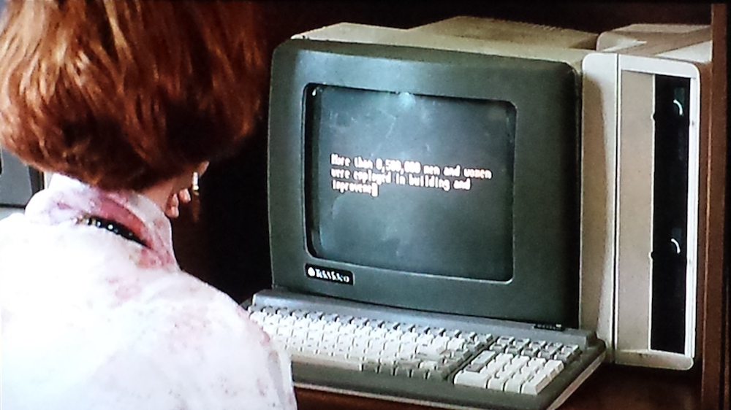

Keep in mind: the majority of our work will be done on Canvas.
- If you’re not familiar with canvas, please make the time to familiarize yourself. If you’re having trouble and cannot view the course on canvas you will have to enable the class in the settings option. It is your responsibility to call canvas and fix this problem. Call Canvas or the SCCCD Helpdesk first before contacting me.
- Reedley Canvas Support
(844) 629-6837
- SCCCD Helpdesk
(559) 499-6070

You are required to have a regular computer, Internet access, and ability to print documents for this class. Do not attempt to do your assignments on a phone or tablet without a keyboard. You will have readings uploaded to Canvas that I will require you to read, print, and bring to class. Accessing assignments via Canvas is a requirement, and it is important that you are able to print the assignments that I do not print for you. If you do not have a home computer or the ability to print, you can do both in the library. I will only accept Microsoft Word electronic submissions. Not Google Doc. Not Notepad.

Warning:
Your electronic submissions must be formatted with Microsoft Word. If you upload your papers and it is not Microsoft Word, I cannot give you feedback. More importantly, I will not read your paper, I will ask you to fix, and it will be considered late.

**If you do not have Microsoft Word on your personal computer at home, you may have to buy the software. An alternative is to use the library on campus.

Be Present and Not Just a Body in the Room.

If you come to class and do not make an effort to actively engage in classroom activities and discussion you are not participating and I will mark you absent. If you come to class unprepared, play on your phone, or fall asleep you are not participating and I will mark you absent. If you come to class to just chat with friends and be disruptive I will mark you absent and ask you to leave my class. If your bad behavior continues I will drop you from my course.

Please note: Even if English is not your major, I encourage you to enter this class with an open mind and to make an effort to make connections to the different texts that are presented in this course. What you learn in English is used across all disciplines and will be beneficial to you throughout the entirety of your academic career.

Don’t be an Asshole
You need to be respectful to myself and to your fellow classmates. Be mindful of your tone and sensitive to your peers. Do not talk over people or undermine their experiences. Bullying will not be tolerated. Passive aggressive mannerisms such as remarks, will not be tolerated. Intimidation and creating a hostile environment because you disagree with a larger conversation or with your peers personal experience will not be tolerated. You are to act professional in my classroom. If you do not follow these rules, I will ask to leave. If your behavior persists I will remove you from my class.
Be aware. Be mindful. Be courteous.

Have an Open Mind

As I stated previously we will be reading, discussing, analyzing, and deconstructing texts that are weighted—meaning the larger conservations of a story, poem, news article, advertisement or contemporary issue may disagree with your personal and social political beliefs. For example: we will discuss feminism, institutionalized racism, white privilege, rape, gender expectation, sexism, misogyny, sexual assault, and marginalized communities (to name a few). In order to thoroughly analyze a text we must discuss these larger conversations and how they are connected. In addition, this is how you will begin to think critically about a text. Which is one of the main goals for this course. I encourage you to have an open mind and to enter into these discussions with an unbiased viewpoint. Remember this is a college course and I expect everyone to have an open mind, even if you do not agree, leave your prejudices at home. Leave your ego at the door. You are students of academia now, and I expect you to act accordingly. If you fail to comply, you will be removed from this course.

Create Community

As students of academia your job is to cultivate community in the classroom. What I mean by cultivate community is to be the best version of yourself. To ask question, to listen to your peers, to be helpful and kind. Don’t be afraid to speak to the person behind you, in front of you, or next to you. Spark a conversation, help a fellow classmate, stick up for someone, create a study group. Utilize the people and resources around you. If someone hasn’t purchased a book because of financial reasons perhaps share, or make copies for them. Be positive. Give someone props, a high five, a smile, for a good idea. Don’t be afraid to be speak up to people that are mistreating other students in class. More importantly, just be aware and kind, and think of ways to bring peace and solidarity to our classroom.

This is a Safe Space

“You don't get to turn someone's sanctuary into an unsafe space.”
― Darnell Lamont Walker

In my classroom you are students of academia. You are community builders. You are the best version of yourself. I want to express, and more importantly emphasize, that our classroom is a safe space for learning. Our classroom is a safe space for innovation, ideas, and inquiries. Our classroom is a safe haven and a peaceful environment. Anyone that disrupts our peace and creates unsafe spaces for students will be removed from this course. If anyone is disrespectful to their peers or myself, I will ask you to leave and drop you from my course. **In addition, homophobic and misogynistic rhetoric will not be tolerated. I take this very seriously—if I hear a student entering into these discourses, you will be removed from my class. If our larger conversations challenges your belief systems, and ideologies, in way, where you can’t be open minded, DON’T TAKE MY COURSE.

Your Education—Your responsibility
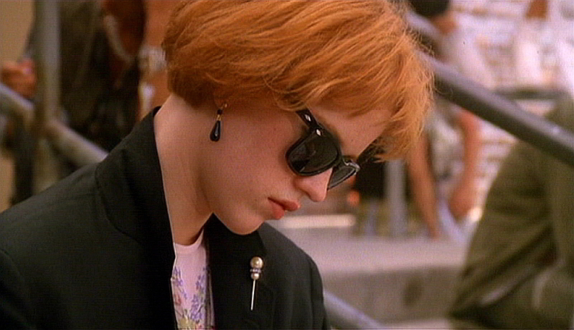
Lastly, I want to emphasize that this is your education, thus your responsibility. I am the facilitator of information, your mentor, instructor, and guide guru through this course. It is up to you, check announcements, to do the work, turn it in on time, take notes, ask questions, and be punctual and aware throughout the duration of this course. You are responsible for your grade, not me. I don’t want to hear excuses, I want to see action.

College Policies

Plagiarism

By enrolling in this course, you join a community requiring academic integrity. When you write your name on an assignment, you take credit for the work contained, whether that be an entire text or only a sentence. Plagiarism, cheating, and other forms of academic dishonesty demonstrate a disrespect of the community and will not be tolerated.

Remember to always quote and cite your sources appropriately, even if they are unpublished or from friends or classmates. An unacknowledged paraphrase, a patchwork from several sources, as well as the submission of someone else’s work (published or not), all constitute plagiarism in the eyes of the college, and will result in a failure of this course. Please ask questions if you’re ever unsure BEFORE you turn in work. Ignorance IS NOT an acceptable excuse. Scholars would agree that “plagiarism is a specific form of cheating: the use of another’s words or ideas without identifying them as such or giving credit to the source” (excerpt from CSUF’s Policies). You will automatically receive zero points on the assignment and the incident will be noted on your academic record if you are caught plagiarizing.

Authority and Disciplinary Actions
Instructors shall be in charge of their classes and students are under obligation to respect the authority of each instructor. Reedley College seeks to develop responsible, democratic citizenship among the students enrolled. Students are responsible for their conduct. Failure to adhere to the college’s standards will result in disciplinary action. The college reserves the right to exclude at any time a student who violates student conduct standards and/or is not taking proper advantage of the opportunities offered. (See Student Right to Know on page 10). Reedley College reserves the right to exclude at any time a student who, in the judgment of the administration, is not taking proper advantage of the opportunities offered.
Important:
In accordance with student conduct policy, if you are disruptive, and disrespectful, to myself, and to the atmosphere of my class, I will ask you to leave and not return for the following class session. Your removal from class will count as absences against you. I will fill out a disruptive behavior report and recommend suspension or removal of my class depending on the severity of the situation. If you are caught cheating such as plagiarizing information on a paper I will fill out an academic dishonesty grievance against you. The end result may be removal, fail from class, or expulsion from school depending on the severity of what occurred.

Accommodation: If you have a verified need for an academic accommodation or materials in alternate media (i.e. Braille, large print, electronic text, etc.) per the Americans with Disabilities Act (ADA) or Section 504 of the Rehabilitation Act, please contact me as soon as possible.

