Intermediate Ceramics
Fall 2018
Art 36-53978-2018FA
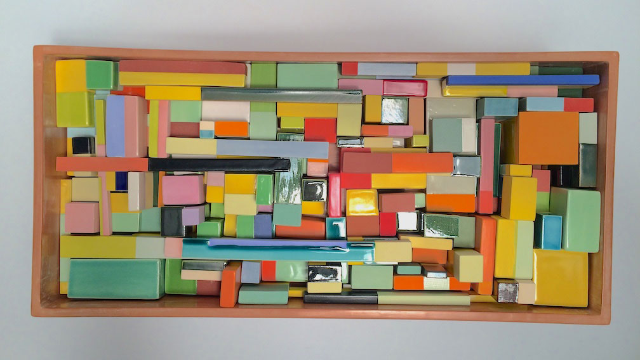
Ceramics Resource Site: www.centralcalclay.comand Reedleyclay on Instagram
Instructor: David Hicks
e-mail: david.hicks@reedleycollege.edu
Office Hours:
Monday – Thursday 8:00 am – 9:00am Art Rm.155
Fridays 8:00 am – 9:00 am via Phone at (559) 697-5709

Catalog Description:
This course will focus on intermediate-level throwing on the potter's wheel. This course will explore use of the potter's wheel as a tool for self-expression and will include the study of clays, glaze formulation and history of the potter's wheel.

Instructors note:
Students enrolled in this course will find them selves in a uniquely diverse group of ceramics focused student. Assignments and projects presented will be formatted in an open concept manner. This means that assignments will be universal in theme and be approachable regardless of skill level and building method. Students in Art 36 are expected to look at all content through the lenses of a potter or wheel-throwing artist.

Course Objective:
In the process of completing this course, students will:
1. Demonstrate through their work an historic and multicultural awareness so far as it relates to ceramics.
2. Demonstrate considerable skill on the potter's wheel.
3. Show an understanding of three-dimensional design as it relates to ceramics.
4. Demonstrate an understanding of glaze formulation by working with empirical formulas and firing glaze test samples.
5. Analyze various clay bodies.
6. Show a basic understanding of ceramic kilns and how to fire them.

Assignments/Grading Policy:
The overall course grade / evaluation will be determined by the completion of the projects
Assigned. Projects will be graded on the guidelines laid out for each assigned project. These guidelines may include but not limited to: scale, craftsmanship, quantity, glaze application/surface treatment and conceptual direction. Each project will have a 100-point value. Students will be assigned 4 major projects during the course of the class. The specific details of each project will be determined as they are assigned. The projects will be formatted in a way that allows students to explore the concept of the assignment through either wheel thrown exercise or hand building processes. There may be opportunities for extra credit. Extra credit will be assigned at the discretion of the instructor on an individual basis. This course requires the full completion of your project in order to receive credit towards final course grade. Incomplete projects will not be considered towards your overall cumulative grade! Completion of work describes work that meets all the guidelines of the assigned project. These guidelines will be given at the beginning of each project. Unfired work will not be considered complete in any circumstance in this course. Untrimmed work will not be considered complete in any circumstance in this course unless specifically noted in the assignment outline.
The projects listed on the class website and canvas are subject to change without notice. The instructor reserves the right to alter or change course projects, assignments, homework, number of, nature of or direction of assigned projects during the semester. Any changes will be noted during class meeting time to students and posted assignments will be updated to reflect changes.
Please be aware of the timelines given and complete all works as scheduled. This is not a punitive rule but rather the fact that the ceramic process necessitates it. Work will be loaded and fired as a class. If you are not present to load you work you will fall behind in a manner that is close to impossible to make up.
Please have you work done on time as stated in class project deadlines. Keep track of your deadline. You will be reminded multiple times as a project is being worked upon, but it is up to you to stay on track.
Students are absolutely expected to spend time outside of class time to complete their projects. Class time will be used for lecture, demonstration and course work. Additional work time will be required to complete projects. The Ceramics studio is open every Friday from 8:30 am – 2:30 pm. This time is reserved for students to work independently on homework, assignments or independent work. Fridays are independent work time free of instruction. Students should make use of this time to complete projects.

Basis for Grade / Evaluation:
Grades will be bases on the points earned cumulatively over the course of the semester. The project / assignment points earned during the semester will be divided by the possible points to generate the course grade. Grades on each project will be posted on CANVAS within one week after project due date. Students are encouraged to monitor their grade on CANVAS. They will be able to track all possible points to date and their total points earned and have an up to date record of their class grade. Students must keep the physical paper slips given to them with the return of all graded projects. These paper slips will be the proof of grade and referenced in the event of grade dispute. Without the paper grade slips any grade changes will only be made at the discretion of the instructor. KEEP YOUR GRADE RECIEPTS!

Project Assessment:
The work produced in this course will be evaluated based on a number of criteria. Each project will be introduced with images, class discussion and thorough demonstrations. Each project will have its target goals as well as areas of assessment laid out and stated at the beginning of the project. Assessment criteria will be based upon measurable aspects of fact and form and not based on personal concepts of aesthetics. We will discuss design principals such as balance, rhythm and formal proportion in class projects and explore their implementation within class projects. Assessment criteria may include the following target areas but are not limited to these examples:

Glaze/Finish: Has the work been properly glazed or finished as illustrated for the project in class demonstrations?
Craftsmanship: Does the work display an adequate command of the materials construction techniques? (Are there structural issues, cracks, and poor construction leading to structural failure, poor formal aspects that lead to inability to use the object in its intended purpose?)
Scale: Does the work meet the size requirements of the project? (Are the sups too small, is the sculpture too large)
Quantity: Did you make the required number of object laid out in the project outline? (We often make multiple cups and bowls for wheel throwing projects
Conceptual Direction: Does your project address the conceptual goals demonstrated for the project? Does it fall in line with the areas of focus the project is intended to address?
Alteration: Did you modify the form in a way that addresses the concepts laid out in the class demonstration? (Example: Did you change the shape of the bowl after you completed the wheel throwing aspect?)

Policy on Late Assignments:
I do not accept late assignments. The nature of this course and the materials we use requires that your projects be completed ON the due dates posted in order for them to be fired in the kiln. Late assignment may not be able to be fired or completed in time for critique or grading. PLEASE finish your project on time with the firing and project deadline given at the beginning of each project. If your work has not been fired, glazed or trimmed (wheel thrown), you will not be able to receive full credit for your work and it will be considered incomplete.
You must be present on the project Critique day in order to receive credit for your project. If you are absent without excuse your work will not be graded. Missing a critique is the same as not taking the exam!
PLEASE BE AT ALL CRITIQUES.
Participation, Attendance and Absences:
Student participation is defined as been present in class, listening and note taking during lectures and demos. Consistent attendance is required to successfully complete this course. Punctuality is required for the class. Being that this is a studio course you will need to be in class to progress through the assignment workload. There will be times when you will need to come in after class hours to complete your projects. The studio will be open and available for outside of class time. Students are welcome to come into any of my ceramics class times to work on projects granted you ask permission to do so. I reserve the right to not have an open lad is there is a critique or special presentation.
Attendance at all classes, critiques, and field trips is mandatory (field trip are often trips to the field on campus to look for natural objects and textures. In the event of an actual off campus “Field Trips” it will be scheduled and cleared ahead of time as an extra activity, alternative activities will be provided should you not be able to attend. Travel and participation in actual field trips is not mandatory. Life happens. There are excuses for some absences, such as medical reason and emergency’s, but sleeping late and inability to find parking are not excusable. Be on time for class.

Absences and their ramifications:
Students with excessive unexcused absences (3 or more) will not be granted extra credit
Opportunities. Excessive absences will in itself reduce your overall grade, as successful completion of work requires you be present in the class studio to create and execute the projects. Poor attendance will affect your performance and ability to execute the assignments.

Supplies:
Let me preface this section by saying this: I know materials are expensive and costly to students. I am not requiring you to purchase items that will not be used on a regular basis. All items listed below will be essential to the course and be necessary for you to be successful in the course. I will not require you to purchase anything that is non-essential, as I DO NOT want to waste your precious funds. There is no textbook requirement for this course, which will prevent extra costs to students. But you must have the items listed in this section to participate in the class activities.

You will be required to purchase the necessary tools and materials needed to complete your projects. It is you responsibility to get the needed tools and supplies by the end of the first week of the semester. Your class materials must be with you in class during class meeting times. Students who do not come to class prepared for class work (with their tools) will be asked to leave and receive an absence on their class attendance record for that day. This course requires the use of tools and materials you are responsible for maintaining and bringing to class. If you come without your materials/tools you are in your actions not taking part in class, and will be considered absent.
Since this is a second semester course in ceramics you will be expected to expand your tool kits. In addition to having and maintain you standard tool kit purchased for Art 10, you will be asked to add additional tools to your kit. Please purchase and have these tools/ items with you at the beginning of the second week of classes. Projects assigned will require you have these items to properly complete the assignment.

Sure-form File/Rasp
Dust masks
Safety Glasses
Plastic Putty Knife
Wet Sanding Sandpaper 2oogrit
Bat Pins ¼” -20 x 5/8” (need two pins and two wing nuts to fit.)
Hack Saw Blades (coarse and or fine tooth)
Epoxy putty stick
Throwing Bat
Propane Torch and bottles of propane fuel
Additionally the following materials are mandatory and must be purchased by the end of the first week of class:
Sketch Book12 x 14, heavy weight paper (something to write on it with)
Ceramic Tool Kit (the one I have available for you in the book store, not another tool kit)
Towel (to wipe your hands clean, do not use paper towels for clay cleanup)
Spray bottle (small one, for use with hand building projects)
Plastic Trash Bags (small kitchen size are perfect, dry cleaning plastic is better)
CLAY (we will use a lot of clay, make sure you buy only the clay I tell you to use! It’s very important!)
If you do not have your materials by the first week of class you will be advised to drop the course. This is a studio course and requires the use and purchase of your course materials. If you come to class unprepared for class work, you will be asked to leave and receive an unexcused absence for the class session. Be prepared for class! You class mates are not there to leach from. They are there to learn and work, not provide you with the things you forget! (See syllabus section on attendance)

STUDIO SAFTEY:
Appropriate clothing should be worn in the studio (work clothes are encouraged). Do not wear clothing you do not want to get clay on. This class will be quite messy in the beginning. Foot ware must be worn at all times (closed toe shoes are recommended). Do not use equipment unless an instructor has checked you out to use the equipment. Dust masks must be worn when mixing dry ingredients. Care should be taken with everything we use in the studio as ceramic materials can and do pose serious health risk if improperly handled or used. This subject will be covered at great length, if you have questions please ask I do not stop advising on studio safety, it will be a regular topic throughout the semester. If you have questions or concerns bring it to my attention. All concerns about safety are taken seriously and will be addressed.

CLEAN UP RULES:
Cleanup is VERY important in the studio. Clean all workspaces when you are done. Return all tools to their proper locations and immediately wipe down equipment when done. Please leave the room as clean as or cleaner than you find it. USE YOUR SPONGE!!!! Make sure you rinse it out regularly when you clean. Clean and return splash pans, stools, chairs, and anything else you see out of place. We will shut down class early every day to provide time to clean. The more efficiently you clean up the longer the work time we will have.
Behavioral Standards:
I expect for the studio to be a place where all students can relax and focus on the project at hand. Students are required to be on time to class. Tardiness is unacceptable and rude. I will generally start the class with some words on the project, timeline of the assignment or with lecture and demo. Please be on time so as not to miss out on the information necessary for you success in the course. Offensive language will not be tolerated. Students will be asked to leave the class if their behavior/language becomes a disturbance to the class and its activities. This includes excessive conversation not related to project at hand. Cell phones are not to be used in class unless you are searching the web for information and inspiration. If your cell phone becomes a distraction I will ask you to turn it off or leave the class. I do not advise the use of personal headphones. This is only because there will be times when I will make announcements or try to engage you in conversation about your work at hand. You may miss the opportunity of be forces to grab your headphones out of your ears with wet clay covered hands. It gets messy and can ruin your headphones. Remember the squeaky wheel gets the grease! If your not trying to learn and engage you will miss out. I am here to teach you information about the class you chose, not to force upon you information you do not seek. If you’re not engaging you are missing out.

Cheating:
Plagiarism and cheating will not be tolerated. Any student caught cheating on exams, assignments, of caught plagiarizing will receive an “F” in the form 0% credit for the assignment and will have their actions reported to the College for academic review. Plain and simple, don’t cheap. Cheating can also defined in this course by having your work completed by someone other than yourself. This includes throwing, trimming, glazing and or any other tasks required to be completed by the individual students as a task, assignment, practice, written project or other hands on activity. Do the work yourself, for yourself and no one else. This class is an activities based studio course. Do not do work for others, it is considered cheating and will result in negative consequences for all parties involved in the act.

Accommodations for Students with Special Needs:

Any student with a documented learning, physical, chronic health, psychological, visual or hearing disability needing academic adjustments is requested to speak directly to Disability Support Services and present the instructor with disability verification provided by the Disabled Student Service Department as early in the semester as possible (preferably within the first week). All discussions will remain confidential.

Please contact the Reedley College Disabled Student Service Department at : (559) 638-0332

DROP DEADLINE:

Check the Reedley College Schedule Be sure to check with the College enrollment office to ensure that you are aware of the last day to drop this course without receiving an “F”. It is your responsibility to manage you academic status. Students who do not show the first Day of class will be dropped to make room for wait-listed students. Students who do not show for the second and third week of classes will be dropped. In other word, if you show for the first class and then stop coming you will be dropped. Please be aware of your responsibilities as a student.

