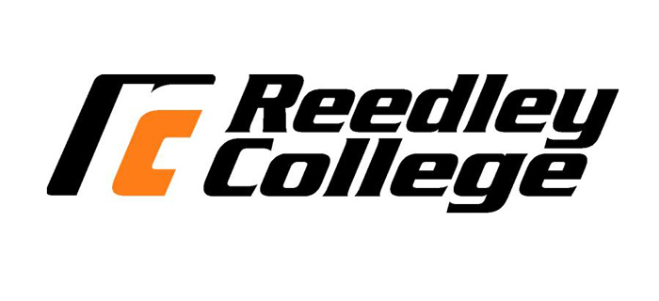
REEDLEY COLLEGE – MAG 44 – AGRICULTURE WELDING FABRICATION
Spring 2017 MAG 44 – #56864 T & Th 1:00pm – 3:15pm
3 Units, 18 weeks (1/9 - 5/18)

Instructor: Darrell Hirschler
Phone: (559) 638-3641 ext. 3477
E-mail: darrell.hirschler@reedleycollege.edu
Office: IND 22
Classroom: IND 17
Lab: IND 11
Office hours: Mon - Thur 12:00pm – 1:00pm & Fri 7:00am – 7:30am
Text Book: Welding & Metal Fabrication Author: Jeffus, L (Delmar 2012)

Description: This course will provide entry level instruction on welding fabrication. Instruction will be provided in the areas of welding techniques, welding plans and blueprints, cutting, fitting, proper tacking procedures, squaring, and finishing.

Student Learning Outcomes:
Upon completion of this course students will be able to:
- Used acquired knowledge and skills to design equipment and tools.
- Use acquired skills to fabricate equipment and tools from a set of designs.
- Fabricate products to industry standards.
- Calculate the cost of a fabricated product.

Course Objectives
- Review, demonstrate and use proper safety procedures relating to welding and fabrication.
- Prepare metal and material for welding.
- Demonstrate the proper cutting techniques used to cut metal.
- Demonstrate proper welding techniques using shielded metal arc welding (SMAW) and gas metal arc welding (GMAW)
- Be able to properly set up and shut down the oxy-fuel setup.
- Develop basic working drawings and materials list.
- Select and order appropriate materials and supplies to construct a project.
- Demonstrate the proper cutting techniques used to cut metal.
- Demonstrate proper metal finishing procedures and techniques.
- Coordinate and construct individual student portfolios. Include: resume, letter of application, work samples, bill of materials, and working drawings.
Course Outline:
The instructor will determine the order in which the following will be presented and developed.
Lecture Content:
- Review: Shop, personal & welding safety
- Metal and material
- Review of SMAW
- Review of GMAW
- Review: Cutting Metals
- Metal finishing
- Project plans: designs and sketches
- Project plans: working drawings
- Work Samples
- Bill of Materials
- Resume
- Letter of Application
- Portfolio
Lab Content:
- Safety Orientation
- GMAW Welding Proficiency
- Torch Cutting & Plasma Arc Proficiency
- Measurement Proficiency
- Metal; Preparation, layout, cutting and fitting
- Metal Clean-up and finishing
- Project Fabrication

Basic Skills Advisories:
Eligibility for English 126 and Math 101
Prerequisites: None

Required Materials: *Optional but recommended
Clear Safety Glasses (Z87.1+) | High Quality Resume Paper
Oxy-Fuel Goggles or Glasses (shade #5) | Report Folder / Binder
Welding Jacket / Leathers – or-  Coveralls / Shop Coat – or –  Long Sleeve Work Shirt & Jeans | Fine Point Sharpies
Approved footwear (leather work boots) | Tape Measure (length equivalent to project)
Welding Helmet (shade #10) | Calculator (basic)
Leather Welding Gloves | Scan-Tron for final exam

How class will be conducted:
- Lecture
- Instructor Demonstrations
- Proficiencies
- Quizzes 10%
- Attendance / Shop Logs 40%
- Portfolio: 30% Due: Tuesday - May 9, 2017 (beginning of class)
- Final: 20% Thursday – May 18, 2017

Point Distribution: 100% - 90% = A
89% - 80% = B
79% - 70% = C
69% - 60% = D
59% and less = F

Essential Information:
- Any assignments turned in over week late will receive 50% credit.
- Home work will not be accepted more than one week late.
- Attendance and participation is very important. You must attend class in order to participate and complete the required work.
- You are required to find out from the instructor any material missed during absence.
- Tests may be made up at the instructor’s discretion.
- Campus policy requires all students who miss 2 consecutive weeks must be dropped.
- In the event of class being cancelled you will be notified by a sign on the door.
- “Because cheating, plagiarism, and collusion is dishonest activities that erode the integrity of the college, each student is expected to exert an entirely honest effort in all academic endeavors. Academic dishonesty in any form is a very serious offense and will incur serious consequences.” – SO DO NOT CHEAT!!
- If you carry a cellphone, please be respectful and set to vibrate before class starts.
- Foul Language will not be tolerated and student will be asked to leave class if not contained.
- Do not leave the classroom or shop area without instructor’s permission.
- Portfolio Due: Tuesday – May 9, 2017 (beginning of class)
  - Each day late (past due date) will reduce portfolio grade 10%
  - Portfolio grade is 30% of total grade in class
  - Do Not Procrastinate on this assignment.

IMPORTANT DATES:
- January 16 (M) Martin Luther King Day No Classes
- February 17 (F) Lincoln Day No Classes
- February 20 (M) Washington Day No Classes
- March 10 End of 1st - 9 week courses
- March 12 (S) Daylight Savings Move clocks forward 1 hr.
- March 10 – 14 Spring Break No Classes
- May 19 End of 2017 Spring Semester

Work Ethic: Most students are enrolled in college classes to obtain a quality job or to enhance their skills for enhancement with their current employment situation. Employers look for a punctual, responsible individual who is prepared to go to work. Our goal is to replicate the workplace environment where a student can develop and demonstrate these desirable traits.
- Punctual: It is customary to arrive at least 5 minutes before work begins. Individuals will be terminated if they are not punctual.
- Responsible: It is expected that an employee works every scheduled work day. Individuals will be terminated if they are not responsible.
- Prepared: It is expected that an employee be prepared when he/she arrives for work. Students must have the appropriate clothing, tools and safety gear to participate in the laboratory. If a student is not prepared, he/she cannot participate and will receive a zero (see “responsible”).

