Art 9 Beginning Painting Spring Semester 2017 Carrera

T, TH 10 am- 12:50 PM Art Building RM 159
Email: tracy.carrera@reedleycollege.edu Office Location: Art RM 154
Office Hours: 8 am -9 am M W
Tues. Thurs. 12-1 pm
Friday 9-10 am

Course Description
Art 9 Beginning Painting
BEGINNING PAINTING: OIL AND ACRYLIC 3 units, 2 lecture hours, 4 lab hours, pass/no pass ADVISORIES: Eligibility for English 1A, and Mathematics 201. This course is an exploration of the creative act of painting using representational, abstract and nonobjective forms. Emphasis is placed on the fundamentals of composition and the ability to handle materials. Students will learn basic color theory, value, line, shape, texture and techniques including direct paint application, glazing, brush strokes and impasto. Issues concerning canvas stretching, brush cleaning, mixing glazes and toxicity are addressed. Through lecture and studio practice, students gain introductory skills in painting within the context of an historical perspective. (A, CSU, UC) (C-ID ARTS 210)
We will be drawing for the first 3 weeks of this course. Students will understand and gain practice in observational drawing which is the foundation for competent design of any sort and representational painting. Students will learn formal language of design followed by painting’s formal language and the fundamentals of artistic expression.
Course Objectives:
• Introduce students to the fundamental processes of visual perception and artistic expression.
• Develop students’ confidence in using painting as a primary medium for artistic expression.
• Develop students’ ability to write and verbalize ideas and processes in art making with a globalized perspective embracing diverse ideas.
• Gain understanding of painting as a medium unto itself but also as a vehicle to blend with other visual forms to create sincere and impactful imagery.
•Develop understanding of history, major styles and contemporary issues in painting

Course Content and Scope:
• Color Theory: (primary/secondary, complementary), transparency/opacity, hue, value (intensity, brightness), Chroma (saturation, purity) & temperature (warm/cold).
• Color Contrast & Attributes: Interaction, harmony, psychology/mood, culture & expression.
• Composition: Space, movement, balance, asymmetry, rhythm, shapes, proportion & lighting.
• Media Characteristics & Surfaces: oil paint on canvas board and paper and other experimental surfaces.
• Painting Techniques: Alla prima, grisaille, glazing, impasto, knife painting, scumbling & blending Oil Mediums: walnut and linseed
• Painting History: Major painting styles & masters in Renaissance, Realism, Impressionism, Post-impressionism, Expressionism, Modernism, Abstract Expressionism & Postmodernism. Students will use this global approach to develop a “critical eye” in evaluation of contemporary painting.
•Linear perspective, compositional structure, figure/ground relationships, visual perception, spatial concepts, and critical thinking skills will all be emphasized.
Demonstrations, videos, Student and Instructor PowerPoint discussions, group and individual critiques are a daily and weekly occurrence as part of the design process.

Art and Design Program Goals Addressed in This Course
* Basic Skills
Developing a foundation of art knowledge, theories, skills, craftspersonship and technologies, where ideas and concepts are communicated in writing, speaking and art making.
* Art Knowledge
within theoretical, cultural, and historical contexts.
* Critical Thinking
Analyzing, interpreting, and questioning traditional methodologies and pre-conceived notions of art and art making through the process of generating and solving problems.
* Professional Preparation
Developing career paths for various art professions and an understanding of the demands and expectations of those areas.

Grading Policy:
Artistic creation is a comprehensive, developmental activity. Grading is based on a plus/minus system based on the students’ performance in several related areas:
• Evidence of students’ understanding and mastery of techniques and concepts
• Implementation of those ideas in the particular assignment
• Initiative demonstrated and individual effort during and after class time
• Degree of participation in class and in group-critiques
• Overall preparedness and progress through the quarter
________________________________________

Project Overview
Weeks 1- 3
Value Scale
Object single Light source
Still Life Charcoal (3 objects)
Reductive Drawing (charcoal)
Charcoal on color surface
Self Portrait (charcoal)
Weeks 4-7 PAINTING BEGINS!
Color Wheel (limited palette)
Cone, cylinder, square still life
Apple
Composition Methods (charcoal)
Weeks 7-10
In class still life (alla prima)
Scumbling technique (fabric)
Light and shadow painting
Mid Semester Student Progress Check in
Weeks 11 -15
Tonal painting (restricted half tones)
Apple painting revisited (glazing)
Draped figure in interior space (alla prima)
Landscape (plein air)
Final Project photo reference
Weeks 16- Finals
Final painting (from photo reference)

Attendance and Class Participation:
Attendance - please read carefully!!!
Attendance is mandatory. This is a studio class where activities and course work are done during class time. It essential that you be in class with all the required materials and prepared to work. Attendance will be taken at the beginning of every class. If you arrive late it is your responsibility to let me know you are present.
If you are absent two consecutive weeks you will be dropped. 5 total absences = an instructor discretionary drop. 6 absences = an automatic drop (W), or F (failing grade) if past the final drop deadline. When you miss a class it is your responsibility to ask a fellow student what you missed, then learn the content. Entire lessons will not be re-taught to you because you were absent.

* 3 tardies or early departures = 1 absence
* Coming to class without supplies = an absence

• Medical or personal problems will be excused but only with professional documentation. This means a statement from a medical professional declaring that you have been ill enough to miss class. A document that states that you had an appointment or that you saw a doctor is not enough. Your illness must be documented as having kept you incapacitated.
• All missed activities and work will need to be made-up outside the regular class. You are responsible for the information missed as a result of an absence. Make an appointment to see me for missed lectures. Students are responsible for finding out what they missed.
•If you have trouble attending class, please discuss your attendance problems privately with me after class. Students who know ahead of time they are going to miss class because of family vacation, major surgery, etc. please let me know ahead of time.
Note: Scheduling a doctor’s appointment during class time does not constitute a medical emergency. If you miss class there are consequences (you will miss out on the lesson, important instructions or activities which will affect your overall grade). Students can make that choice but please accept the outcomes for that choice.

Academic Dishonesty:
Academic honesty is fundamental to the activities and principles of a university. All members of the academic community must be confident that each person’s work has been responsibly and honorably acquired, developed, and presented. Any effort to gain an advantage not given to all students is dishonest whether or not the effort is successful. The academic community regards academic dishonesty as an extremely serious matter, with serious consequences that range from probation to expulsion. When in doubt about plagiarism, paraphrasing, quoting or collaboration, consult the course instructor. Any student suspected of submitting work done by someone else will be reported to the Dean of Academics.
Students with Special Needs
Students with disabilities, whether physical, attention related, learning or psychological, who believe that they may need accommodations in this class, are encouraged to contact the appropriate institutional department as soon as possible to ensure that accommodations are implemented in a timely fashion. There may be an authorization that is required before any special accommodations can be made.
If you need accommodations because of a disability, if you have emergency medical information to share with me, or if you need special arrangements in case the building must be evacuated, please inform me immediately. Please see me privately after class, or at my office. To request academic accommodations (for example, a note taker or extended time on exams), students must also register with the Office of Student Disability Services on campus.
Intellectual Pluralism
The University community welcomes intellectual diversity and respects student rights. Students who have questions or concerns regarding the atmosphere in this class (including respect for diverse opinions) are encouraged to contact Dean of Instruction of Reedley College Dr. Davis whose office is in the Admin. Building. All students will have the opportunity to submit an anonymous evaluation of the instructor at the end of the course.

Supplies List

Beginning Painting Carrera Fall 2017
Painting supplies list

Painting I students will use a limited palette to strengthen their color mixing skills and stay mindful of the role values play in painting.
Broadening the palette happens in Intermediate Painting 19

Oil paints (please note all tubes should be 37 ml and M Graham oil paint brand!

Titanium white (large tube)

Cad red medium
Yellow ochre
Ivory black

Walnut Oil (preferred) or
Refined linseed oil 16 oz (Utrecht).
Gessoed Canvas panels 8x12" (10)
Paper towels (at least 5 rolls)
Palette knife (metal, not plastic- see image above right)
Brushes: 3 filbert hog bristle oil painting brushes sizes 4. 6 and 8
Fast Orange hand cleaner (auto parts store)

Palette (glass or disposable paper palette with tear-off sheets or resin palette or wood if you prefer). Should be at least 9x12” approx if not larger. Painting with a small palette is like cutting a watermelon on a tiny cutting board!

Tackle box or container to carry materials
Painting apron to protect clothing
Small metal painting medium container with a lid (to hold small amounts of walnut or linseed oil while you paint)
Questions about supplies?
Email me with questions. Remember, I’m here to help you!

tracy.carrera@reedleycollege.edu

Weeks 1- 3 Drawing with pencil/ charcoal
Focus on edges, tonal changes, rendering, accuracy in proportion
In class as well as homework projects

Charcoal drawing still life cube and sphere single light source
Value Chart homework
Week 2
Drawing forms with charcoal (still life)
Continuation of grisaille still life homework: Object single light source Due Week 3
Week 3
Drawing (value changes in planes of form)
Dramatic lighting presentation
Black and white still life: building composition (variety in value and size)
Monochromatic painting (merging shadow shapes) Homework: Watch ‘Why Beauty Matters’ documentary
Week 5
Composition Discussion: Space, Movement, Balance, Direction & Rhythm; Golden Section and setting up figurative interior scene to photograph and use as reference.
Homework: John Singer Sargent_documentary__2 paragraph impression paper due week 7

Week 6
Meet individually with instructor to discuss mid-quarter improvement.
In class continuation of Motion’ painting Due Thursday for critique
Week 7 Spoken Word Vanitas due Tuesday Week 9
In class studio time continuation Spoken Word Vanitas
______________________
Week 8
In class studio time continuation Spoken Word Vanitas
Week 9
Spoken Word Vanitas paintings due for critique
Edge recognition: flesh/fabric/glass _alla prima due by end of class today!______________
Week 10 Tromp-l’oeil 2 Small objects/playing card painting 5x5” Homework to be handed in during final time.
Alla prima painting from Nude model (simplification of planes and edges) due at end of class
Homework: Watch ‘Love Light and Silence the work of Vermeer’_
Week 11 In class time to work on final painting projects
Students presentation of final painting projects are ‘their final’. Students must be present for the officially scheduled final time slot. Not doing so will have a negative effect on student’s overall grade.
______________________________________________________

Key things to remember to succeed in this course
Art is WORK. It is not easy and each student will struggle in different ways. Small ‘failures’ are healthy and natural in the creative process, therefore, there is no failure in this class unless you give up, so breathe easy. You can do this. I’m here for you.
You got to come to the party and commit to immersing yourself in class! This is a studio course and this kind of magic can only be experienced in REAL TIME in REAL SPACE!
This course requires students to expand conceptually as well as technically. Students are asked to be aware of what is important to them and to bring that awareness into their paintings.
Treat your fellow students the way you want to be treated. Diversity is important to the vibrancy of this course and life in general. Discriminatory remarks don’t belong in this class. Period.
The art studio is a sacred space. Creativity and respect reign here. This means keeping the space usable and clean for everyone.
I’m here for you. I am flawed and I’m always trying to improve my teaching practice and myself as a person as we all are. I’m here because I’ve had impactful teachers who shared their knowledge with me and I want to be to my students what my teachers were to me. I’m down for students who are down for themselves!
Student success is my success! If you are struggling or have any questions, please come see me during my office hours. This is my dream job and part of what makes it worthwhile for me is getting to know how I can help my students achieve their creative goals. I may not have all the answers but I will do all I can to help you find them! Let’s light this candle.

Art 150 Painting I Winter 2016 Professor Carrera

Course: 5105 Art 150 Tues. Thurs. 12:15- 2:45 PM B 16 RM 170
Email: tcarrera@highline.edu Office Location: B 16 RM 111 (or RM 170)
Office Hours: MWF 10-11 am Tues. Thurs. T TH 3-4 pm Phone: Ext. 3118

Palette (glass or disposable paper palette with tear-off sheets or resin palette or wood if you prefer). Should be at least 9x12” approx if not larger. Painting with a small palette is like cutting a watermelon on a tiny cutting board!
Tackle box or container to carry all this stuff
Painting apron
Small metal painting medium container (to hold small amounts of your linseed/walnut oil while you paint)
Art 150 Painting I Winter 2016 Professor Carrera

Week 5 ‘Motion’ Project Description page 1
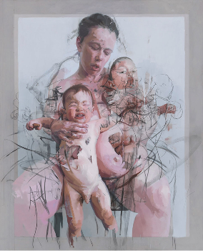
Composition Discussion: Space, Motion, Balance, Direction & Rhythm; setting up figurative interior scene to photograph and use as reference.
20th Century UK artist
Jenny Saville
‘Mothers’
What does this painting communicate? Is this a peaceful image?
What does the mother’s (the woman is the artist Jenny Saville herself) expression say to you? Is she engaged with the viewer? Does this image feel ‘posed’ or formal?

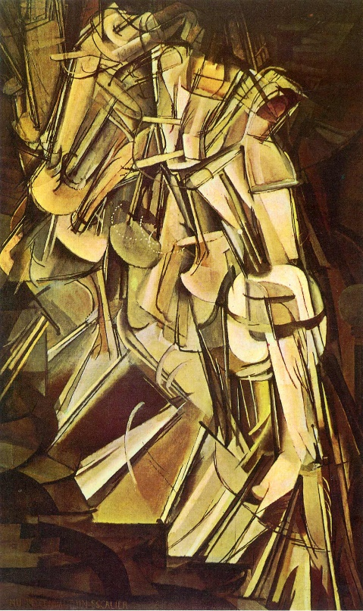
Art 150 Painting I Winter 2016 Professor Carrera

Week 5 ‘Motion’ Project Description
19th Century French born artist Marcel Duchamp ‘Nude Descending Staircase # 2’
What previous art movement rejected this piece by calling ‘too futurist’?
Dark outlines limit the contours of the body while serving as motion lines that emphasize the dynamics of the moving figure, while the accented arcs of the dotted lines seem to suggest a thrusting pelvic motion. The movement seems to be rotated counterclockwise from the upper left to the lower right corner, where the gradient of the apparently frozen sequence corresponding to the bottom right to top left dark, respectively, becomes more transparent, the fading of which is apparently intended to simulate the "older" section.

page 2
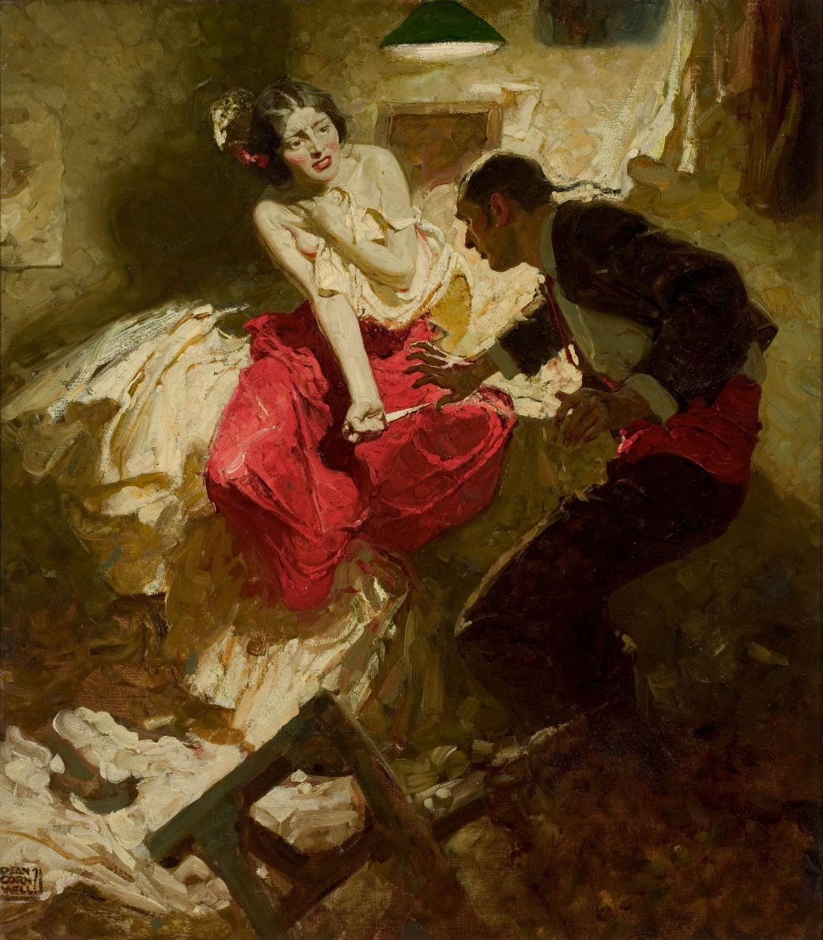

19th Century Dean Cornwell American Illustrator ‘The Red Shawl’
What 2 constricting diagonals are adding power to the scene?
Hint: one is line of sight
Where is the hardest edge located?

Art 150 Painting
I Winter 2016 Professor Carrera
Week 5 ‘Motion’ Project Description page 3
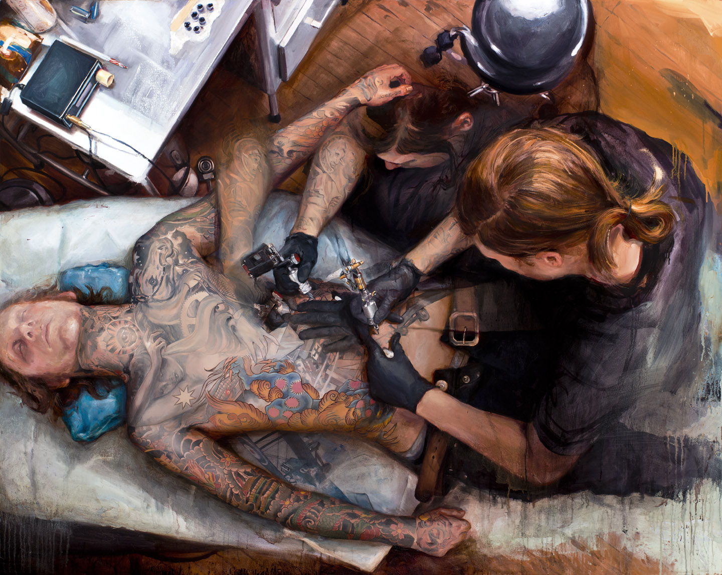
20th Century American
Shaun Barber
‘Spencer’
How is the artist creating a sense of motion in the figures and how we as viewers engage this scene?

Art 150 Painting I Winter 2016 Professor Carrera

Assignment 1 Week 5-7 ‘Motion’ Project Description page 4
Due Feb. 25th

How do I create motion in an oil painting?
Answer: I take time to explore a variety of visual solutions keeping in mind overall shape relationships and placement, lighting, contrast, rhythm, repetition and tension.

Things you will need for this project:
- charged cell phone with photo capabilities to take 30 photographs in class of scene set up (or use the in class digital camera).
- Thumb drive.
- Hardcopies of images you will use as reference for your painting

- Create 5 pages of written brainstorming in your sketchbook which will include the following:

- Start with words. What are some action or ‘visual words’ to describe motion? Tension, leap, run, explode… etc…
- What are objects which come to our minds when we talk about motion?
- Ideation Refinement Think about overall shapes which have movement. Does a conical shape have more motion potential than a square? What about spheres?

- Create 20 thumbnail pencil sketches of possible composition options expressing ‘movement’. Keep in mind the human figure will be the focal point in your composition. Think about various perspectives and positions of the figure.

- Create 20 value studies from your thumbnail pencil sketches in your sketchbook.
- From these choose 3 strongest compositions.
- Refine 3 versions of each composition in your sketchbook.
- Choose the strongest solution to take to the photo reference stage.
- Utilizing fellow students in class, set up your ‘scene’. Manipulate lighting for your composition. What kind of scene is it? A dramatic psychological confrontation? A joyful carefree scenario? A mysterious scenario? Someone engaged in physical labor? What is the narrative and how does motion fit into the story? Are movements slow or fast? Graceful or strained and irregular?
- Shoot 30 images using your phone or the class digital camera from a variety of perspectives. Some below eye level, some above. Take full advantage of the
photoshoot. Utilize props, fabric, lighting, positioning, etc… to replicate your composition.

This final painting and ideation stage material will be due on Tuesday Feb 23rd.
The grading rubric for this project is two part

Ideation and Development stage:
5 full pages brainstorming words/ sketches
20 thumbnails exploring different composition options.
20 value studies
3 strongest compositions
3 refinement versions of each (totaling 9)
30 photo reference images presented to professor Carrera in class on thumb drive.

Finished painting stage:

Fully resolved and intentional painting demonstrating the utilization of ideation stage.
Proper proportion, perspective, lighting consistency
Cohesive, intentional paint application (mindful of every inch of painting surface)
Technical application of paint on canvas
Effective use of values according to narrative/ theme
Appropriate color mixing

Recommendations for success:

- Read directions carefully.
- Ask for clarification from Professor Carrera if you are not sure what to do.
- Follow the outline in creating your painting. Don’t skip steps.
- The brainstorming, ideation, development and refinement stages are crucial and you should spend at least 10 hours out of class time on this portion of the project!
- Remember to email Professor Carrera with questions. tcarrera@highline.edu
- Start this project the day it is assigned and utilize your time wisely in class and out.

Art 150 Painting I Winter 2016 Professor Carrera

Assignment 2 Week 6 ‘Spoken Word Vanitas’ Project Description page 1

In the arts, vanitas is a type of symbolic work of art especially associated with still-life painting in Flanders and the Netherlands in the 16th and 17th centuries, though also common in other places and periods. The Latin word means "vanity" and loosely translated corresponds to the meaninglessness of earthly life and the transient nature of all earthly goods and pursuits

- I need 6 volunteers who will stand and read one of these ‘Spoken Word’ poems by other Reedley students. After the class hears all 6 poems read aloud, students will choose one of these poems to use as inspiration for the next painting which will also reference ‘Vanitas’.

- Brainstorm in your sketchbooks, write down key descriptive words or passages in your chosen poem. What stands out the most? What is the overall ‘message’ of the poem?

We’ve been shown examples of variety of still life objects and how contrast (smooth v textured, shiny vs. mat finish, transparent vs. opaque, small vs. large, complex vs. simple, etc…)

You will bring some objects from home which you think will work for this project. Other good props to have are dead flowers, a clock, and other objects which speak to the passage of time and the fleeting quality of life.

Situate your still life set ups around the studio.
Light your set up and begin painting starting with the block in.
We will work on these for 3 class sessions
Due Tuesday Week 9

Assignment 3 Week 10 ‘’ Tromp-l’oeil 2 Small objects/playing card painting 5x5” Homework to be handed in during final time.

Tromp-l’oeil means ‘to fool the eye’.
Do research on this painting tradition.
How deep is the space meant to be in your picture plane? Feet? Inches?
I will pass out a playing card to each student.
Pin, tape or somehow affix the playing card to a vertical surface. Attach two other small objects or other pieces of paper, one of your sketches, next to the playing card.
Think about color choices. Even the push pin color you choose will have an effect on this intimate painting.
This project is all about detail. It should take at least 10 hours painting time. Start on it as soon as possible.
Due March 22nd during final time.

