Oral Interpretation

Spring 2016
Communication 12: Fundamentals of Interpretation
Instructor: Vanessa Buldo
E-mail address: vanessa.buldo@reedleycollege.edu
Phone: 638-3641 ext. 3680
Office location: Soc. 38
Office Hours: Monday-Thursday 10-11 am, Friday 10-11 am via email.

Required Materials:

Textbook:
Jaffe, Clella. Performing Literary Texts: Concepts and Skills.
Independence: Cengage, 2006.

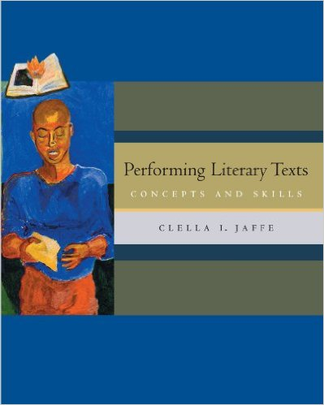

(3) scan-tron forms

Course Description:
The interpretation of literature through critical analysis and oral performance of selected works including but not limited to: poetry, fiction, essays, drama, and children's literature. This includes both individual and pair/group performances. Oral Interpretation fulfills the General Education Requirement for Area C for transfer.

Student Learning Outcomes:

Upon completion of this course, you will be able to:
- Create and perform interpretive programs of various literary genres that are adapted to the audience.
- Select and analyze various the literary merit of various forms of literature.
- Demonstrate emotion and develop characterization through vocal control and non- verbal characterization.
- Critically evaluate the effectiveness of oral interpretation performances through constructive critique and self-analysis.
Objectives:
In the process of completing this course, students will:
- Select and analyze various forms of literature including (but not limited to) poetry, fiction, nonfiction and drama.
- Create and perform programs of various literary genres.
- Evaluate both professional and student performances.
- Prepare written analysis of various forms of literature.
- Project emotion and develop characters through vocal control and nonverbal characterization.
- Combine different types of literature to develop complete interpretive programs.
- Edit literature using techniques that focus on unity of time, place, action, mood and character.
- Perform a variety of verbal and nonverbal skills to bring the literature to life and heighten the effectiveness of the performer's message.
Assignments:

Performance #1 Storytelling 50
Performance #2 Children’s Literature 100 (Signature Assignment)
Performance #3 Mixed Genre Program 200 (Signature Assignment)
Performance #4 Readers’ Theatre 100
Scripts 25 points each (2) 50 (Signature Assignment)
Exams: 1 100 2 100
3 100
Children’s Literature Analysis 100 (Signature Assignment)
Participation 100

Extra Credit may be earned only if signature assignments are completed and will not exceed 50 points.

The following numerical guidelines will be used in the assignment of final grades.

900-1000 = A
899-800 = B
799-700 = C
699-600 = D
599-0 = F

Dropping and adding classes:
It is the student’s responsibility to add or drop a class by the designated date. Failure to drop a class prior to the drop date will result in an F in the class. Add and drop dates can be found in the schedule of courses. Please decide quickly if you choose not to continue in this class as other students may be trying to add.

Late and missed assignments:
- Student may make-up one speech with a two letter grade drop on assigned days. The make-up day may not be during regular class, but students will need to work within the given schedule.
- No attachments by e-mail accepted for any assignment. If a student wants an assignment reviewed prior to the date it is due he/she must provide a hard copy.
- It is the responsibility of the student to contact the instructor and inform him or her of any problem.
- Accommodations will be made for students with a verifiable medical excuse.

Classroom Deportment:
A huge part of this class is performance. We will be exploring and learning about various literary texts and interpreting various genres. Please support your classmates and applaud their efforts. Students who do not behave in a respectful manner will be asked to leave or even drop the class. Please use courteous cell phone behavior. Text messaging during class is not appropriate especially during other students’ presentations. As we are all adults it is important to behave in a professional and courteous manner to provide a safe and comfortable learning environment for all.

On exam and speech days the classroom door will be locked ten minutes after class begins. This is in an effort to avoid disruptions and distractions once speeches and exams begin. Students are not allowed to enter through the lab beyond the allotted time or they will receive a zero.

Plagiarism and cheating will not be tolerated and will result in a zero on an assignment and proper consequences for all students involved.
Student Rights:
So that students are fully aware of their rights and responsibilities they are encouraged to become familiar with the Schedule of Courses. Students with disabilities should identify themselves so that appropriate accommodations can be made.

Daily Schedule

1-11 | Introductions and Syllabus  Why interpretation?  Speech Outlines | Ch. 1
1-13 | Your Role In Interpretation  Audience Roles | Ch. 2
1-18 | Holiday
1-20 | Selecting texts for performance | 3
1-25 | Storytelling performances
1-27 | Storytelling continued
2-1 | Using your voice and body  Assign Children’s Literature | Ch. 5
2-3 | Mini Presentations  Voice and body activity
2-8 | Rehearsal and Performance  Styles of Delivery | Ch. 6
2-10 | Practicing delivery
2-15 | Holiday
2-17 | Review for Exam #1 (Ch.1-6)
2-22 | Exam #1
2-24 | Children’s Literature Presentations
2-29 | Presentations
3-2 | Continue Presentations
3-7 | Finish Presentations
3-9 | Performing Prose  Assign Mixed Genre Performances | Ch. 7
3-14 | Performing Drama | Ch. 8
3-16 | Drama Continued
3-21 | Performing Poetry  Poetry Activity | Ch. 9
3-23 | Mixed Genre presentations begin
3-28 | Mixed Genre continued
3-30 | Continue Speeches
4-4 | Finish Presentations
4-6 | Assign Groups and Reader’s Theatre Assignment
4-11 | Review for Exam 2 (Ch. 7-9)
4-13 | Exam #2
4-18 | Make-up Speech Day
4-20 | Groups Meet
4-25 | Begin Performances
4-27 | Performances
5-2 | Finish Performances
5-4 | Prepare for Showcase
5-9 | The Showcase
5-11 | Review for Final Exam
5/16-5/19 | Final Exam

*Note: this syllabus is subject to change depending on the needs of the class.

