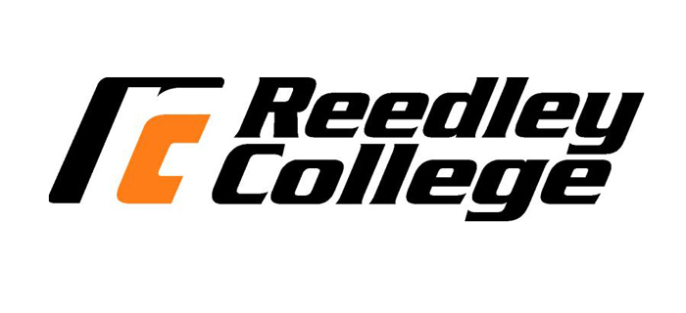
REEDLEY COLLEGE – MANUFACTURING TECHNOLOGY
FALL 2016 MFGT 23 – #59115 ELECTRICITY
2 Units, 9 weeks (08/15 - 10/14)
Tuesday / Thursday: 6:00 pm to 8:15 pm
Instructor: Darrell Hirschler
Phone: (559) 638-3641 ext. 3477
E-mail: darrell.hirschler@reedleycollege.edu
Office: IND 22
Classroom: IND 17
Lab: IND 19 & 24A
Office hours: Tue / Thurs 5:30 pm – 6:00 pm & Mon / Wed 12:00 pm – 1:00 pm
Description:
The study of basic energy sources developed for commercial / manufacturing use. Methods that are used to measure potential difference and power, residential and industrial safety. Basic electrical codes, wire, and industrial troubleshooting. Basic shop electrical repairs and installations.
Expected Outcomes:
- Service and operate electrical systems using safe shop techniques.
- Calculate common mathematical problems associated with electrical systems.
- Understand basic electrical theory
- Understand how to measure voltage, current and resistance.
- Understand how the code applies to the use and installation of materials and components.
- Understand basic residential and commercial wiring practices.
- Understand how to work with basic electrical hand tools and test equipment.
- Understand the basic materials and components used in electrical wiring.
- Understand how to perform basic Ohm’s Law calculations.
- Understand Series-vs- Parallel circuits.
- Understand basic electrical symbols and terminology

Basic Skills Advisories:
Eligibility for English 126 and Math 101
Prerequisites: None
Required Materials: *Optional but recommended
Clear Safety Glasses (Z87.1+) | *Lineman’s Pliers
#2 Pencil / Eraser | *Long Nose Pliers
Basic Calculator | *Slip Joint Pliers
3-ring Binder w/ Lined Paper | *Utility Knife (Retractable Blade)
Wire Strippers | *Water Pump Pliers (channel locks)
6-in-1 Screwdriver | Scan-Tron for final exam

How class will be conducted:
- Lecture
- Instructor Demonstrations
- Lab Tasks / Assignments
- Quizzes
- Homework Assignments
- Final Exam
Course Outline:
Week 1: Introductions; electrical safety, electrical theory and principles; electrical generation, electrical distribution; electrical terminology, tools and materials.
Week 2: Residential Electrical; Circuit conductors, connections and protection; Basic electrical symbols, Residential Branch Circuits (Romex- following the path of electricity);
Week 3: Wiring & Installing Branch Circuits – A/C Residential (Romex)
Week 4: Commercial Circuits; Wiring & Installing Service Entrance Panels & Sub Panels; EMT; Circuit breakers; Grounding.
Week 5: Volt Ohm Meter (finding voltage, amperage, resistance & continuity.
Week 6: Ohm’s Law, Calculating Voltage, Calculating Amperage, Calculating Wattage, Calculating Resistance, Basic electrical troubleshooting
Week 7: Electric Motors, Types, Interpreting Name Plate Information, 3 phase vs Single Phase, Motor Switches and Basic Controls.
Week 8:
*NOTE: Content and order may be changed as deemed necessary by the instructor.

Essential Information:
- Any assignment turned in up to one week late will receive 50% credit.
- Home work will not be accepted more than one week late.
- Attendance and participation is very important. You must attend class in order to participate and complete the required work.
- In the event of class being cancelled you will be notified by a sign on the door.
- “Because cheating, plagiarism, and collusion in dishonest activities erode the integrity of the college, each student is expected to exert an entirely honest effort in all academic endeavors. Academic dishonesty in any form is a very serious offense and will incur serious consequences.” – SO DO NOT CHEAT!!
- If you carry a cellphone, please be respectful and set to vibrate before class starts.

IMPORTANT DATES:
AUGUST 15 M START OF FALL SEMESTER
AUGUST 15 - OCTOBER 14 M-F SHORT TERM CLASSES, FIRST NINE WEEKS
AUGUST 26 F LAST DAY TO DROP A FULL-TERM CLASS FOR REFUND
SEPTEMBER 2 F LAST DAY TO REGISTER FOR A FULL-TERM FALL CLASS
SEPTEMBER 2 F LAST DAY TO DROP A FALL FULL-TERM CLASS TO AVOID A W
SEPTEMBER 5 M LABOR DAY (NO CLASSES HELD)
SEPTEMBER 9 F LAST DAY TO CHANGE TO/FROM A PASS/NO-PASS
OCTOBER 14 F LAST DAY TO DROP A FULL-TERM CLASS
OCTOBER 17 - DECEMBER 16 M-F SHORT TERM CLASSES, SECOND NINE WEEKS
NOVEMBER 11 F VETERANS DAY (NO CLASSES HELD)
NOVEMBER 24 - 25 TH-F THANKSGIVING HOLIDAY
DECEMBER 12 - 16 M-F FINAL EXAM WEEK
DECEMBER 16 F SEMESTER ENDS
DECEMBER 17 - JANUARY 8 M-W WINTER BREAK

