MATH-250 FALL 2016 T,TH @ 6:00-7:15p
Mr. Jose Garcia (jogarciamath@gmail.com) Room: FEM 4
Course ID: garcia13122

PRE-ALGEBRA

WELCOME to Pre-Algebra: Students who attend class regularly, come prepared to class, participate in class, take notes, do the assignments, and pass the assessments should be successful. You MUST make an effort and do your BEST to ensure success in this class. To pass this course you will need a C or better grade to move on to the next level.

COURSE DESCRIPTION: In this course we will study arithmetic operations of whole numbers integers, fractions and decimals, expressions and polynomials, equations, and geometric formulas along with arithmetic applications. This course is designed to give students a quick review of college arithmetic to prepare students for MATH 256 or MATH 201.

COURSE OBJECTIVES: Student’s performance will be evaluated upon their ability to
- Develop an understanding of the base ten number system.
- Learn basic addition and multiplication facts of single digit integers.
- Learn, practice and apply the operations of addition, subtraction, multiplication and division of rational numbers.
- Convert numbers between decimals and fractions.

COURSE CONTENT OUTLINE: We will study a total of 6 chapters in this course.
Chapter 1 Whole Numbers | Chapter 6: Decimals
Chapter 2: Integers | Chapter 3: Expressions and Polynomials
Chapter 5: Fractions and Rational Expressions | Chapter 4: Equations

EQUIRED MATERIALS: Two spiral gridpaper notebooks, Cambridge brand in the bookstore. No other notebooks will be accepted!
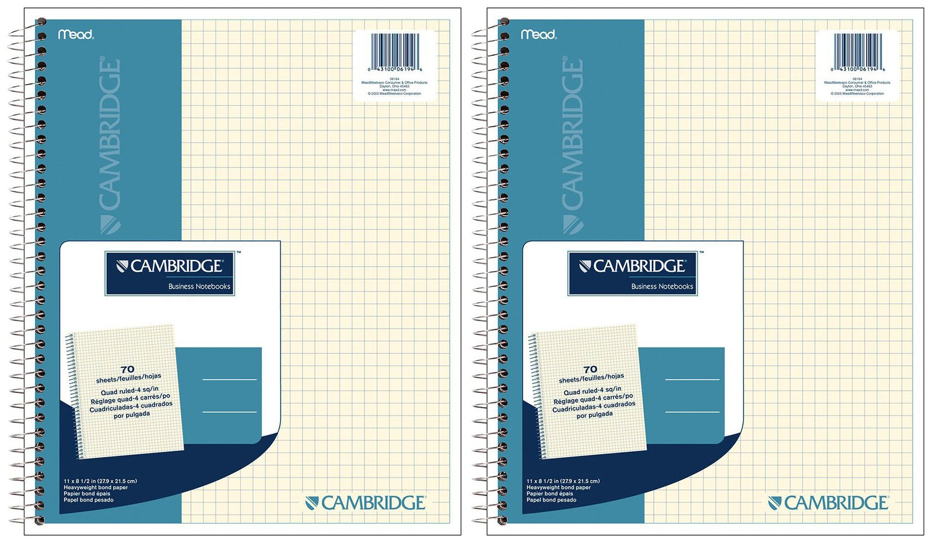
- 3-Ring Binder
- Pencils
- Access Code to My Math Lab (Pearson)

ASSIGNMENTS: Online assignments will account for 20% of your grade.
- Each homework assignment will be completed online and the assignments can be found at the My Math Lab website, www.pearsonmylabandmastering.com. You may work ahead if you like; all homework assignments for the entire chapter will be made available to the student approximately three days before the start of the chapter. It is important to stay current to be successful in this course! Each assignment has a due date and time. Any late assignment will lose 25% of the points possible for every day is late.
- Students who do not sign up at www.pearsonmylabandmastering.com. and complete the first two assignments (Sections 1-1 and 1-2) by Wednesday, August 24, 2016 will be dropped. My Math Lab will allow you to enroll on their site with a temporary access without buying the access code.
- Any student who enrolls with a temporary access code will be required to have purchased the access code and be permanently enrolled in the My Math lab course by Wednesday, September 7, 2016. Failure to do so will result in a drop from the course!

IMPORTANT NOTICE: While working on an assignment, you do not have to complete an entire assignment in one seating. If you choose to stop for a while, make sure to click SAVE icon and the program will save your work. You can come back to work on the assignment and continue where you left off at another convenient time.
- Being absent on the day the assignment is due does not excuse you from the late submission penalty.

TUTORIAL SERVICES: Tutoring is available in the Tutorial Center during business hours which is located NEXT to the Library and Math Center is located in the FEM-1.
Note: If you have any questions you would like to ask of me, your, please ask me during class time or contact me via email and I will do my best to help you.

ASSIGNMENTS NOTEBOOK: ALL online assignments problems are to be worked out completely, with all work shown in one of the two gridpaper spiral notebooks listed in the materials list. These notebooks are to be used EXCLUSIVELY for this class. Each assignment and the problems of the assignment are to be clearly labeled and answers are to be boxed or highlighted. The Assignment Notebook will be collected on the test day and will be worth two homework assignments. I will not accept notebooks that do not follow these guidelines and I will not accept late notebooks.
QUIZZES: There will be weekly in-class homework assignments quizzes. These quizzes will be worth 20 points each and will be given either at the beginning or the end of class. Any students who are not in their seats when the quiz is handed out will not be allowed to take the quiz and will receive a grade of zero for that quiz. There will be no makeup quizzes for students coming in late or leaving class early or for students absent on the day of a quiz. Students leaving class early on the day a quiz is given will receive a grade of zero for that quiz.

ATTENDANCE: Attendance is NOT OPTIONAL. Students are expected to attend all class meetings, be on time, and be in class the entire class session. Leaving class early will be counted as a tardy and two tardies can be counted as an absence. Five (5) absences may result in a drop from the course. However, if you decide to drop the course, it is your responsibility to make the drop official in the Admissions and Records office or else possibly receive a grade of F.
Attendance Grade: Since attendance is not optional, it will be counted as part of your grade. You will receive three attendance grades throughout the semester (Chapter 1, and 2, Chapter 5 and 6, Chapter 3 and 4) each one worth 10 points.
EXAMS:
- Six (6) exams, worth 100 points each will be given. The exams usually cover ONE chapter of material.
- There are NO MAKEUPS for missed exams. NO EXCEPTIONS!!
- If you absolutely must be absent on the day an exam is scheduled, you may discuss with me the possibility of taking the exam early

IMPORTANT DATES:
August 24, 2016 | Deadline to enroll in MML and complete first two assignments
September 2 , 2016 | Last day to add this course
September 5, 2016 | Labor Day
September 7, 2016 | Deadline to be PERMANENTLY ENROLLED in MML
October 14 , 2016 | Last day to drop
November 11, 2016 | Veteran’s Day Holiday
November 24-25, 2016 | Thanksgiving Holiday
December 13, 2016 | Final Exam
NOTE: If you have a verified need for an academic accommodation or materials in alternate media per the Americans with Disabilities Act or Section 504 of the Rehabilitation Act, please contact me as soon as possible.

PERSONAL AND TECNOLOGY EMERGENCIES:
I am well aware that sometimes emergencies arise both in your personal life and with the technology that you may be using. To account for these unexpected events, I have made the following allowances:
- The lowest two homework assignments grades will be dropped.
- The lowest two quiz grades will be dropped.
- The final exam counts as the seventh exam and may replace the lowest exam (or a zero score if you miss an exam) if the final exam score is higher.

FINAL EXAM: A two-hour comprehensive final exam is worth 100 points and it will be given during finals week. This final exam is cumulative (Chapter 1-6), mandatory and will counts as a regular exam. The final may be used to replace a low exam score or a missed exam. The final may not be used to replace the homework assignment grade, quiz grade or attendance grade.
GRADING:
Letter Grade | Grading Scale | Categories | Percent of Grade
A | 89.5%-100% | Assignments | 20%
B | 79.5%-89.4% | Quizzes | 15%
C | 66.5%-79.4% | Attendance | 5%
D | 54.5%-66.4% | Six Exams and  Final Exam | 60%
F | 0%-54.4%

**EXAMPLE: If you homework assignments average is 85, the average of your quizzes is 70, the average of your attendance grades is 90 and the average of your exams and the final exam 78, then you would compute your grade as follows;
(.20)(85)+(.15)(70)+(.05)(90)+(.60)(78) = 17+10.5+4.5+46.8 = 78.8

- Your grade will then be determined by reading the above chart with the grading scale. Thus, your grade in the above example will be 78.8% or C.

ACADEMIC DISHONESTY: Reedley College rules on plagiarism will be strictly enforced. Academic dishonesty in any form is a very serious offense and will incur serious consequences, including but not limited to receiving a grade of F in the course. The student receiving the grade on their transcript needs to be the person doing the work at ALL TIMES in this class. If not, the student will receive an automatic F in the course, and suffer the utmost consequences of plagiarism as set for the Reedley College’s Academic Regulations.

