Reedley College

Syllabus for Biology 10L
Introduction to Biology
Fall Semester, 2016

Instructor:

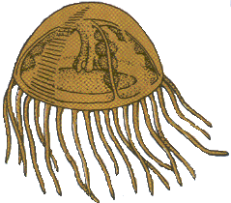
Gary W. Potter (e-mail gary.potter@reedleycollege.edu), Please include Biol. 10L in the subject line or I will not open your e-mail!

Meeting Times:

Monday & Wednesday, 7:25 PM until 8:15 PM.

Holidays & Other important dates.

Monday, August 15, 2016: Fall semester begins.
Friday, August 26, 2016: Last day to drop a class for a full refund.
Friday, September 2, 2016: Last day to register for a full time class in person.
Friday, September 2, 2016: Last day to drop a class to avoid a W in person.
Monday, September 5, 2016: Last day to drop a class to avoid a W using Web Advisor.
Monday, September 5, 2016: Labor Day holiday (No classes held, campus closed)
Friday, October 14, 2016: Last day to drop a class without a letter grade.
Friday, November 11, 2016: Veteran’s Day Holiday (No classes held, campus closed)
Thursday & Friday, November 23 & 25, 2016: Thanksgiving Holiday (No classes held,
campus closed)
Monday, December 12, 2016: Final Exam.
Friday, December 16, 2016: End of Fall Semester, 2016.

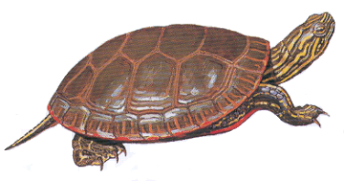
Exam Dates:

Exam # 1: Monday, September 19, 2016
Exam # 2: Monday, October 24, 2016
Exam # 3: Monday December 12, 2016

Course Description:

Biology 10L is a laboratory course recommended for the non-biological science and pre-education majors. (It supplements biology 10.) This is an introductory course using biological concepts. The structure, function, inheritance, evolution, and ecology of organisms are covered. Field trips may be required. Not open to students with credit in Biology 3.

Course Content:

Student Learning Outcomes: Upon completion of this course, students will be able to:

1. Evaluate current scientific literature and examine how the scientific method is employed in biological research.
2. Identify levels of biological organization and apply these concepts to living systems.
1. By examining anatomical and physiological features.
2. By investigating chemical and energy relationships.
3. Assess human impacts on natural systems and critically evaluate solutions to
environmental problems.
4. Explore the cellular basis of life.
5. Apply the principles of Mendelian genetics to evolutionary theory and human medicine.
6. Recognize the function of DNA and how its discovery has impacted modern science.
7. Classify the wide range of living organism and identify the evolutionary mechanisms
that have impacted this diversity.
8. Recognize the chemical basis of life.

Course Objectives:

In the process of completing this course, students will:

1. Compare and contrast Eukaryote and Prokaryote cell structure.
2. Recognize chemical elements, bonds and properties of water.
3. Compare anatomical and physiological features seen in the animal kingdom with emphasis
on human body systems.
4. Calculate genetic probabilities based on the principles of Mendelian genetics.
● Identify human genetic mutations and explain probable causes of their occurrence.
5. Distinguish the processes of transcription and translation and identify their roles in protein
synthesis.
6. Diagram plant life cycles and identify major plant adaptations.
7. Explain and compare the processes of photosynthesis and cellular respiration.
8. Demonstrate knowledge of evolutionary theory and identify the different mechanisms
responsible for biological change.
9. Describe energy flow and nutrient cycling within an ecosystem.
● Consider human impact on natural systems.
10. Relate principles of population ecology to the study of the global human population.
11. Read scientific literature and apply the steps of sthe scientific method to laboratory
research.

Accommodations for students with disabilities:

If you have a verified need for an academic accommodation or materials in alternate media (i.e., Braille, large print, electronic text, etc.) per the Americans with Disabilities Act (ADA) or Section 504 of the Rehabilitation Act, please contact me as soon as possible.

Required Materials:

1. Notebook or three ring binder for note taking.
2. Recommended Text: Sierra Nevada Natural History, revised ed. Storer, T., Usinger, R., & Lukas, D., Univ. of California Press. 2004.
3. Biology Drawing Paper & pencil, for lab plates.
4. Camera or cell phone with photo capability – for field trips/photo essay project
Expectations:

A. You are expected to attend all class sessions. Two or more absences from laboratory
periods may very likely put you in jeopardy of failing. Unless there are extenuating
circumstances, such absences may also get you dropped from the course.
B. You are responsible for finding out what you missed and for making up missed work due
to absence.
C. Cheating and plagiarism will not be tolerated. Students caught cheating will receive a
zero for that assignment, quiz, or test. Cooperative learning is limited to working in
groups during labs.
D. Assignments are expected to be turned in on time. In case of absence, I will be accept
late papers up to two class meetings after the due date, with a grade deduction of 10% per
per each class meeting that it is late.
E. Guests are not allowed in class!

Grading: Your grade will be determined by using an accumulative point total of all laboratory reports, as well as laboratory exams. Extra credit will be limited to a few bonus questions on tests and an occasional special quiz or assignment. Extra credit will not be given for any other work! At the end of the semester, your accumulated point total will be divided by the total number of points possible to determine your percentage grade. The lab reports will make up about 60% of your grade, quizzes and exams will make up about 40 % of your grade. Your final letter grade will be determined using the following grading scale:

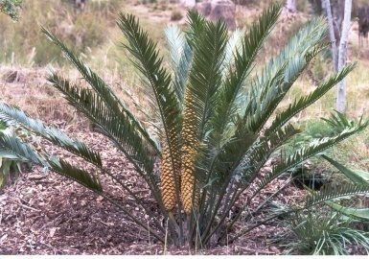
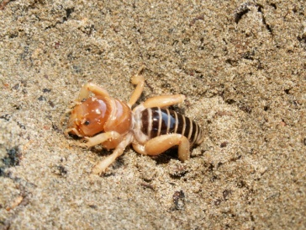
90% to 100% = A
80% to 89.9% = B
70% to 79.9% = C
60% to 69.9% = D
0% to 59.9% = F

Grades will not be rounded! 89.99999999% is a B+ not an A-!

Projects: 50 points each. More details on each of these will be presented later.

1. Plant Collection Project: Collect and identify each of the major groups of plants

2. Photo Essay Project: Demonstrate Sierra Nevada ecological communities with a photo display of Grasslands, Foothill Woodland (Savannah), Chaparral, Yellow Pine Forest,
and Riparian habitats with indicator species of each.

Week Lab. Topics.

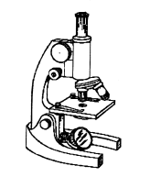
1 Lab. 1: What is life? Observation and Interpretation.
Lab. 2: Use of the compound microscope.

2 Lab. 3: Scientific method.
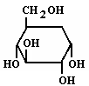
Lab. 4: Diagramming of atoms.

3 Lab. 5: Chemical tests for basic organic food groups.
Lab. 6: Properties of water.
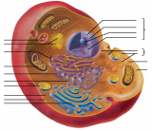
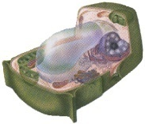
4 Lab. 7: Cell structure, onion skin, cheek cells, Anacharis leaf.
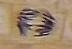
5 Lab. 8: Diffusion and osmosis
Lab. 9: Mitosis

Lab. Test# 1: Exam # 1: Monday, September 19, 2016: Biological methods, chemistry, and
cells

6 Lab. 10: Photosynthesis & Pigment chromatography
Lab. 11: Respiration

7 Lab. 12: DNA & RNA worksheet.
Lab. 13: Protein synthesis worksheet.

8 Lab. 14: Chi square & corn genetics Lab.
Lab. 15: Genetics problems & Human Genetics

9 Lab. 16: Evolution lab.
Lab. 17: Introduction to Photo essay project on California Plant Communities.

10 Lab. 18: The Plants & Fungi; Introduction to The Plant Collection Project

Test # 2: Monday, October 24, 2016: Photosynthesis, Respiration, Genetics, & Evolution
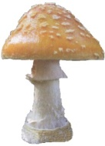
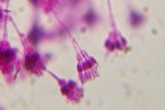
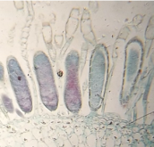
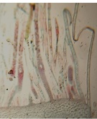
11 Lab. 19: Fungus and Mosses Lab.

12 Lab. 20: Flower dissection Lab.
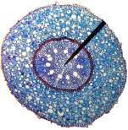
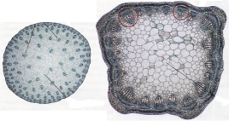
Campus field trip to point out plants for plant collection project!

13 Lab. 20: Plant morphology & Anatomy (2 lab periods)
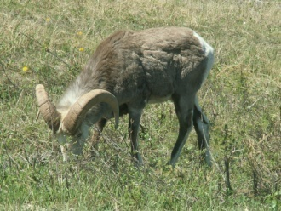
14 Lab. 21: Dichotomys keys
Lab. 22: Animal Taxonomy Lab.

15 Lab. 23: Animal Labs. (2 lab periods)

16 Lab. 24: Tissues Lab. (2 lab periods) Human Organs & Systems work sheets at home.
Plant Collections Due: Monday, November 28, 2016

17 Lab. 26: Population Ecology lab. (2 lab periods)

Photo Essay Project Due: Monday, December 5, 2016

18 Final Laboratory exam: Exam # 3: Monday December 12, 2016.

