Reedley College

Syllabus for Biology 10
Introduction to Biology
Fall Semester, 2015
Instructor:

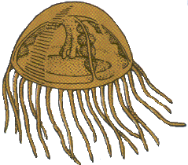
Gary W. Potter (e-mail gary.potter@reedleycollege.edu), Please include Biol. 10 in the subject line or I will not open your e-mail!

Meeting Times:

Monday & Wednesday, 6:00 PM until 7:15 PM.

Holidays: No Classes will meet.

Monday, September 7, 2015: Labor Day holiday
Wednesday, November 11, 2015: Veteran's Day (No classes held, campus closed)
Thursday & Friday, November 26 & 27, 2015: Thanksgiving holidays.

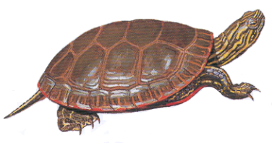
Exam Dates:

Exam # 1: Wednesday, September 9, 2015
Exam # 2: Monday, October 26, 2015
Exam # 3: Monday November 23, 2015
Exam # 4: Monday, December 14, 2015

Course Description:

Biology 10 is a lecture course recommended for the non-biological science and pre-education majors. This is an introductory course using biological concepts. The organismal structure, function, inheritance, evolution, and ecology are covered. Field trips may be required. Not open to students with credit in Biology 3.

Course Content:

Student Learning Outcomes: Upon completion of this course, students will be able to:

1. Evaluate current scientific literature and examine how the scientific method is employed in biological research.
2. Identify levels of biological organization and apply these concepts to living systems.
1. By examining anatomical and physiological features.
2. By investigating chemical and energy relationships.
3. Assess human impacts on natural systems and critically evaluate solutions to
environmental problems.
4. Explore the cellular basis of life.
5. Apply the principles of Mendelian genetics to evolutionary theory and human medicine.
6. Recognize the function of DNA and how its discovery has impacted modern science.
7. Classify the wide range of living organism and identify the evolutionary mechanisms
that have impacted this diversity.
8. Recognize the chemical basis of life.

Course Objectives:

In the process of completing this course, students will:

1. Compare and contrast Eukaryote and Prokaryote cell structure.
2. Recognize chemical elements, bonds and properties of water.
3. Compare anatomical and physiological features seen in the animal kingdom with emphasis
on human body systems.
4. Calculate genetic probabilities based on the principles of Mendelian genetics.
● Identify human genetic mutations and explain probable causes of their occurrence.
5. Distinguish the processes of transcription and translation and identify their roles in protein
synthesis.
6. Diagram plant life cycles and identify major plant adaptations.
7. Explain and compare the processes of photosynthesis and cellular respiration.
8. Demonstrate knowledge of evolutionary theory and identify the different mechanisms
responsible for biological change.
9. Describe energy flow and nutrient cycling within an ecosystem.
● Consider human impact on natural systems.
10. Relate principles of population ecology to the study of the global human population.
11. Read scientific literature and apply the steps of sthe scientific method to laboratory
research.

Accommodations for students with disabilities:

If you have a verified need for an academic accommodation or materials in alternate media (i.e., Braille, large print, electronic text, etc.) per the Americans with Disabilities Act (ADA) or Section 504 of the Rehabilitation Act, please contact me as soon as possible.

Required Materials:

1. Textbook: Mader, Sylvia S., Essentials of Biology, 4th edition (2015), McGraw-Hill
Companies Inc.
2. Notebook or three ring binder for note taking..

Expectations:

A. You are expected to attend all class sessions. Four absences from lecture periods may very
likely put you in jeopardy of failing. Unless there are extenuating circumstances, such
absences may also get you dropped from the course.
B. You are responsible for finding out what you missed and for making up missed work due
to absence.
C. Cheating and plagiarism will not be tolerated. Students caught cheating will receive a
zero for that assignment, quiz, or test. Cooperative learning is limited to working in
groups during labs.
D. Assignments are expected to be turned in on time. In case of absence, I will be accept
late papers up to two class meetings after the due date, with a grade deduction of 10% per
per each class meeting that it is late.
E. Guests are not allowed in class!

Grading: Your grade will be determined by using an accumulative point total of assignments, quizzes, and exams. Quizzes are worth 10 points each, the written exams are worth 100 points each. Each exam will consist of a combination of multiple choice and short answer essay questions. Two makeup quizzes will be given. Your score on the makeup quizzes will be used to make up a missed quiz or to replace the score of a quiz on which you scored lower than on the makeup quiz. No low quiz will be thrown out! Extra credit will be limited to a few bonus questions on tests and an occasional special quiz or assignment. Extra credit will not be given for any other work! At the end of the semester, your accumulated point total will be divided by the total number of points possible to determine your percentage grade. Tests will make up about 70% of your grade, quizzes will make up about 15% of your grade, and special assignment and/or essays will make up about 15 % of your grade. Your final letter grade will be determined using the following grading scale:

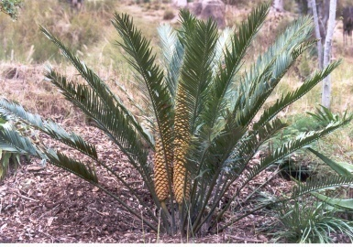
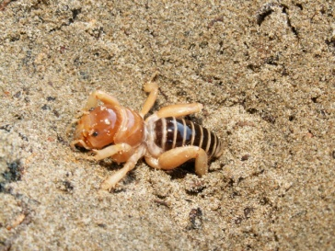
90% to 100% = A
80% to 89.9% = B
70% to 79.9% = C
60% to 69.9% = D
0% to 59.9% = F

Grades will not be rounded! 89.99999999% is a B+ not an A-!

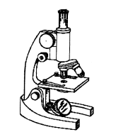
Week Lecture Topics.

1 Review the Syllabus; Biological Methods and Concepts.

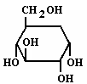
2 Introduction to chemistry.

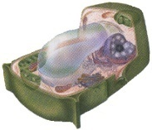
3 Biochemistry, The Organic Molecules of Life
4 Finish biochemistry & begin cell structure,

5 Cell function & cell reproduction

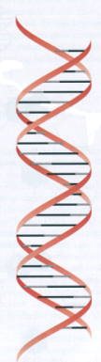
Test# 1: Wednesday, September 9, 2015: Scientific method, chemistry, cell structure &
function.

6 Cellular respiration, fermentation & Photosynthesis
7 DNA & RNA structure and function. Protein Synthesis

8 Meiosis and Mendelian genetics & human genetics.

9 Evolution, Microevolution & Macroevolution Classification, Systematics, & Taxonomy

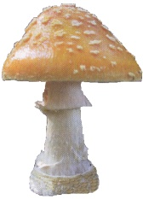
Test # 2: Wednesday, October 26, 2015: Photosynthesis, Respiration, Genetics, & Evolution

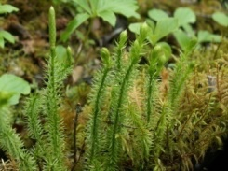
10 The First Forms of Life, Viruses, Prokaryotes & Protists Plants & Fungi
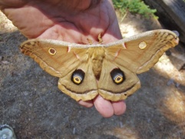
11 Plant anatomy & Physiology

12 The Animal; Kingdom.
13 Human & Animal Structure & Function
Human Systems

Test # 3: Exam # 3: Monday November 23, 2015: Protista, Fungi, Plants, & Animals
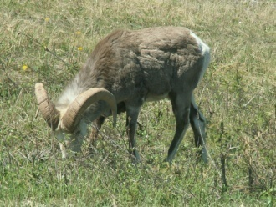

14 Ecology of Populations, Communities & Ecosystems

15 Human Impact on Ecosystems

16 Exam # 4: Monday, December 14, 2015: Ecosystems, biomes, communities, animal behavior, & Human populations.

