SYLLABUS

Class Hours/Room No | M W F 12 p.m. – 12:50 p.m. PHY 70 (Lecture)  Th 12 p.m. – 12:50 p.m. SOC 31 (Lecture)  T 12 p.m. – 1:50 p.m. PHY 70 (Lab)
Class No | 59775
Instructor | Sharon Wu
Phone | 638-3641 ex-3497
Office Hours | Tuesday | 2 pm – 3pm
 | Thursday | 1 pm – 2 pm
 | Friday | 10 am – 11 am
 | or By appointment
Office | FEM 1D
E-mail | sharon.wu@reedleycollege.edu

Course Objectives:
In the process of completing this course, students will:
A. Perform some of the simpler calculations in the areas of mechanics, properties of matter, heat, sound and waves.
B. Use the appropriate language of physics and mathematics to solve problems in physics in the areas of mechanics, properties of matter, heat, sound and waves.
C. Perform simple physics in the areas of mechanics, properties of matter, heat, sound and waves to acquire understanding of more difficult concepts in general physics.
D. Understand and apply basic physics concepts presented in lectures to the completion of problem assignment and lab reports.
E. Employ the scientific method in experiments in physics which yield results consistent with information presented in lectures.

Learning Outcomes:
Upon completion of this course, students will be able to:
A. Recognize the systematic nature of the discipline of physics in the areas of mechanics, properties of matter, heat, sound and waves and develop new ideas using previously held knowledge as the foundation.
B. Apply sound reasoning skills, developed through the problem solving process of physics, to responsible decision making.
C. Apply knowledge in the areas of mechanics, properties of matter, heat, sound and waves in other science related courses.

Course Outline:
- Kinematics
- Vector quantities
- Newton’s Laws
- Conservation of energy and momentum
- Rotating bodies
- Gravity
- Oscillatory motion
- Mechanical waves
- Heat and Temperature
- Thermodynamics

Course Prerequisite:
MATH 4A - Trigonometry or MATH 4C - Trigonometry/Precalculus and eligibility for English 1A.

Textbook:
Title: Physics 9e
Authors: John D. Cutnell & Kenneth W. Johnson
Publisher: John Wiley & Sons, Inc.

Blackboard
Blackboard is used for announcement and general class related information
To log-in Reedley College Blackboard:
User name: your student ID
Password: your student ID (* Be sure to change your password after you login)

WileyPLUS

WileyPlus is an online learning and homework assessment system.
- Go to www.wileyplus.com, click on Register For a New Class as shown on the right.
- Find Reedley College.
- Click on the + sign to expand course GENERAL PHYSICS (ALGEBRA)
- Click on the green arrow, , for PHYS 2A, 2012 Fall

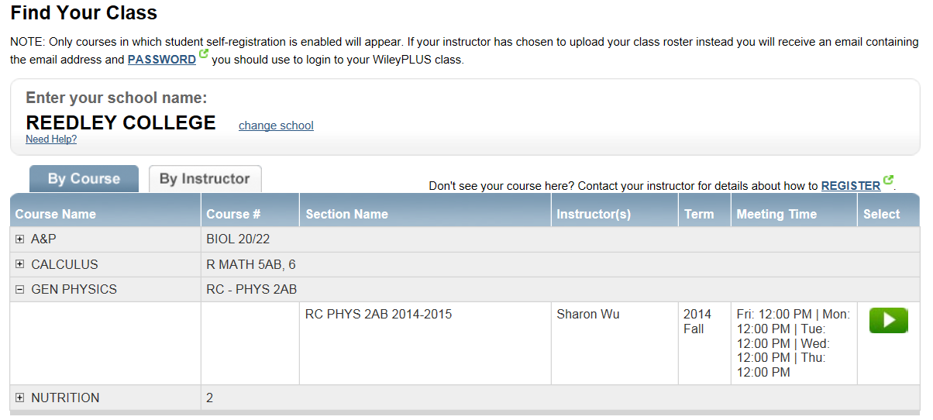

Or use following URL: http://edugen.wileyplus.com/edugen/class/cls406499/

Homework Assignments:
Homework is assigned for each chapter on WileyPLUS.

Laboratory:
This class has a lab that is mandatory. There are data sheets that you will need to complete as part of your lab activity that is due at the end of each lab session. You are required to follow a number of safety precautions in the laboratory. You must read and sign the safety agreement before beginning of the first lab.

Tests:
There will be a test every two or three chapters. And there is a final exam at end of the semester. Each test has conceptual questions that are multiple choices; and detailed physics problems that will be solved by the student. Early tests can be arranged with a very good reason. A more difficult late test can only be arranged if you have an excuse verified by an impartial party (i.e., a doctor or a court note).

Grading:
30% of the final grade points are from homework assignment
10% of the final grade points are from laboratory work
60% of the final grade points are from chapter tests

Final grade is assigned using following scale:
90-100 % A
80- 89% B
70- 79% C
60- 69% D
< 60 % F

- If you have perfect attendance and your grade is within 1 point (or 1%) of the next higher letter grade, the instructor will award you the next higher letter grade.

Important Dates:

Class begin | Monday | 08/11/2014
Last day to register | Friday | 08/29/2014
Last day to drop this class to avoid a “W” | Friday | 08/29/2014
Last day to change to/from a Pass/No-Pass grading basis | Friday | 09/12/2014
Last date to drop this class | Friday | 10/10/2014
No classes:
Labor Day | Monday | 09/01/2014
Veterans Day | Tuesday | 11/11/2014
Thanksgiving | Th & F | 11/27 – 11/28/2014
Final Exam | Monday | 12/8/2013  12:00 pm – 1:50 pm

Attendance:
Attendance will be taken at beginning of each class. Students are expected to attend all class meetings, be on time, and be in class the entire class session. Students, who leave the class before the end of class, will be counted as tardy. Two tardiness count as one absence. Your classmates and I would greatly appreciate that you take care of your personal needs (i.e., using the restroom, getting a drink…etc.) before the class begins.
Students will be dropped from the class if they fail to attend the first class session of the semester. During the semester up to final drop date, any student who missed more than two weeks of class meetings will be dropped from this class (8 classes).

Student Conduct:
Students are expected to conduct themselves in a responsible manner in the classroom. Specific rules and regulations have been established in Board Policy 5410. Failure to adhere to the accepted standards will result in disciplinary action. Campus Policies on Student Conduct is described in Reedley College Class Schedule.

Accommodations for students with disabilities:
If you have a verified need fro an academic accommodation or materials in alternate media (i.e., Braille, large print, electronic text, etc.) per the Americans with Disabilities Act (ADA) or Section 504 of the Rehabilitation Act, please contact me as soon as possible.

Plagiarism and Cheating Policy:
Cheating and plagiarism is prohibited in the class. Incidents of cheating and plagiarism will result a failing grade on the particular examination or assignment in question.

