Reedley College
Spring 2013
1/7/13 – 5/17/13

Course: IS 47 - 57170 – VISUAL BASIC
Class Meets: TTh, 12-1:50pm – BUS 49
Instructor: Daniel Morales, BS/MS
Email: daniel.morales@reedleycollege.edu and daniel.morales@alumni.usc.edu
Phone: 559-638-3641 ext.3264 (if no answer: leave a detailed message)
Office Hours: Room Bus 47: MW 8-9am, TTh 10-11am, or by appointment

Text Books and Study Material:
- Microsoft Visual Basic 2008 Reloaded, 3rd Edition. Author: Diane Zak. ISBN: ISBN-10: 1-4239-0250-5 | ISBN-13: 978-1-4239-0250-8
- USB flash drive

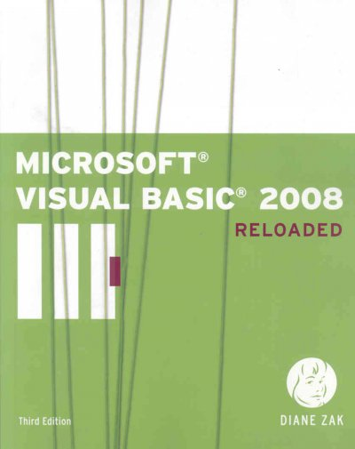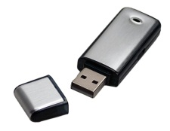

- Course Description and Information
This course provides an introduction to programming in Visual Basic. Students will develop computer programs using the Visual Basic programming language in Windows®-based computers. The course emphasizes planning, designing, writing, testing, debugging, and documenting Visual Basic programs.

- Course Learning Objectives
  - Understand programming approaches: top down, structured, and object oriented
  - Comprehend the following concepts of Visual Basics
    - Integrated Development Environment
    - Classes and objects
    - Controls and their properties and methods
    - Built-in Functions
  - Plan and design Visual basic computer programs
  - Write, test, and debug computer programs using the Visual Basic programming language
  - Create Visual Basic executable files
  - Document Visual Basic computer programs
  - Work in groups to complete assigned class projects

- Course Learning Outcomes
  - Design and develop simple to moderately complex Visual Basic computer programs.
  - Document Visual Basic computer programs and designs.
  - Correct errors in Visual Basic programs.
- Attendance
Attendance is required and the instructor reserves the right to take roll at any time during the duration of the class period. To achieve successful completion of the course, it is critical for the students taking this course to attend all classes. I will drop you if you have more than six unexcused absences or if you have missed class for two weeks in a row. I will allow three excused absences. An excused absence is one where the student has given the instructor prior notice of the absence. Also, I will count three tardies as an absence.

- Learning Methods
  - Lectures
  - Required reading
  - Blackboard and textbook assignments
  - Hands on projects (lab work)

- Reading, Assignments, Hands on Projects and Exams
Assigned readings must be read prior to attending class. Students are required to complete assignments, hands-on projects, and exams on their own. In other words, you may not collaborate with fellow students.

All examinations must be completed individually. Collaborative work will not be allowed during examinations. The use of books, notes, cell phones, and other electronic devices will not be allowed during examinations, unless specifically stated by the instructor prior to the examination. Make up examinations, assignments, and hands-on projects are only granted with advanced notification.

Late work will not be accepted. If a student fails to attend class and a project is due that day, the student will lose points for that project.

- Outcomes Assessment
Assignments 20%
Exams 20%
Hands on Projects 30%
Final Exam 10%
Participation 20%

Grading scale:
90-100% = A 80-89% = B 70-79% = C 60-69% = D <60% = F

- Final Drop Date
The final drop date for this class is:
- Friday, January 18th, for a refund
- Friday, January 25th, to avoid a “W”
- Friday, March 8th, to avoid a “Letter Grade”
It’s each student’s responsibility to drop the class if they are no longer attending or no longer interested, otherwise they risk obtaining a grade of “F” in the class.

- Policies
Campus code requires that shoes or sandals and appropriate attire be worn at all times on campus. Eating, drinking, and smoking are not allowed in the classroom or computer labs. Cell phones must be turned off or in the silence/vibrating mode while class is in session. If you need to use your cell phone (to make/receive a call or to send a text message) please go outside of the classroom. No visitors are allowed while class is in session. A student will be subject to discipline if she or he:
- Prevents other students from pursuing their authorized curricular or co-curricular interests.
- Interferes with or disputes faculty and administrators who are fulfilling their professional responsibilities.
- Prevents classified employees from fulfilling their prescribed duties.
- Deliberately endangers the safety of persons or the security of college property.
- Violates Reedley College computers and networks usage policy.
- Violates Reedley College cheating/plagiarism policy.

- Accommodations
If you have a verified need for an academic accommodation or materials in alternate media (i.e. Braille, large print, electronic text, etc...) per the Americans with Disabilities Act or Section 504 of the Rehabilitation Act, please contact the instructor as soon as possible.

- Cheating and Plagiarism
Cheating is the act or attempted act of taking an examination or performing an assigned, evaluated task in a fraudulent or deceptive manner such as having improper access to answers, in an attempt to gain an unearned academic advantage. Cheating may include, but is not limited to, copying from another’s work, supplying one’s work to another, giving or receiving copies of examinations without an instructor’s permission, using or displaying notes or devices inappropriate to the conditions of the examination, allowing someone other than the officially enrolled student to represent the student, or failing to disclose research results completely.

Plagiarism is a specific form of cheating: the use of another’s words or ideas without identifying them as such or giving credit to the source. Plagiarism may include, but is not limited to, failing to provide complete citations and references for all work that draws on the ideas, words, or work of others, failing to identify the contributors to work done in collaboration, submitting duplicate work to be evaluated in different courses without the knowledge and consent of the instructors involved, or failing to observe computer security systems and software copyrights.

Incidents of cheating and plagiarism may result in any of a variety of sanctions and penalties, which may range from a failing grade on a particular examination, assignment, or hands-on project in question to a failing grade in the course, at the discretion of the instructor and depending on the severity and frequency of the incidents.

