Reedley College
Fall 2013
8/12/13 – 12/13/13

Course: IS 40A - 50391 – INTERNET CONCEPTS & DESIGN
Class Time: Online (Using Blackboard)
Instructor: Daniel Morales, BS/MS
Email: daniel.morales@reedleycollege.edu and daniel.morales@alumni.usc.edu
Phone: 559-638-3641 ext.3264 (if no answer: leave a detailed message)
Office Hours: Room Bus 47: M-TH 10-11am, or by appointment

Text Books and Study Material:
- HTML5 and CSS3 (Complete), Author: Vodnik, Sasha. ISBN-13: 978-1-111-52798-3 Publisher: Cengage

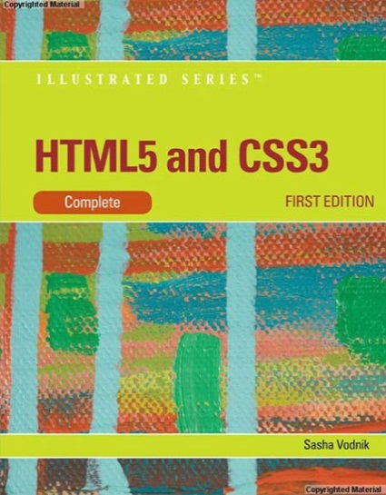

- Course Description and Information
This course provides a hands-on introduction to the Internet and World Wide Web, including the use of email, Usenet newsgroups, Gopher, FTP, and Telnet. The course includes the hypertext markup language (HTML), the use of web page editors, creating Web pages, hardware and software setup requirements, the use of the Internet for research and business, ethical and security issues.

Much in Information Systems industry require a great deal of attention to detail and critical thinking skills to succeed, therefore much in this course will require you to demonstrate attention to detail and the ability to read and understand instructions.

- Course Learning Objectives
  - Recognize networks, the Internet and World Wide Web (WWW).
  - Recognize the hardware and software needs for connecting to the Internet.
  - Access the Internet and the WWW using browsers, Telnet, and FTP.
  - Demonstrate the ability to retrieve and post Usenet messages.
  - Demonstrate the ability to compose and send email.
  - Recognize the Internet communication tools.
  - Be familiar with conducting search procedures utilizing search engines and directories.
  - Explore Uniform Resource Locators (URLs) to access Web Pages.
  - Identify, evaluate and analyze Internet information for research purposes.
  - Explore web page design analysis, evaluation, and critiquing.
  - Practice using HTML coding to create web pages.
  - Practice using web page editors to create web pages.
  - Demonstrate the ability to use FTP to post web pages.
  - Explore ethical decisions about the use of information from electronic media.
  - Determine Internet-related security issues.
- Course Learning Outcomes
- Differentiate between network, the Internet and the World Wide Web.
- Connect computer hardware to the Internet.
- Browse to access web sites.
- Create and send email.
- Perform topic searches on the Internet.
- Differentiate the types of activities on the Internet.
- Recognize the components of a web site.
- Recognize the coding formats in web page design.
- Create a web site using HTML.
- Create a web site using a web editor.
- Evaluate web sites for any ethical concerns.
- Recognize basic security concerns with creating a web site.
- Learning Methods
  - Required reading: PowerPoint presentations
  - Documents
  - Videos
  - Blackboard Assignments
  - Hands-on projects (lab work)
  - Exams

- Attendance
I will drop you if you haven’t completed any work for 2 weeks in a row.

- Readings, Assignments, Hands on Projects, and Exams
Students are required to complete assignments, hands-on projects, and exams on their own. In other words, you may not collaborate with fellow students.

All examinations must be completed individually. Collaborative work will not be allowed during examinations. The use of books, notes, cell phones, and other electronic devices will not be allowed during examinations, unless specifically stated by the instructor prior to the examination. Make up examinations, assignments, and hands-on projects are only granted with advanced notification.

Late work will not be accepted. If a student fails to submit an assignment or project on the day that it is due then the student will lose points for that project.

- Due Dates
You will find all work that is due, organized into folders, in Blackboard. For this online class, work will be due on Tuesdays by 11:59pm. This means you have all day on Tuesday to work. Tuesday is over at 11:59pm.

- Outcomes Assessment
Assignments 20%
Exams 30%
Hands on Projects 30%
Final Exam/Project 20%

Grading Scale:
90-100%=A, 80-89%=B, 70-79%=C, 60-69%=D, <60%=F

- Final Drop Date
The final drop date for this class is:
- Friday, August 23rd, for a refund
- Friday, August 30th, to avoid a “W”
- Friday, October 11th, to avoid a “Letter Grade”
It’s each student’s responsibility to drop the class if they are no longer attending or no longer interested, otherwise they risk obtaining a grade of “F” in the class.

- Policies
Campus code requires that shoes or sandals and appropriate attire be worn at all times on campus. Eating, drinking, and smoking are not allowed in the classroom or computer labs. Cell phones must be turned off or in the silence/vibrating mode while class is in session. If you need to use your cell phone (to make/receive a call or to send a text message) please go outside of the classroom. No visitors are allowed while class is in session. A student will be subject to discipline if she or he:
- Prevents other students from pursuing their authorized curricular or co-curricular interests.
- Interferes with or disputes faculty and administrators who are fulfilling their professional responsibilities.
- Prevents classified employees from fulfilling their prescribed duties.
- Deliberately endangers the safety of persons or the security of college property.
- Violates Reedley College computers and networks usage policy.
- Violates Reedley College cheating/plagiarism policy.

- Accommodations
If you have a verified need for an academic accommodation or materials in alternate media (i.e. Braille, large print, electronic text, etc...) per the Americans with Disabilities Act or Section 504 of the Rehabilitation Act, please contact the instructor as soon as possible.

- Cheating and Plagiarism
Cheating is the act or attempted act of taking an examination or performing an assigned, evaluated task in a fraudulent or deceptive manner such as having improper access to answers, in an attempt to gain an unearned academic advantage. Cheating may include, but is not limited to, copying from another’s work, supplying one’s work to another, giving or receiving copies of examinations without an instructor’s permission, using or displaying notes or devices inappropriate to the conditions of the examination, allowing someone other than the officially enrolled student to represent the student, or failing to disclose research results completely.

Plagiarism is a specific form of cheating: the use of another’s words or ideas without identifying them as such or giving credit to the source. Plagiarism may include, but is not limited to, failing to provide complete citations and references for all work that draws on the ideas, words, or work of others, failing to identify the contributors to work done in collaboration, submitting duplicate work to be evaluated in different courses without the knowledge and consent of the instructors involved, or failing to observe computer security systems and software copyrights.

Incidents of cheating and plagiarism may result in any of a variety of sanctions and penalties, which may range from a failing grade on a particular examination, assignment, or hands-on project in question to a failing grade in the course, at the discretion of the instructor and depending on the severity and frequency of the incidents.

- Class Schedule
The topics, assignments, projects, and due dates will be posted on Blackboard.

