Syllabus – Spring 2012

Course: ESL 261I – Beginning Reading, Writing and Grammar (52298)

Time/ Location:

Monday | Tuesday | Wednesday | Thursday | Friday
ESL 261 (52298)  9:00 - 10:50  FEM 12 | ESL 261 (52298)  9:00 - 9:50  FEM 12 | ESL 261 (52298)  9:00 - 10:50  FEM 12 | ESL 261 (52298)  9:00 - 9:50  LAL 2 | ESL 261 (52298)  9:00 - 9:50  POR 1
 |  |  | 9:00 - 9:50  LAL 1 | 9:00 - 9:50  LAL 1

Units: 8

Important Dates: No Classes: 1/16, 2/17, 2/20, 4/2 - 4/7
Deadline to drop the class to avoid a “W” (withdrawal): 1/27
Deadline to drop the class to avoid a grade: 3/9
Final Exam: Wednesday, May 16, 2012, 9:00 – 10:50, FEM12

Instructor: David Nippoldt
Office: FEM 4G
Office Hours: Monday 11:00 – 11:50, Tuesday 10:00 – 11:50
Phone: 638-3641 ext. 3100
Email: David.Nippoldt@ReedleyCollege.edu

Materials: 1. Required: * Focus On Grammar 2 Text/ Workbook Package, Schoenberg, Longman, 4rd Edition.

2. Required: *Reading Explorer Intro/CD ROM Package, Chase, Cengage, 1st Edition.

*These are workbooks. Used books are not acceptable.

Description: ESL 261I is an integrated skills course designed for speakers of other languages who want to learn reading, writing, and grammar at the beginning level. This course may be taken concurrently with ESL 261LS. ESL 261I is six levels below English 1A. Students who successfully
complete this course will be prepared for ESL 264.

Subject Prerequisites: English as a Second Language 260 or placement through a multiple-measure process, including an appropriate score on an approved ESL placement Exam.

Repeatability: This course may not be repeated after successful completion.

Course Objectives: In the process of completing this course, students will:
- read beginning materials on familiar social themes.
- identify main ideas and supporting details.
- use strategies to recognize vocabulary in context.
- use strategies to increase reading comprehension and speed on familiar topics.
- write and edit sentences and basic paragraphs.
- identify and use grammatical structures in written English.
- identify and correct grammatical errors.
- use software applications for language learning.
Course Outcomes: Upon completion of this course, students will be able to:
- read and understand beginning-level texts.
- write sentences and basic paragraphs at the beginning level.
- recognize and use beginning grammar structures.
- perform basic language learning computer tasks.

Grading: This is a pass / no pass course. Current grades will be available to students throughout the semester on Blackboard. Final grades will be calculated as follows:
Pass (P) >70%;
No Pass (NP) <70%

Categories | Weight
Homework/ Lab | 10%
Writing | 25%
Reading Exams | 25%
Grammar Exams | 25%
Final Exam | 15%

Homework: Classroom and lab assignments are due at the beginning of the class period on the date due unless stated otherwise. Some assignments may be turned in electronically. Unless other arrangements are made, no credit will be given for homework handed in late. Extra work or makeup work will not affect your grade.

Exams: The date for exams will be announced in advance. If you are absent on the day of an exam, you will receive a zero score. You will not be allowed to take the exam on a later day unless you have made arrangements with the instructor before the exam. Some exams may be given using the computer.

Writing: Your writing will be read by other students in this class. This includes exchanging and reading paper for the purpose of review. This also includes possibly projecting your paper on the screen for the whole class to review. Choose writing topics that you are willing for others to read. Your writing will not be private.

Class Participation: Your active participation in class is important for not only you but also your classmates. Make it your priority to be in class everyday. You are expected to come to class on time with your homework complete, and actively engage in classroom activities such as group discussions and pair practice. If you miss class, you are still responsible for the homework and activities that went on in your absence. Contact a classmate or your teacher for assignments so you can be prepared for the next class. If you miss more than five days, you may be dropped from the class.

Canceled Class: In the event that class must be canceled unexpectedly, an official form will be placed on the classroom door by the Dean’s Office. When you arrive to class, you are responsible to read the notice for any special assignments or instructions.

Accommodations for students with disabilities: If you have a verified need for an academic accommodation or materials in alternate media (i.e., Braille, large print, electronic text, etc.) per the Americans with Disabilities Act (ADA) or Section 504 of the Rehabilitation Act, please contact the instructor as soon as possible.

Other Policies:
- 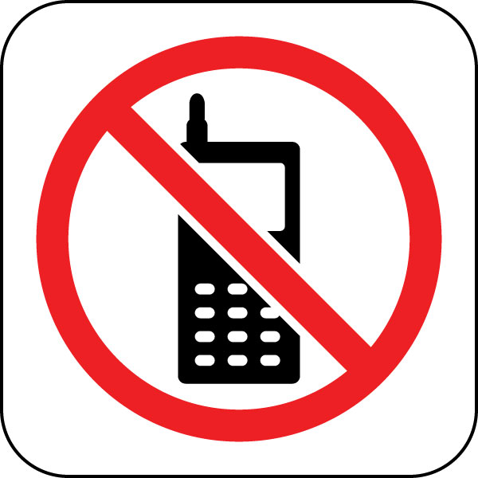Children are not allowed in class. Adult visitors are allowed with permission of the instructor. Please make arrangements in advance.
- Please do not use cell phones during class time. Set your phone so it does not ring. Do not answer your phone, make calls, or text during class.
- A student will receive no credit for an assignment or exam if in the opinion of the instructor the student has cheated or plagiarized.
- If you miss class, please communicate with the instructor. You may be dropped from the class if you miss more than 4 class periods.

Schedule (subject to change):
Weeks | Focus On Grammar 2 (FOG) | Reading Explorer Intro (RE)
1 – 2
3 – 4 | Exam: Part I—  Be: Present and Past (Units 1 – 3) | Exam: Units 1 - 3
5 – 6 | Exam: Part II—  Nouns, Adjective, Prepositions (Units 4 – 6)  Exam: Part III—  Imperatives and the Simple Present (Units 7 – 10)
7 – 8 | Exam: Part IV—  There is/ There are/ Possessives, Modals: Ability and Permission (Units 11 – 14)  Exam: Part V—  Present Progressive (Units 15 – 17) | Exam: Units 4 – 6
9 – 10 | Exam: Part VI—  Simple Past (Units 18 – 20)  Exam: Part VII—  Verb Review and Contrast and Expansion  (Units 21 – 23)
11 – 12 | Exam: Part VIII—  The Future (Units 24 – 26) | Exam: Units 7 – 9
13 – 14 | Exam: Part IX—  Count/ Non-Count Nouns; Much/ Many; Quantifiers (Units 27 – 29)
15 – 16 | Exam: Part X—  Modals: Requests, Advice, Necessity (Units 30 – 32) | Exam: Units 10 – 12
17 | Exam: Part XI—  Comparisons (Units 33 – 36)
18 | Final Exam

