Reedley College: Sanger

Syllabus for Biology 3
Introduction to Biology
Spring Semester, 2012
Instructor:

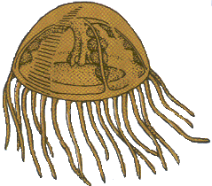
Gary W. Potter (e-mail gary.potter@reedleycollege.edu), Please include Biol. 3 in the subject line or I will not open your e-mail!

Meeting Times:

Monday & Wednesday, 6:00 PM until 8:15 PM.

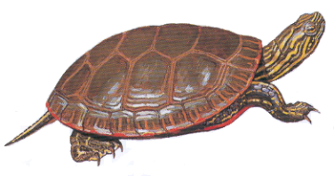
Holidays: No Classes will meet.

Monday, January 16, 2012: Martin Luther King holiday
Friday, February 17, 2012: Lincoln Day holiday
Monday, February 20, 2012: Washington's Day holiday.
April 2-6, 2012: Spring Recess
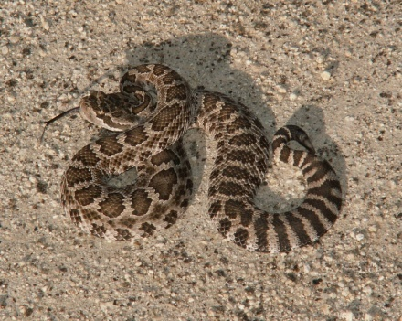
Exam Dates:

Exam # 1: Monday, February 13, 2012
Exam # 2: Monday, March 19, 2012
Exam # 3: Wednesday April, 27, 2012
Exam # 4: Monday, May 14, 2012

Other Important Dates:

January 23: Last day to drop a Spring, 2012, full-length class for a refund
January 30: Last day to drop a Spring, 2012, full-length class to avoid a “W”
March 19: Last day to drop a Spring, 2012 class (letter grades will be assigned after this date.)
May 18: Spring semester ends. Commencement.

Course Description:

Biology 3 is recommended for the non-biological science and pre-education majors. This is an introductory course using biological concepts. The organismal structure, function, inheritance, evolution, and ecology are covered. Field trips may be required.

Course Outcomes:

Upon completion of this course, students will be able to:

A. understand the process of scientific method, microscopy, and the cell.
B. identify levels of organization from the cell to the organismal level. Identify human organ systems structure and function.
C. evaluate scientific literature and current biological achievements.
D. assess the role of human ecology, earth resources, and limitations.
E. learn nature through the study of plants structure, functions, and process such as photosynthesis
F. apply the principles of genetics to humans and understand the outcome of reading DNA.
G. classify and evaluate the wide range of living organisms and their place on earth.
H. understand the chemical basis of life.
I. identify life from an evolutionary approach.
J. understand the chemical and energy relationships at all levels of biological organization.

Course Objectives:

In the process of completing this course, students will:

A. read, analyze, evaluate, and discuss Scientific Method, Microscopy, The cell, and Levels of Organization.
B. learn the periodic table of the elements and chemistry of the carbon atom and chemical structure of living organisms.
C. read appropriate scientific literature on classification.
D. learn the cell’s structure, function, and organization of living organisms
E. observe and document the structure and function of the human body by examining the organ systems: reproduction, respiration, circulation, excretion, and digestion.
F. review classical and molecular genetics and learn the process of replication, transcription, and translation.
G. perform experiments, observe, and record data.
H. learn plant structure, physiology, and interaction including photosynthesis and aerobic respiration.
I. study evolution.
J. observe chemical and energy relationships.

Accommodations for students with disabilities: If you have a verified need for an academic accommodation or materials in alternate media (i.e., Braille, large print, electronic text, etc.) per the Americans with Disabilities Act (ADA) or Section 504 of the Rehabilitation Act, please contact me as soon as possible.

Required Materials:

1. Textbook: Mader, Sylvia S., Essentials of Biology, 2nd edition (2010), McGraw-Hill
Companies Inc.
2. Notebook or three ring binder for note taking..
3. Recommended Text: Sierra Nevada Natural History, revised ed. Storer, T., Usinger, R., & Lukas, D., Univ. of California Press. 2004.
4. Biology Drawing Paper & pencil, for lab plates.
5. Camera – for field trips/photo essay project
Expectations:
A. You are expected to attend all class sessions. Two or more absences from laboratory
periods and four absences from lecture periods may very likely put you in jeopardy of
failing. Unless there are extenuating circumstances, such absences may also get you
dropped from the course.
B. You are responsible for finding out what you missed and for making up missed work due
to absence.
C. Cheating and plagiarism will not be tolerated. Students caught cheating will receive a
zero for that assignment, quiz, or test. Cooperative learning is limited to working in
groups during labs.
D. Assignments are expected to be turned in on time. In case of absence, I will be accept
late papers up to two class meetings after the due date, with a grade deduction of 10% per
per each class meeting that it is late.
E. Guests are not allowed in class!

Grading: Your grade will be determined by using an accumulative point total of all laboratory reports, quizzes, and exams. Quizzes and Lab Reports are worth 10 points each, the written exams are worth 100 points each. Each exam will consist of a combination of multiple choice and short answer essay questions. Laboratory practical exams will be given from time to time and will consist of ten to fifteen stations worth 2 points each. Two makeup quizzes will be given. Your score on the makeup quizzes will be used to makeup a missed quiz or to replace the score of a quiz on which you scored lower than on the makeup quiz. No low quiz will be thrown out! Extra credit will be limited to a few bonus questions on tests and an occasional special quiz or assignment. Extra credit will not be given for any other work! At the end of the semester, your accumulated point total will be divided by the total number of points possible to determine your percentage grade. Your final letter grade will be determined using the following grading scale:

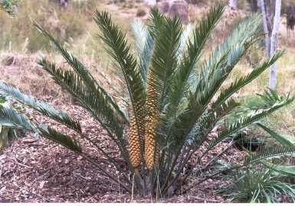
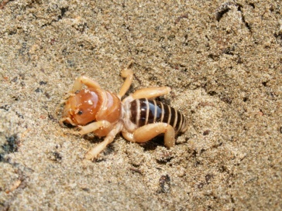
90% to 100% = A
80% to 89.9% = B
70% to 79.9% = C
60% to 69.9% = D
0% to 59.9% = F

Grades will not be rounded! 89.99999999% is a B+ not an A-!

Projects: More details on each of these will be presented later.

1. Pollination Project: Design a plant with pollination type and seed dispersal.

2. Plant Collection Project: Collect and identify each of the major groups of plants

3. Photo Essay Project: Demonstrate Sierra Nevada ecological communities with a photo display of Grasslands, Foothill Woodland (Savannah), Chaparral, Yellow Pine Forest,
and Riparian habitats with indicator species of each.

Week Lecture & Lab. Topics. Reading

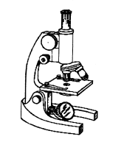
1 Lectures: Review the Syllabus; Biological Methods and Concepts. Ch. 1
Lab. 1: What is life? Observation and Interpretation.
Lab. 2: Scientific method.

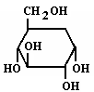
2 Lectures: Introduction to chemistry. Ch. 2 Lab. 3: Diagramming of atoms.
Lab. 4: Use of the compound microscope.

3 Lectures: Biochemistry, The Organic Molecules of Life Ch. 3
Lab. 5: Chemical tests for basic organic food groups.

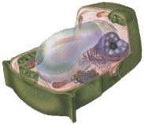
4 Lectures: Biochemistry, continued.
Cell structure, function Ch. 4
Lab. 6: Cell structure, onion skin, cheek cells, Anacharis leaf.

5 Lectures: Cell reproduction Ch. 8
Lab. 7: Mitosis

Test# 1: Monday, February 13, 2012: Biological methods, chemistry, cells

6 Lectures: Cellular respiration, fermentation Ch. 6
Photosynthesis Ch. 7
Lab. 6: Photosynthesis & Pigment chromatography
Lab. 7: Respiration
7 Lecture: DNA & RNA structure and function. Ch. 11
Protein Synthesis
Lab. 8: DNA & Protein synthesis worksheet.

8 Lecture: Meiosis and Mendelian Genetics & Ch. 8 Human Genetics Ch. 10
Lab. 9: Genetics Lab., Genetics problems & Human Genetics Ch. 13

9 Lecture: Evolution, Microevolution & Macroevolution Ch. 15
Classification, Systematics, & Taxonomy Ch. 16 Lab. 10: Microevolution lab.

Test # 2: Monday, March 19, 2012: Photosynthesis, Respiration, Genetics, & Evolution
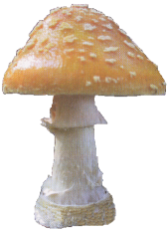
10 Lecture: The First Forms of Life, Viruses, Prokaryotes & Protists Ch. 17
Plants & Fungi Ch. 18
Lab. 11: The Plants & Fungi; Introduction to The Plant Collection Project
Lab. 12: Pollination Project. Film: "Sexual Encounters of the Floral Kind."
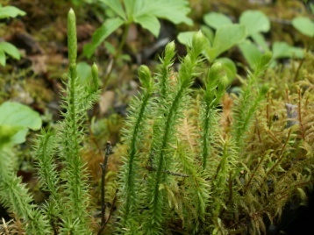
11 Lecture: Plant anatomy & Physiology Ch. 20 & 21
Lab. 14: Plant morphology & Anatomy

12 Lecture: The Animal; Kingdom. Ch. 19
Lab. 15: Animal Taxonomy Lab.

13 Lecture: Human & Animal Structure & Function Ch. 22 through 29
Lab. 16: Human & Animal Tissues, Organs & Systems

Test # 3: Exam # 3: Wednesday April, 29, 2012: Protista, Fungi, Plants, & Animals

14 Monday, April 18, 2011: Pollination Project Presentations
Lecture: Human Systems continued Ch. 22 through 29
15 Lecture: Ecology of Populations Ch. 30
Lab. 17: Population Ecology

Plant Collections Due: Wednesday, May 2, 2012
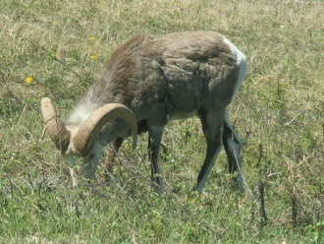
16 Lecture: Communities & Ecosystems Ch. 31
Lab. 18: Ecosystems & Biomes

17 Lecture: Human Impact on Ecosystems Ch. 32

Wednesday, May 9, 2012: Photo Essay Project Due

Review for lecture final exam

18 Exam # 4: Monday, May 14, 2012: Ecosystems, biomes, communities, animal behavior, & Human populations.

