Office Technology 41 Medical Administrative Assistant Reedley College

Fall 2012 MWF 1:20 – 2:30, BUS 41 #52519: 8/13/12-12/14/12

Instructor: Toni Ensz Office: be 44 Phone: 638-3641, Ext: 3785
BUS 41: 638-3641, Ext. 3335
Email: toni.ensz@reedleycollege.edu
Office Hours: T 1:00 - 2:00 pm and TH 1:00 - 3:00 pm in BUS 41 or by appointment
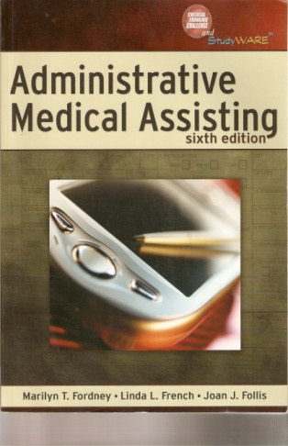
Required Text and Supplies:
- Administrative Medical Assisting, sixth edition, Fordney, French & Follis
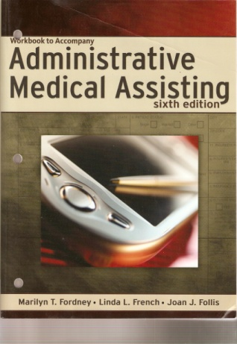
- Workbook to accompany Administrative Medical Assisting, Sixth edition, Fordney, French and Follis
- Flash Drive

course description:
This course will present policies and procedures used in a medical facility. Attitudes, behavior, ethics, records, and office duties are some of the topics covered.

course outcomes:
Upon completion of this course, students will be able to:

- list and define medical administrative duties, including bookkeeping.
- identify medical ethics and medical-legal implications for the medical assistant.
- learn the rules and demonstrate the ability to complete the various medical administrative assistant duties.
- organize thoughts and demonstrate knowledge of medical terminology in the production of letters and memos.
- select appropriate forms for specific uses and use good judgment in formatting other. documents.

course objectives:
In the process of completing this course, students will:

- complete the various medical administrative assistant duties.
- demonstrate an understanding of medical ethics and medical-legal implications.
- use problem-solving methods to perform medical notebook maintenance, exhibit preparation, records management, and medical word processing.
- use inductive and deductive methods of reasoning in analyzing medical terminology, procedures and policies in the production of letters, memos, and medical forms

basic skills advisories:
English 125, English 126, and Math 101
subject advisories:
OT10 - Medical Terminology and ability to type 35 wpm

Attendance and Tardies:
- Just as it is expected that employees will be present for all workdays, students are expected to attend all class meetings, be on time, and be in class the entire class session. Roll is taken each class period. The only excused absences are those due to a school-related activity or a requirement to appear in court and you must let me know before the absence. Any other absence, calling me to tell me you will be absent does not excuse you but is considered professional courtesy and will be noted in your attendance record. (On the job, if you do not call prior to being absent, you will be reprimanded or fired.) Students leaving class before the end of class will be recorded as a tardy and 3 points will be deducted from participation.

- If you decide to drop the course, it is your responsibility to make the drop official in the Admissions and Records office or else possibly receive a grade of F. The drop date for this class is October 12, 2012

- I do not accept late work, nor do I allow for make-up work (this includes in-class work, homework, and tests). This means you need to be in class and do the work as assigned. If you are aware you are going to be absent, you may complete the assignment and hand it in early, but no late work will be accepted.

- In this class, you are allowed 4 absences (not necessarily consecutive) before being dropped from the class. Absences and tardies will affect your grade. Five points will be deducted each day of non participation and 3 points for each tardy. Students are expected to be on time. Two tardies may be considered 1 absence.

Holidays:
- Monday, September 3 – Labor Day
- Monday, November 12 – Veterans Day
- Thursday & Friday, November 22-23 – Thanksgiving Break
Tests:

- There are no make-ups for missed tests. If you foresee that you have an unavoidable situation on an upcoming test date, you may arrange to take the test early. No late tests will be allowed. Telephone or email me to discuss a specific situation.

- Try not to be late for an exam. If you are late, you may take the exam up to the time the first student finishes the exam and leaves. After the first student leaves, you may not take the exam and it will count as a missed exam.

Final Exam:

- A comprehensive final exam will be given at the end of the quarter. The final exam will be given on Wednesday, December 12, 1:00-3:00.
Grade | Percentage of total points
A | 90-100%
B | 80-89%
C | 70-79%
D | 60-69%
F | 59% and lower

Grading:
Class Participation & Quizzes 20%
Homework/Workbook 50%
Chapter & Unit Tests 20%
Final 10%

Web address to access your progress grades:
- http://sc.webgrade.classmanager.com/reedleycollege/
- Your User ID is the same as your Reedley College Student ID.
- I will email you your password and a link to the Web site at the end of week 2.

Cell Phones:
- Please place your phones on vibrate before class begins. No texting allowed in class. If you must take a phone call, please step out of the classroom when talking. I will ask you to leave class and deduct 3 points from your participation grade if you continually have your phone out during class. No earphones allowed in class.

ADA:
- If you have special needs as addressed by the Americans with Disabilities (ADA) act including alternate media requests, please notify your course instructor immediately. Reasonable efforts will be made to accommodate your special needs.

Academic Dishonesty:
- Students at Reedley College are entitled to the best education that the college can make available to them, and they, their instructors, and their fellow students share the responsibility to ensure that this education is honestly attained. Because cheating, plagiarism, and collusion in dishonest activities erode the integrity of the college, each student is expected to exert an entirely honest effort in all academic endeavors. Academic dishonesty in any form is a very serious offense and will incur serious consequences.

- Cheating is the act or attempted act of taking an examination or performing an assigned, evaluated task in a fraudulent or deceptive manner, such as having improper access to answers, in an attempt to gain an unearned academic advantage. Cheating may include, but is not limited to, copying from another’s work, supplying one’s work to another, giving or receiving copies of examinations without an instructor’s permission, using or displaying notes or devices inappropriate to the conditions of the examination, allowing someone other than the officially enrolled student to represent the student, or failing to disclose research results completely.

- Plagiarism is a specific form of cheating: the use of another’s words or ideas without identifying them as such or giving credit to the source. Plagiarism may include, but is not limited to, failing to provide complete citations and references for all work that draws on the ideas, words, or work of others, failing to identify the contributors to work done in collaboration, submitting duplicate work to be evaluated in different courses without the knowledge and consent of the instructors involved, or failing to observe computer security systems and software copyrights.

- Incidents of cheating and plagiarism may result in any of a variety of sanctions and penalties, which may range from a failing grade on a particular examination, paper, project, or assignment in question to a failing grade in the course, at the discretion of the instructor and depending on the severity and frequency of the incidents.
Receipt and Acknowledgement of OT 41 syllabus

I, _________________________________acknowledge the receipt of this OT 44 syllabus.
(Print your name legibly)

I have read the guide and understand the policies and procedures of this course. I particularly understand the policies regarding Attendance, make-ups, cell phones, and Grading, as outlined in this document.
Signature ____________________________

Id # _________________________________

Date _________________________________

Phone # ______________________________

