Office Technology 41 medical administrative assistant reedLEY COLLEGE

Quarter 1, Fall 2010 T TH & F 12:00pm-2:35, POR5 #51062 : 08/17/10-10/15/10

Ms. Carolyn Belcher (Ms. “B”) Cell Phone: 559-285-4248

Email: carolyn.belcher@fresnocitycollege.edu Office Hours by appointment

Course Description:
This course will present policies and procedures used in a medical facility. Attitudes, behavior, ethics, records, and office duties are some of the topics covered.

Course Objectives:
In the process of completing this course, students will:
- list and define medical administrative duties, including bookkeeping.
- identify medical ethics and medical-legal implications for the medical assistant.
- learn the rules and demonstrate the ability to complete the various medical administrative assistant duties.
- organize thoughts and demonstrate knowledge of medical terminology in the production of letters and memos.
- select appropriate forms for specific uses and use good judgment in formatting other documents.

Basic Skills Advisories:
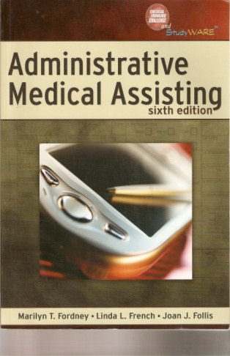
ENGLISH 125, ENGLISH 126, AND MATH 101
Subject Advisories:
OT10 MEDICAL TERMINOLOGY AND ABILITY TO TYPE 35 WPM
Required Text And Supplies:
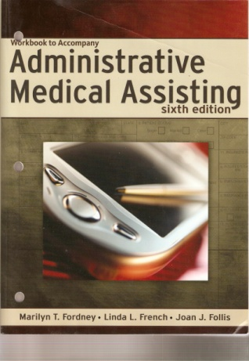
- Administrative Medical Assisting, sixth edition, Fordney,French, Follis; Delmar Cengage Learning, 2008, ISBN 978-1-4180-6411-2
- Workbook to Accompany Administrative Medical Assisting, sixth edition, Fordney,French, Follis; Delmar Cengage
Learning, 2008, ISBN 978-1-4180-6412-9
- Jump Drive (aka USB drive, Flash drive, Thumb drive)

Student Learning Outcomes:
Upon completion of this course, students will be able to:
- Complete the various medical administrative assistant duties.
- Demonstrate an understanding of medical ethics and medical-legal implications.
- Use problem-solving methods to perform medical notebook maintenance, exhibit preparation, records management, and medical word processing.
- Use inductive and deductive methods of reasoning in analyzing medical terminology, procedures and policies in the production of letters, memos, and medical forms.
- Understand the HIPPA regulations as they pertain to the medical administrative assistant duties.

Suggestions For Success:
- Read the chapter assignments. Try to stay ahead in your reading. Test yourself by going through the Key Terms and the Review activities at the end of each chapter.
- Attend every class that you possibly can
- Participate in class discussions and ask questions when you don’t understand something.
- Turn in every assignment on time (Late Work is NOT ACCEPTED)
- Take every test
- Take every quiz
- There will be extra credit given periodically in the semester. Take advantage of it.

In the words of Lou Tice “Live your life on a want to, choose to, like it, love it basis; be fully accountable for your actions by understanding and accepting the consequences of the choices you make.”

Instructor Changes:
- The instructor reserves the right to change, add to, delete from, or alter any aspect of this syllabus during the semester, as necessary. Changes will be announced in class. Adequate notice will be given when changes are made.
- The instructor reserves the right to round up grades which are 5-10 points off a whole letter grade. For example, 795 points can be rounded up to 800 if that would give the student a “B”.

Class Participation
This course requires class participation. Participation points will be earned on a daily basis in this course. Five participation points per day are earned in this course for class participation. If you do not attend class, you cannot earn the participation points for the day. Students leaving class before the end of class will be counted as being absent and will lose participation points. There are no bad questions unless they are intended to disrupt the learning process. You may not work on homework during class. You may not study for another class, sleep, or read a book or access the Internet during class. CELL PHONES AND PAGERS ARE TO BE IN SILENT-MODE. Students are required to participate in all class discussions and activities.
Class Policies:
- Students are expected to attend all class meetings, be on time, and be in class the entire class session
- Professional conduct is expected from you at all times; dress accordingly,
- Your classmates and I would greatly appreciate that students in the class take care of any personal needs (i.e., using the restroom, getting a drink, sharpening a pencil) before class begins.
- If you decide to drop the course, it is your responsibility to make the drop official in the Admissions and Records office or else possibly receive a grade of “F”.

STUDENTS MAY BE DROPPED FROM THIS COURSE ON THE 2ND CONSECUTIVE ABSENCE OR ON THE 3RD NON-CONSECUTIVE ABSENCE PRIOR TO THE DROP DEADLINE.
- Absolutely no eating, drinking, smoking, children or pets in the classroom. If you have a soda fountain drink or coffee, please drink it before entering the room. If you have bottled water, please put it inside your bag or discard it as you enter the room.
- If you get dropped and want to add the class again, you will go to the back of the waiting list.
- If you need to respond to the cell phone or send a text message, please go outside the class room.
- This class will operate under all college policies listed in the FCC/Reedley catalog for fall 2010
Policy Violations:
- First violation: Verbal Warning
- Second violation: You will be dismissed from class for the remainder of the day and an incident report will be filed with the Dean’s Office.
- Third violation: You will be dropped from the class with a grade of “F” and the incidents will be reported to the appropriate college personnel for further disciplinary action.

Holidays:
None

Important Dates:

Drop Deadline: September 16, 2010 (Thursday)
Last day to drop a class for a fee refund/reversal: August 27, 2010 (Friday)
End of three (3) week drop period (no “W” on transcript): September 3, 2010 (Friday)
Late registration and add/drop: August 16 to September 3, 2010 (Monday to Friday)

Tardies:
Students are expected to be on time. It is distracting, rude and unfair to fellow classmates and to the instructor when a student is late; two tardies results in a loss of 1 participation point.

Homework:
Some lab work will be collected. Each assignment collected will be graded on completeness, neatness, and effort. Lab work should be written or keyboarded on one side of a standard sized paper 8 ½ x 11 (No spiral paper, please) stapled in the upper left-hand corner, and in order. Record the class name, your name, homework (chapter and problems), and date on each homework assignment. No late homework will be accepted! Note: Being absent the day homework is collected does not entitle you to turn it in late! Telephone or email me to discuss your specific situation.

Quizzes:
Quizzes are listed on the Daily Assignments sheet. Missed quizzes cannot be makeup.
Tests:
Missed tests cannot be makeup. If you foresee that you have an unavoidable situation on an upcoming test date, you may arrange to take the test early. No late tests will be allowed. Telephone or email me to discuss a specific situation.

Final Exam:
Percent of Total Points | Grade | Point  Range
90-100 | A | 1350-1500
80-89 | B | 1200-1349
70-79 | C | 1050-1199
60-69 | D | 900-1049
0-59 | F | 0-899
A two-hour comprehensive final exam will be given at the end of the quarter. The date and time of the exam is as follows: Friday, October 15, 12:00- 2:00 p.m.

Grading Points:

- QUIZZES & CLASS PARTICIPATION: 275
- LAB WORK: 849
- TESTS: 376
TOTAL POINTS 1,500

14 quizzes @ 10 pts = 140 pts
27 class days @ 5 pts = 135pts
Lab Work = 849 pts
Total Unit Test including the final – 376 pts

ADA
If you have a verified need for an academic accommodation or materials in alternate media (i.e.: Braille, large print, electronic text, etc.) per the Americans with Disabilities Act or Section 504 of the Rehabilitation Act please contact your instructor as soon as possible. Reasonable efforts will be made to accommodate your special needs.

Academic Dishonesty
Students at Reedley College are entitled to the best education that the college can make available to them, and they, their instructors, and their fellow students share the responsibility to ensure that this education is honestly attained. Because cheating, plagiarism, and collusion in dishonest activities erode the integrity of the college, each student is expected to exert an entirely honest effort in all academic endeavors. Academic dishonesty in any form is a very serious offense and will incur serious consequences.

Cheating is the act or attempted act of taking an examination or performing an assigned, evaluated task in a fraudulent or deceptive manner, such as having improper access to answers, in an attempt to gain an unearned academic advantage. Cheating may include, but is not limited to, copying from another’s work, supplying one’s work to another, giving or receiving copies of examinations without an instructor’s permission, using or displaying notes or devices inappropriate to the conditions of the examination, allowing someone other than the officially enrolled student to represent the student, or failing to disclose research results completely.

Plagiarism is a specific form of cheating: the use of another’s words or ideas without identifying them as such or giving credit to the source. Plagiarism may include, but is not limited to, failing to provide complete citations and references for all work that draws on the ideas, words, or work of others, failing to identify the contributors to work done in collaboration, submitting duplicate work to be evaluated in different courses without the knowledge and consent of the instructors involved, or failing to observe computer security systems and software copyrights.
These are two of the most serious offenses in the teaching-learning process. Students who are caught cheating will receive an “F” for the course and have a copy of a Dishonesty Infraction Form put into their scholastic record. Some examples of cheating include but are not limited to the following:

- Putting your name on another students work
- Helping another student during a test or quiz
- Using any kind of notes (on paper or on any electronic device) during a test or quiz
- Downloading something off of the Internet and attempting to pass it off as your own work.

In short, cheating will not be tolerated in this class.

Receipt and Acknowledgement of the OT 41 Syllabus

I, __________________________________ acknowledge the receipt of this OT 41 syllabus.
^{(Print your name legibly)}

I have read the guide and understand the policies and procedures of this course. I particularly understand the policies regarding Participation, Cell Phones, Policy Violations and Grading, as outlined in this document.

Signature ____________________________________
ID#__________________________________________
Date_________________________________________
Phone #______________________________________ (only with your permission)
E-mail________________________________________

