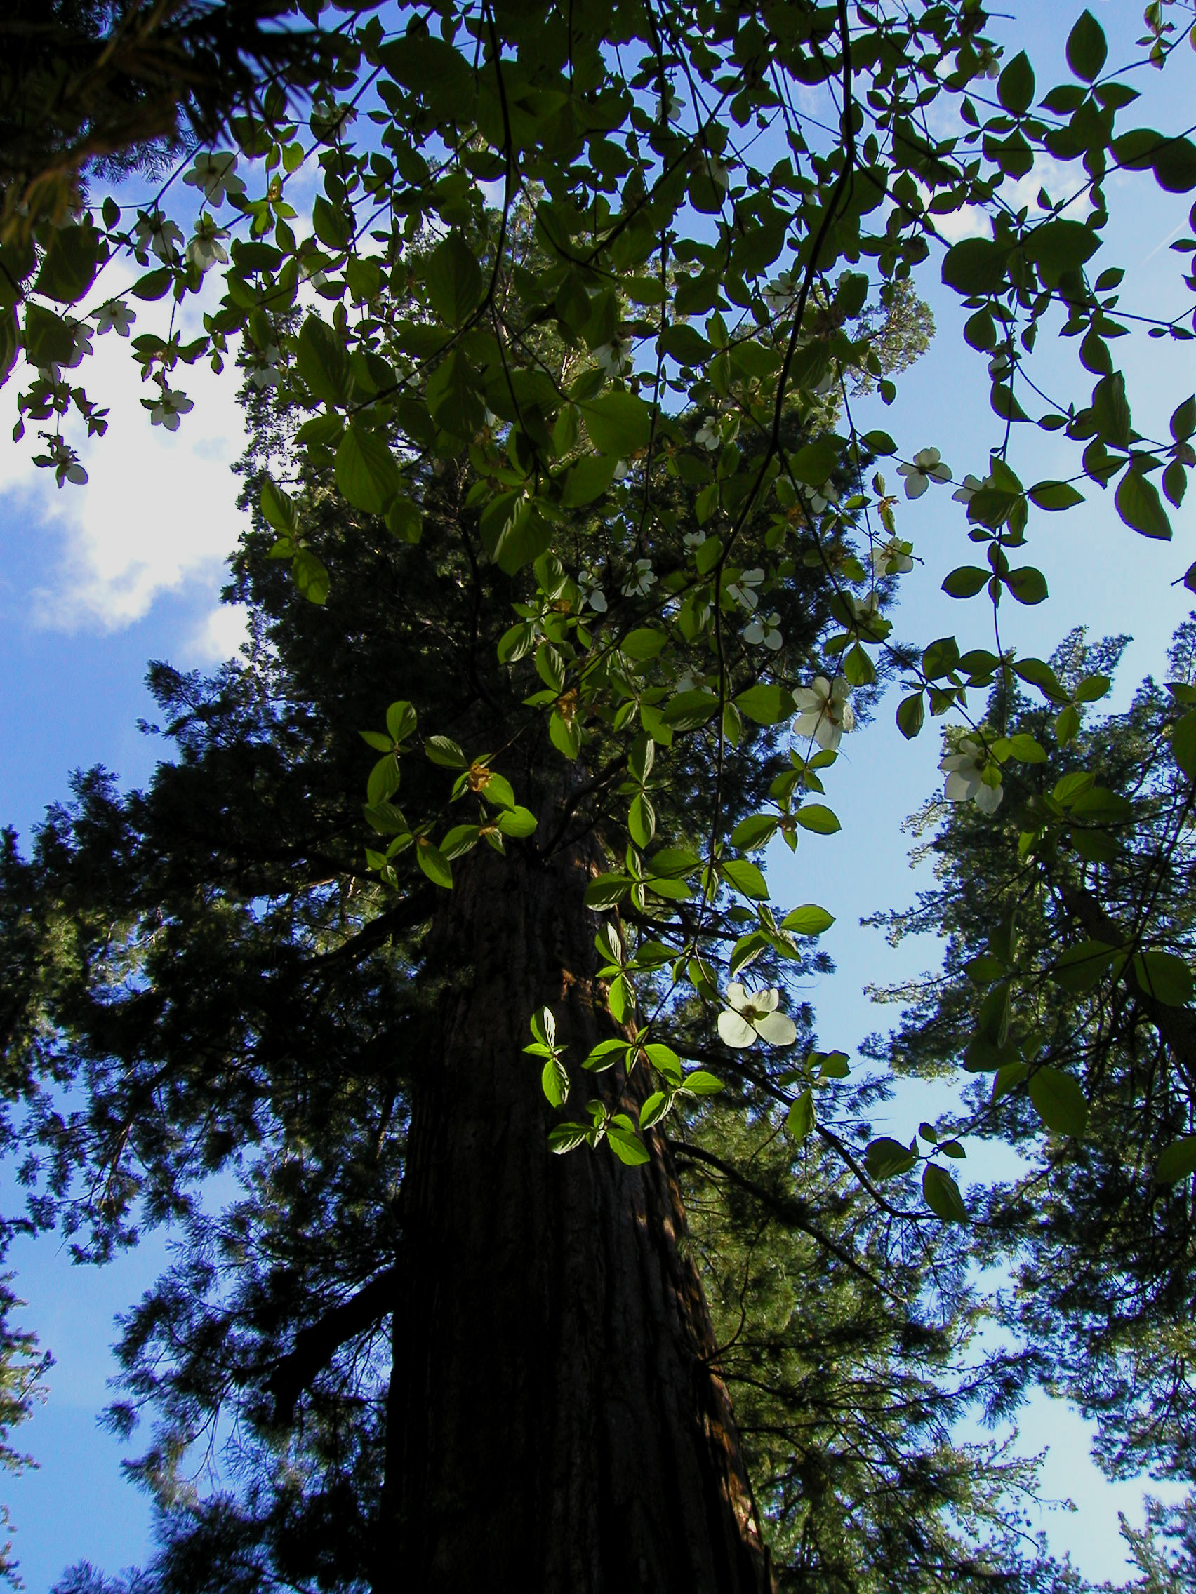
NR 25 – Forest & Resource Management
Reedley College – Spring 2005
Lecture 1:00-1:50 M,T Room FEM 7
Lab 2:00-4:50 T Room FEM 8

Instructor Jason Pinkerton
Office: FEM 3, Phone: (559) 638-3641, Ext. 3260
Office Hours: M --- 11:00-1:00 and TH --- 12:00-1:00 other times by appointment
Email: jason.pinkerton@reedleycollege.edu

Course Objectives
This course will provide opportunities for research of management plans for public and private resource lands. The process through which land management plans are created will be explored. Emphasis will be placed on management of forests, applying skills, science, and knowledge to solve practical field problems.

Textbook (not required)
“Forest management”, 4th Edition, by Davis, L.S., N.K. Johnson, P.S. Bettinger, and T.E. Howard. McGraw-Hill, 2001.

Classroom Conduct
Please turn cellular phones and pagers off during class time. (1 point will be deducted from your final grade for each cell phone ring).

Accommodation Statement
“If you have a verified need for an academic accommodation or materials in alternate media (i.e., Braille, large print, electronic text, etc.) per the Americans with Disabilities Act (ADA) or Section 504 of the Rehabilitation Act, please contact me as soon as possible.”

Field Trips
There will be several laboratory excursions taken during the semester. These trips will generally occur during the scheduled class time. However, we may return to campus after 4:50 pm on occasion. Always come to lab prepared for outside activities. Being prepared means sturdy hiking shoes or boot, long pants, and water.

Participation and Grading Policy
Grading for this course is based on the sum of two exams, a comprehensive final, lab assignments/reports, homework, and unannounced quizzes. Both lecture and laboratory material will be covered on midterm exams and quizzes. No early or makeup exams will be given, unless previously (one week) authorized by the instructor. Quizzes cannot be made up. All reports will be typed, double spaced, 12 point font, with one-inch margins. Length will be specified for each assignment. All late assignments will be deducted 15% and must be turned in within one week of due date to receive credit. Individual participation will be considered when assigning your final grade. Final grades may be curved based on a percentile of the highest point total in the class. Grades will be assigned based on a straight percentage system according to the following scale:

Course Grade | Cumulative Percent | Breakdown of Grades | Percentage
A | 90-100 | Reports | 10%
B | 80-89 | Meetings | 10%
C | 70-79 | Participation | 10%
D | 60-69 | Presentations | 10%
F | <59 | Unannounced Quizzes | 10%
 |  | Forest Management Plan | 10%
 |  | Two Midterm Exam(s) | 20%
 |  | Cumulative Final Exam | 20%
 |  | TOTAL | 100%

LAST DAY TO DROP THE COURSE Friday, March 11th

Tentative Schedule

Date Lecture Topic Lab Topic
1/10 Introduction
1/11 Forest Management Internet Assignment
1/17 M.L.King Jr. Holiday (NO CLASS)
1/18 Basic Elements & Methods Presentation
1/24 Basic Elements & Methods (cont.)
1/25 Predicting Outcomes Management Plans
1/31 Multiple Use
2/1 Multiple Use (cont.) Natural Resources Debate
2/7 Confrontation Mitigation
2/8 Healthy Forest Tahoe Lab
2/14 Review
2/15 Midterm Exam 1 No Lab
2/21 Presidents’ Holiday (NO CLASS)
2/22 Contracting Work Mgmt. Presentation (Watershed)
2/28 Policy & Law
3/1 Policy & Law (cont.) Wilderness Act
3/7 Modeling & Data Collection
3/8 Modeling & Data Collection (cont.) Data Collection Lab
3/14 Forest Valuation
3/15 Forest Valuation (cont.) Field Trip
3/21 Spring Break (NO CLASS)
3/22 Spring Break (NO CLASS)
3/28 Endangered Species
3/29 Habitat Conservation Plan Sequoia Lake Visit
4/4 Review
4/5 Midterm Exam 2 No Lab
4/11 Forest Management Planning
4/12 Forest Management Planning Local Issue Presentation
4/18 Forest Management Planning (cont.)
4/19 Ecosystem Management Guest Lecture
4/25 Ecosystem Management (cont.)
4/26 Ecosystem Management (cont.) Mgmt. Plan Presentation
5/2 Ecosystem Management (cont.)
5/3 Holistic Management Mgmt. Plan Presentation
5/9 Holistic Management
5/10 Review Open Lab
5/16 1:00 – 2:50 pm Final Exam

