Reedley College, including Madera Center Community College and Oakhurst Center Community College, Mark Analysis for Spring 2016
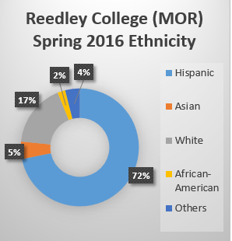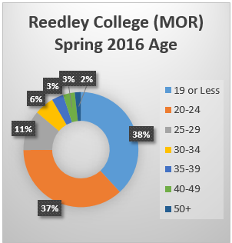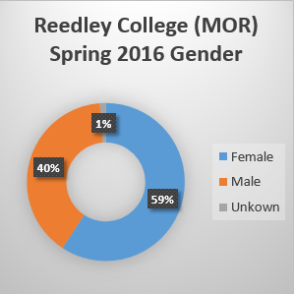

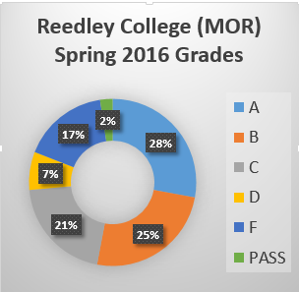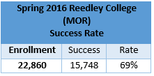

Spring 2016, a total of 10 students enrolled and started in the Reedley College Flight Science Program (AMT):
Table 1.1

Reedley College (MOR) success rate for Spring 2016 was 69%. Grades and Success rate for spring 2016 Flight Science Program:
Table 2.1 (Grades and Success Rate)
COURSE | # of Students | Pass | Success Rate
FLGHT-101 | 9 | 8 | 89%
FLGHT-102 | 10 | 7 | 70%
FLGHT-103 | 10 | 7 | 70%
OVERALL | 29 | 22 | 76%

GRADES | FLGHT-101 | FLGHT-102 | FLGHT-103
A | 1 | 0 | 4
B | 3 | 5 | 2
C | 4 | 1 | 1
D | 0 | 1 | 0
F | 1 | 2 | 1
W | 0 | 1 | 2
Overall retention rate for the Flight Science Program is 90%.

Table 2.2 Job Market (National, State and Regional):
Bureau of Labor Statistics: Airline Pilots, Copilots, and Flight Engineers:
BLS estimated a 5.2% Employment increase from 2014-2025.

State:
http://www.bls.gov/oes/current/oes532011.htm#st

1997 | 2002 | 2007 | 2012 | 07-12  % Chg.
228 | 224 | 366 | 307 | -16.1%
Industry Snapshot: Scheduled & Non-scheduled Air Transportation

Scheduled Air Transportation, number of establishments:
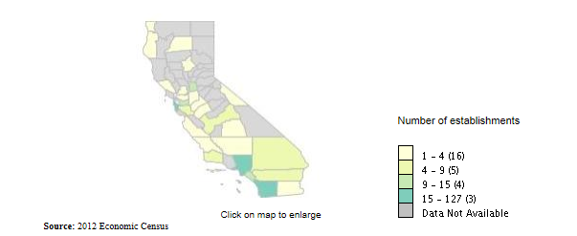
Scheduled Air Transportation, number of employees:
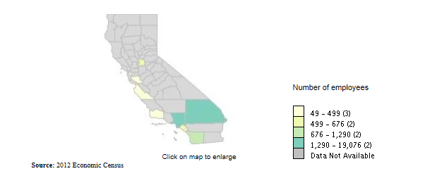
Non-scheduled Air Transportation, number of establishments:
 | 1997 | 2002 | 2007 | 2012 | 07-12  % Chg.
Number of establishments | 185 | 221 | 283 | 252 | -11.0%
Total employment | 2,068 | 3,013 | 3,599 | 3,421 | -4.9%
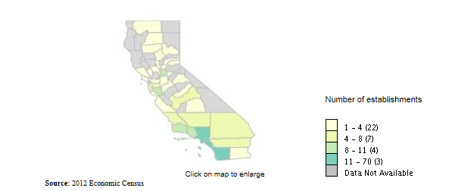
Non-scheduled Air Transportation, number of employees:
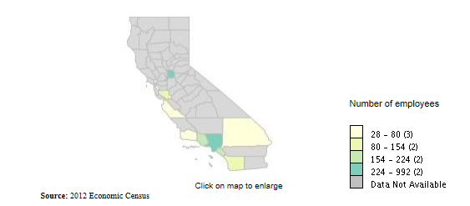

 | 1997 | 2002 | 2007 | 2012 | 07-12  % Chg.
Total Employment | 12,442 | 18,193 | 19,833 | 18,989 | -4.3%
Employees per establishment | 26.03 | 31.05 | 31.63 | 28.30 | -10.5%
Industry Snapshot: Support Activities for Air Transportation
Number of establishments:
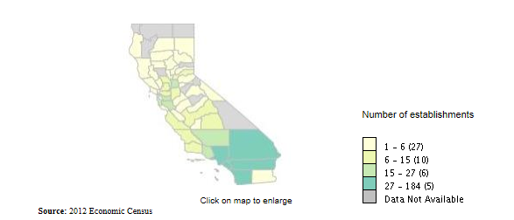
Support Activities for Air Transportation, number of employees:
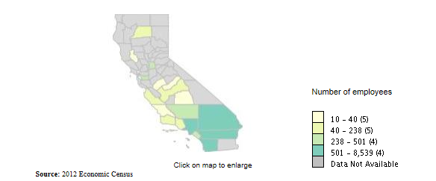
Data retrieved from: United States Census Bureau: http://thedataweb.rm.census.gov/TheDataWeb_HotReport2/econsnapshot/2012/snapshot.hrml?STATE=6&COUNTY=ALL&IND=%3DCOMP%28%28C4*C4%29%2FC4%29&NAICS=4881&x=9&y=8
Literature Review:
Andersen, Birgit. (2016, January 28). Pilot Shortage Threatens to Slow U.S. Airline Growth. Forbes. Retrieved from http://www.forbes.com/sites/oliverwyman/2016/01/28/pilot-shortage-threatens-to-slow-u-s-airline-growth/#36f4d3fabb6e

Fitzpatrick, Alex. (2016, March 22). Here’s the Major Crisis the Airlines Are Facing Now. Time. Retrieved from http://time.com/4257940/pilot-shortage/

Murphy, Kate. (2016, April 16). Plenty of Passengers, but Where Are the Pilots? New York Times. Retrieved from http://www.nytimes.com/2016/04/17/opinion/sunday/plenty-of-passengers-but-where-are-the-pilots.html?_r=0

The United States is on the verge of an airplane pilot shortage.
- To meet global growth over the next 18 years, Boeing forecasts that the industry will need more than a half million new pilots (NY Times).

- Roughly 18,000 pilots in the United States who will age out by 2022 (NY Times).

- Airlines are adding more airplanes just as a wave of pilots nears retirement and regulations on pilot duty times have tightened (Forbes).

- According to the Department of Transportation, airlines carried a record 895.5 million passengers in the United States in 2015, up 5 percent from the previous year (NY Times).

- In addition to widespread delays and cancellations, at least 29 communities, from Modesto, Calif., to Macon, Ga., have lost air service since 2013, and hundreds more had their number of flights reduced. Meanwhile, airports that haven’t lost service complain they can’t get additional flights to keep up with local economic development (NY Times).

- The number of commercial aircraft in service in the U.S. to rise 7.7 percent during the next 20 years to 8,067. The forecast expects the number of commercial aircraft in the global fleet to rise 40 percent to 34,437 aircraft (Forbes).

- U.S. pilots also fly for international airlines and corporate fractional flight operations, further boosting demand. Europe is expected to need 95,000 pilots, and Asia will likely need 226,000 (Forbes).

- It’s not just airlines that are feeling the pinch: flight schools, charter and corporate operations, weather trackers and crop-dusting outfits all say they are struggling to find pilots (NY Times).

What has caused the shortage?
- Current regulatory and industry situation can only yield about two-thirds of the pilots the U.S. will need in the next 20 years (Forbes).

- New regulations further constrain the availability of new pilots. As demand for air travel grows rapidly (global commercial airline capacity rose more than 6 percent last year (Forbes).

- New regulations introduced in 2013, designed to increase pilot proficiency, mandate that co-pilots working for commercial airlines hold airline transport pilot (ATP) certificates (Forbes).

- According to the U.S. Government Accountability Office, the military, traditionally the largest source of airline pilots, now accounts for only 30 percent of new airline pilots (Forbes).

- Increasing the number of hours required of first officers, from 250 to 1500 (Time).

Collaborative solutions:
- Airlines [will need to] find ways to work with partners to cultivate a pilot pipeline (Forbes).

- Leading airline executives are considering a new approach to the problem by forming partnerships with operators, training providers, and even regulators to shape the pipeline of pilots in training (Forbes).

- Developing programs with vocational or collegiate flight schools, developing more formalized feeder programs with regional partners, or financing the next generation of qualified pilots (Forbes).

- Aviation industry experts suggest that airlines need to start subsidizing and overseeing pilot training as in the so-called ab initio programs common in Europe, Asia and the Middle East. Airlines like British Airways, Lufthansa and China Eastern Airlines pay all or part of new cadets’ training, often at flight schools in the United States (NY Times).

Points to consider:

- “The real problem the industry is facing is young people aren’t making the decision to become an airline pilot,” said Capt. Tim Canoll, a Delta pilot and president of the Air Line Pilots Association. “It takes a very motivated person to meet the physical, emotional and intellectual challenge of becoming a pilot, and that same motivated person does the math looking at what it takes and the return on investment, and it just doesn’t add up,” particularly when training costs alone can reach $150,000 (NY Times).

- New hourly requirements make it more expensive to become a pilot ion the first place. Prospective pilots pay roughly $150,000 for the requisite training, hours, and college degree. Entry-level salaries at regional carriers, a popular jumping off point for new pilots, hover around $20,000 (Time).

- “We’ve had $5 billion of new industry come to our area, and the airlines say they can’t grow us because there aren’t enough pilots,” said Mike Hainsey, executive director of the Golden Triangle Regional Airport, which serves Columbus, Starkville and West Point, Miss. (NY Times)

