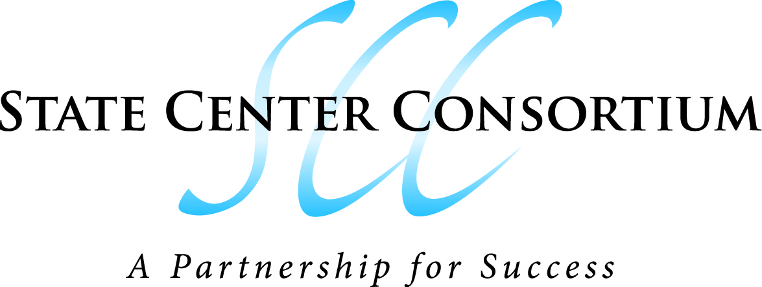
2+2 Articulation Approval Process
February 21, 2013
PolyCom Video Conference 12:00 – 12:30 PM
DO North/Clovis Center: CCB-305 (Building B), Reedley College: CCI208,
Fresno City College: OAB 226; Willow International: AC1 – 149A
AGENDA
- Brief Background on 2+2 Articulation

- Review Current 2+2 Articulation Approval Process
  - Average Approval Time

- Proposed Changes to Approval Process
  - State Center Consortium Articulation Officer
  - Streamlining the Process
  - Title 5 – High School Articulation

- Next Steps
  - Curriculum Committee Approval
  - Chancellor’s Cabinet Review
  - SCCCD Board Approval

